
Published annually by the Macalester College Department of Economics and Omicron Delta Epsilon

Table of Contents

Foreword
……………..………………………………………….…………Professor J.Peter Ferderer 3

Do Differences in Unemployment Benefits Explain Unemployment
in Spain Relative to Portugal?
………………………………………………………………………….WilliamaCreedon 5

How Does Mass Media Exposure Affect Knowledge of Different
Contraceptive Techniques Among Women in Brazil?
…………………………………………………..….………………..CarolineaDavidson 25

Closing the Gap: Examining How Financial Literacy Affects the Saving Behavior of Low-Income Households

…………………………………………………....……Alexia Diorio & Rosamond Mate 42

Peru: Do Mothers as Role Models Affect their Teenage Daughters’ Sexual Behavior?
………………………………………………………………….……….…Iva Djurovic 57

What Does Love Have To Do With It? An Economic Analysis of the Marriage Decision for non-GLB and GLB couples in the United States
…………………………………………………………………………AnnaaGraziano 75

On The Economic Applications of Brouwer’s And Kakutani’s Fixed Point Theorems: General Equilibrium and Game Theory
……………………………………………………………………...…..Yacoub Shomali 91

Macalester Journal of Economics
MJE
Volume 24 Spring 2013
Macalester Journal of Economics

Volume 24 Spring 2013

Omicron Delta Epsilon

Yacoub Shomali ‘13, President
Kwame Fynn ‘13, Vice President
Anna Jacob ‘13, Secretary

Editors

Natalie Camplair ‘13
Sasha Scarlett Indarte ‘13
Rebekah Tedrick-Moutz ‘13
Economics Faculty and Staff

Paul Aslanian  Emeritus Professor | Jeffery Evans  Adjunct Professor | Jane Kollasch  Department Coordinator | Raymond Robertson  Professor
Amy Damon  Assistant Professor | Peter Ferderer  Professor | Joyce Minor  Karl Egge Professor | Mario Solis-Garcia  Assistant Professor
Liang Ding  Professor | Gary Krueger  Professor | Karine Moe  F.R. Bigelow Professor,  Department Chair | Vasant Sukhatme  Edward J. Noble Professor
Karl Egge  Emeritus Professor |  |  | Sarah West  Professor

A Note from the Editors

We would like to congratulate the authors of these six papers on their exceptional work. We thoroughly enjoyed working with you and reading your work. Although we are unable to publish every paper we would have liked to, we were truly impressed by the quality of the submissions from everyone. We would also like to thank all of the faculty who recommended papers for their time and excellent taste. Lastly, we would like to thank Jane Kollasch for her guidance and assistance with the journal itself. Fantastic work everyone!

Foreword

The Macalester Journal of Economics is produced by the Macalester College chapter of Omicron Delta Epsilon, the international honors society in economics. The editors – Natalie Camplair (Portland, Oregon), Alexandra Indarte (Minneapolis, Minnesota and Ibiza, Spain) and Rebekah Tedrick-Moutz (Charleston, South Carolina) – have done an outstanding job selecting and editing six papers which represent the best scholarship to emerge from our courses this past year.
Why do Americans save so little? Alexia Diorio (Shoreline, Washington) and Rosamond Mate (Champaign, Illinois) examine whether lack of financial literacy explains this seemingly shortsighted behavior. After controlling for a number of standard determinants, they find that individuals who grasp the concept of portfolio diversification tend to save more while those who understand inflation save less. Interestingly, differences in financial literacy do not help explain why the poor save less than the wealthy.
The next two articles explore fertility in Latin American. Iva Djurović (Belgrade, Serbia) examines the determinants of teenage pregnancy in Peru. Consistent with previous research, she finds that increased education and use of condoms during the first sexual experience are associated with decreased likelihood of pregnancy. On the other hand, a mother’s background (education, age at first birth, and emotional abuse experience) has little independent impact on the likelihood of pregnancy among teenage daughters.
How do women learn about contraception? Caroline Davidson (Lexington, Massachusetts) focuses on Brazil and finds that exposure to mass media increases the depth of knowledge about the range of available contraception techniques. Caroline makes the compelling case that the depth of knowledge matters because the optimal birth control method varies with a person’s circumstances.
Anna Graziano (Saint Paul, Minnesota) asks whether love influences the decision to get married. She compares Gary Becker’s (1974) seminal theory on this subject to a model that includes relationship quality and compatibility variables and finds that the latter are more important in predicting the likelihood of marriage. The influence of these variables is not significantly different between gay, lesbian and bisexual couples and heterosexual couples. Love matters irrespective of sexual orientation.
William Creedon (Hoffman Estates, Illinois) explores why Spain has experienced such high unemployment over the past three decades, while neighboring Portugal has not. He finds that the differences can be partly explained by the longer duration of Spain’s unemployment benefits and its lower union density. One cannot read this paper without wondering whether there are important lessons here for the United States.
Yacoub Shomali (Amman, Jordon) provides the final contribution by showing the role of fixed point theorems in proofs of the existence of general equilibrium and Nash equilibrium. These ideas are at the core of economics and Yacoub’s article nicely illustrates the mathematical prowess of our students.

On behalf of my colleagues in the Economics Department, I am delighted to present the work of these talented students. I am confident that you will find it informative and interesting.

J. Peter Ferderer
Professor of Economics

Do Differences in Unemployment Benefits Explain Unemployment in Spain Relative to Portugal?

William Creedon ‘13
Labor Economics

This paper determines that unemployment benefits partially explain Spanish unemployment relative to Portugal from 1985 to 2009. The difference in the maximum duration of unemployment benefits between Spain and Portugal is highly statistically and economically significant. A one month increase in maximum benefit duration in Spain relative to Portugal would increase unemployment in Spain (relative to Portugal) by approximately 1 percentage point. Unionization, and to a lesser extent wage bargaining coordination also explain the Spanish-Portuguese unemployment differences. Analytical comparisons between Spain and Portugal’s economies should continue to provide valuable policy insight; insight which at this time is crucial to help Spain and the Eurozone return to a path of economic growth and resilience.

I. Introduction

Nearly one in four Spaniards is out of work and seeking employment. Not only is Spain’s current level of unemployment astonishingly high in comparison with its fellow Organization for Economic Cooperation and Development (OECD) members, but Spain has struggled with periods of exceptionally high unemployment for nearly three decades. High unemployment and related reductions in national income in Spain contribute to the anemic economic recovery in Europe since the 2008 financial crisis and need to be combatted.
In a long-run comparison with Germany, France, the United Kingdom, Italy, and Portugal, Spain has experienced much greater unemployment levels and greater volatility in unemployment in the last 25 years (World Development Indicators). Portugal, in stark contrast, experienced exceptionally low and stable unemployment over that period (see fig. 1). Some research has focused on understanding the difference between the two apparent unemployment “outliers” of Portugal and Spain (Bover, García-Perea, and Portugal, 2000). The two countries not only represent extremes in unemployment levels for members of the OECD, but merit comparison because of the many historical, cultural and institutional similarities between both countries. Blanchard and Jimeno (1995) conclude the unemployment benefit system is the only major institutional difference between these two countries and hence the driving force behind their disparate unemployment experiences. In this paper, I seek to carry forward this analysis and determine if unemployment benefits explain differing unemployment levels in Spain and Portugal.
Specifically, I am interested in determining if unemployment benefits and other institutional factors explain the difference in the unemployment rates between Spain and Portugal between 1985 and 2009. The difference between Spanish and Portuguese labor taxation, for example, does not appear to explain the difference in the two countries’ unemployment; other institutional differences, however, are explanatory. In this paper I consider the labor market institutions of unemployment benefits, collective bargaining, and tax policy and their effects on unemployment outcomes in the two countries.
I perform three base regressions in my analysis: (i) a random effects regression on a panel of Spanish and Portuguese data with a dummy variable for Spain included as a covariate, (ii) an OLS regression of unemployment on the institutional covariates for each country individually, and (iii) a regression of the difference in unemployment between Spain and Portugal by the differences within the variables from my guiding equation between Spain and Portugal. I find that within Portugal, changes in union density correlate positively with unemployment rates over time. Within Spain, wage bargaining coordination is negatively correlated with unemployment and payroll taxes are positively correlated with unemployment. Increases in the difference in maximum unemployment benefit duration positively correlate to the differences in Spanish and Portuguese unemployment, differences in union density negatively correlate to differences in unemployment, and high wage bargaining in Spain relative to Portugal negatively correlates to differences in unemployment. In conclusion, unemployment benefits, in terms of the maximum duration of unemployment benefits, do explain unemployment differences between Spain and Portugal, and evidence suggests collective bargaining explains unemployment differences as well.
My paper is organized as follows: Section II reviews the appropriate literature on unemployment in Spain and Portugal. Section III outlines the theory developed by Layard, Nickell, and Jackman (1991) that I utilize and modify to explain unemployment as a function of institutional factors such as the maximum allowed duration of unemployment benefits. Section IV A presents the summary statistics of my data and Section IV B presents my results and robustness analyses. Section V reports my conclusion that the maximum duration of unemployment benefits explains unemployment in Spain vis-à-vis Portugal.

II. Literature Review

I categorize the literature by its level of focus on unemployment in Spain and Portugal and by chronological progression of research on the issue of unemployment. I then propose a gap in the literature that this paper fills.
Papers that principally and comprehensively address the discrepancy between Spanish and Portuguese unemployment are limited. Blanchard and Jimeno find four elements of labor markets that could reasonably cause the gap between Spanish and Portuguese unemployment: fiscal policy or the “tax wedge,” collective bargaining, employment protection, and unemployment benefits. After deeper evaluation of these four factors, however, the authors argue that only unemployment benefits appear to be substantially different between Spain and Portugal. They noted eligibility requirements are significantly stricter in Portugal, which leads Spain to have more unemployed persons receiving benefits than Portugal.
A more recent study that focuses specifically on a comparison between the two countries is that of Bover, García-Perea, and Portugal (2000). They focus on labor market institutions instead of shocks, but unlike the previous authors, they estimate unemployment using micro-data from the late 1970s through the mid-1990s. They find that two key institutional differences explain the Portuguese-Spanish unemployment differential: unemployment benefits and wage flexibility. The authors explain that before 1985, Portugal had “virtually no [unemployment benefit] system” while Spain’s was generous (p. 410). By 1989, however, the Portuguese system of benefits was covering a significantly larger portion of the unemployed and the replacement ratio had risen. Then Spain, in 1992, tightened unemployment eligibility criteria and reduced the replacement ratio. Despite this convergence in policy by the 1990s, Spain’s benefit system was still more generous than Portugal’s.
The second finding of Bover, García-Perea, and Portugal’s paper is that wages are considerably less flexible in Spain and play a major role in accounting for unemployment there. Specifically, wage floors established through collective bargaining are higher in Spain and more homogenous across industry sectors than in Portugal. The authors attribute these outcomes and the greater relative power of Spanish unions to exclusive jurisdiction rules, greater union coordination, and the public financing of unions. Theory suggests that greater union power alone results in higher unemployment, but that high wage bargaining coordination results in lower unemployment; this will be discussed in section three.
Bentolila and Jimeno (2006) bridge the gap from a focus on Spain and Portugal to a focus on Spain in comparison to the OECD. They discuss unemployment in Spain primarily in the context of the unemployment experience of OECD members, but also direct attention to the puzzling difference in that experience between Spain and Portugal. Bentolila and Jimeno find that institutions as opposed to shocks were primarily responsible for the trend in Spanish unemployment from 1975 to 1995. They caution, however, that Spanish institutions “amplified the effects of aggregate shocks, which seem to have been similar in the rest of the OECD” (p. 331). This suggests that although Portugal and Spain in particular faced very similar shocks, Spanish and Portuguese institutions must be effectively different. In contrast to previous studies, however, the authors claim “unemployment benefits get too much blame for the rise in unemployment” and that collective bargaining deserves more blame. “Unions have an undisputed grip on collective bargaining [in Spain], whose regulation remains unchanged since the early 1980s”, according to Bentolila and Jimeno (p. 332). Bentolila and Jimeno’s conclusion remains the same when specifically comparing Portugal and Spain: unemployment benefit replacement rates and their durations are much lower in Portugal than Spain, but it is primarily the high wages achieved by Spanish collective bargaining which explains the unemployment differential between the two countries.
Two papers discuss broad economic and unemployment differences across OECD countries. The work of Layard, Nickell, and Jackman (1991; hereafter referred to as LNJ) takes a macroeconomic approach to analyze the effects of institutions and economic shocks on unemployment rates in 19 OECD countries. They find the economies studied perform well in response to exogenous shocks under two general conditions; first, if the countries have an unemployment benefits system that discourages long-term unemployment, and second, if the system of wage determination is “satisfactory” (p. 449). In practice, benefits may still be generous, but the duration must be short so as not to encourage long-term unemployment. A “satisfactory” system of wage determination, can take two forms: a competitive non-unionized labor market or a labor market in which bargaining is centrally coordinated on the employer side. The levels of union coverage and coordination in Spain and Portugal are high relative to other OECD countries, but in Portugal more bargaining power and coordination lie within employer unions, while in Spain employers have less power and its two unions tend not to coordinate (Layard, Nickell, and Jackman 1991). In summary, LNJ suggest that unemployment benefits and collective bargaining together are driving the difference between unemployment levels in the two nations.
Jaumotte (2011) specifically compares Spain with the EU15, or the 15 European countries within the OECD, and is able to analyze much more recent data than previous studies. Jaumotte implicitly argues the majority of Spanish unemployment derives from wage inflexibility caused by the level of centralization of its collective bargaining. Spain has an intermediate degree of coordination which takes place not at the firm level, but at the provincial and industry level. This is similar to Portugal, but the system is worse in Spain for four reasons: (i) national wage guidelines act as minimums and are bid up over many levels—the compounded effect is a substantial wage increase; (ii) bargains apply to all workers in the sector; (iii) firms’ wage agreement “opt-out” clauses are restrictive and not readily used; (iv) wages are highly indexed to inflation but not corrected when inflation is lower than expected. She also concludes unemployment benefits and the tax wedge are material sources of unemployment for the Spanish labor market, but these claims were weakly addressed in her analysis.
This paper seeks to carry forward the work of studies which take a close look at institutional differences between Spain and Portugal. This paper considers the recent unemployment trends in the late 1990s and 2000s to discover what occurred during that time to harmonize Spanish and Portuguese unemployment levels, an area not adequately researched. It contributes to resolving the disagreement between studies on the Spanish-Portuguese unemployment puzzle regarding the importance of unemployment benefits and collective bargaining (Blanchard and Jimeno (1995), Bover, García, and Portugal (2000), and Bentolila and Jimeno (2006). Moreover, my analysis of recent data on benefits and collective bargaining in both countries corroborates the relationship between those institutions and the unemployment rate found in broader cross-country studies involving the OECD (Layard, Nickell, and Jackman, 1991; Jaumotte 2011).

III. Theory
A. Theoretical Framework

I follow the approach of LNJ (1991) to relate unemployment with union power and unemployment benefits and outline their model below. The model begins with an economy of many identical firms that are all unionized. The union’s role in the economy is to maximize worker utility by maximizing the wage of its median voter while the firm’s goal is to maximize profits. For simplification, unions only bargain for wages. When unions bargain for higher wages, firms must reduce employment to maximize profits. Thus, there is a bargaining period and an outcome period, where some workers may be laid off. In this model, workers are laid off at random, and therefore the expected utility of the median voter is the same as the utility for all workers. The authors build the model based on game theory; firms and unions will settle on a wage bargain because if there were a strike or lockout, both parties would lose revenue and wage income, respectively. Firms and unions are therefore going to maximize the total value of the outcome of the wage bargain, or the Nash-bargaining maximand, given by

$$\left[1\right] Ω={\left(W_{i}-A\right)}^{β}[{{S(W}_{i})]}^{β}Π_{i}^{e}(W_{i})$$

$W_{i}$ is the real wage at firm i, $A$ is the expected alternative income for a worker who randomly has lost their job, $β$ is a measure of union power, $S$ is the probability of being employed by the same firm in the next period (relative to the current period in which the bargain is being negotiated) as a function of the wage, and $Π_{i}^{e}$ is the expected operating profit—the excess of revenue when there is no strike. $S$ is decreasing in increasing wage and $Π_{i}^{e}$ decreases in increasing wage. The expected alternative income is given by

[2] $A=\left(1-φu\right)W^{e}+φuB$ $W^{e}>B$

where $u$ is the level of unemployment in the economy, $W^{e}$ is the expected real wage outside the firm, and $B$ is the real unemployment benefit payment. $φ$ is a constant which depends negatively on the turnover rate and positively on the discount rate as is confined to a domain of 0 < $φ$ < 1. The expression $\left(1-φu\right)$ reflects that the chances of getting a job are lower the greater the level of unemployment. The authors also assume unions have perfect foresight regarding $u$ and $B$, so that their bargain is made with perfect information.
By calculating the first-order condition of the Nash-bargaining maximand and substituting the terms of that expression for relationships derived from the Cobb-Douglas production function and a constant elasticity demand function, the authors arrive at their final relationship between unemployment and the replacement ratio and union power. The relationship is expressed by equation [3].

$$\left[3\right] u^{*}=\frac{1-ακ}{\left(ε_{SN}+\frac{ακ}{β}\right)\left(1-\frac{B}{W}\right)φ}$$

The final assumption required to make equation [3] a direct expression for unemployment is that the replacement ratio $\frac{B}{W}$ must be exogenous. $ε_{SN}$ is the elasticity of employment survival of workers at a firm with respect to the firms’ expected employment, $κ=1-1/σ$ is the measure of product market competiveness, and $α$ is the labor intensity of production at the firm.
The union and unemployment theory developed by LNJ suits this paper’s purposes well. It relates not only union bargaining power with unemployment, but it also includes a role for unemployment benefits. From equation (9) unemployment is positively related to union power, $β$. In LNJ’s hypothesized economy, when unions have a great deal of power and only bargain for wages, unions bargain successfully for high wages but have to accept larger unemployment at their firm. Unemployment is negatively related to the labor intensity of the firm, $α$, and the firm’s market power in the product market, $κ$. The higher the labor intensity of production, the more difficult it is for firms substitute capital for workers, and thus the lower the unemployment rate. The greater the firm’s market competitiveness the more output they produce and sell at a given price and the more workers they will employ; hence, a negative relationship with unemployment. Unemployment is positively related to the replacement ratio, $\frac{B}{W}$, because the higher the ratio, the larger the alternative income, leading unions bargain for even higher wages which leads to greater unemployment. Lastly, the model clearly has roles for the firms’ product market competitiveness and the intensity of labor in the firm’s production process, but this paper will not consider these. In accordance with Bover, García-Perea, and Portugal (2000), labor intensity, product competitiveness, and turnover and discount rates are unlikely to differ greatly across Spain and Portugal and would therefore not explain the differences in each country’s unemployment rates.
What the union theory of LNJ does not include are roles for maximum benefit duration or tax wedge. In both Spain and Portugal there are payroll and income taxes which could contribute to form such a tax wedge. A tax wedge is any tax policy or set of policies which create or expand a gap between what workers take home as pay and employers end up paying for labor. Such policies typically include taxes for social security and national healthcare programs. Maximum benefit duration is the longest continuous period of time an unemployed worker may receive unemployment benefit payments. For this paper and for interpretive purposes, longer benefit durations have the effect of raising the replacement ratio value and therefore increasing unemployment.
To descriptively illustrate the effect of a payroll tax in the most general framework, consider the following: a payroll tax assessed on firms or employees increases the cost of labor for firms and lowers the wage received by workers. Initially, there is a labor market equilibrium with wage w₀ and employment E_{0.} Suppose the tax of t is then imposed on workers (assessing the tax on firms or workers makes no difference in the employment outcome). All workers end up only taking w-t euros home. One may envision this as a leftward shift of the labor supply curve, where the new equilibrium consists of w₁ such that w₁ < w₀, and E₁ such that E₀ < E₁. The greater the tax t, the greater the leftward shift in supply, and the lower the employment outcome (or the higher the unemployment).
I incorporate the tax wedge into the equation for unemployment developed by LNJ as follows

$$\left[4\right] u^{*}=\frac{1-ακ}{\left(ε_{SN}+\frac{ακ}{β}\right)\left(1-\frac{B}{W(1-τ)}\right)φ}$$

The after-tax wage is some fraction of the bargained wage, where $τ$ is the rate of taxation. As the tax wedge increases, the after-tax wage decreases, the observed benefit ratio increases and unemployment increases.

B. Union Power and Guiding Equation

What is union power? When taking the theoretical model to data, this variable must be reasonably defined. In the literature, studies typically measure union power as union coverage, union density, and the level of wage bargaining coordination (e.g. Bentolila and Jimeno, 2006; Blanchard and Wolfers, 2000). Union Coverage measures the number of workers in an industry for whom collective bargaining agreements determine wages, and these workers need not be official union members. Union density refers to the proportion of the labor force in union membership (“trade union”). Neither is a perfect measure of the number of workers bargaining in the economy, but in previous cross country comparisons, models typically use data on union coverage as opposed to density. This is also more in line with the model outlined above, which is concerned with wages and alternative incomes.
Union power is also a matter of the bargaining structure of collective bargaining. If unions bargain on a firm-by-firm basis, there are alternative jobs if a worker is laid off at one firm, and there may be a substantial value for $A$ from the model. If, by contrast, there were one union bargaining with a single federation of employers on behalf of a country’s entire workforce, then there would be no other firms or industries in the economy providing a work alternative. $A$ would only represent the value of unemployment benefits and therefore the one union would have little bargaining power. They have little power because they are less willing to press for high wages and risk a lower post-bargain employment survival probability. High coordination implies that firms and unions are bargaining on a broad level, typically nationally. Low coordination implies small scale firm-level bargaining. Without a high degree of union coordination, a unionized economy results in higher unemployment. An economy with little unionization has an outcome close to full employment, ceteris paribus. An economy with high unionization but high coordination among employers and unions in wage bargains also results in low unemployment. These outcomes support a quadratic relationship between union coverage and unemployment; when union density is high, unemployment may be high or low depending on the level of wage bargaining coordination. This relationship is supported in my data (fig. 2). These outcomes suggest an interaction between union coverage and coordination, but, in line with the literature, I do not include an interaction in this paper.
From theory outlined above, LNJ (with my own modifications) have developed a framework for how workers and unemployment respond to benefits and expressed an interaction between unionization and coordination. From this framework, I build a regression model for unemployment and express the expected signs for the coefficients. The guiding equation of the regression model is
$$\left[5\right] {Unemployment}_{it}=$$
$$α+ β_{1}^{} {Replacement Ratio}_{it}^{}$$
$$+β_{2}^{} {Duration}_{it}^{}$$
$$+β_{3}^{} {Union Coverage}_{it}^{2}$$
$$+β_{4}^{} {Coordination}_{it}^{}$$
$${ + β}_{5}^{} {TaxWedge}_{it}^{}+ε$$

where unemployment in country i at time t is a function of the replacement ratio, the maximum duration of benefits, the tax wedge, the union coverage, and the degree of union coordination.

IV. Empirical Evidence
A. Summary Statistics

To estimate the guiding equation, I need data for each variable in the equation for both Spain and Portugal at the same frequency. I use annual observations of these variables from 1985 to 2009. Table 1 presents the theoretical variables and their expected signs as well as the data I used for those variables (which were seldom ideal) and their definitions and sources. Table 2 details the different levels of wage coordination, measured by an index developed by Jelle Visser (2009). Due to the similarity between levels 2 and 3, I create a binomial variable ‘CoordinationHigh’ that is 1 if the wage bargaining index level is 4 and 0 if otherwise. If otherwise, coordination is assumed to be low, theoretically resulting in higher unemployment. As a proxy for the tax wedge, I use the employer social security payroll marginal tax rate (employer marginal rate or EMR, see Table 1 for details). Using the data I gathered, the guiding equation can be explicitly written as

$$\left[6\right] {Unemployment}_{it}=$$
$$α+ β_{1}^{}{NetreplacementRatio}_{it}^{}$$
$$+β_{2}^{}{Duration}_{it}^{}$$
$$+ β_{4}^{}{Union Density}_{it}^{2}$$
$$+β_{5}^{}{CoordinationHigh}_{it}^{}$$
$$+β_{6}^{}{EMR}_{it}^{}+ε$$
Table 3 presents the summary statistics. From Table 3, Spain’s average unemployment rate is 10 percentage points greater than Portugal’s, and Spain’s standard deviation on the unemployment rate is 5 percentage points, while that of Portugal is only 1.6 percentage points. Spain’s standard deviation reflects the “wild ride” of Spain’s unemployment experience over the period (Bentolila and Jimeno 2006). On average, Portugal has had a slightly higher net replacement ratio than Spain, yet Portugal has had low unemployment, which runs counter to theory and suggests benefits in terms of replacement ratios do not explain unemployment differences between the two countries. Maximum benefit duration is higher on average in Spain, and this variable therefore might explain higher unemployment in Spain than Portugal. Portugal’s squared union density is, on average, clearly higher than Spain’s and Portugal’s wage bargaining coordination is lower. Theoretically, this combination should lead to higher unemployment for Portugal. Future research ought to consider Portugal in detail to better understand the nature of collective bargaining in that country and explain their counter-theoretical unemployment experience. Lastly, the mean of the employer marginal tax rate (EMR), is higher in Spain and theoretically matches Spain’s higher unemployment compared to Portugal.

B. Main Results

Accounting for estimation issues, I perform a preliminary regression following equation [6] above using a robust random effects estimation technique. Table 4 column (1) presents the results of this regression. This regression does not reveal what uniquely explains unemployment differences in Spain and Portugal, but explains overall unemployment in the Iberian Peninsula. It assumes the effect of the covariates is the same in each country. The only statistically significant explanatory variable for unemployment in this regression is the marginal social security contribution rate levied on employers or the employer marginal rate (EMR). I compare the main results to the results when a dummy variable for Spain is added as a covariate (column 2). One can observe that the statistical significance of the EMR and coefficient values in the regressions change when Spain is added to the regression. Columns (3) through (7) present alternative specifications of the equation from column (2) as sensitivity analyses. Only in the absence of the EMR does the Spain dummy variable become significant (column 7). In a preliminary response to the question of whether unemployment benefits explain unemployment in Spain vis-à-vis Portugal, these results indicate that benefits variables seem unable to explain any of the unemployment variation in the data when controlling for the other theoretical covariates. These results also motivate specific analysis of the difference between Spain and Portugal’s unemployment.
In order to analyze possible country specific effects of unemployment covariates, I repeat the random effects estimation above but interact the Spanish dummy variable with the variables of the guiding equation. The incorporation of interacting covariates creates several new issues of severe collinearity involving several of the interaction terms in the model. Nevertheless, I do not make any changes to the model that will be regressed, but my robustness checks exclude multicollinear variables. I find that specifications of interaction models produce no meaningful results and do not include them in a table. The main regression includes all covariates but none are statistically significant. In the absence of the EMR, squared union density has a different effect in Spain than in Portugal (at the 10 percent significance level); in Spain, a 10 percentage point increase in union density would raise unemployment by 2.5 percentage points more than in Portugal. This provides a weak indication that union power may be playing a role in explaining Spanish unemployment vis-à-vis Portugal, and not unemployment benefits.
My next regression explores the possibility of different variables having different effects on unemployment in Spain and Portugal by examining the model on subsets of data for each country. I use a robust OLS regression of Spain and Portugal’s individual unemployment series on the variables of the guiding equation. As maximum benefit duration in Spain remains constant throughout the period of study, I exclude it from Spain-specific regression. Table 5 presents the results of these regressions, where column (1) repeats regression (1) from Table 4. The dissimilarities between regressions (2) and (3) emphasize the differences in significant explanatory variables for the two countries and the different effects they have.
Replacement rates have no significant effect on unemployment in either country, and in Portugal the maximum benefit duration is insignificant. Unemployment benefits, therefore, may not explain Spanish unemployment vis-à-vis Portugal. For Portugal, squared union density is a significant factor positively related to unemployment; for Spain this variable has a negative sign and is insignificant. In Spain, high wage bargaining coordination has a significant negative correlation with the unemployment rate. The EMR also has a significant positive relationship with unemployment in Spain. Overall, these results indicate that the level of wage bargaining coordination and the EMR may explain Spanish unemployment relative to that of Portugal. In Portugal, these variables have no effect, but in Spain high coordination correlates with lower unemployment and a higher EMR correlates to higher unemployment.
Regressions with a Spanish dummy variable covariate and regressions with Spanish interactions suggest the unemployment benefits have no relationship with unemployment in either Spain or Portugal. Individual country data only indicates what relationships exist within each country. To ultimately determine if unemployment benefits explain unemployment in Spain vis-à-vis Portugal, I regress the difference in Spanish and Portuguese unemployment on the difference within the variables from the guiding equation.
Table 6 presents the results of the Spanish-Portuguese differences regression. Column (1) records the main regression results while the subsequent columns present sensitivity analyses using different model specifications. The primary findings of the main regression are (i) that the difference in maximum benefit duration is highly significant and positively correlated with the difference in unemployment rates and (ii) that the difference in union density is highly significant and negatively correlated with the difference in unemployment rates. Both relationships are also highly robust to different model specifications. The main model estimates that a 1 month increase in the difference between Spanish and Portuguese benefit durations increases the difference between Spanish and Portuguese unemployment rates by approximately 1 percentage point. Spain’s maximum unemployment benefit duration did not change over the time period of study, but from the mid-1980s to the late 1990s, Portugal’s maximum benefit duration was substantially lower than Spain’s. It was over these years that the difference between Spanish and Portuguese unemployment was also highest. In 2000, Portugal matched their maximum benefit duration with Spain and in the early 2000s the gap in unemployment between the two groups converged mainly due to sizeable declines in Spain’s unemployment but also to some increases in Portuguese unemployment. This finding strongly supports the hypothesis that unemployment benefits, at least in terms of their maximum duration, explain the difference in unemployment between Spain and Portugal.
The effect of a ten percentage point increase in the difference in union density would correlate with a 0.35 percentage point decrease in the difference in unemployment between Spain and Portugal. It is important to note that over the period of study, Spain’s union density always lies below Portugal’s union density and Spain’s unemployment rates always lie above those of Portugal. An increase in Spain’s union density would shrink the union gap with Portugal and also shrink the unemployment gap with Portugal by lowering unemployment. Theory is ambiguous about the effect of union density alone—its effect depends on the level of coordination in wage bargaining—and so this result is in line with theory. If squared union density is negatively related with unemployment rates in Spain (which would agree with the sign from Table 5 column 3), theory suggests it must be the case that Spain has higher degrees of wage bargaining coordination for the Nash bargain to result in low unemployment. This condition of high wage bargaining is reasonably met given the average level of wage coordination in Spain is higher than Portugal (from the summary statistics) and from 2002 to 2008 (a period when the unemployment gap was small and Spanish unemployment was historically low), Spanish wage bargaining was consistently high relative to Portugal.
The level of wage bargaining is marginally statistically significant, but its sign fits well with the findings of the within-country regressions and agrees with theory. Effectively, this dummy variable indicates whether or not Spain has a high level of wage coordination relative to Portugal. If Spain’s level of coordination is high while Portugal’s is low, the difference will be 1, and its effect reduces the difference between Spanish and Portuguese unemployment by 1.59 percentage points specifically by lowering unemployment in Spain by that amount. This variable is sensitive to different model specifications, but maintains its significance in the absence of the EMR and increases in significance in the absence of benefit duration.

V. Conclusion

In summary, my paper reports evidence that unemployment benefits explain Spanish unemployment relative to Portugal from 1985 to 2009, as presented in the results of the Spanish-Portuguese difference regression (Table 6 column (1)). The net replacement ratio appears to have no effect on the difference between Spanish and Portuguese unemployment and this finding is generally robust. The difference in the maximum duration of unemployment benefits, however, is highly statistically and economically significant. A one month increase in maximum benefit duration in Spain relative to Portugal would, by my estimation, increase unemployment in Spain (relative to Portugal) by approximately one percentage point. This result agrees with my theory and the literature relevant to understanding unemployment differences in Portugal and Spain.
Maximum benefit duration alone does not paint a complete picture; unionization, and to a lesser extent wage bargaining coordination also explain the Spanish-Portuguese unemployment differences. An increase in the difference in squared union density between the two countries decreases the difference in unemployment. The theoretical prediction for the effect of union density is ambiguous and depends on the level of wage bargaining coordination in labor markets. In future research, an interaction term between union density and coordination should be examined to better understand these variables’ relationships with unemployment. The presence of high wage coordination in Spain relative to Portugal also negatively relates to the unemployment difference. Within Spain high wage bargaining coordination leads to a substantial reduction in unemployment. Decreases in the EMR within Spain would also have a large and significant mitigating effect on unemployment there.
The literature suggests that collective bargaining and unemployment benefits explain the difference between Spain and Portugal’s unemployment experiences; Bentolila and Jimeno (2006) in particular claim that collective bargaining is more to blame than unemployment benefits. My analysis suggests that the latter claim is inaccurate for my period of study (1985 to 2009). My results suggest that collective bargaining may have some effect on unemployment, but the supporting evidence is weak and requires further research, whereas unemployment benefits in terms of the maximum benefit duration have a strong positive relationship with unemployment.
The primary caveats of my paper relate to the quality of the variables I use. The net replacement ratio may not be a better measurement of benefits than the gross replacement ratio, and in future research it is imperative to find a better measure of benefits for both Spain and Portugal than the data I use. I concoct maximum benefit duration from various sources. Although confident the measurement is consistent, I cannot guarantee it is an accurate portrayal of the population of workers in both countries. In addition to union density, the inclusion and investigation of union coverage as a measure of union power would improve this paper; union density may underestimate the impact of collective bargaining in the two countries’ labor markets. The EMR is not a perfect proxy for the tax wedge variable and may underestimate the impact of taxation in labor markets. Future research should attempt to use more reliable data, which may be available from the statistics institutes and central banks of Spain and Portugal.
Future research ought to consider Portugal in detail to better understand the nature of collective bargaining in that country, as it appears Portugal is able to maintain low employment despite high unionization and low wage bargaining coordination. Analytical comparisons between Spain and Portugal’s economies should continue to provide valuable policy insight; insight which at this time is crucial to help Spain and the Eurozone return to a path of economic growth and resilience.

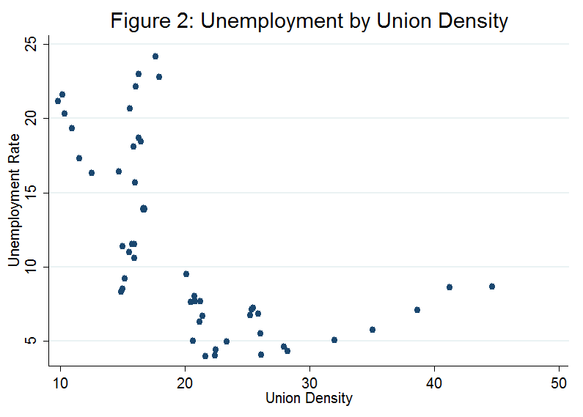

Table 1: Summary of Variables
Theoretical Variable | Sign | Empirical Variable | Definition | Source
Unemployment Rate | NA | Unemployment Rate | Percentage of the civilian labor force unemployed | OECD Stat.Extracts
Replacement Ratio | (+) | Net replacement Ratio | The cash value of unemployment benefits, less taxes, received by an unemployed one-earner household with two children, divided by the wage less taxes when the household worker was employed. Taxes consist of mandatory contributions to social insurance programs, less cash transfers (ii). | Unemployment Replacement Rates Dataset (van Kliet and Caminada, 2012)
Maximum Benefit Duration | (+) | Maximum Benefit Duration | The longest continuous period of time, measured in months, during which a prime-aged worker (age 40-45) with over 6 years tenure in their previous job and dependents may receive benefits (iii). | Bover, García-Perea, Portugal (2000), Pereira (2006), OECD "Benefits and Wages: Policies" Dataset
Union Coverage | (Amb) | Union Density | The ratio of wage and salary earners that are trade union members, out of the total number of wage and salary earners. | OECD Stat.Extracts
Wage Bargaining Coordination | (-) | Wage Bargaining Coordination Index Level | An index from one to five, where increasing values imply greater coordination between firm and union wage bargainers (see Table 2). | ICTWSS
Tax Wedge | (+) | Employer Social Security Payroll Tax (Marginal Rate) | The marginal social security contribution rate levied on employers, or employer marginal rate (EMR) (iv). | OECD Tax Database, Table III.2 “Employer Social Security Contributions.”
Notes: (i) The expected sign for union coverage is theoretically ambiguous, and is usually, but not always, found to be positive in the literature (Blanchard and Wolfers, 2000; Layard, Nickell, and Jackman (1991). (ii) Workers were assumed to earn the average production worker wage (from 1985 to 2000) or the average wage (from 2000 to 2009) when employed. (iii) The maximum duration measure does not include the duration of any supplemental unemployment assistance that may be available in special circumstances. I assume that the replacement ratio for 40 year old workers used in this paper corresponds to the maximum duration of benefits for which they would be eligible; primarily, I assume that the average 40 year old worker has 6 or more years of tenure with their employer. For Portugal, between 1985 and 1989, the maximum duration is calculated as 12 months plus one month for each year of tenure, given an individual is less than 45 years old and has at least six years tenure with his or her latest employer. I assume the minimum tenure length of six years and record the maximum duration as 18 months would be representative of the average Portuguese worker. To complement the data from Bover, García-Perea, and Portugal (2000), I use the maximum benefit duration from the OECD’s “Benefits and Wages: Policies” dataset on unemployment benefit programs for both Spain and Portugal. This dataset records the maximum benefit duration for 40 year old workers, which still coincides with the information gleaned from Bover, García-Perea, and Portugal. Maximum durations are given for the years from 2010, 2007, and 2005 and I assume that there are no changes in policy in the intervening years. I also ensure the policy on maximum duration was accurate between 1999 and 2005. In particular, Portugal had undergone two reforms by 1999 and 2000, such that benefits in those years were limited to 21 and 24 month maximums, respectively (Pereira, 2006). (iv) The EMR is the best proxy for the tax wedge available to me. It underrepresents the tax wedge, but when combined with the net replacement ratio, which is adjusted for individuals’ tax burdens, the overall representation of the tax wedge in this analysis is fairly accurate.

Table 2: Coordination in Wage Bargaining
Index Value | Definition
5 | Economy-wide bargaining based on a) enforceable agreements between the central organizations of unions and employers affecting the entire economy or entire private sector, or on b) government imposition of a wage schedule, freeze, or ceiling.
4 | Mixed industry and economy-wide bargaining: a) central organizations negotiate non-enforceable central agreements (guidelines) and/or b) key unions and employers associations set pattern for the entire economy.
3 | Industry bargaining with no or irregular pattern setting, limited involvement of central organizations and limited freedoms for company bargaining.
2 | Mixed industry and firm level bargaining, with weak enforceability of industry agreements
1 | None of the above, fragmented bargaining, mostly at company level
Source: ICTWSS Codebook and Variable Description, Jelle Visser, 2009.

Table 3: Summary Statistics
Variable | Obs. | Mean-Portugal | Mean-Spain | Std. Dev.-Portugal | Std. Dev.-Spain | Minimum-Portugal | Maximum-Portugal | Minimum-Spain | Maximum-Spain
Unemployment | 25 | 6.303 | 16.482 | 1.637 | 5.016 | 3.957 | 9.518 | 8.293 | 24.171
Net Replacement Ratio | 25 | 77.168 | 74.495 | 1.375 | 7.819 | 75.072 | 79.703 | 68.489 | 89.362
Maximum Benefit Duration | 25 | 19.720 | 24.000 | 3.736 | 0 | 16 | 24 | 24 | 24
Squared Union Density | 25 | 738.758 | 222.903 | 427.160 | 64.550 | 406.002 | 1990.079 | 96.870 | 323.007
Wage Coordination Level | 25 | 3.000 | 3.360 | 0.707 | 0.490 | 2 | 4 | 3 | 4
High Coordination | 25 | 0.240 | 0.360 | 0.436 | 0.490 | 0 | 1 | 0 | 1
EMR | 25 | 24.100 | 30.642 | 0.415 | 0.405 | 23.750 | 25.000 | 29.950 | 31.600
Sources: OECD StatExtracts, ICTWSS Database, Unemployment Replacement Rates Dataset, Bover, García-Perea, and Portugal (2000), Pereira (2006).

Table 4: RE Regression Results with Spain as Covariate
Independent Variable | (1) | (2) | (3) | (4) | (5) | (6) | (7)
Net Replacement Ratio | -0.0316 | -0.0560 | - | -0.0561 | -0.0413 | -0.0568 | -0.0878
 | (0.110) | (0.114) | - | (0.112) | (0.112) | (0.112) | (0.107)
Maximum Benefit Duration | 0.0316 | 0.00801 | 0.00844 | - | -0.00845 | 0.00283 | 0.00625
 | (0.276) | (0.278) | (0.275) | - | (0.276) | (0.275) | (0.277)
Squared Union Density | 0.00157 | 0.00250 | 0.00230 | 0.00250 | - | 0.00260 | 0.00308
 | (0.00237) | (0.00262) | (0.00255) | (0.00258) | - | (0.00258) | (0.00255)
High Coordination | -0.0699 | -0.128 | -0.134 | -0.127 | -0.190 | - | -0.198
 | (0.513) | (0.519) | (0.516) | (0.512) | (0.518) | - | (0.506)
EMR | 1.570*** | 0.815 | 0.982 | 0.814 | 1.084 | 0.858 | -
 | (0.552) | (1.039) | (0.979) | (1.027) | (1.006) | (1.009) | -
Spain | - | 7.099 | 5.899 | 7.132 | 3.617 | 6.892 | 12.68***
 | - | (8.256) | (7.823) | (8.126) | (7.370) | (8.120) | (4.565)
Constant | -29.39 | -10.39 | -18.61 | -10.21 | -15.43 | -11.38 | 11.32
 | (19.15) | (29.28) | (24.17) | (28.49) | (28.94) | (28.57) | (10.55)
Observations | 50 | 50 | 50 | 50 | 50 | 50 | 50
Number of Countries | 2 | 2 | 2 | 2 | 2 | 2 | 2
Within-R-Squared | 0.039 | 0.006 | 0.042 | 0.005 | 0.035 | 0.003 | 0.003
Between-R-Squared | 1.000 | 1.000 | 1.000 | 1.000 | 1.000 | 1.000 | 1.000
Overall-R-Squared | 0.671 | 0.651 | 0.674 | 0.650 | 0.671 | 0.645 | 0.627
Robust standard errors in parentheses
*** p<0.01, ** p<0.05, * p<0.1

Table 5: Regression Results for Country Subsets
Independent Variable | (1) Overall | (2) Portugal | (3) Spain
Net Replacement Ratio | -0.0316 | -0.449 | 0.170
 | (0.110) | (0.276) | (0.159)
Maximum Benefit Duration | 0.0316 | 0.0323 | -
 | (0.276) | (0.110) | -
Squared Union Density | 0.00157 | 0.00346** | -0.0129
 | (0.00237) | (0.00127) | (0.0175)
High Coordination | -0.0699 | -0.301 | -4.550**
 | (0.513) | (0.673) | (1.807)
EMR | 1.570*** | -2.648 | 5.838**
 | (0.552) | (1.591) | (2.126)
Constant | -29.39 | 101.7* | -170.6**
 | (19.15) | (53.92) | (65.05)
Observations | 50 | 25 | 25
Number of Countries | 2 | - | -
R-squared | - | 0.305 | 0.598
Within-R-Squared | 0.039 | - | -
Between-R-Squared | 1.000 | - | -
Overall-R-Squared | 0.671 | - | -
Robust standard errors in parentheses
*** p<0.01, ** p<0.05, * p<0.1
Notes: Estimation using a simple robust OLS regression. Because of the small sample size, these regressions have little power to determine significance, but they provide some idea of the importance of certain factors on unemployment in Portugal and Spain. For the Spain regression, maximum duration was omitted because it does not vary over the entire time range of the data.

Table 6: Regression Results for Spanish-Portuguese Differences
Independent Variable | (1) | (2) | (3) | (4) | (5) | (6)
Net Replacement Ratio Difference | -0.169 | - | -0.0219 | 0.0125 | -0.163 | -0.233**
 | (0.143) | - | (0.278) | (0.107) | (0.124) | (0.0853)
Maximum Duration Difference | 0.996*** | 0.952*** | - | 1.071*** | 1.233*** | 1.018***
 | (0.196) | (0.214) | - | (0.210) | (0.144) | (0.208)
Squared Union Density Difference | -0.00353*** | -0.00227** | -0.00525** | - | -0.00299*** | -0.00363***
 | (0.00122) | (0.00103) | (0.00248) | - | (0.000880) | (0.00120)
High Coordination Difference | -1.585* | -1.558 | -4.713*** | -1.274 | - | -1.589*
 | (0.916) | (0.932) | (0.845) | (1.039) | - | (0.881)
EMR Difference | 1.046 | 2.406* | 2.604 | 1.333 | 1.069 | -
 | (1.898) | (1.217) | (3.361) | (1.857) | (1.880) | -
Constant | -3.013 | -10.62 | -9.058 | -2.939 | -4.069 | 3.518**
 | (12.33) | (8.769) | (20.83) | (12.15) | (12.20) | (1.255)
Observations | 25 | 25 | 25 | 25 | 25 | 25
R-squared | 0.838 | 0.828 | 0.633 | 0.807 | 0.814 | 0.835
Robust standard errors in parentheses
*** p<0.01, ** p<0.05, * p<0.1
Note: Estimation using simple OLS robust regression.

References
Bentolila, Samuel, and Juan F. Jimeno. “Spanish Unemployment: The End of the Wild Ride?” In Werding, Martin. Structural Unemployment in Western Europe: Reasons and Remedies (pp. 317-343). Cambridge, Mass: MIT Press, 2006.
Blanchard, Olivier, and Juan F. Jimeno. "Structural Unemployment: Spain Versus Portugal." The American Economic Review. 85.2 (1995): 212-218. Print.
Blanchard, Olivier, and Justin Wolfers. "The Role of Shocks and Institutions in the Rise of European Unemployment: the Aggregate Evidence." Economic Journal. 110.462 (2000). Print.
Bover, Olympia, Pilar García-Perea, Pedro Portugal, and Peter B. Sørensen. "Labour Market Outliers: Lessons from Portugal and Spain." Economic Policy. 15.31 (2000): 379-428. Print.

“European Monetary Union (EMU)." The Penguin Dictionary of Economics. London: Penguin, 2003. Credo Reference. 28 Nov. 2007. Web. 4 Dec. 2012. <http://www.credoreference.com/entry/penguinecon/european_monetary_union_emu>.
“European Union." The World Factbook. CIA, 9 Nov. 2012. Web. 15 Oct. 2012. <https://www.cia.gov/library/publications/the-world-factbook/geos/ee.html>.
Jaumotte, F. 2011. The Spanish labor market in a cross-country perspective, IMF Working Paper 11/11, Jan. (Washington, DC, IMF). Retrieved September 25, 2012, from <http://www.imf.org/external/pubs/ft/wp/2011/wp1111.pdf>

Layard, Richard; Nickell, Stephen and Jackman, Richard. “Unemployment: Macroeconomic performance and the labour market.” Oxford: Oxford University Press, 1991.
Nickell, Stephen. "Unemployment and Labor Market Rigidities: Europe Versus North America." The Journal of Economic Perspectives. 11.3 (1997): 55-74. Print.
Pereira, Ana. "Assessment of the changes in the Portuguese Unemployment System." Economic Bulletin - Bank of Portugal (2006). Web. 5 Nov. 2012.
“Unemployment rates by sex, age and nationality (%)." Eurostat LFS series - Detailed quarterly survey results. Eurostat. European Commission, 12 July 2012. Web. 25 Sept. 2012. <http://appsso.eurostat.ec.europa.eu/nui/show.do?dataset=lfsq_urgan&lang=en>.
van Kliet, Olaf, and Koen Caminada (2012), “Unemployment replacement rates dataset among 34 welfare states 1971-2009: An update, extension and modification of the Scruggs’ Welfare State Entitlements Data Set”, NEUJOBS Special Report No. 2, Leiden University.
Visser, Jelle. "ICTWSS: Database on Institutional Characteristics of Trade Unions, Wage Setting, State Intervention and Social Pacts in 34 countries between 1960 and 2007." Amsterdam Institute for Advanced Labor Studies. University of Amsterdam, 3 May 2011. Web. 1 Nov. 2012. <http://www.uva-aias.net/208>.
World Development Indicators, The World Bank.

Appendix I: Detail of Layard, Nickell, and Jackman (1991) Nash Bargaining Theory

Recall that combining the purposes of unions and firms results in the following Nash-bargaining maximand:
$$\left[1\right] Ω={\left(W_{i}-A\right)}^{β}{{S(W}_{i})}^{β}Π_{i}^{e}(W_{i})$$
$W_{i}$ is the real wage at firm i, $A$ is the expected alternative income for a worker who randomly has lost their job, $β$ is a measure of union power, $S$ is the probability of being employed by the same firm in the next period (relative to the current period in which the bargain is being negotiated) as a function of the wage, and $Π_{i}^{e}$ is the expected operating profit—the excess of income when there is no strike. $S$ increases in increasing wage and $Π_{i}^{e}$ decreases in increasing wage. The expected alternative income is given by
$\left[2\right] A=\left(1-φu\right)W^{e}+φuB$ $W^{e}>B$
where $u$ is the level of unemployment in the economy, $W^{e}$ is the expected real wage outside the firm, and $B$ is the real unemployment benefit payment. $φ$ is a constant which depends negatively on the turnover rate and positively on the discount rate. The expression $\left(1-φu\right)$ reflects that the chances of getting a job are lower the greater the level of unemployment. The authors also assume unions have perfect foresight regarding $u$ and $B$, so that their bargain is made with perfect information. The optimal outcome for the bargained wage is found by differentiating the log of the objective function with respect to $W_{i}$ and setting the result equal to zero; equation [3] expresses the outcome of this procedure.
$$\left[3\right] \frac{β}{W_{i}-A}+\frac{β}{Si}\frac{{∂S}_{i}}{{∂W}_{i}}-\frac{N_{i}}{Π_{i}}=0$$
Then LNJ rearrange the expression to give the mark-up of the firm wage over outside opportunities.
$$\frac{W_{i}-A}{W_{i}}={\left(\frac{W_{i}}{S_{i}}\frac{{∂S}_{i}}{{∂W}_{i}}+\frac{W_{i}N_{i}}{βΠ_{i}}\right)}^{-1}$$
$$\frac{W_{i}-A}{W_{i}}={\left(\frac{N_{i}^{e}}{S_{i}}\frac{{∂S}_{i}}{∂N_{i}^{e}}\frac{∂N_{i}^{e}}{{∂W}_{i}}\frac{W_{i}}{N_{i}^{e}}+\frac{W_{i}N_{i}}{βΠ_{i}}\right)}^{-1}$$
$$\left[4\right] ____=\frac{1}{ε_{SN}ε_{NW}+W_{i}N_{i}/βΠ_{i}}$$
In equation [4], and $ε_{NW}$ is the absolute elasticity of expected employment with respect to the wage. LNJ assume $ε_{SN}$ can be at most 1 as $S_{i}$ is a probability.
Firms’ profits in this economy depend on their production function and any product market power they may have. The authors again reasonably assume a Cobb-Douglas production function $Y_{i}=N_{i}^{α}K_{i}^{1-α}$ and a demand curve $Y_{i}=P_{i}^{-σ}Y_{di}$, where $Y_{di}$ is a demand index. Sparing detail, it follows that $ε_{NW}$ can be expressed as
$$\left[5\right] ε_{NW}=\frac{1}{1-ακ}$$
and that
$$\left[6\right] \frac{W_{i}N_{i}}{Π_{i}}=\frac{ακ}{1-ακ}$$
where $κ=1-1/σ$ is the measure of product market competiveness. Combining equations (5) and (6) with equation (4), the authors express the wage mark-up as $κ$
$$\left[7\right] \frac{W_{i}-A}{W_{i}}=\frac{1-ακ}{ε_{SN}+ακ/β}$$
The final steps are to substitute the expression for $A$ and subsequently solve for $u$. In order to do this, the authors claim that $W_{i}=W^{e}$. This follows from the fact that all firms in the economy are identical; hence, $W_{i}=W$, where $W$ is the aggregate wage. Workers’ expectation of the wage, however, is still influenced by perceptions of inflation. In order for $W_{i}=W^{e}$ to be true, LNJ assume stable inflation over the bargaining period and subsequent work period; i.e. that the value of the wage bargained will be the same once payment for labor resumes. Incorporating equation [2] into the expression for the wage market by $W_{i}=W^{e}=W$ , LNJ express the wage markup alternatively as
$$\left[8\right] \frac{W_{i}-A}{W_{i}}= φu\left(1-\frac{B}{W}\right)$$
and substituting (8) into equation (7) and allows LNJ to solve for equilibrium unemployment:
$$\left[9\right] u^{*}=\frac{1-ακ}{\left(ε_{SN}+\frac{ακ}{β}\right)\left(1-\frac{B}{W}\right)φ}$$
The final assumption required to make equation (8) a direct expression for unemployment is that the replacement ration $\frac{B}{W}$ must be exogenous, but this is a reasonable assumption for most countries that legislate labor market policies.

Appendix II: Estimation Issues
Four estimation issues challenge my statistical inference; heteroskedasticity, serial correlation, non-stationarity, and multicollinearity. I produce a likelihood ratio statistic for the group of variables and from the insignificant p-value, I conclude there is heteroskedasticity. Using the Wooldridge Test for autocorrelation to determine the existence of serial correlation, the F-statistic was sufficiently improbable that I conclude there is serial correlation in the data. Conveniently, with panel data both of these errors are reparable by using robust standard errors in my main estimations and robustness checks. Using a version of the Dickey-Fuller Test, I conclude that the net replacement ratio, maximum duration, the marginal social security contribution rate of employers (EMR), and coordination index level two (at the seven percent level) are non-stationary. I choose to ignore potential non-stationarity as my random effects regression primarily picks up variance between Portugal and Spain, and not within each country over time; that is, the time series component of the panel data contributes much less to explaining unemployment relative to the cross country differences. Lastly, there was moderate collinearity between squared union density and maximum benefit duration, and squared union density and EMR. I leave squared union density in the model because it is clearly necessary to answering my central question and the collinearity is mild.
How Does Mass Media Exposure Affect Knowledge of Different
Contraceptive Techniques Among Women in Brazil?

Caroline Davidson ‘13
Introduction to Econometrics

This paper examines the effect of mass media exposure on the range of contraceptive knowledge among women in Brazil. Using nationally representative data from 2006, I measure the effect of exposure to television, the newspaper, magazines, and the radio on fourteen different contraceptive techniques. In general, I find that mass media exposure increases the number of contraceptive techniques known. This paper fills a hole in the literature by examining knowledge of a diversity of contraceptive techniques.

I. Introduction

Various studies have examined the relationship between mass media exposure and contraceptive knowledge and use, but these studies have not examined the depth of contraceptive knowledge. Though knowledge about contraception in general is an important point of study, it is also important to understand how much women know about the range of contraceptive techniques available. Certain contraceptive techniques may fit certain lifestyles better than others, thus it is important that women are aware of the best option for them so that contraceptive use becomes less of a burden. Certain women may also face resistance from male sexual partners about using male condoms, or may be unable to take hormonal forms of birth control such as the pill, thus knowledge about alternative techniques is imperative for these women. In this paper I examine how mass media exposure affects women’s knowledge about the range of contraceptive techniques in Brazil. Due to data limitations, I follow the literature’s trend on focusing on women, though understanding the determinants of contraceptive knowledge among men is equally important.
In Section II, I review the existing literature on mass media and family planning behaviors such as contraceptive use and fertility. In Section III, I outline a theoretical model based on the supply and demand of contraceptive knowledge. In Section IV, I discuss my data and define the variables used in my analysis. In section V, I present my empirical results and robustness analysis. Finally, in Section VI, I conclude and propose avenues for future research.

II. Literature Review
Evidence from a number of studies suggests that increased mass media exposure leads to higher rates of contraceptive use (Gupta et al. 2003; McNay et al. 2003; Olaleye and Bankole 1994). McNay et al. (2003) study uneducated women in India and find that mass media exposure operates as a form of social learning. Mass media acts as a channel of diffusion contributing to the increased use of contraception. The authors propose two mechanisms through which increased mass media exposure may lead to increased use of contraception. First, mass media may feature explicit family planning messages, influencing both knowledge of and preferences regarding contraception. Secondly, mass media may operate by exposing viewers to different lifestyles that value smaller family sizes.
Similar studies exist that examine the relationship between mass media exposure and fertility. Jensen and Oster (2007) find that cable television viewers in India may change their fertility preferences when exposed through television to different lifestyles and increased information about the outside world. The study finds that with the introduction of cable television, the trend of rising birth rates slows by 0.09 births per year. The study finds no significant relationship between cable television introduction and desired fertility. The study’s findings may indicate an increase in birth spacing, time elapsed between births for the same woman, but not on the overall fertility rate.
Ferrara, Chong, and Duryea (2008) consider a type of mass media specific to Brazil: novelas, or Brazilian soap operas. The authors find that soap operas have contributed to the rapid decline in the fertility rate in Brazil over the past four decades. The dramatic drop in the fertility rate in Brazil is notable for being the only of its kind in the developing world. Though China has also experienced rapid decline in fertility in recent decades, this decline has been due to government policy aimed at population control. Brazil has had no such government policies. Rather, Brazil’s ubiquitous novelas have spread throughout Brazil the image of the ideal family as white, urban, middle to upper middle class, and small. The authors find evidence suggesting that this has influenced fertility preferences among women in Brazil, contributing to stopping behavior, when women stop having children, rather than to delayed first births, a finding which makes sense given Brazil’s steadily high adolescent fertility rate.
A number of studies examining the link between mass media exposure and contraceptive use do so in the context of national family planning policies (Gupta et al. 2003; Olaleye and Bankole 1994). Gupta et al. (2003) examine the effect of multimedia behavior change communication (BCC) campaigns in Uganda on rates of current contraceptive use and intention to begin contraceptive use within the next 12 months. They find a statistically significant relationship between exposure to BCC messages and increased use of contraception as well as with intention to use contraception in the near future. Olaleye and Bankole (1994) examine the adoption and current use of contraception in Ghana after the establishment of the Ghana National Family Planning Programme. Using data from the 1988 Ghana Demographic and Health Survey, the study examines two media-related explanatory variables of interest: (1) exposure to family planning messages in the media, and (2) women’s views on the acceptability of family planning messages in the media. The study finds a positive relationship between both of these explanatory variables and current contraceptive use as well as intention to begin contraceptive use.
Cheng (2011) examines the effect of mass media in increasing contraceptive knowledge among women for a period during Taiwan’s family planning program. The program used mass media such as radio, television, newspapers and movie-theater advertisements to educate people about contraceptive techniques. The study finds that women who were exposed to mass media regularly have greater contraceptive knowledge than women with less mass media exposure.
My paper fills a hole in the literature by examining the effect of mass media exposure on knowledge of different methods of contraception. Though Cheng (2011) examines the effect of mass media on contraceptive knowledge, the study does so in the context of Taiwan’s family planning program. Thus mass media content included explicit family planning messages promoted by the government. My paper explores the role of mass media as a diffuser of popular culture, not as a vehicle for explicit family planning messages. My paper also considers the diversity of contraceptive options and the extent to which women in Brazil know about the range of options available.

III. Conceptual Model
Though little research exists on factors affecting knowledge of multiple contraceptive techniques, some of the same factors that affect contraceptive use can be expected to affect contraceptive knowledge, a necessary precursor to use. I use a supply and demand framework to structure my theory.
A number of factors may affect both the supply of and demand for contraceptive knowledge, including age and the number of years a woman has been sexually active. As age increases, the amount of information that a woman has been exposed to in her daily life increases, potentially increasing her supply of contraceptive knowledge. As women age, their demand for contraceptive knowledge may also increase as they reach a stopping age and seek out techniques for avoiding pregnancy. As the number of years that a woman has been sexually active increases, I expect that the supply of contraceptive knowledge she has come into contact with increases. I also expect that her demand for contraceptive knowledge increases as she may seek out alternative methods that are more conducive to her lifestyle or more effective.
Education affects both supply and demand of contraceptive knowledge as well. Regardless of whether education includes a sexual education component, as women (and men) become more educated they should become increasingly equipped to seek out knowledge of various contraceptive techniques and evaluate which ones work best for them, increasing the supply of knowledge. Equipped with these new skills, women may also increase their demand for contraceptive knowledge.
Religion may also affect contraceptive knowledge, especially in a highly Catholic country such as Brazil. Ferrara, Chong, and Duryea (2008) include a dummy variable equal to one if a woman is Catholic in their analysis of fertility in Brazil. I expect that Catholicism decreases the supply of contraceptive knowledge. Because of the Catholic Church’s teachings, I believe Catholicism may also decrease the demand for contraceptive knowledge.
Income affects the supply and demand sides of the contraceptive knowledge equation. Women with higher incomes have access to more resources for learning about different contraceptive techniques, increasing supply. These women may also have a higher demand for contraceptive knowledge since they have the disposable income to choose more expensive techniques. Inability to pay for expensive contraceptive techniques may discourage women with lower incomes from seeking out alternative techniques.
I expect that certain factors affect only the supply of contraceptive knowledge, such as networks. The first type of network I consider is a health network. I expect that women with greater access to health care have greater contraceptive knowledge. With increased access to doctors, hospitals, and health coverage the supply of contraceptive knowledge available to women should increase. Social networks and personal relationships play an important role in increasing the supply of contraceptive knowledge available to women, as recognized by Cheng (2011). I expect that women who live in households with other women may know more about contraceptive techniques, as they are likely to share information amongst each other.
Geography may also play a role in determining supply. I expect contraceptive knowledge to be more readily available in urban areas than in rural areas with less globalized and more socially conservative cultures. Wide regional disparities exist in Brazil, with the Northeast region known for being among the least developed and having an adolescent fertility rate well above the national rate (Gupta 2000). Regional cultural and political differences may also cause contraceptive knowledge across regions to vary. I expect the Northeast to have the lowest average contraceptive knowledge and the most developed Southeast region, which includes São Paulo and Rio de Janeiro, to have the highest average contraceptive knowledge.
Behind the myth of Brazil as a “racial democracy” lies a Brazil plagued by structural racism. Brazilian society is still organized in a way that discriminates based on race, and I believe this may affect the supply of contraceptive knowledge to different racial groups. Structural racism could operate, for instance, through educational quality, whereby schools with a higher proportion of White students may receive better resources. Thus, though students at different schools may have the same number of years of education, the quality of that education may vary based on race and that variation is not measured in a years of education variable. Similarly, the quality of health care provision in a neighborhood may vary based on its racial composition, affecting the supply of contraceptive knowledge in that neighborhood. My model includes a variable for race to take into account structural advantages and disadvantages based on race not accounted for by the other variables in my model.
To this existing theory, I add my hypothesis that mass media affects the supply of contraceptive knowledge by acting as a provider of knowledge in society and as a vehicle for advertising messages by producers of contraceptives. Thus, my equation for the supply of contraceptive knowledge is:

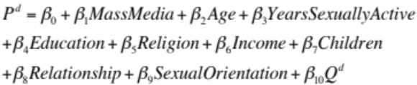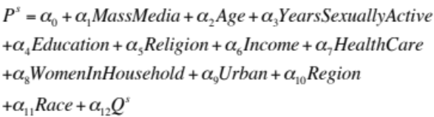
Additional variables may affect the demand for contraceptive knowledge, including relationship status and number of children. Ferrara, Chong, and Duryea (2008) include a dummy variable equal to one if a woman is married in their regression for fertility, and I suspect that a similar relationship may hold with respect to contraceptive knowledge. As the number of children a woman has increases, I expect that her demand for contraceptive knowledge increases as she approaches a stopping age and no longer wishes to have more children. Women with some current contraceptive knowledge may seek out new, more permanent contraceptive techniques such as sterilization or intra-uterine devices (IUDs). Stopping behavior is especially relevant in Brazil, where the rapid decline in fertility in recent decades can be attributed to stopping behavior and not to decreased adolescent fertility rates (Gupta 2000; Ferrara, Chong, and Duryea 2008).
Sexual orientation and choice of sexual partners may also affect the demand for contraceptive knowledge. Women who are not engaging in sex with men may have a lower demand for contraceptive techniques since they do not need to protect themselves from pregnancy. They do still have to protect themselves from sexually transmitted infections (STIs) and this may lead them to possess knowledge of a different set of sexual protection methods than heterosexual women.
I propose that mass media exposure also affects the demand for contraceptive knowledge by exposing women to different lifestyles, values, and portrayals of the ideal family size than the Brazilian reality. The small family sizes portrayed on television may lead to increased demand among women for contraceptive knowledge as they seek to conform to this smaller, idealized family size. My equation for the demand of contraceptive knowledge is:

These equations for the supply and demand of contraceptive knowledge are the structural equations that form the basis of my theoretical framework. The equilibrium point between these two equations for each woman represents her individual level of contraceptive knowledge. At this equilibrium point, P ^{s} = P ^{d} = P and Q ^{s} = Q ^{d} = Q. Setting the two above equations equal to one another, I solve for Q to derive my guiding equation:

The coefficients in this equation represent the observable reduced form parameters, gammas (γ), which are determined by the deep parameters, alphas (α) and betas (β), from the supply and demand equations. In the context of this paper, we are concerned with the coefficient on the mass media variable, where:
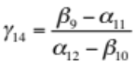

IV. Data
I use cross-sectional data from the 2006 Pesquisa Nacional de Demografia e Saúde da Criança e da Mulher (National Demographic Study on Children’s and Women’s Health). Conducted nationally in Brazil in 1986, 1996 and 2006, the study is representative of the country as a whole and was carried out in five macro-regions including both urban and rural areas. The team interviewed a total of 15,575 women in 2006. My analysis is based on the 12,355 observations from 2006 with available data on the variables of interest. The study team conducted interviews at the household and individual levels. The individual survey for women includes sections on characteristics of the woman, reproduction, contraception, access to medication, pregnancy and childbirth, vaccination and health, marriage and sexual activity, fertility planning, characteristics of spouse and woman’s work, and anthropometric measures.
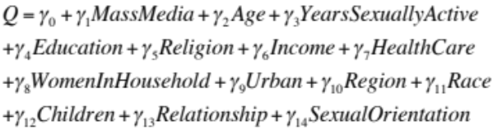The contraception section of the survey asks women if they know of, have heard of, have used, or are using fourteen different contraceptive methods: female sterilization, vasectomy, the pill, intrauterine devices (IUDs), injections, Norplant (implant), male condoms, female condoms, diaphragms, vaginal cream, abstinence while ovulating, pulling out, the morning after pill (Plan B), and other methods. In my research, I am interested in whether the women know of these different techniques. I thus construct my response variable, Number of Methods Known, by summing the total number of methods each individual woman knows. Table 1 displays the breakdown of contraceptive knowledge among the women included in my analysis. Male Sterilization is the most-known method, followed by female sterilization, pulling out, and the female condom. Figure 1 displays a graph of the roughly normal distribution of Number of Methods Known. Most women in my sample know between 6 and 8 contraceptive methods.
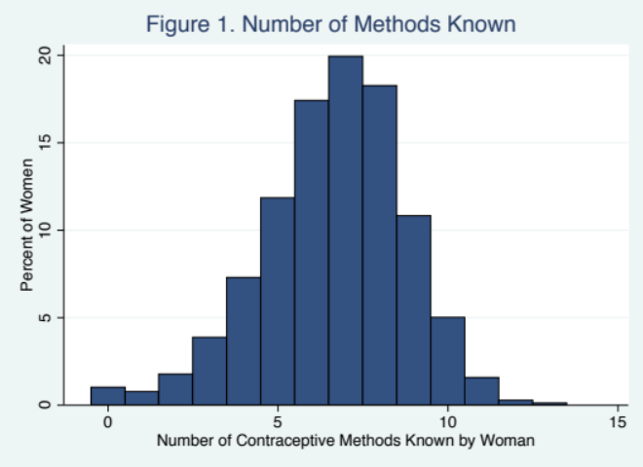
My independent variable of interest, mass media exposure, consists of three types of exposure: reading the newspaper or magazine, listening to the radio, and watching television. The survey asks women whether they do each of these every day, almost every day, at least once a week, less than once a month, or not at all. Table 2 displays the summary statistics for the mass media variables. The levels of the individual mass media variables are mutually exclusive, meaning that women who report watching television every day are not also recorded as watching almost every day, so I include all levels of the variables in my analysis without repeating women.
Table 3 displays summary statistics for the remaining, control variables. Income comes from a question on the survey asking the household’s gross income in the last month and is recorded in Reais (R$). Women in the study range between 15 and 49 years old, with a mean age of 33 in my data. Health Plan is a dummy variable for which a value of one represents that the woman has a health plan or health insurance. For education I use the number of years of education a woman has had. Using the woman’s age and the age at which she first engaged in sex, I construct a variable for the number of years each woman has been sexually active.
The survey asks women whether they are formally married, in a relationship with a man or woman, or not in a relationship. I include this as a categorical variable with three levels in my analysis: single, in a relationship, and married. Because of the way the data are coded, it is not possible to tell whether women who are in relationships are in relationships with men or women. The survey does not ask women for their sexual orientation, so I am not able to include this variable in my model. Sexual orientation is the only variable from my guiding equation for which I do not have data. The survey records the number of eligible women in the household. I subtract one from this number to create a variable for the number of other women in the household apart from the respondent. I include a variable for the number of children each woman has given birth to who are still alive.
Urban is a dummy for which a value of one represents that the woman currently lives in an urban area. The study also divides the country into five commonly used macro-regions: North, Northeast, South, Southeast, and Center. I include region as a multi-level categorical variable.
The survey asks respondents to self-identify their skin colors given the following choices: amarela (yellow), branca (white), indígena (indigenous), parda (mixed), preta (black), and don’t know. I maintain the Portuguese terminology as well as a literal English translation in parentheses because the Brazilian classification of skin color is unique and the same classification system would not be used in English. I include race as a multi-level categorical variable.
I include religion as a dummy variable with six levels: Afro-Brazilian religion, Catholic, Spiritual, Evangelical, no religion, and other religion.

V. Empirical Results
5.1 Estimation Issues
Because I have cross-sectional data, I check for multicollinearity and heteroskedasticity in my data. Age and Years Sexually Active exhibit strong multicollinearity due to the limited variation in starting age among women. Over fifty percent of the women in my sample first had sex between the ages of 15 and 18. I drop Years Sexually Active from my model, as I believe age is a more important determinant of contraceptive knowledge since women can learn about contraception before they become sexually active. I remedy the heteroskedasticity in my data with robust standard errors.

5.2 Regression Results

Table 4 displays the main results of my analysis for the mass media variables. As expected, all the mass media coefficients are positive suggesting that relative to zero media consumption, exposure to any kind of media increases the range of contraceptive knowledge. All four levels of reading the newspaper/magazine are statistically significant. Watching television becomes statistically significant once women watch it at least once a week. Listening to the radio only becomes significant once women listen to it every day, and it is only significant at the 10% level. These results suggest that exposure to the newspaper, magazines, and television increase contraceptive knowledge among women in Brazil, but not exposure to the radio.
To check whether the mass media variables as a whole have an impact on contraceptive knowledge, I use a series of F-Tests that test the significance of a set of dummy variables. I run four F-Tests in all: (1) for all levels of reading the newspaper/magazine, (2) for all levels of listening to the radio, (3) for all levels of watching TV, and (4) for all levels of all my mass media variables. I conclude that reading the newspaper/magazine, watching TV, and mass media exposure in general (as measured by all three media forms) impact contraceptive knowledge, while listening to the radio does not have an overall impact.
Main results for the control variables are displayed in Table 5. A number of these are statistically significant. Age is positive and statistically significant at the one percent level. This could either suggest that a woman’s contraceptive knowledge tends to increase as she ages or that generational differences exist in contraceptive knowledge that have to do with different cultural contexts over time. For example, the positive coefficient on age could represent that older women grew up in a more liberal society that where discussions of contraception were more widespread. Given that Brazilian society is becoming less conservative over time, I favor the first interpretation of the age coefficient.
Some geographic variables significantly affect contraceptive knowledge. The coefficient on the urban dummy is positive and significant, implying that women living in urban areas have greater contraceptive knowledge than those in rural areas. I include all five levels of region in my regression and use the average as the reference level. Both the Northeastern and the Southern regions are statistically significantly lower than the average. Contraceptive knowledge in the Central and Northern regions is statistically significantly higher than the national average.
The coefficient on years of education is also positive and statistically significant, confirming my theory’s assertion that increases in education are associated with increased levels of contraceptive knowledge. Women in relationships, but not married, have statistically significantly higher contraceptive knowledge than single women, who were used as the reference level for my relationship status variable.
The number of other women in the household and the number of children are statistically significant but the signs are negative, not positive as I had expected. I am worried about potential endogeneity with the number of children. The negative coefficient in my main results could indicate that having more contraceptive knowledge causes women to have fewer children as they are more informed on preventing pregnancy. I address this further in my robustness section.
None of the levels of the religion variable are statistically significantly different from the omitted reference level of no religion. The omitted reference level for skin color is Branca (White). Contraceptive knowledge for Amarela (Yellow) is statistically significantly higher than for Branca (White). The coefficient on Preta (Black) is negative, but only significant at the ten percent level. The coefficient for women who declined to identify their skin color is negative and significant at the one percent level. I suspect this may be due to women who have experienced discrimination based on their skin color not wishing to identify this characteristic to interviewers. If so, this could suggest that structural racism does affect the supply of contraceptive knowledge. This could be a potentially fruitful avenue for future research.
5.3 Robustness
To see if the effect of mass media varies by age, I repeat my regression for two different age groups with results displayed in Table 6. The first group is a subset of women between the ages of 15 and 30 containing 6,250 observations. For these younger women, reading the newspaper/magazine daily and almost every day are not statistically significant. Listening to the radio every day becomes statistically significant for this group. The second group is a subset of women between the ages of 31 and 49 containing 6,105 observations. For these older women, all four levels of reading the newspaper/magazines remain statistically significant, as do the three levels of watching television that were statistically significant in the main results. In general, reading the newspaper/magazine has a greater impact on contraceptive knowledge for women over 30 while watching TV has roughly the same impact across age groups.
Table 7 displays a series of robustness checks by region. I run the regression individually for each of the regions to see if certain types of mass media have greater effects on contraceptive knowledge in certain regions. I find that reading the newspaper/magazine has the greatest effect in the Northern region of Brazil, while watching TV appears to have the greatest effect in the Southeastern and Southern regions. Watching TV is the only significant mass media variable in the Northeastern and Southeastern regions. None of the regions show a statistically significant impact of listening to the radio. Differences also emerge when examining urban and rural areas separately, as shown in Table 8. In urban areas, reading the newspaper/magazines has a greater effect on contraceptive knowledge than in the rural areas. Watching TV has a statistically significant and roughly equivalent effect in both urban and rural areas. For the rural subset, the coefficients on the radio variables are greater and listening to the radio every day becomes statistically significant at the five percent level.
Finally, I do one last robustness check excluding the number of children from my regression. Due to potential endogeneity with this variable, my coefficients may be biased. It may be that instead of a large number of children inducing stopping behavior and increasing contraceptive knowledge, the large number of children is caused by low contraceptive knowledge. Thus, I compare my main results to a regression excluding the number of children as a variable, displayed in Table 9. Overall, when I drop the number of children from the model, the magnitude of the significant mass media variables increases slightly. The only change in significance among the mass media variables is that listening to the radio every day becomes significant at the five percent level. The only variable that changes signs when I take out the number of children is whether women have a health plan, which changes from positive to negative but is not statistically significant in either the main results or the new regression. Throughout all of my robustness analysis, the statistically significant coefficients are all positive, indicating that mass media exposure has a positive effect on contraceptive knowledge

VI. Conclusion
I find evidence suggesting that mass media exposure contributes to increased contraceptive knowledge among women in Brazil. My results are robust to a large number of conditions, including media type, geographic features, and age group. My paper begins to fill a hole in the literature regarding the effect of mass media exposure on the volume of contraceptive knowledge. Further research could examine contraceptive methods individually to see if different kinds of media affect knowledge of different contraceptive techniques differently. For example, how do the three types of media used in this study affect knowledge of female sterilization? A valuable continuation of the work begun in this paper would be to examine whether knowledge of a wider range of contraceptive techniques leads to higher contraceptive use.

References
Cheng, Kai-Wen. (2011). The effect of contraceptive knowledge on fertility: The roles of mass media and social networks. Journal of Family and Economic Issues, 32(2), 257-267.
Gupta, Neeru. (2000). Sexual initiation and contraceptive use among adolescent women in Northeast Brazil. Studies in Family Planning, 31(3), 228-238.
Gupta Neeru, Katende, Charles, & Bessinger, Ruth. (2003). Associations of mass media exposure with family planning attitudes and practices in Uganda. Studies in Family Planning, 34(1), 19-31.
Jensen, Robert, & Oster, Emily. (2009). The power of TV: Cable television and women's status in India. Quarterly Journal of Economics, 124(3), 1057-1094.
La Ferrara, Eliana, Chong, Alberto, & Duryea, Suzanne. (2008). Soap operas and fertility: Evidence from Brazil. CEPR Discussion Paper No. 6785.
McNay, Kirsty, Arokiasamy, Perianayagam, & Cassen, Robert H. (2003). Why are uneducated women in India using contraception? A multilevel analysis. Population Studies, 57(1), 21-40.
Ministério da Saúde. (2006). Pesquisa Nacional de Demografia e Saúde da Criança e da Mulher [Data file]. Available from http://bvsms.saude.gov.br/bvs/pnds/banco_dados.php

Ministério da Saúde. (2006). Pesquisa Nacional de Demografia e Saúde da Criança e da Mulher. Retrieved March, 2012, from http://bvsms.saude.gov.br/bvs/pnds/index.php Olaleye, David O., & Bankole, Akinrinola. (1994). The impact of mass media family planning promotion on contraceptive behavior of women in Ghana. Population, 13(2), 161-77.

Tables and Figures

Table 1. Contraceptive Knowledge
Contraceptive Technique | Number of Women | Percentage of Women
Vasectomy (Male Sterilization) | 9852 | 79.7%
Female Sterilization | 9348 | 75.7%
Pulling Out | 9214 | 74.6%
Female Condom | 8919 | 72.2%
Plan B | 8661 | 70.1%
Periodic Abstinence | 8243 | 66.7%
Injections | 7744 | 62.7%
Diaphragm | 5840 | 47.3%
Intra-Uterine Device (IUD) | 5176 | 41.9%
Implant | 3472 | 28.1%
Vaginal Cream | 3255 | 26.3%
Male Condom | 1502 | 12.2%
The Pill | 841 | 6.8%
Other Methods | 12 | 0.1%

Table 2. Summary Statistics for Mass Media Variables
Independent Variable | Mean | Standard Deviation
Don't Read Newspaper of Magazine | 0.323 | 0.468
Read Less Than Once a Month | 0.200 | 0.400
Read At Least Once a Week | 0.239 | 0.427
Read Almost Every Day | 0.138 | 0.344
Read Every Day | 0.100 | 0.301
Don't Listen to the Radio | 0.157 | 0.364
Listen Less Than Once a Month | 0.047 | 0.212
Listen At Least Once a Week | 0.130 | 0.337
Listen Almost Every Day | 0.155 | 0.362
Listen Every Day | 0.510 | 0.500
Don't Watch TV | 0.046 | 0.210
Watch Less Than Once a Month | 0.009 | 0.094
Watch At Least Once a Week | 0.044 | 0.205
Watch Almost Every Day | 0.092 | 0.289
Watch Every Day | 0.809 | 0.393
Observations: 12,355

Table 3. Summary Statistics for Control Variables
Independent Variable | Mean | Std. Dev. | Min | Max
Household Income (R$) | 1190 | 1848 | 0 | 50,000
Age | 30.9 | 9.7 | 15 | 49
Health Plan | 0.229 | 0.420 | 0 | 1
Years of Education | 8.83 | 4.25 | 1 | 18
Years Sexually Active | 13.04 | 9.31 | 0 | 37
Single | 0.343 | 0.475 | 0 | 1
In a Relationship | 0.289 | 0.453 | 0 | 1
Married | 0.368 | 0.482 | 0 | 1
Number of Other Women in Household | 0.49 | 0.76 | 0 | 5
Number of Children | 1.74 | 1.72 | 0 | 14
Urban | 0.719 | 0.449 | 0 | 1
Central Region | 0.204 | 0.403 | 0 | 1
Northeastern Region | 0.200 | 0.400 | 0 | 1
Northern Region | 0.187 | 0.390 | 0 | 1
Southeastern Region | 0.207 | 0.405 | 0 | 1
Southern Region | 0.203 | 0.402 | 0 | 1
Skin: Amarela (Yellow) | 0.028 | 0.166 | 0 | 1
Skin: Branca (White) | 0.380 | 0.485 | 0 | 1
Skin: Indígena (Indigenous) | 0.022 | 0.146 | 0 | 1
Skin: Don't Know | 0.006 | 0.077 | 0 | 1
Skin: Parda (Mixed) | 0.467 | 0.499 | 0 | 1
Skin: Preta (Black) | 0.096 | 0.294 | 0 | 1
Afro-Brazilian Religion | 0.003 | 0.058 | 0 | 1
Catholic | 0.654 | 0.476 | 0 | 1
Spiritual | 0.029 | 0.167 | 0 | 1
Evangelical | 0.223 | 0.416 | 0 | 1
No Religion | 0.074 | 0.261 | 0 | 1
Other Religion | 0.017 | 0.129 | 0 | 1
Observations: 12,355

Table 4. Main Results for Mass Media Variables
Independent Variable | Regression Coefficients
Read Newspaper/Magazine Less Than Once a Month | 0.223***
 | (0.052)
Read At Least Once a Week | 0.272***
 | (0.052)
Read Almost Every Day | 0.178***
 | (0.063)
Read Every Day | 0.153**
 | (0.077)
Listen to Radio Less Than Once a Month | 0.0613
 | (0.099)
Listen At Least Once a Week | 0.0408
 | (0.068)
Listen Almost Every Day | 0.0255
 | (0.066)
Listen Every Day | 0.101*
 | (0.054)
Watch TV Less Than Once a Month | 0.332
 | (0.259)
Watch At Least Once a Week | 0.648***
 | (0.126)
Watch Almost Every Day | 0.592***
 | (0.108)
Watch Every Day | 0.677***
 | (0.092)
Robust Standard Errors in Parentheses
*** Significant at the 1% level, ** significant at the 5% level, * significant at the 10% level
note: Full tables for all regressions available upon request.

Table 5. Main Results for Control Variables
Independent Variable | Regression Coefficients
Household Income (R$) | -1.52E-05
 | (0.000)
Age | 0.0301***
 | (0.003)
Health Plan | -0.00394
 | (0.051)
Years of Education | 0.0852***
 | (0.006)
In a Relationship | 0.169***
 | (0.052)
Married | 0.0654
 | (0.051)
Number of Other Women in Household | -0.0678**
 | (0.026)
Number of Children | -0.0984***
 | (0.015)
Urban | 0.247***
 | (0.045)
Central Region | 0.0970**
 | (0.038)
Northeastern Region | -0.109***
 | (0.036)
Northern Region | 0.142***
 | (0.039)
Southeastern Region | 0.0169
 | (0.038)
Southern Region | -0.139***
 | (0.040)
Observations | 12,355
R-squared | 0.0773
Robust Standard Errors in Parentheses
*** Significant at the 1% level, ** significant at the 5% level, * significant at the 10% level

Table 6. Robustness by Age Group
 | Regression Coefficients
Independent Variable | (i) | (ii)
Read Newspaper/Magazine Less Than Once a Month | 0.165** | 0.270***
 | (0.074) | (0.074)
Read At Least Once a Week | 0.163** | 0.410***
 | (0.071) | (0.076)
Read Almost Every Day | 0.135 | 0.246***
 | (0.086) | (0.094)
Read Every Day | 0.0155 | 0.313***
 | (0.112) | (0.106)
Listen to Radio Less Than Once a Month | 0.0332 | 0.0529
 | (0.141) | (0.137)
Listen At Least Once a Week | -0.0577 | 0.0837
 | (0.100) | (0.092)
Listen Almost Every Day | 0.104 | -0.0692
 | (0.095) | (0.092)
Listen Every Day | 0.196** | -0.00109
 | (0.078) | (0.076)
Watch TV Less Than Once a Month | 0.141 | 0.569
 | (0.364) | (0.364)
Watch At Least Once a Week | 0.660*** | 0.576***
 | (0.174) | (0.181)
Watch Almost Every Day | 0.497*** | 0.628***
 | (0.153) | (0.152)
Watch Every Day | 0.593*** | 0.695***
 | (0.127) | (0.132)
Observations | 6,250 | 6,105
R-squared | 0.0916 | 0.0760
Robust Standard Errors in Parentheses
*** Significant at the 1% level, ** significant at the 5% level, * significant at the 10% level
Note: (i) younger age subset, (ii) older age subset

Table 7. Robustness By Region
 | Regression Coefficients
Independent Variable | (i) | (ii) | (iii) | (iv) | (v)
Read Newspaper/Magazine Less Than Once a Month | 0.266** | 0.173* | 0.405*** | 0.0206 | 0.246*
 | (0.117) | (0.103) | (0.115) | (0.126) | (0.128)
Read At Least Once a Week | 0.334*** | 0.202* | 0.336*** | 0.210* | 0.291**
 | (0.122) | (0.109) | (0.118) | (0.120) | (0.117)
Read Almost Every Day | 0.125 | 0.11 | 0.497*** | 0.147 | 0.0233
 | (0.149) | (0.134) | (0.148) | (0.134) | (0.143)
Read Every Day | 0.00192 | -0.0844 | 0.481*** | -0.158 | 0.463***
 | (0.188) | (0.178) | (0.174) | (0.179) | (0.146)
Listen to Radio Less Than Once a Month | 0.00467 | -0.095 | 0.154 | -0.152 | 0.211
 | (0.210) | (0.213) | (0.194) | (0.261) | (0.250)
Listen At Least Once a Week | 0.0197 | -0.126 | 0.236* | 0.0496 | -0.0546
 | (0.155) | (0.146) | (0.137) | (0.158) | (0.174)
Listen Almost Every Day | -0.113 | -0.046 | 0.125 | 0.0491 | 0.0614
 | (0.154) | (0.142) | (0.132) | (0.143) | (0.178)
Listen Every Day | 0.000402 | 0.0601 | 0.151 | 0.123 | 0.126
 | (0.120) | (0.118) | (0.109) | (0.123) | (0.146)
Watch TV Less Than Once a Month | -0.827 | 0.0272 | 0.579 | 0.135 | 1.149*
 | (0.834) | (0.460) | (0.443) | (0.585) | (0.630)
Watch At Least Once a Week | 0.550* | 0.599** | 0.383 | 0.822*** | 0.678**
 | (0.320) | (0.257) | (0.243) | (0.284) | (0.315)
Watch Almost Every Day | 0.559** | 0.247 | 0.347* | 0.590** | 0.935***
 | (0.254) | (0.231) | (0.200) | (0.245) | (0.281)
Watch Every Day | 0.510** | 0.634*** | 0.313* | 0.737*** | 0.882***
 | (0.218) | (0.191) | (0.169) | (0.210) | (0.246)
Observations | 2,518 | 2,472 | 2,308 | 2,555 | 2,502
R-squared | 0.047 | 0.086 | 0.205 | 0.049 | 0.088
Robust Standard Errors in Parentheses
*** Significant at the 1% level, ** significant at the 5% level, * significant at the 10% level
note: (i) Central Region, (ii) Northeastern Region, (iii) Northern Region, (iv) Southeastern Region, (v) Southern Region

Table 8. Robustness By Urban/Rural
 | Regression Coefficients
Independent Variable | (i) | (ii)
Read Newspaper/Magazine Less Than Once a Month | 0.226*** | 0.198**
 | (0.064) | (0.091)
Read At Least Once a Week | 0.306*** | 0.207**
 | (0.062) | (0.099)
Read Almost Every Day | 0.222*** | 0.0985
 | (0.072) | (0.141)
Read Every Day | 0.240*** | -0.22
 | (0.083) | (0.235)
Listen to Radio Less Than Once a Month | -0.00822 | 0.234
 | (0.109) | (0.239)
Listen At Least Once a Week | 0.0058 | 0.124
 | (0.078) | (0.145)
Listen Almost Every Day | 0.00519 | 0.0462
 | (0.078) | (0.124)
Listen Every Day | 0.0482 | 0.216**
 | (0.064) | (0.102)
Watch TV Less Than Once a Month | 0.233 | 0.39
 | (0.329) | (0.427)
Watch At Least Once a Week | 0.573*** | 0.540***
 | (0.168) | (0.199)
Watch Almost Every Day | 0.467*** | 0.595***
 | (0.147) | (0.171)
Watch Every Day | 0.568*** | 0.569***
 | (0.132) | (0.129)
Observations | 8,887 | 3,468
R-squared | 0.058 | 0.0999
Robust Standard Errors in Parentheses
*** Significant at the 1% level, ** significant at the 5% level, * significant at the 10% level
note: (i) Urban Only, (ii) Rural Only

Table 9. Excluding Number of Children
Independent Variable | Regression Coefficients
Read Newspaper/Magazine Less Than Once a Month | 0.228***
 | (0.053)
Read At Least Once a Week | 0.283***
 | (0.052)
Read Almost Every Day | 0.189***
 | (0.063)
Read Every Day | 0.159**
 | (0.077)
Listen to Radio Less Than Once a Month | 0.0789
 | (0.099)
Listen At Least Once a Week | 0.0616
 | (0.068)
Listen Almost Every Day | 0.0445
 | (0.066)
Listen Every Day | 0.119**
 | (0.054)
Watch TV Less Than Once a Month | 0.338
 | (0.262)
Watch At Least Once a Week | 0.667***
 | (0.126)
Watch Almost Every Day | 0.619***
 | (0.108)
Watch Every Day | 0.710***
 | (0.092)
Observations | 12,355
R-squared | 0.0738
Robust Standard Errors in Parentheses
*** Significant at the 1% level, ** significant at the 5% level, * significant at the 10% level

Closing the Gap: Examining How Financial Literacy Affects the Saving Behavior of Low-Income Households

Alexia Diorio ‘12 and Rosamond Mate ‘12

Public Finance

This paper examines the effect of financial literacy on saving behavior for low-income households using data from the National Financial Capability Study. We examine the significance of different indicators of financial literacy, which include stated as well as demonstrated ability and understanding by financial topic. We discuss the differential effect of these measures on low-income households, which has been missing from previous literature. Our results indicate that although financial literacy is a positive determinant of saving behavior for the general population, the differential effects of financial literacy for low-income individuals are ambiguous. Stated measures of financial literacy appear to close the savings gap between wealthy and low-income households, whereas revealed measures widen the gap.

- Introduction
Saving matters, particularly for low-income households. Savings provide safety during financial hardship, facilitate consumption smoothing, increase the probability of future gain in financial status, and may allow individuals to access opportunities that might otherwise be unattainable. However, over half of Americans are living paycheck to paycheck and 55 percent report spending more or equal to their paycheck (FINRA 2010). Neoclassical economic theory predicts that low-income households should save at relatively similar rates to their high-income counterparts (Leland, 1968). However, studies have found that even when controlling for characteristics such as income, age, and education, only 30 percent of families in the lowest income quintile save, as opposed to 84 percent of families in the highest income quintile (Schneider and Tufano 2007). The most obvious explanation is low-income households simply do not have the financial ability to set aside savings. However, evidence shows that this is not necessarily the case. After controlling for income, a large proportion of low-income households, some have estimated as high as 70 percent, do have the ability to save. Despite this, low-income households have both lower amounts of savings and a lower propensity, or likelihood, to save than high-income households.
This discrepancy is yet to be fully understood, though researchers have proposed several alternative explanations. Beverly and Sherraden (1999), for instance, argue that low-income individuals are less likely to have access to four major institutional determinants of savings: institutionalized saving mechanisms, incentives, facilitation, and financial information. Low-income individuals are less likely to have access to these institutions because of bad credit or debt, reduced physical access, or from not being employed in the formal labor market. In addition, preferences and expectations may influence saving (Beverly and Sherraden 1999). When tested empirically, these institutions and expectation measures have been found to significantly influence saving (Hogarth & Anguelov 2003, Hogarth et al. 2006). However, due to the difficulty of obtaining data, the effect of financial literacy on saving was absent from these empirical tests. Empirical research on financial literacy, and especially its impact on saving for low-income individuals, has been notably absent from the literature. As existing literature has found a positive correlation between financial literacy and education, which is in turn correlated with income, there may be a link between financial literacy and financial behavior for low-income households.
Research shows substantial gaps in financial literacy in the United States, ranging from a lack of understanding portfolio diversification to general math skills. Given its theoretical importance and the demonstrated lack of financial literacy, understanding the degree to which financial literacy affects saving behavior is crucial, particularly for those designing policies to increase saving rates. Using new data, our research analyzes the effect of financial literacy on the saving behavior of low-income households. We hypothesize that a higher degree of financial literacy has a strong, positive effect on saving rates.
Researchers have empirically examined the link between financial literacy and saving, but not specifically for low-income households. Several papers build on the classic economic Life-Cycle Model and examine the effect of financial literacy on access to credit (Simpson & Buckland 2009), saving for retirement (Lusardi & Mitchell 2010) and credit card behavior (Allgood & Walstad 2011). All of these three papers find that financial literacy significantly affects their variable of interest. Although none of these papers control for any additional institutional barriers important for saving rates of the poor, their empirical results provide some initial evidence that financial literacy influences saving.
The most closely related set of papers to our topic are those that examine the effects of financial literacy through employer-mandated financial literacy programs or matched saving accounts, such as Individual Development Accounts (IDAs). Clancy et al. (2001), Fry et al. (2008) and Bayer et al. (2008) find that financial training significantly increases savings for low-income people. Interestingly, Bayer et al. (2008) find that low-income workers experience a greater increase in saving rates from financial education when compared to higher-income workers. Though none of these papers use a control group to address selection bias into these programs, they offer preliminary evidence that financial literacy may positively affect saving rates for low-income people.
The existing literature provides some evidence of significant barriers to saving for low-income households, and that financial literacy influences saving behavior. However, to the best of our knowledge our paper is the first empirical test of financial literacy on saving behavior for low-income people using a nationally representative data set with specific detail on individuals’ stated and demonstrated financial knowledge. This paper proceeds as follows; in section II, we will discuss the theory that motivates this research, and in section III we present our empirical approach. In section IV, we present our results, and in section V we conclude.

- Theory
Neoclassical economics presents several theories on the determinants of saving behavior. The basis of these theories is that individuals are concerned about future as well as present consumption, and therefore save in order to “smooth” their consumption from one period to the next (Beverly et al. 2008). Modigliani (1954) developed the Life-Cycle Model which states that consumption and saving patterns are determined by an individual’s stage in their “life-cycle” or in other words, by age. This implies that individuals save most when they are middle-aged (and presumably when their income is greatest), and save least when they are retired or in school. The majority of research conducted on financial literacy is centered on saving for retirement, so the Life-Cycle Model is most commonly used. It is typically modified to include a variety of other variables such as social status, aspirations, and expectations (for example see Beverly and Sherraden 1999, Hogarth and Anguelov 2003).
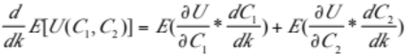
In contrast, Friedman’s (1957) Permanent Income Hypothesis states that individuals save when income increases temporarily, but they raise consumption standards when their income increases permanently. This implies that individuals only save when experiencing temporary income fluctuations. This model is not as applicable for long-run saving behavior.
A third theory of saving, focused on “buffer stocks” was introduced by Leland in 1968. This model involves the precautionary motive for saving, which states that individuals accumulate “buffer stocks” to smooth consumption in the face of income uncertainty (Leland 1968). This model is more applicable due to our focus on general saving behavior, as opposed to life-cycle behavior such as saving for retirement. We use this model as the foundational theory for our research.
Leland (1968) develops this model by incorporating uncertainty of future earnings into a two-stage utility function where utility is derived from consumption now and in a future period. The consumer chooses a saving rate, k, to maximize his or her expected value of utility constrained by consumption over both periods:
Max E(U(C₁, C₂))
where C₁ and C₂ are consumption in periods one and two and are defined as:
C₁ = (1-k)I₁
C₂ = I₁ + (1+r)kI₁
The variable k is the constant saving rate, r is the exogenous and perfectly known interest rate, I₁ is the income in period one (which is certain) and I₂ is income in period two and is uncertain but with a known probability density function. The first order condition that maximizes this expected value of utility is:

= 0

As C₂ depends on the unknown future income, utility cannot be optimized directly from this first order condition, but Leland approximates its expected value with a Taylor expansion. By adding Pratt’s theory of “decreasing risk aversion to concentration,” Leland shows that, in this simplified case, there is a positive precautionary demand for savings (pg 469).
Figure 1
On Current Consumption | Perfect Market | Imperfect Market
Substitution Effect | ↑ | ↑
Income Effect | ↓ | ↓
Leland’s model, however, is limited by two key assumptions. First, he assumes no credit risk by assuming a fixed and known r, and second, he assumes perfect information, where an individual understands exactly the benefit he or she will receive by saving. Relaxing these assumptions has the potential to change Leland’s predicted positive demand for precautionary savings and explain the poor saving behavior of low-income individuals. As Leland predicts, individuals react to income riskiness by raising the level of saving in the current period. However, they react to credit riskiness by reducing the amount of savings in the current period because the return to their investment is uncertain. This contradiction generates conflicting income and substitution effects as depicted in Figure 1. If consumers understand how to mitigate the risk of their investment and also understand the benefits of earning returns on savings, then even with credit risk, we would expect the income effect to dominate and precautionary savings to remain positive (Sandmo 1970, Lusardi 1998). The results of this scenario are presented in the first column of Figure 1.
However, in an imperfect market with information failure in the form of poor financial literacy, the magnitudes of these income and substitution effects may change. If individuals have a low level of financial literacy, they may not be able to obtain necessary information such as rates of return on certain saving vehicles, and they might not understand interest or inflation. This would increase the credit risk faced by the individual, which would lead the substitution effect to become larger, reducing the demand for savings. At the same time, if individuals do not understand the full benefits of saving, then the income effect will diminish in magnitude, further reducing the demand for savings. The results of this scenario are presented in the second column of Figure 1. With imperfect markets due to poor financial literacy, the substitution effect may be more likely to dominate, thus implying that the demand for precautionary savings may not be positive.

- Data and Empirical Approach
Data

Readily available data that include information on financial literacy have, until recently, been almost exclusively gathered from the implementation of specific programs. To the best of our knowledge, no one has explicitly examined the link between specific forms of financial literacy and saving for low-income households with a nationally representative random sample. We use data from the National Financial Capability Study (NFCS), which was conducted in 2009 to assess the state of financial literacy in the US. After omitting households that do not answer financial literacy questions, we are left with a sample of 26,421 households, with roughly 500 from each state (including Washington D.C.). Respondents are weighted within each state so that the survey matches 2008 Census distributions on age category by gender, ethnicity, and education. These data do not offer us a dollar measure of savings; however, they do indicate saving behavior and include measures of many of the institutional and behavioral determinants of savings that are discussed in our literature. These measures are detailed below.

Empirical Approach

We use a modified precautionary saving model based on the suggestions of Beverly and Sherraden (1999), which allows us to isolate the effect of financial literacy by controlling for institutional and behavioral variables in addition to classical saving determinants. These measures are grouped into related vectors so that our empirical model takes the form:
Saver OR Emergency-Saver = α + Dβ₁ + Cβ₂ + Instβ₃+ FinLitβ₄ + Interactβ₅ + ε
“Saver” is a dummy variable with a value of one if the individual stated that they spent less in the previous year than their annual income, and a zero otherwise. Although using a dummy does not seem ideal, Hogarth and Anguelov (2003) cite this as strength, especially for cross-sectional data where the quantity of savings may not reflect typical saving behavior. Using a dummy variable will allow us to focus on the process of saving, which may be more telling than a dollar amount. The alternative dependent variable, “Emergency Saver,” is defined as one if an individual reported that they set aside emergency or “rainy day” funds, and a zero if otherwise. D is a vector of demographics that includes age, income quintile, sex, race, education level, marital status, family size, employment status, spouse’s employment status, and state. Fixing for state is important as both financial literacy and financial institutions vary systematically across states (Banerjee 2010). We also include a constructed dummy for households most likely to take up welfare, which is defined as single female heads of household with dependent children earning less than $25,000 a year.
The vector C contains classical determinants of saving which includes variables that are important for precautionary theory as well as behavioral economics. These variables are risk aversion, emergency security, income uncertainty, motives, and being able to save. “Risk” is a self-reported score from 1-10 of how willing an individual is to take risks with their financial investments, 10 being the greatest willingness to take risk. “Emergency Security” is set equal to one if the individual has familial financial
support, health insurance, renter/homeowner insurance, or life insurance. “Income Uncertainty” is a dummy that is assigned a one if a household reports that it experienced a recent unexpected change in income. “Motives” is a dummy variable that is equal to one if the respondent says she or he is either saving for college or retirement. “Able to Save” is a dummy variable that is based on an individual’s indication of how difficult it is to cover their bills in a month, where all individuals who did not respond “very difficult” are assigned a one for able to save.
The vector Inst includes institutional determinants of savings such as whether an individual is banked, if they have credit access, or if they have assets. “Banked” indicates that a family has either a checking or a savings account. “Credit Access” indicates that a household has some form of a loan (mortgage, home equity, or auto loan). “Assets” assigns a one to households that own property or part of a business.
Finally, for the vector FinLit, we use variables for both demonstrated and self-reported financial literacy. Respondents are asked five simple multiple-choice questions that test various aspects of financial literacy including compounding interest, the effect of inflation on accumulated savings, bond prices, basic mortgage payment structure, and portfolio diversification. From these questions we construct a variable called “Demonstrated Financial Literacy,” which ranges from zero to five for the number of questions answered correctly. As with any survey, guessing is a concern. Though truly random guessing should not bias our results, we do confirm that no respondents were “guessing” systematically by selecting the same response option for all questions. We test both our constructed demonstrated financial literacy measure and dummies indicating correct responses to these questions individually in our financial literacy models.
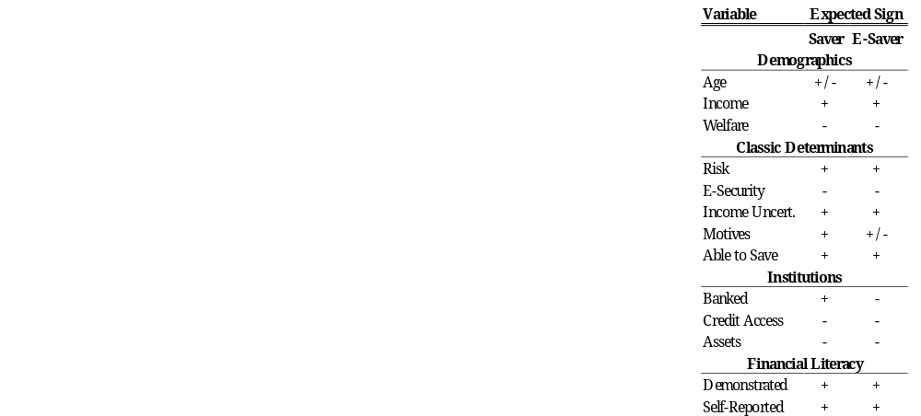

Self-reported financial literacy is based on four questions where respondents are asked how strongly they agree with the following questions on a scale of 1-7, (where 7 is strongly agree or very high):

- I am good at dealing with day-to-day financial matters, such as checking accounts, credit and debit cards, and tracking expenses.
- I am pretty good at math.
- I regularly keep up with economic and financial news.
- How would you assess your overall financial knowledge?
For each question we construct three dummy variables indicating those who strongly disagree (1-2), those who fall in the middle (3-5), and those who strongly agree (6-7). Lastly, we create interaction terms (Interact) with income and all measures of self-reported and demonstrated financial literacy to allow the effect of financial literacy to vary across income group.

Summary Statistics

Preliminary analysis of our weighted data indicates that 69 percent of the US population are neither savers nor emergency savers, which implies that only 31 percent of the US population has any savings (this is consistent with other studies’ findings such as Hogarth and Angelov who find that 26% of all households self-reported as savers and Hilgart and Hogarth who found 39% of their population were actively saving). Of those who set aside emergency funds, 24 percent also state that they spend more than they earn in a year, implying that they do not save in general. We also calculate that 94 percent of our population is banked, and the percentage of households who save or emergency-save is lower when they are unbanked. This evidence is consistent with Beverly and Sherraden’s (1999) hypothesis that limited access to institutions can hinder saving behavior.
Table 1 presents population percentages of (emergency) saver and non-saver populations across our set of demographic control variables. The percentage of households who save in the population increases as income increases for both the saver category and the emergency saver category. From these means, our data support previous findings that a lower proportion of low-income households save than their wealthier counterparts, and a greater proportion of the saver population and emergency saver population have higher levels of education. As existing literature argues that financial literacy and education are correlated, this is consistent with our hypothesis that increased financial literacy leads to increased saving behavior.
Table 2 examines our financial literacy variables explicitly (“Demonstrated Financial Literacy” as well as “Stated Financial Literacy”, which corresponds to question 4 of the self-reported variables) by saver and emergency saver populations. Interestingly, there does not appear to be a substantial difference between saver and non-saver populations for either the demonstrated or stated levels of financial literacy, although the difference between emergency saver and non-emergency-saver populations is slightly more pronounced. Respondents with emergency savings have a higher average demonstrated financial literacy score by 0.8 compared to those without emergency savings.
- Analysis and Results
Our empirical analysis develops in five steps. For each step we run regressions first using “saver” and then using “emergency saver” as the dependent variable. As the dependent variables are both dummy variables, logistic regressions are the most appropriate estimator. All presented results are the marginal fixed effects of these models. Our first step is to model savers and emergency savers by a full set of demographic control variables. The second step adds variables included in our vector defined “Classical Determinants of Saving.” Our third step adds our “Institutions” vector. In our fourth step we add financial literacy variables to isolate the significance of these determinants on savings behavior. From this set of models we observe how much additional variation in saving and emergency-saving behavior is explained by financial literacy. In our fifth and final step we add the interaction terms between income groups and all of our financial literacy variables. This allows us to examine differences of the effect of financial literacy for low-income households, where low-income is defined as the lowest quintile of our sample population. The buildup of the modeling sequence is justified by log likelihood ratio tests, as we find that each vector added to the model is significant in explaining additional variation in the dependent variables.

Demographic Controls

From our first model, with only controls, we observe that lower income households are significantly less likely to save than the reference group (those who earn more than $100,000). The lowest income quintile is 25.6 percent less likely to be a saver and 35.1 percent less likely to be an emergency saver than the richest category. Individuals with lower levels of education and dependent children are also significantly less likely to be savers and emergency savers. This is consistent with what was indicated by our preliminary summary statistics. With respect to fully employed respondents with fully employed spouses or partners, those who are disabled or have disabled partners are significantly less likely to be savers or emergency savers. Non-white individuals are significantly more likely to be savers but significantly less likely to be emergency savers. In this basic demographics model, California is the reference state. Few states significantly affect a household’s probability of being either a saver or an emergency-saver. As a set, fixing for state is significant.

Classical Determinants of Savings
Results of the classical variables are presented in Table 4. Ability to save is significant and positive, increasing the probability of being a saver by 11.9 percent and the probability of being an emergency saver by 24.0 percent. Families that have recently experienced unexpected changes in income (and therefore have more uncertainty about future income levels) are less likely to save. Though this is not consistent with Leland’s risk aversion hypothesis, it is easily explained according to the permanent income hypothesis: if the income shock has been negative then households may be less able to save while maintaining their accustomed consumption level and so they draw down savings to compensate in the short run. Having a family safety net for financial support and insurance (thus providing some emergency security) does not significantly affect the probability of being a saver, but it increases the probability of being an emergency saver by 6.2 percent. Individuals who are less sensitive to credit risk are more likely to save (without controlling for financial literacy) and this is consistent with our theoretical expansion of Leland’s hypothesis and indicates that more risk adverse individuals substitute away from savings and towards consumption now.

Institutions

In the second column of Table 4 we include measures for potential institutional savings barriers. All three variables, indicating that the household is banked, owns property (i.e. has assets) and has access to credit (in the form of a mortgage or loan), are all significant. Being banked only significantly increases the probability of being an emergency saver. Households who own property, however, are 6 percent more likely to be savers and 18 percent more likely to be emergency savers. Having access to credit is also as expected – households that have demonstrated their ability to borrow money are less likely to save, which is consistent with the hypothesis that credit constrained households must rely more on their own accumulated savings instead of borrowing in an emergency.

Financial Literacy

Table 5 shows results from our fourth step, where we add financial literacy variables to the model. All previous results are robust to the inclusion of these variables, and the coefficients on the financial literacy variables themselves are robust to controlling for both stated and demonstrated levels of financial literacy. Unfortunately, a log likelihood ratio test indicated that our constructed “Demonstrated Financial Literacy” variable that tallies correct responses is not valuable in the saver regressions. However, the disaggregated demonstrated financial literacy questions are valuable as a set and in conjunction with stated financial literacy levels. In general, fewer variables are significant in the saver models. This may simply be a product of how the saver variable is defined, as households likely have savings even when they report consuming equal to their income.
Table 5 shows that both staying up to date with financial news and higher overall self-reported financial literacy increase the probability of being a saver and having emergency savings. The lowest level of stated financial proficiency has very few observations (only 9 percent of respondents) rendering it insignificant. Individuals who have a medium level of financial proficiency are significantly less likely, by 8.6 percent, to save than individuals with a high level of financial proficiency for all of the regressions presented. Surprisingly, low stated levels of math ability increase the probability of being either a saver or an emergency saver. This means that people who say they are bad at math are actually more likely to save (and emergency-save), by around 4 (6) percent for low math ability and 2 (3) percent for medium math ability.
Table 5 also presents coefficients on demonstrated financial literacy for each question. The questions on compounding interest and on mortgages are not significant for either saver or emergency-saver. Interestingly, the coefficient on the inflation question is significant and negative, implying that when individuals correctly understand inflation, they are less likely to save or emergency save. The lack of significance on compound interest is inconsistent with our “incomes effect” theory where an understanding of the benefits from savings should increase the propensity to save. The coefficients on the bond question as well as on portfolio diversification are significant and positive. This is in line with our hypothesis that those who understand financial markets are able to attain higher rates of return (increasing their income effect) and mitigate their investment risk (reducing the substitution effect).
It is interesting to note that when stated and demonstrated variables are run together, both the bond and portfolio diversification questions become less significant for savers. This means that some of the variation in stated variables explains the variation in these two questions. We might hypothesize that individuals who keep up with the financial news, for example, also invest in the stock and bond markets.

Interaction Terms

Table 6 presents the most important coefficients from our best model, including the differential effects of stated and demonstrated financial literacy for low-income individuals. The table shows that low-income individuals who rated themselves in the middle range of financial proficiency are 12 percent less likely to be emergency-savers than high-income individuals who also rank themselves in the middle range. This is important because without disaggregating financial proficiency by income, the coefficient on the lowest income quintile as a whole indicates an 18 percent reduction in the probability that these households are emergency savers.
The interaction term also indicates that low-income individuals with an intermediate level of financial proficiency are only 3 percent less likely to be savers and 7 percent less likely to emergency-save than the most financially proficient people of low income. This is an improvement over the coefficient on middle-proficiency as a whole, which indicates that these people are 10 percent less likely to save and 13 percent less likely to emergency-save with respect to very proficient individuals.
The interaction term for a low level of familiarity with financial news for low-income groups is only significant for saver (and not emergency-saver). This term indicates that low-income, low-ranking individuals are 28 percent less likely to emergency save than low-ranking high-income individuals, severely exacerbating the effect of the original coefficient. Of similar magnitude, we see individuals who reported a medium level of financial literacy are 23 percent less likely to have emergency savings than their high-income counterparts.
The second half of Table 6 on demonstrated financial literacy reveals that the low-income group is consistently less likely to either be savers or have emergency savings, even when having responded correctly to these questions. For instance, of individuals who answer the compounding interest question correctly, low-income groups are actually 3.5 percent less likely to have emergency savings, whereas on the whole the people who answered this question correctly are more likely to have emergency savings by 5.4 percent. Similarly, of individuals who answered the mortgage question or the portfolio diversification question correctly, low-income groups are 2 to 3 percent less likely to save.

- Conclusion
We find that, after controlling for classical saving determinants and institutional barriers, financial literacy is a significant determinant of saving behavior for the entire population. However, support for our theory on the importance of financial literacy is ambiguous. Understanding compound interest is not significant at all and understanding inflation makes an individual less likely to save. This is inconsistent with our hypothesis, where individuals who understand the benefits of saving are more likely to save. Yet, understanding portfolio diversification and bond markets makes an individual more likely to save, which is consistent with our theory of the ability of financial literacy to mitigate the substitution effect of credit risk.
When we examine the differential effect of financial literacy for low-income populations, we find conflicting results. Stated measures of financial literacy are generally consistent with our hypothesis, indicating that increased financial literacy helps explain the discrepancy in saving rates between high and low-income households. For instance, individuals reporting a moderate level of financial proficiency mitigate the low probability of saving demonstrated by low-income individuals as a whole. When we examine demonstrated interaction terms, the effect is not consistent with our hypothesis. The net effect of all (significant) demonstrated financial literacy measures is negative with the addition of the interaction terms for the lowest income population. This means that low-income people are, in fact, less likely to save when they answer these questions correctly. This suggests that financial literacy is not explaining the discrepancy in saving behavior between high-income and low-income households.
Some limitations of this analysis must be noted. Without panel data, we are unable to sweep out unobserved individual specific characteristics correlated with our measures of financial literacy over time. As many individuals, particularly those with low incomes, save at different rates across different time periods, panel data would also allow us to distinguish between the short term fluctuations and long run saving trends. If, for instance, financial knowledge does increase saving when financial stability improves for a low-income household, our cross-sectional analysis may underestimate the importance of the effect of financial literacy.
Another limitation is the lack of a continuous measure for saving amounts, which is limiting as our constructed saving variables could suffer from self-reporting bias. In addition, due to data constraints, we are unable to control for the potential endogeneity of savings behavior. This may be a significant limitation as engaging in good saving behavior may also improve financial literacy. Finally, we are not able to control for peer effects on saving behavior, which may be especially significant for low-income households.
This paper contributes to the literature by empirically testing the effect of financial literacy on saving behavior using data that can be extrapolated to the entire US population. In addition, this paper is able to examine the significance of different indicators of financial literacy. Specifically, this paper discusses the differential effect of these measures on low-income households, which has been missing from previous literature. Our results indicate that although financial literacy is a positive determinant of saving behavior for the general population, the differential effects of financial literacy for low-income individuals are ambiguous. Stated measures of financial literacy appear to close the savings gap between wealthy and low-income households, whereas revealed measures widen the gap in the population. This implies that addressing the overall state of financial literacy in the United States would improve saving behavior, but we cannot conclude that policies to encourage low-income individuals to save through a focus on financial literacy are appropriate. Future research should attempt to control for other variables that may impact low-income households, such as peer effects, debt, or psychological effects to better understand this savings gap.

References

Allgood, S., Walstad, W. (2011). The Effects of
Perceived and Actual Financial Knowledge of Credit Card Behavior. Networks Financial Institute and Indiana State University.

Banerjee, S. (2010). How Do Financial Literacy and
Financial Behavior Vary By State? Employee Benefits Research Institute.

Bayer, P., Bernheim, D., Scholz, J. K. (2009). The
Effects of Financial Education in the Workplace: Evidence from a Survey of Employers. Economic Inquiry. Vol.47 No.4 605-624

Bernheim, B. D., Garrett, D. M. (1996). The
Determinants and Consequences of Financial Education in the Workplace: Evidence from a Survey of Households. National Bureau of Economic Research.

Beverly, S. G., Hilgert, M. A., & Hogarth, J. M. (2003).
Household Financial Management: The
Connection Between Knowledge and Behavior. Federal Reserve Bulletin.

Beverly, S. G., & Sherraden, M. (1999). Institutional
Determinants of Saving: Implications for Low-Income Households and Public Policy. Journal of Socio-Economics, 457-473.

Clancy, M., Grinstein-Weiss, M., Schreiner, M. (2001).
Financial Education and Savings Outcomes in Individual Development Accounts. St. Louis: Center for Social Development, Washington University

Dynan, K. E., Skinner, J., Zeldes, S. P. (2004). Do the
Rich Save More? Journal of Political Economy, vol 112, 397-444.

FINRA Financial Industry Regulatory Authority. News

Release: “FINRA Foundation Releases Nation's First State-by-State Financial Capability Study.” December 2010. http://www.finra.org/newsroom/newsreleases/2010/p122538

Friedman, M. (1957). A Theory of the Consumption
Function. National Bureau of Economic Research. Princeton University Press. No.63

Fry, T. R. L., Mihajilo, S., Russell, R., Brooks, R. (2008).
The Factors Influencing Saving in a Matched Savings Program: Goals, Knowledge of Payment Instruments, and Other Behavior. Journal of Family and Economic Issues, vol 29, 234-250.

Hogarth, J., Hazembuller, A., Wilson, M. (2006). How
Much Can the Poor Save?, CFED/Federal Reserve System Closing the Wealth Gap Policy Research Forum.

Hogarth, J. M., & Anguelov, C. E. (2003). Can the Poor
Save? Association for Financial Counseling and Planning Education.

Hubbard, R. G., Skinner, J., & Zeldes, S. P. (1995).
Precautionary Saving and Social Insurance.
Journal of Political Economy , 360-399.

Kennickell, A. B., Starr-McCluer, M. & Surette, B. J.
(2000). Recent Changes in US Family Finances: Results from the 1998 Survey of Consumer Finances. Federal Reserve Bulletin, 1-29.

Leland, H. (1968) “Saving and Uncertainty: The
Precautionary Demand for Saving.” The Quarterly Journal of Economics. Vol. 82 No. 3

Lusardi, A. (1998). “On the Importance of the
Precautionary Saving Motive.” American Economic Association 88: 449-453

Lusardi, A. & Mitchell, O. S. (2008). Planning and
Financial Literacy: How Do Women Fare? National Bureau of Economic Research.
Lusardi, A. & Mitchell, O. S. (2009). Financial Literacy
in the United States. FINRA Investor Education
Foundation.

Lusardi, A. & Mitchell, O. S. (2010). How Ordinary
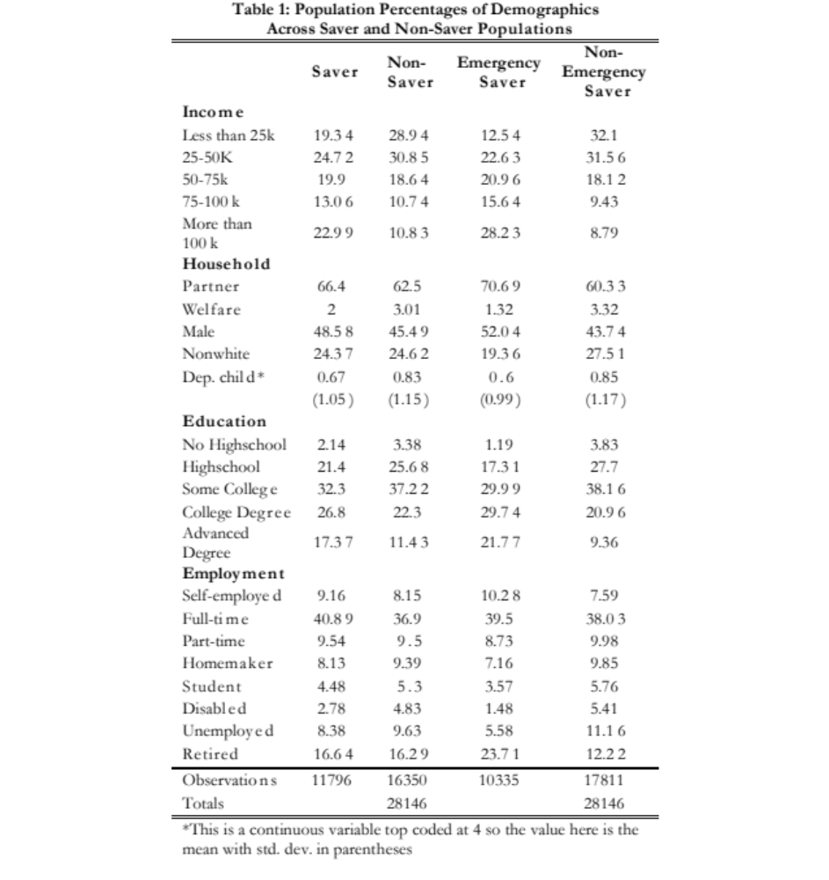
Consumers Make Complex Economic Decisions: Financial Literacy and Retirement Readiness. U.S. Social Security Administration (SSA).

Modigliani, F & Blumberg, R. (1954). Utility Analysis
and the Consumption Function: An Interpretation of Cross-Section Data. Post-Keynesian Economics. Rutgers University Press. 388-436

National Financial Capability Study, public use dataset.
Produced and distributed by the U.S. Department of the Treasury, the President's Advisory Council on Financial Literacy, and the FINRA Investor Education Foundation (2010).

Sandmo, A. (1970). “The Effect of Uncertainty on
Saving Decisions.” The Review of Economic Studies 37: 353-360

Schneider, D., & Tufano, P. (2007). New Savings from
Old Innovations: Asset Building for the Less Affluent. In J. S. Rubin, Financing Low-Income Communities: Models, Obstacles, and Future Directions. New York: Russels Sage.

Seidman, E., & Tescher, J. (2003). From Unbanked to
Homeowner: Improving the Supply of Financial Services for Low-Income, Low-Asset Customers. The Center for Financial Services Innovation.

Sherraden, M. (1991) Assets and the Poor: A New
American Welfare Policy. Armonk, NY. Sharpe, Inc.

Simpson, W. and Buckland, J. (2009). Examining
Evidence of Financial and Credit Exclusion in
Canada from 1999 to 2005. Journal of Socio-Economics, vol 38, 966-976.

Appendix

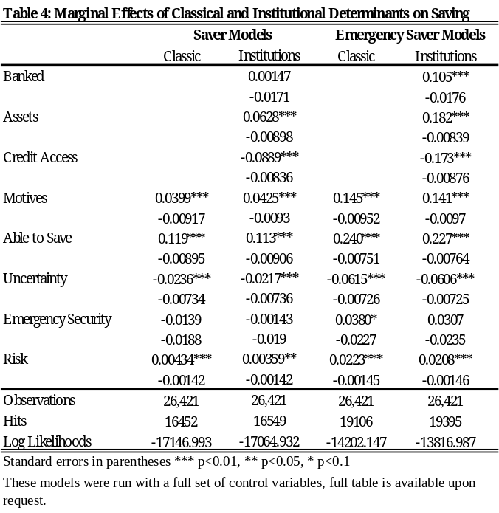

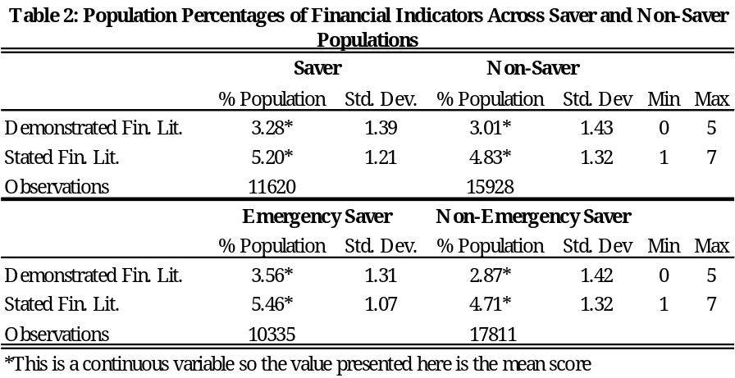

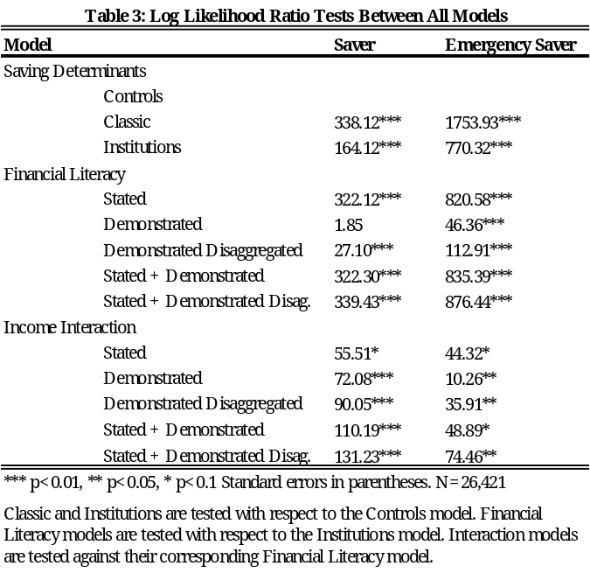

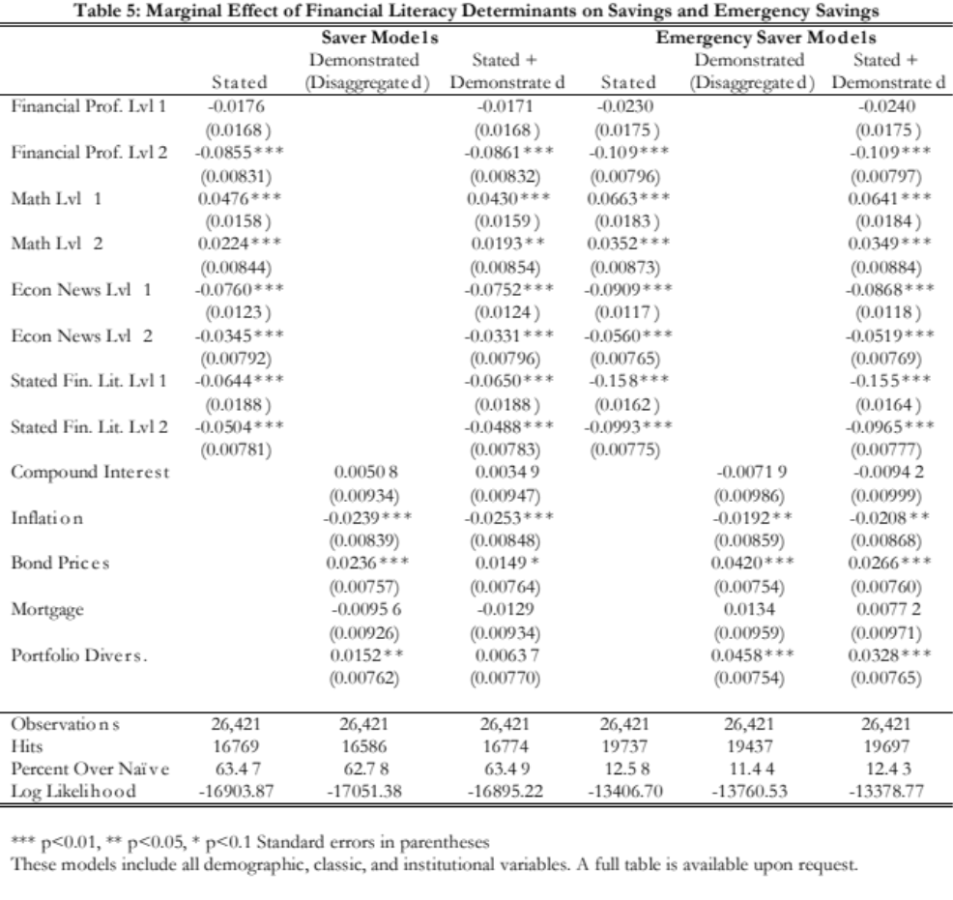
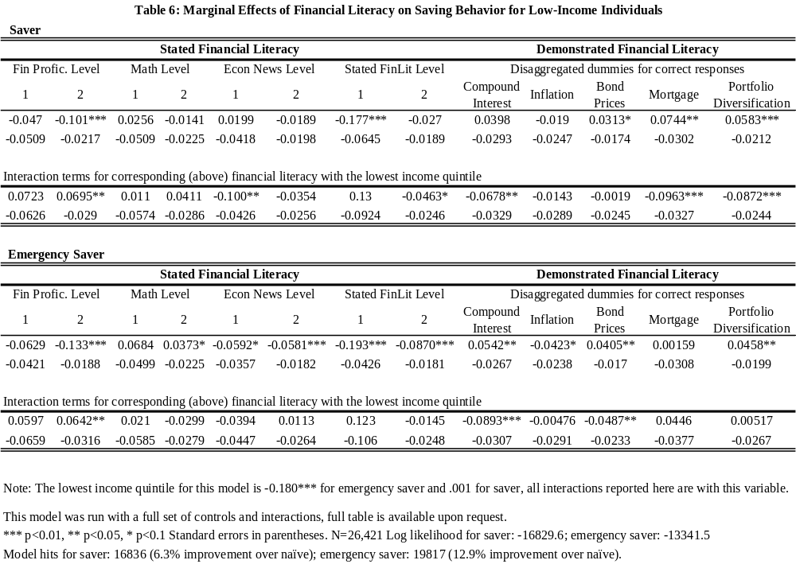

Peru: Do Mothers as Role Models Affect their Teenage Daughters’ Sexual Behavior?
Iva Djurovic ‘13
International Economic Development

Adolescent pregnancies are a persistent problem in Peru. They are associated with lower educational outcomes, lower human capital, and intergenerational transmission of poverty. This paper contributes to a better understanding of the relationship between intra-household dynamics and adolescent pregnancies. The analysis of binary outcome models is based on a sample of 1,029 sexually active women aged 15-24 and their mothers from the Peru Demographic Health Survey 2011. The findings demonstrate that mothers as role models do not affect their adolescent daughters’ sexual behavior. Staying at school, postponing sexual debut, and regular contraceptive use reduce the rate of pregnancy among adolescents.

I. Introduction

More than half of the world’s population today is less than 25 years old and roughly 85% of this age group lives in the developing world. The sexual behavior of young people has become a major social and public health concern, especially with regard to unplanned pregnancies (Mehra et al., 2012). Adolescent fertility in the Latin American and the Caribbean region (LAC) has been decreasing at a slower rate than overall fertility since the 1970s. Moreover, LAC has had the lowest rate of reduction in adolescent fertility in the world. In Peru, adolescent fertility went from 65.1 live births per 1,000 teenage girls in 2000, to 51.1 in 2010. Despite being below the regional average (71.7), adolescent pregnancies in Peru are a persisting problem (World Development Indicators, 2011).
The consequences of teenage pregnancies can be adverse: teenagers have worse pregnancy outcomes than their adult counterparts, and they are more likely to undergo unsafe and often times fatal abortions. On the macroeconomic level, high adolescent fertility rates are correlated with less completed schooling and thus lower human capital. On the microeconomic level, the cycle of poverty is self-perpetuating and often ends in intergenerational transmission of poverty (Rodriguez Vignoli, 2008; Giocolea et al., 2009; Conde-Agudelo et al., 2005).

II. Literature Review

Adolescent girls from low socio-economic backgrounds become mothers sooner in life and with greater frequency than their peers from relatively higher socio-economic settings. For example, a matched case-control study in Ecuador revealed that the odds of pregnancy are fifteen times higher for adolescents living in very poor households compared to relatively wealthier households, with no significant difference by ethnic origin (Giocolea et al., 2009).
In Brazil, fertility is around 10 times higher for the poorest and least educated adolescents, relative to their wealthier and more educated peers (Cavenaghi et al., 2011). Flórez (2005) found that the poorest adolescent girls in Colombia became mothers sooner in life than girls from medium and higher socio-economic strata because they initiated sexual relations and formed formal unions earlier in their reproductive lives, and also because they were less likely to use planned parenthood services. Samandari and Speizer (2010) obtained similar results for Honduras, El Salvador and Nicaragua. Another multi-country study found that the poorest adolescents were also significantly less likely to have economic autonomy, be exposed to media and be enrolled in school, all of which explain why fertility is higher among the relatively poorer adolescents (Rani and Lule, 2004).
There is disagreement in the literature about the direction of causality between education and early pregnancy. It has historically been assumed that early childbearing is an impediment to educational, social and economic achievements of young women. A variety of studies show a strong relationship between educational attainment and adolescent fertility. Bbaale and Mpuga (2011), Giocolea et al.(2009), Cavenaghi et al.(2011) and Samandari and Speizer (2010), among others, found that low educational attainment was a strong predictor of early pregnancies. Even though these are correlated, it remains a challenge to prove the causal relationship between them.
A study carried out in Brazil in 2007 reported that 40.2% of teenage mothers had abandoned school before they got pregnant, thus disputing the mainstream arguments that early motherhood decreases educational attainment (Heilborn et al., 2007). Naslund-Hadley and Binstock (2010) conducted a qualitative study in Peru and Paraguay and discovered that educational underachievement normally preceded pregnancy rather than resulted from it. Besides, poor socio-economic conditions, low expectations of life and the perceived low quality of education often incentivize teenage girls to have children in order to affirm their autonomy (Naslund-Hadley and Binstock, 2010; Rodriguez Vignoli, 2008). Unfortunately, observing girls’ perceived quality of education and expected educational outcomes is challenging, thus making it difficult to control for endogeneity between educational outcomes and early pregnancies.
Schools play a vital role in disseminating information about sexual and reproductive health (SRH), encouraging the usage of SRH services and thus controlling adolescent pregnancies. In Ecuador, Giocolea at al. (2009) found that adolescents who did not have any type of sex education in secondary schools were at a higher risk of early pregnancy than their peers who received sex education. Still, special attention should be paid to the quality and accuracy of SRH education provided. Naslund-Hadley and Binstock (2010) reported that adolescents in Paraguay and Peru rated sex education at schools as embarrassing, especially when taught to boys and girls together. Girls were discouraged from asking questions because they would be stigmatized otherwise. One 15-years-old mother stated: “They always explained everything as taboo.” In a study in Bogotá and Cali, Colombia, information about sexual relations and reproductive health coming from parents and schools caused additional concerns; exposure to information increased the likelihood of early pregnancy instead of decreasing its incidence, reaffirming the importance of providing adequate information to adolescents (Flórez, 2005).
Most researchers stress the importance of contraception knowledge and use among adolescents. Giocolea et al. (2009) found that Ecuadorian girls who did not use contraception during their first sexual intercourse were 4.3 times more likely to have experienced early pregnancy than girls who did use contraception. Buston et al. (2007) found that teenage girls who experienced pregnancy the United Kingdom were less likely to have used contraception during their first sexual intercourse, or have talked to their partner about it. Moreover, they found that, the earlier a girl initiated sexual relations, the more likely she was to have experienced an early pregnancy. Hotchkiss et al.(2006), and Bbaale and Mpuga (2011), among others, found that higher educational attainment corresponds to a higher rate of contraception use among adolescents, which then decreases adolescent fertility. Rani and Lule (2004) and Babalola et al. (2008) reported that exposure to mass media provided crucial information on contraceptive methods and family planning, increased contraceptive use and decreased adolescent fertility.
Findings on adolescent fertility rates in urban and rural areas differ across countries. Samandari and Speizer (2010) found that, in El Salvador, Nicaragua and Honduras, adolescents in urban areas were more likely to be sexually active than their peers in rural areas, thus the likelihood of early pregnancies was higher in urban areas. Bbaale and Mpuga (2011) found that rates of contraception use in Uganda were higher among rural adolescents compared to urban adolescents. However, another study in Uganda found that living in rural area significantly increased the likelihood of early parenthood for males, but not for females (Mehra et al., 2012).
Several studies found that experiencing abuse during childhood or adolescence increases the chances of early pregnancy. In El Salvador, women who experienced sexual abuse, physical abuse or any type of abuse had a 48%, 42% and 31% higher risk, respectively, of adolescent pregnancy than women who did not experience any type of violence. Intimate partner violence in adolescence increased the risk of pregnancy by almost 11 times (Pallitto and Murillo, 2008). In Ecuador, girls with childhood or adolescence abuse experience were three times more likely to have had an early pregnancy (Giocolea at al., 2009).
Lastly, societal norms that involve gender inequalities can have devastating consequences for adolescent girls. A girl is often required to be passive and ignorant when it comes to sexual relations, while a young man’s role is to demonstrate his manhood through risky behavior (Shaw, 2009). Adolescent girls in LAC countries typically lack power to exercise their reproductive rights, especially when it comes to contraception use. Naslund-Hadley and Binstock (2010) revealed that the main reason for girls not using contraception to prevent pregnancy was that “he did not like it”. A study in Argentina concluded that, the older the male partner was, the less likely was a teenage girl to set her own conditions for having sexual relations. The non-use of contraception typically means that the relationship is “stable” and rests on trust (De Biase, 2012; De la Cuesta, 2001). This type of risky behavior does not only increase the chances of early pregnancy, but also the incidence of STIs and the spread of HIV among adolescents.
Most of the above mentioned studies include a set of parental characteristics when analyzing the impact of particular factors on adolescent pregnancy: parental education level, socio-economic status, religion and parental presence in the household are the most common ones. To the best of my knowledge, there has not been a study conducted in Peru that explicitly investigates the influence of mothers as role models on their daughters’ sexual behavior. Therefore, with a goal to contribute to the existing literature, this paper explores the impact of the gender power dynamics in the household and maternal experiences on teenage girls’ sexual and reproductive behavior.

III. Theoretical Framework

The theoretical framework for this research paper is based on Gary Becker’s theory of family economics (Becker, 1981, p.135-147), which is adapted for the purposes of this paper so to adequately address teenage girls’ behavior and decision making on an individual level. Adequate use of different contraceptive methods can lead to a decline in teenage fertility. To demonstrate the effectiveness of birth control methods, Gary Becker suggested we consider the relationship between the number of births ($n)$, the period of vulnerability/exposure to births $(V)$, the average time required to have a conception that will result in a live birth ($B)$, and the average time of sterility during and after giving a live birth ($S)$, in a simple equation:
(1) $n= \frac{V}{(B+S)}$
Here,$(B+S$) is the average time period between two live births. Given that $B$ is the “waiting time” for conception, it depends on the probability of conception during any coition ($p)$, and the frequency of coition $(t)$:
(2) $B≅1/{(pt)}$
The “waiting time” for conception decreases with the increase in sexual intercourse frequency ($t)$, and the non-use of birth control methods that increase the probability of conception $(p)$. Therefore, regular use of contraception and abstinence decrease the probability of pregnancy. Nonetheless, the evidence has shown that adolescent girls in developing countries often times do not use contraception even though it is available to them, and do not abstain from sexual relations even though they are advised to do so, which leads to a high number of teenage pregnancies.
An adolescent girl optimizes her utility depending on a spectrum of factors. Her utility function is the following:
(3) $U=f(n, C; z)$
where $U$ is utility, $n$ is the number of children, $C$ is consumption of all other goods, and $z$ accounts for all other factors, such as family, cultural, social and demographic characteristics.
The budget constraint of her family is the following, where $I$ is income, and $P_{n}$ and $P_{C}$ are the price of children and the price of all other goods, respectively:
(4) $P_{n}n+P_{C}C=I$
The second constraint determines a teenage girl’s demand for children. In the following equation, the number of children is subject to expected benefits from education$(E)$, nature of girl’s sexual behavior$\left(H\right)$, sexual and reproductive power she holds$(W)$, childhood abuse experience$(X)$, and maternal characteristics$(M)$:

(5) $n=g(E,H, W, X, M)$

The final constraint is obtained by substituting constraint (5) in constraint (4):

(6) $P_{n}g\left(E,H, W, X, M\right)+P_{C}C=I$

Therefore, the optimization problem of a teenage girl is to:

(7) $\max{ U}=f(n, C; z)$

subject to the final constraint she faces:

(8) $P_{n}g\left(E,H, W, X, M\right)+P_{C}C=I$

This optimization problem can be solved using the Lagrangean method:
Choose $n,C$ given the equation:
(9) $\text{L=f}\left(\text{n,C,z}\right)\text{-}$$$\text{λ}\left[\text{I-}{\text{P}}_{\text{n}}\text{g}\left(\text{E,H, W, X, M}\right)\text{-}{\text{P}}_{\text{C}}\text{C}\right]$$

Where the first order conditions are:

(10) ${\text{L}}_{\text{n}}\text{:}\frac{\text{∂U}}{\text{∂n}}\text{-λ}{\text{P}}_{\text{n}}\text{=0}$ → $\text{M}{\text{U}}_{\text{n}}$
(11) ${\text{L}}_{\text{C}}\text{:}\frac{\text{∂U}}{\text{∂C}}\text{-λ}{\text{P}}_{\text{C}}\text{=0}$ → $\text{M}{\text{U}}_{\text{C}}$
(12) ${\text{L}}_{\text{λ}}\text{:[I-}{\text{P}}_{\text{n}}\text{g}\left(\text{E,H, W,X, M}\right)\text{-}{\text{P}}_{\text{C}}\text{C]=0}$

From (10) and (11) the following relationship is obtained:

(13) ${\frac{\text{∂U}}{\text{∂n}}}/{\frac{\text{∂U}}{\text{∂C}}}\text{=}{\text{M}{\text{U}}_{\text{n}}}/{\text{M}{\text{U}}_{\text{C}}}\text{= }{{\text{P}}_{\text{n}}}/{{\text{P}}_{\text{C}}}$
The ratio of the marginal utility of children and the marginal utility of consumption is equal to the ratio of their prices.
By plugging (10) and (12) back into the constraint we get that the optimal number of children is a function of the price of children ${(P}_{n})$, the price of all other goods ${(P}_{C})$, income${ (I}^{*})$, expected benefits from education$(E)$, nature of girl’s sexual behavior$\left(H\right)$, sexual and reproductive power she holds$(W)$, childhood abuse experience$(X)$, and maternal characteristics$(M)$:

(14) ${\text{n}}^{\text{*}}\text{=h(}{\text{P}}_{\text{n}}\text{, }{\text{P}}_{\text{C}}\text{, }{\text{ I}}^{\text{*}}\text{, E,H, W, X, M)}$

IV. Methodology

4.1. Data and Variables of Interest

The data for this research paper were drawn from the Peru Demographic Health Survey 2011. This is a nationally representative survey that contains data on 98,662 men and women. Questionnaires for women of reproductive age were given to 22,517 qualified women aged 15-49. The women of interest were those aged 15-24, and their mothers; a total of 3,072 daughter-mother couples were identified. For the purposes of this paper, the analysis was completed on a subsample of 1,029 sexually active women.
The dependent variable is a dummy variable for adolescent pregnancy experience. A woman is considered to have experienced an adolescent pregnancy if she gave birth and/or had a terminated pregnancy (abortion or miscarriage) by the age of 19, or if she was pregnant at the time of the survey and was not older than 19. Roughly 42% of sexually active women in the sample experienced adolescent pregnancy (Table 1). Eighty nine percent of girls had their first sexual intercourse during adolescence, while almost 50% began sexual relations before they turned 17 (Table 2). Table 3 shows that only 32% of girls used contraception during their first sexual intercourse. With respect to current contraceptive use by place of residence, 40% of girls in rural areas use some sort of contraception, compared to 49% in urban areas (Table 4). Table 5 shows the distribution by wealth quintile: 18%, 24%, 23%, 21% and 14% of women in the sample belong to the lowest, lower middle, middle, upper middle and the highest wealth quintile, respectively. Table 6 presents the summary statistics for all the daughter-specific variables that will be used in this paper.
When maternal characteristics are added to the sample, the number of observations decreases to 442 (Table 7). The means and the standard deviations of the variables of interest do not change significantly, as shown in tables 6 and 7. Maternal characteristics of interest are abuse experience (emotional and sexual), and age at first birth. Roughly 58% of mothers in the sample gave birth in adolescence (Table 8). Table 9 summarizes mothers’ abuse experience: 37% of mothers experienced emotional abuse and 13% of mothers experienced sexual abuse.

4.2. Empirical Model

Based on the theoretical model in section 3, and the nature of the data described in section 4.1., the empirical model is the following:
$$\text{Adolescent Pregnancy = }{\text{α}}_{\text{0}}\text{+ }{\text{β}}_{\text{1}}{\text{Υ}}_{\text{1}}\text{+ }{\text{β}}_{\text{2}}{\text{Υ}}_{\text{2}} \\ \text{+}{\text{β}}_{\text{3}}{\text{Υ}}_{\text{3}}\text{+}{\text{β}}_{\text{4}}{\text{Υ}}_{\text{4}}\text{+}{\text{β}}_{\text{5}}{\text{Υ}}_{\text{5}}\text{+}{\text{β}}_{\text{6}}{\text{Υ}}_{\text{6}}\text{+}{\text{β}}_{\text{7}}{\text{Υ}}_{\text{7}}\text{+}{\text{β}}_{\text{8}}{\text{Υ}}_{\text{8}}$$ $\text{+}{\text{β}}_{\text{9}}{\text{Υ}}_{\text{9}}\text{+}{\text{β}}_{\text{10}}{\text{Υ}}_{\text{10}}\text{+}{\text{β}}_{\text{11}}{\text{Υ}}_{\text{11}}\text{+}{\text{ϵ}}_{\text{1}}$, where:

Υ1: Education
Υ2: Wealth Quintile
Υ3: Geographic Location
Υ 4: Age at First Sexual Intercourse
Υ 5: Used Condom at First Sexual Intercourse
Υ 6: Current Contraceptive Use
Υ 7: Number of Partners in a Lifetime
Υ 8: Mother's Education in Years
Υ 9: Mother's Age at First Birth
Υ 10: Mother’s Emotional Abuse Experience
Υ11: Mother's Sexual Abuse Experience
Given the nature of the Peru Demographic Health Survey, some of the variables identified by the theory section were not observed, and were thus omitted or substituted in the empirical model. For instance, women’s expected benefits from education were unobserved, and this variable was substituted with education attainment in years. This variable is potentially endogenous to adolescent pregnancies, but this is the second-best variable according to the literature considering that adolescent girls’ intentions to stay pregnant in order to avoid school are unobserved.
Further, sexual and reproductive power that women exercise in relationships is also largely unobserved. Nonetheless, condom use at first sexual intercourse is a good proxy for sexual and reproductive power: if a woman used a condom at first sexual intercourse, she is likely to hold more power in relationships compared to women who did not use protection. Therefore, a negative coefficient is expected for this variable.
Variables that account for the nature of sexual behavior are the age at first sexual intercourse, number of partners in a lifetime, and current contraceptive use. Maternal characteristics are the age at first birth, and sexual and emotional abuse experience. The last two variables account for maternal characteristics, but at the same time partly control for daughters’ abuse experience since those observations were missing from the data set.

V. Results and Discussion

5.1. Main Results

Main regression results are presented in Table 10. Moderate heteroskedasticity was present, so robust standard errors were used. Given that the results for multivariate logit and probit regressions with default and robust standard errors were almost identical, only robust standard errors results are presented. In order to preserve the sample size, the first two regressions were run on daughters’ characteristics exclusively, and the third and fourth regressions included maternal characteristics as well. The values of AIC and BIC, as well as the pseudo R-squared, indicate that logit and probit models fit the data in a similar manner; probit was slightly more efficient in fitting daughters’ characteristics, while logit was slightly more efficient when maternal characteristics were added to the model. Therefore, probit and logit coefficients are used for the interpretation of the first and the second pair of regressions, respectively.
Educational attainment has a significant negative impact on adolescent pregnancies. In the first two regressions, 1 additional year of education decreases the likelihood of pregnancy by 3%. When maternal characteristics are controlled for, the impact of education increases to 5%. Postponing sexual debut by one year decreases the chances of early pregnancy by 7% (8.3% when maternal characteristics are included). Using a condom at first sexual intercourse decreases the chances of early pregnancy by 23% (30.3% when controlling for the mother). The reasoning behind these results is quite straightforward, and in accordance with the literature.
Current contraceptive use coefficients indicate that, relative to not using contraception, using traditional methods decreases the chances of early pregnancy by 19.7%, while the coefficient for modern contraceptives, 8.6%, is positive and significant at 5% level. When maternal characteristics are controlled for, the traditional methods coefficient becomes insignificant, while modern contraceptives coefficient remains positive and significant. On the one hand, it is possible that girls who had a difficult early pregnancy experience in the past are now more precautious and use modern contraceptives so to avoid future inconveniences. On the other hand, it is likely that girls who are currently using a traditional method (for instance, abstinence), have always used this method and it has proven to be more effective than not using any contraception at all. Therefore, current contraceptive use is likely to be endogenous to adolescent pregnancies.
There are two potential endogeneity issues: education level and current contraceptive use are likely to be endogenous with early pregnancy outcomes. However, these two endogeneity issues are recognized only by a number of qualitative studies (Naslund-Hadley et al., 2010; Rodriguez Vignoli, 2008; Heilborn et al., 2007), while most quantitative (experimental and non-experimental) studies control for these variables regardless of potential endogeneity. Therefore, due to the lack of adequate instrumental variables, this paper adheres to the existing literature and potentially endogenous variables are kept in the model.
Remaining explanatory variables appear insignificant across all four regressions, thus their true coefficients equal zero. Even though statistically insignificant, they all have the expected signs in the first two regressions; although, the signs of some coefficients change when maternal characteristics are included. It is possible that these signs switch as a consequence of including irrelevant variables (i.e. maternal characteristics). Moreover, the true coefficients of maternal characteristics are zero and two out of three signs are the opposite of what was predicted, which indicates that maternal characteristics are irrelevant to adolescent pregnancy outcomes in these models. In order to test this assumption, an F-test of joint significance was performed on daughters’ and mothers’ characteristics separately. As presented in Table 10, daughters-specific variables are jointly significant at 1% level, while mothers’ characteristics are jointly insignificant. This leads to a conclusion that mothers as role models do not have an impact on their teenage daughters’ sexual behavior.
Regarding the limitations of these models, special attention should be paid to the potential bias in the coefficient estimates caused by omitted variables. As indicated earlier, adolescent girls’ true preferences and perceived tradeoffs between motherhood and education are unobserved. Variables on childhood and adolescent abuse were missing from the data set, and mothers’ abuse experience variables were irrelevant. Furthermore, cultural aversion to contraception, socially favorable gender dynamics in relationships and other socio-cultural characteristics are unobserved and are thus likely to have caused bias in the coefficient estimates.

5.2. Robustness Analysis

The first robustness check is shown in Table 11. In order to confirm that the insignificance of maternal characteristics is due to their irrelevance and not due to the loss of information when the sample size decreased from 1,029 to 442 observations, early pregnancy outcomes were regressed on daughters’ characteristics exclusively for the subsample of 442 women. By comparing Tables 6 and 7, it is obvious that the means and standard deviations of observed characteristics for the two samples do not substantially differ. Coefficients that were significant when regressions were run on the larger sample are still significant and have expected signs, while some of the statistically insignificant variables changed sign. Even though the real values of these coefficients are zero, the signs could have switched because some unobserved characteristics changed as the sample was reduced to 442 observations. For instance, it could be that these 442 daughters whose mothers fully answered the questionnaires have certain characteristics that other women in the sample do not have: they could have been less abused as children, or enjoy more parental support when it comes to school achievements. These unobserved characteristics are another potential source of bias in the coefficient estimates.
Regressions in Table 12 include mother-specific variables. Daughters’ educational attainment is now controlled for with a categorical variable, rather than years of education. Women are 42.4% less likely to have had an adolescent pregnancy if they have more than secondary education, relative to having completed only primary school. Further, regressions in Table 12 include a more detailed explanatory variable for residence: the true values of these coefficients are zero, indicating no statistically significant difference between women who live in large cities, small cities and towns, relative to those who live in the countryside. Moreover, maternal sexual abuse experience now has a positive impact on adolescent pregnancies: women whose mothers experienced sexual violence are 17.1% more likely to be pregnant as teenagers. Women whose mothers were sexually abused perhaps desire to have children as early as possible in their reproductive lives, so to escape an abusive environment in the household. This significance is possibly due to a lower level of endogeneity after a categorical variable for education was included.
Table 13 presents marginal effects of explanatory variables on adolescent pregnancies. Since the main results showed that maternal characteristics were jointly insignificant, marginal effects are computed only for daughter-specific variables. For nonlinear models, the average behavior of all individuals differs from the behavior of a single average individual, thus the coefficients for the marginal effect at the mean are roughly 18% greater than the average marginal effect coefficients. Using a condom at first sexual intercourse is associated with the biggest change in the likelihood of early pregnancies as its marginal effect is the strongest. The second strongest marginal effect on teenage pregnancies is the age at first sexual intercourse: the average marginal effect of postponing sexual debut by one year is a decline in the odds of early pregnancy of 5.3%.

VI. Conclusions

The results of this paper confirm some of the findings in the existing literature. First, higher educational attainment is associated with a lower likelihood of teenage pregnancies. Second, early sexual debut increases the chances of teenage pregnancy. Third, the use of a condom at first sexual intercourse decreases the likelihood of early conception. Women who are currently using modern contraceptives are more likely to have experienced an early pregnancy relative to those who are not using any contraception. In contrast, current use of traditional contraceptive methods is associated with a lower likelihood of early pregnancies. Finally, a woman is more likely to have been pregnant as a teenager if her mother ever experienced sexual abuse. Nonetheless, maternal characteristics – age at first birth, experience with emotional violence, and experience with sexual violence – jointly seem to have no influence on adolescent pregnancy outcomes.
These results should be interpreted carefully because endogeneity and omitted variables are potential causes of bias in the coefficient estimates. Endogeneity is probable considering that educational attainment and current contraceptive use are likely to be endogenous to adolescent pregnancy outcomes. Some omitted variables include adolescent girls’ true preferences given their perceived tradeoffs between motherhood and education, childhood abuse experience and unobserved individual, social and cultural characteristics.
Longitudinal analysis could solve at least a portion of the endogeneity issue. If young women are observed over a sufficiently long period of time, patterns of contraceptive use would be evident and the meaning of its coefficients could be interpreted with more certainty. In addition, the relationship between school attendance and pregnancy would be clearer.
DHS questionnaires for women of reproductive age contain a variety of insightful questions. Nonetheless, a substantial number of observations relevant to this study were missing from the 2011 data set. Using a more specific questionnaire and improving data collection is essential for obtaining adequate results for policy makers and thus further reducing adolescent fertility in Peru.

References.

Babalola, Stella; Folda, Lisa; Babayaro, Hadiza. The Effects of a Communication Program on Contraceptive Ideation and Use among Young Women in Northern Nigeria. Population Council, Studies in Family Planning, Vol. 39, No. 3, September 2008. Pages: 211-220.

Bbaale, Edward; Mpuga, Paul. Female Education, Contraceptive Use, and Fertility: Evidence from Uganda. Consilience: The Journal of Sustainable Development. Vol.6, Issue 1, 2011. Pages: 20-47.

Becker, Gary S. A Treatise on the Family. Cambridge, Mass: Harvard University Press, 1981.

Buston, Katie; Williamson, Lisa; Hart, Graham. Young Women Under 16 Years with Experience of Sexual Intercourse: Who Becomes Pregnant? Journal of Epidemiological Community Health, Vol. 61, 2007. Pages: 221-225

Cameron, A. Colin; Trivedi, Pravin K. Microeconometrics Using Stata (Revised Edition). Stata Press, 2010.

Cavenaghi, Susana; Alvez, Diniz; Eustáquio, José. Diversity of Childbearing Behaviour in the Context of Below-Replacement Fertility in Brazil. United Nations: Department of Economic and Social Affairs. Population Division

Expert Paper Number 2011/8; New York, 2011.

Cigno, Alessandro. Economics of the Family. Oxford: Clarendon Press, 1991.

Conde-Agudelo, Agustin; Belizan, Jose; Lammers, Cristina. Maternal-perinatal Morbidity and Mortality Associated with Adolescent Pregnancy in Latin America: Cross-sectional Study. American Journal of Obstetrics and Gynecology, Vol. 192, 2005. Pages: 342-349.

De Biase, Tesy. Alcohol, Drogas y Sexo: una Combinación Frecuente y Peligrosa en la Adolescencia. La Nación, accessed: 11/30/2012.

De la Cuesta, Carmen. Taking Love Seriously: The Context of Adolescent Pregnancy in Colombia. Sage Publications: Journal of Transcultural Nursing, Vol.12, No. 3, July 2001. Pages: 180-192.

Flórez, Carmen Elisa. Factores Socioeconómicos y Contextuales que Determinan la Actividad Reproductiva de las Adolescentes en Colombia. Revista Panamericana de Salud Pública, 2005; 18(6): 388-402.

Giocolea, Isabel; Wulff, Marianne; Ohman, Ann; San Sebastian, Miguel. Risk Factors for Pregnancy Among Adolescent Girls in Ecuador’s Amazon Basin: A Case-control Study. Pan American Journal of Public Health, Vol.26, No.3, 2009. Pages: 221-228.

Heilborn, Maria Luiza; Reis Brandão, Elaine; Da Silva Cabral, Cristiane. Teenage Pregnancy and Moral Panic in Brazil. Culture, Health & Sexuality, Vol.9, No.4, Jul. - Aug. 2007. Pages: 403-414.

Hotchkiss, David R.; Rous, Jeffrey J.; Seiber, Eric E.; Berruti, Andres A. Maternal and Child Health Service Use a Casual Gateway to Subsequent Contraceptive Use?: A Multi-country Study. Population Research and Policy Review Vol.24, 2005. Pages: 543-571.

Mehra, Devika; Agardh, Anette; Odberg Peterson, Karen; Ostergren, Per-Olof. Non-use of Contraception: Determinants Among Ugandan University Students. Global Health Action, 2012.

Meuwissen, Liesbeth; Gorter, Anna; Knottnerus, André. Impact of Accessible Sexual and Reproductive Health Care on Poor and Underserved Adolescents in Managua, Nicaragua: a Quasi-experimental Intervention Study. Journal of Adolescent Health, Vol.38, 2006. Pages: 56.e1-56.e9.

Naslund-Hadley, Emma; Binstock, Georgina. The Miseducation of Latin American Girls: Poor Schooling Makes Pregnancy a Rational Choice. Inter-American Development Bank, 2010.

Pallitto, Christina; Murillo, Victoria. Childhood Abuse as a Risk Factor for Adolescent Pregnancy in El Salvador. Journal of Adolescent Health, Vol.42, 2008. Pages: 580-586.

Rani, Manju; Lule, Elizabeth. Exploring the Socioeconomic Dimension of Adolescent Reproductive Health: a Multicountry Analysis. International Family Planning Perspectives, Vol.30, No.3, 2004; Pages:110–117.

Rodriguez Vignoli, Jose. Reproducción Adolescente y Desigualdades en América Latina y el Caribe: un Llamado a la Reflexión y a la Acción. OIJ/CEPAL, 2008.

Samandari, Ghazaleh; Speizer, Llene S. Adolescent Sexual Behavior and Reproductive Outcomes in Central America: Trends over the Past Two Decades. International Perspectives on Sexual and Reproductive Health. March, Vol.36, No.1, 2010. Pages: 26-35.

Shaw, Dorothy. Access to Sexual and Reproductive Health for Young People: Bridging the Disconnect Between Rights and Reality. International Journal of Gynecology and Obstetrics, Vol.106, 2009. Pages: 132–136.

Studenmund, A. H. Using Econometrics: A Practical Guide (Fifth Edition). Pearson: Addison Wesley, 2006.

The World Health Organization: The Sexual and Reproductive Health of Younger Adolescents: Research Issues in Developing Countries, 2011.
Data sources:
National Institute of Statistics and Information of Peru: http://www.inei.gob.pe/
World Development Indicators: http://data.worldbank.org
United Nations, Department of Economic and Social Affairs: Population Division: http://www.un.org/esa/population/

Tables and Figures
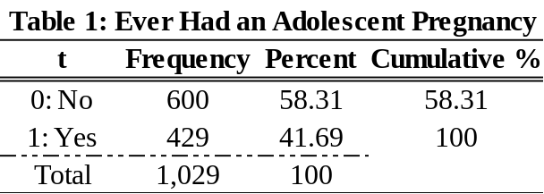

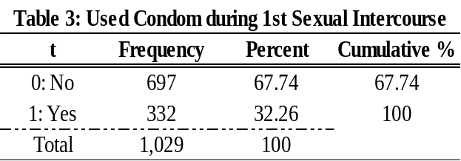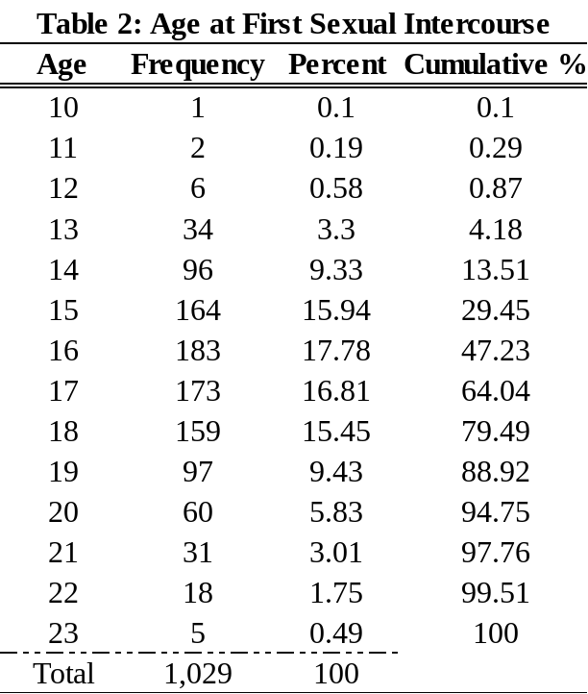

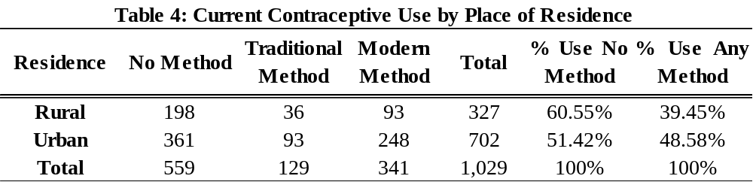

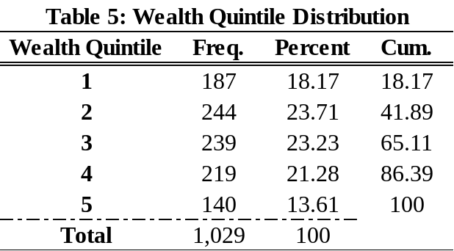

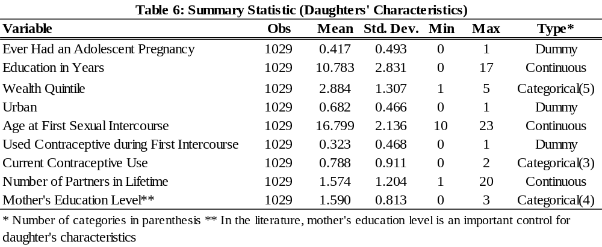

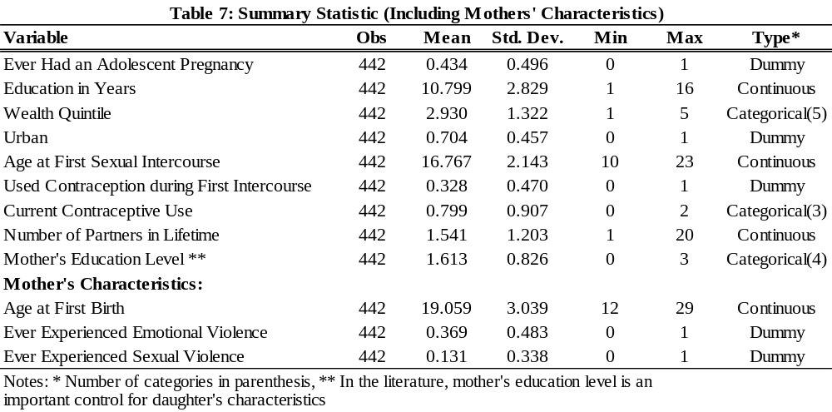

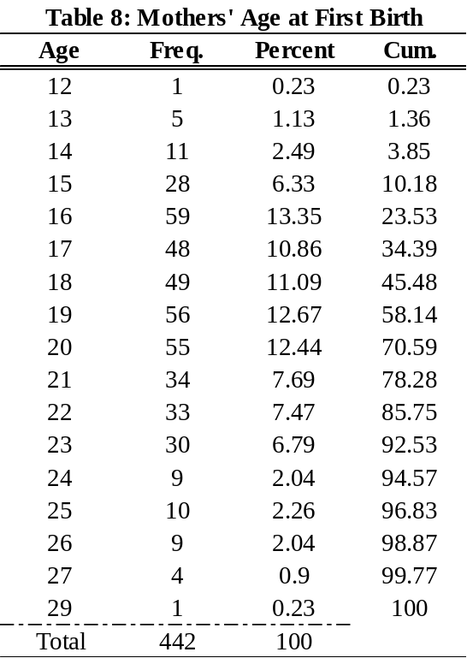

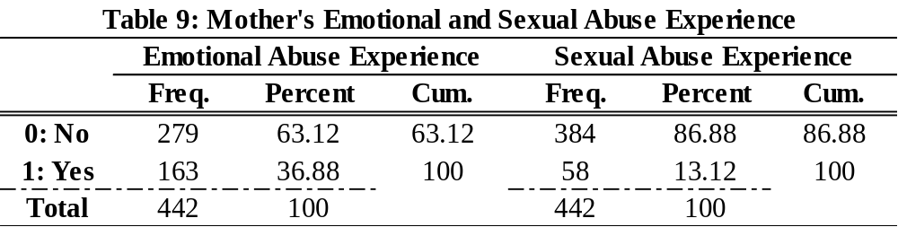

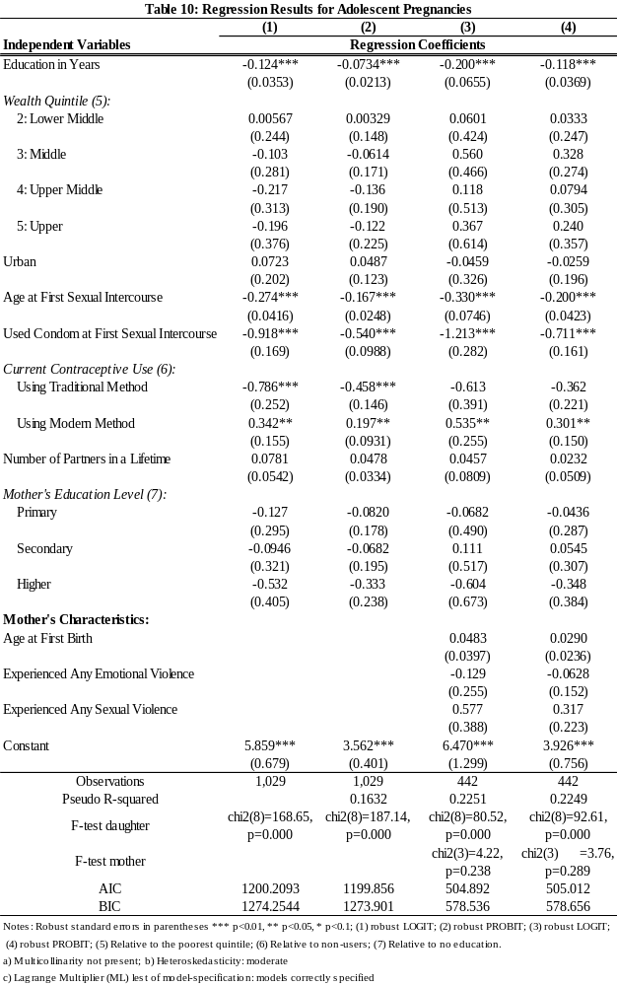
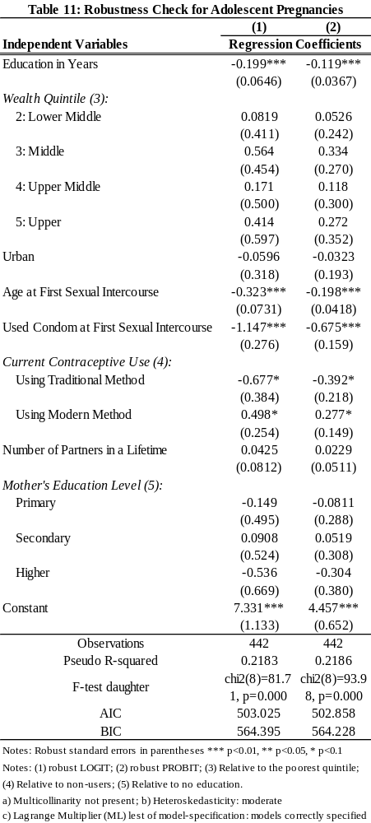
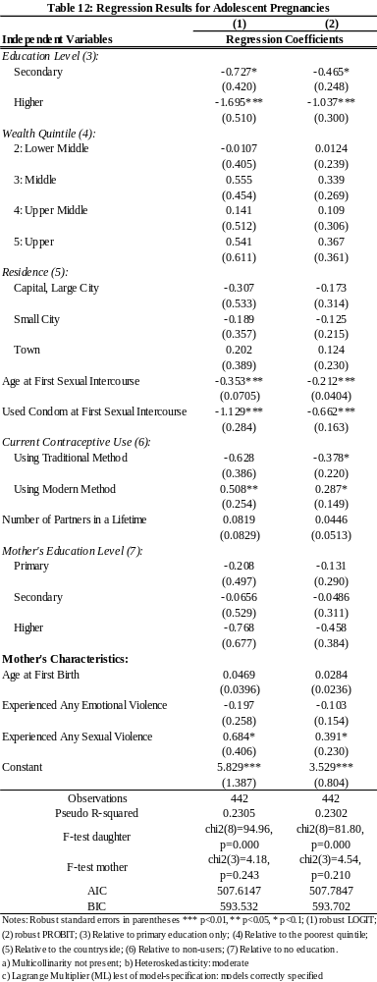
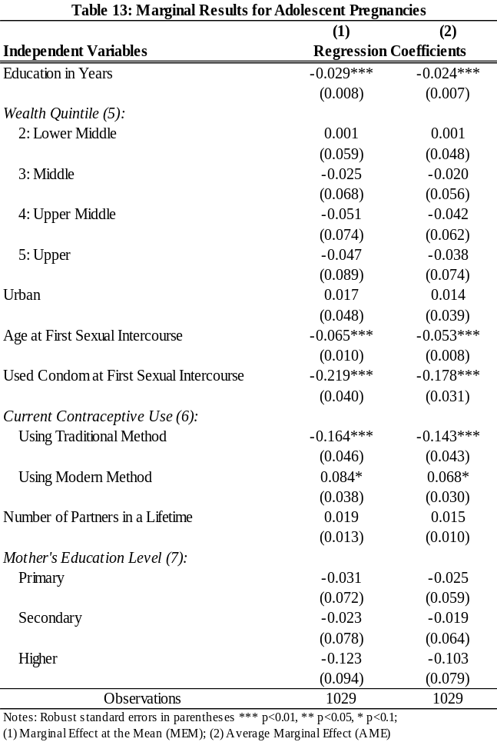

What Does Love Have To Do With It?
An Economic Analysis of the Marriage Decision for non-GLB and GLB couples in the United States

Anna Graziano ‘13

Introduction to Econometrics
This paper analyzes the marriage decision for four groups, non-GLB men and women and GLB men and women. By comparing Gary Becker’s seminal theory of marriage to a model that includes relationship quality and compatibility variables, I find that the latter are more important factors for couples in predicting their likelihood of marriage. From this I conclude that love does matter. Additionally, I find few significant differences in predicting marriage likelihood between non-GLB and GLB couples. Thus, I also conclude that, empirically, GLB couples marriage decisions are not vastly significantly different from non-GLB couples.

Introduction

What does love have to do with marriage? During the 2012 election season, the institution of marriage was a widely debated topic. For the first time in U.S. history, three states voted to legally recognize gay marriages (The Economist, 2012), an indication that the definition of marriage and the reasons that people marry are evolving. At the same time, heterosexual marriage rates have been declining since the 1960s. Over the past few decades, female labor force participation has increased, decreasing women’s economic dependence on marriage. As a result, greater competition in the job market led both men and women to prolong their education, building human capital. Not surprisingly, empirical research finds wages, non-labor income, education, and the ratio of sexes as determinants of marriage demand (Fulop, 1980).
Fulop’s research is based on Becker's (1974) Theory of Marriage, a seminal paper in the field of family economics. However, modeling marriage using Becker’s theory presents one interesting problem: it does not account for love. This paper will add to Becker’s model of marriage by comparing his model with and without relationship quality and compatibility variables, as proxy conditions for love. I compare these models to determine what factors have the greatest impact on marriage likelihood among couples. In addition to addressing love, the results of my research will contribute to the existing body of economic research on marriage by modeling gay, lesbian, and bisexual (GLB) marriages. This allows me to compare heterosexual and homosexual marriage decisions to see if variation in sexual preference indicates significant differences in why couples marry. Finally, I provide a comprehensive view of non-GLB and GLB males’ and females’ marriage decisions by investigating both genders in one paper.
The results of my analysis find love proxy variables to be greater determinants of marriage likelihood for females, males, and GLB females compared to Becker’s original model. The most influential variable for GLB males is not a love proxy variable, however relationship quality is a close second. Overall, this indicates measures of love matter more for married couples in my dataset rather than maximizing household economic productivity. Moreover, I find empirical evidence that GLB couples exhibit similar tastes and preferences as non-GLB couples in their relationships.
This paper is organized as follows. Section 1 will provide a summary of the Becker’s (1974) theory of marriage and related empirical work in this field. Section 2 will address the ideal model and the ideal data. Section 3 will present the empirical model, description of data, and empirical technique. Section 4 will describe the results. Section 5 will discuss differences between GLB and non-GLB couples. Section 6 will assess the accuracy of the empirical model. Finally, Section 7 will conclude the paper.

I. Literature Review
1.1 Summary of Economic Theories of Marriage
In the current body of literature surrounding the economics of marriage, there are two prominent models. The Common Preference model, introduced by Becker (1974), and the Bargaining Model pioneered by Manser and Brown (1980) and McElroy and Horney (1981), further expanded by Lundberg and Pollak (1993, 1996). The major contribution of the Bargaining Model is the inclusion of divorce-level utility. The authors of Marriage and the Family - An Economic Approach summarize these and other economic theories of marriage (Hoffman & Averett, 2010). However, since this paper considers marriage decisions only, I focus my discussion on Becker’s (1974) theory.
The Common Preference model (Becker, 1974) assumes partners maximize a joint family utility function by maximizing household production good Z (the sum of all consumption goods, both market and non-market). One partner, the husband for example, is willing to marry if the amount of Z he can consume when married is greater than when he is single. Similarly, the wife is willing to marry if the amount of Z she can consume when married is greater than when she is single. This assumes that, in marriage, each spouse shares his or her production with the other spouse. As a result, there are gains from specialization, regardless of productivity level. That is, if each spouse is identical in terms of market and nonmarket productivity, one will specialize in market work and the other in nonmarket work. By cooperating and sharing, the amount of market and nonmarket goods both spouses consume increases.

1.2 Related Empirical Work and Methods
The related empirical work to this paper builds off Becker’s (1974) production theory of marriage to explain why people choose to marry. The majority of empirical marriage research relies on data from the U.S. Census, and considers marriage rates rather than individual marriage decisions (Freiden, 1974; Watson & McLanahan, 2009; Greenwood, Guner, Korcharkov, & Santos, 2012). Blau, Kahn, and Waldfogel (2000) also rely on U.S. census data but perform a two-stage analysis where a linear probability model predicts marriage incidence. An Ordinary Least Squares (OLS) regression is used by Freiden (1974) to model marriage rates, while Greenwood et al. (2012) employ a minimum-distance estimation procedure. Following these researchers, I use OLS and logistic regression to analyze marriage likelihood among couples.
In a survey of literature on the economic analysis of marriage, Fulop (1980) lists relative wages, education, and the ratio of marrying aged women to marrying aged men as primary determining factors of the marriage decision. In most other empirical work some measure of income appears, as income is correlated with the ability to support a partner (Fulop, 1980). The ratio of males to females and the role of education also appear frequently as independent variables. Education affects the level of specialization among couples while the ratio of sexes reflects the availability of potential partners (Fulop, 1980).
Watson and McLanahan (2009) find that a man’s income relative to his reference group affects his decision to marry. These researchers treat income as the financial determinant of marriage, assuming a certain threshold income is required before marriage. Similarly, Blau et al. (2000) and Greenwood et al. (2012) include wage in their specification. Freiden (1974) includes the male/female relative wage and proxies for income (median value of owner occupied housing and median value of monthly gross rent) in his specification.
Other important variables to consider are the ratio of sexes and the role of education and female labor-force participation. Freiden (1974) and Blau et al. (2000) find some measure of the ratio of men to women to affect the incidence of marriage. When marriage markets are better for women (i.e. more available men than women), more women tend to be married. Higher education and greater female labor-force participation is found by Greenwood et al. (2012) to account for declining marriage rates between 1960 and 2005. Their findings imply that working women are less economically dependent on men and hence do not need to marry.
As demographic variables, such as income and education level, vary within groups, Watson and McLanahan (2009) disaggregate their data by race/ethnicity-specific groups within Metropolitan Statistical Areas (MSAs). Freiden (1974) and Blau et al. (2000) also take advantage of disaggregation by MSA. This results in significant and robust findings for whites, and limited findings for blacks and Hispanics across studies. Other demographic variables are used to disaggregate the data including the proportion of the population that was Catholic (Freiden, 1974).
II. Ideal Model and Ideal Data

The ideal model would investigate the marriage decision using individual level data instead of national aggregates such as marriage rates. Individual level data allows me to identify factors affecting marriage decisions that could be obscured by the use of aggregated data, such as relationship quality. Based on current theory and empirical work described in Section 1.2, the ideal specification to model current marital status would include independent variables for the following individual characteristics: age, yearly income, years of education, race, ratio of women to men, number of children, MSA status, and the opportunity cost of marriage. Except for race, the observations for these variables need to be from the time period prior to the marriage to avoid issues with endogeneity. For example, the number of children may affect marriage likelihood, while at the same time, marriage likelihood may affect the number of children. For the purposes of this paper, a quantifiable measure of love would also be included in the ideal model. Unfortunately, the current theory and literature does not offer a variable to measure love. Equation 1 summarizes the ideal model with marriage in time period t.
(1)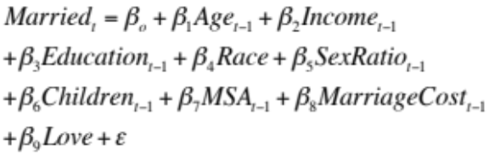

III. Empirical Method

3.1 Empirical Model

The empirical model this paper estimates is summarized in equation 2. I refer to this model as the model of marriage with love proxy variables in what follows of this paper.

(2)
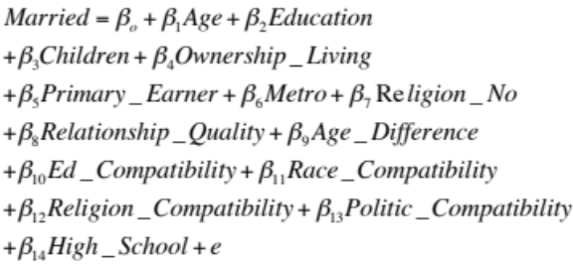

The model of marriage with love proxy variables includes both the theoretically accepted determinates of marriage (i.e., variables representing age, income, education, race, children, MSA status, and cost of marriage) and proxy measures of love (i.e., relationship quality and several compatibility variables). As the data used are cross-sectional, the empirical model does not include the ratio of sexes as a variable representing marriage market conditions. This is a shortcoming of the available data and may create bias in my estimates. Table 1 relates each theoretical concept and measure of love to the associated variable used in this paper. Also in the table, I include the hypothesized direction of each variable’s effect on marriage likelihood.
Age, the presence of children, and ownership of living quarters are hypothesized to positively affect the likelihood of marriage. Since education theoretically delays entrance into marriage and decreases the economic need for a spouse (Becker, 1974), an increase in years of education is hypothesized to decrease the likelihood of marriage. However, empirically it is the case that highly educated men and women tend to be married more often than those with less education (Campbell, 2010). Thus the expected sign is ambiguous. Since this paper is based on Becker’s theory, a negative directional hypothesis is proposed.
The primary income earner effect is hypothesized to be negative for females and positive for males. Since there is a less dominant social norm of “Husband Income Earner” and “Wife Homemaker” for GLB couples, the hypothesized effect of this variable is unknown for these groups. If there exists previous empirical work in Economics regarding GLB social norms and their effect on marriage, it was not researched within the scope of this paper.
Empirically, religious association was found to decrease divorce rate (Freiden, 1974). Hence, a decrease in likelihood of marriage is expected for those who reported no religious association. In addition, as cited in Campbell (2010), the “State of Our Unions” report finds highly educated couples tend to have religious faith in their relationships.
As 89% of survey participants reported living in an MSA, this variable is expected to increase the likelihood of marriage. This is because, especially for the GLB community, living in a populous area increases the odds of meeting a potential partner (Schwartz, 2011).
This paper investigates the role of love in couples’ marriage decisions. The hypothesis is that relationship quality and compatibility matter more than production gains in determining marriage likelihood among couples.

3.2 Description of Data and Summary Statistics

Rather than using U.S. Census data and analyzing marriage rates, this paper will investigate individual marriage decisions and provide a snapshot picture of factors influencing this decision for non-GLB females and males and GLB females and males. The same theory will be applied to all groups in order to test if different factors matter more or less between groups.
This paper uses cross-sectional, individual data of U.S. residents from Wave 1 of the How Couples Meet and Stay Together survey (Rosenfeld & Reuben, 2009). The survey and dataset were accessed through the Interuniversity Consortium for Political and Social Research (ICPSR). Fortunately, individual level data were obtained. I include only observations for respondents in romantic relationships and aged 19 to 59. The data were then categorized by GLB status, and separated into non-GLB females, non-GLB males, GLB females, and GLB males. The dependent variable was created to be binary indicating whether the couple was married. In this case, marriage includes traditional marriages, civil unions, and domestic partnerships. The survey question asking which partner earned more income referred to earnings from the previous year, however it is unclear whether the partners were married in the previous year. Thus this variable is not the ideal measure of income. Another shortcoming is that the data do not distinguish between first marriages and subsequent marriages. Lastly, the survey did not ask participants about love specifically, only the quality of their relationship.
Going forward, it will be helpful to keep the following summary statistics in mind. The compiled dataset includes 927 respondents who report being in a relationship. 41.75% identify as GLB and 58.25% do not identify as GLB. 54.05% of the observations are female and 45.95% are male. The average age of GLB participants is 43 years while for non-GLB participants it is 35 years. Lastly, 89.00% of respondents in the dataset reported living in a metropolitan area, and 100% of GLB identifying respondents reported living in a MSA.

3.3 Estimation Method

I estimate the likelihood of marriage among couples using the following analysis. First, a logistic regression of the marriage model with and without love proxy variables was compared to OLS regressions for non-GLB females, non-GLB males, GLB females, and GLB males. The marginal effects of logistic regression and OLS were also compared. Marginal effects can be generally understood as the change in the dependent variable due to a one-unit change in the independent variable(s). The logistic regression was determined to be the correct specification because the dependent variable was binary and heteroskedasticity was present in the OLS specification for all groups. In what follows of this paper, the discussion will refer to the logistic regression unless otherwise specified.
The proxy love variables (relationship quality, age difference, same high school, and religious, political, race, and education compatibility) were then formally tested for their improvement upon the model without them. Next, interaction variables were created to assess whether there was a significant difference in the effect of the variable between GLB and non-GLB couples. Lastly, the estimation method analyzed the accuracy of the model in predicting marriage likelihood within the observations.

IV. Results

As depicted in Tables 2-5, the model of marriage with love proxy variables explains the variance in marriage decisions for couples in the dataset with theoretically sound coefficient signs for GLB couples more often than for non-GLB couples. OLS regression and logistic regression lead to marginal effects of the same signs and similar magnitude, except for in the case of religion compatibility for GLB males. In this case the sign changes from negative to positive when using logistic regression instead of OLS. The logistic regression with love compatibility variables for all groups except GLB males has a likelihood ratio statistic greater than its critical value, indicating that the model explains the variance in the survey sample well. Also for GLB males and GLB females, the model without love proxy variables has a likelihood ratio statistic lower than its critical value. Unfortunately, for all groups the likelihood ratio test indicates the inclusion of love variables does not improve upon the model without love proxy variables. Parts 4.1 through 4.4 will discuss the results for non-GLB females, non-GLB males, GLB Females, and GLB males separately. Figure 1 is the crucial figure in this paper. It displays the magnitudes of each variable for each group, thus providing a useful comparison between groups. I refer to this figure frequently in the subsequent discussion.

4.1 Marriage Likelihood for non-GLB Females

Likelihood of marriage for females in this dataset is most heavily determined by the ownership status of their living quarters when love proxy variables are not included in the model. Without modeling the effect of love, women who own their living quarters see a 0.07 decrease in their likelihood of marriage. This sign is not in the hypothesized direction. The addition of love proxy variables for non-GLB females changes the effect of this variable to a 0.05 decrease in the likelihood of marriage. Also, the statistical significance of this variable drops from the 5% level to the 10% level with the inclusion of love proxy variables. In addition, when love proxy variables are included, the direction of the effect of children in the household changes from positive to negative. This result implies that children affect non-GLB women’s marriage decision in a surprisingly negative way when accounting for love among couples. Hence, this may be preliminary evidence that the definition of marriage is changing for this group.
For non-GLB women, when love proxy variables are included in the model, the largest determinant of marriage likelihood is race compatibility. When women in this dataset are the same race as their partner, the model predicts a 0.07 decrease in likelihood of marriage. This sign is also not in the hypothesized direction, again additional evidence that the definition of marriage is changing for these women. With the inclusion of love proxy variables, the ownership of living quarters drops to the second largest determining factor in marriage likelihood. Thus, the inclusion of love proxy variables reveals marriage likelihood for non-GLB women is most influenced by racial compatibility whereas without considering the effect of love proxy variables, the most important factor was home ownership. The discussed values are given in Table 2.

4.2 Marriage Likelihood for non-GLB Males

For non-GLB males in this dataset, living in a metropolitan area has the greatest effect on marriage likelihood when the model excludes love proxy variables. Those who reported living in a metropolitan area see a 0.04 increase in their likelihood of marriage. The second most important determinant of marriage likelihood for these men is education. As their years of education increase, their likelihood of marriage decreases by 0.03. This effect is also statistically significant at the 1% level.
However, as seen in Figure 1, when love proxy variables are added to the model, having attended the same high school as their partner becomes the greatest factor in determining marriage likelihood. Men in this dataset who attended high school with their partner see a 0.13 increase in likelihood of marriage. The effect of living in a metropolitan area is the second most important factor, and actually increases slightly from the model without love proxy variables to 0.05. The third influential variable on marriage likelihood is relationship quality. As relationship quality increases, the model predicts a 0.03 increase in marriage likelihood. These results appear in Table 3.
Thus, this paper finds evidence in support of the hypothesis that love does play a role in the marriage decision for non-GLB men in this survey. Having attended the same high school as their partner, as a measure of compatibility, is an important factor in their marriage decision. In addition, relationship quality affects the likelihood these men are married.

4.3 Marriage Likelihood for GLB Females

Before factoring in love proxy variables, marriage likelihood is most heavily influenced by living in a metropolitan area for GLB females. Those who report living in a metropolitan area see a 0.1 increase in likelihood of marriage. The second most important factor is religion. GLB women who report no religious association see a 0.08 decrease in marriage likelihood.
When love proxy variables are included in the model, the quality of the relationship has the strongest influence on marriage likelihood in this dataset. As relationship quality increases by one unit, marriage likelihood increases by 0.19. This value is statistically significant at the 1% level. The second most important variable after inclusion of the love proxy variables is racial compatibility. Female GLB couples of the same race in this dataset see a decrease of 0.13 in their likelihood of marriage. Similar to non-GLB females, this finding is interesting as it implies different race couples are more likely to be married, contrary to what I expected. The importance of religious association increases with the inclusion of love proxy variables, predicting a 0.12 decrease in likelihood for those reporting no religious association. These variables are illustrated in Figure 1 and given in Table 4. For this group, including love proxy variables when modeling marriage likelihood produces results indicating compatibility and relationship quality are the most important factors in their marriage decision.

4.4 Marriage Likelihood for GLB Males

For GLB males, the effect of owning living quarters and living in a metropolitan area are the greatest factors in determining marriage likelihood before including love proxy variables. GLB men who report owning their living quarters see their likelihood of marriage increase by 0.1. Those who report living in a metropolitan area see an increase of 0.08 in their marriage likelihood.
Once love proxy variables are factored in, ownership of living quarters remains important for GLB males, but the model predicts relationship quality to have approximately the same influence on marriage likelihood. For both these variables, GLB men see an increase of 0.08 in their likelihood of marriage. Having attended the same high school predicts a decrease of 0.08 in marriage likelihood, and sharing the same political views predicts an increase of 0.07 in marriage likelihood. These relationships are illustrated in Figure 1 and given in Table 5. Thus, once again, evidence is found supporting love proxy variables as important determinants of marriage likelihood for this group.

4.5 Results Summary

This paper finds evidence in support of relationship quality as an important factor for GLB couples in this survey sample when making their marriage decisions. I find that for non-GLB females and males and GLB females, one of the proxy measures for love has the greatest effect on marriage likelihood. For GLB males, I find an equivalent effect of a love proxy variable and a production theory variable. This can be seen in Table 6, the critical table, where I rank the most influential variables for each group. In the case of both non-GLB and GLB females, racial compatibility was one of the top factors decreasing likelihood of marriage. Interestingly, non-GLB men see a large increase in marriage likelihood if they attended the same high school as their partner, whereas GLB men see a large decrease in marriage likelihood. Thus by including love proxy variables in the marriage model, the variable with the greatest prediction of marriage likelihood became one of the proxy variables. Hence, by this measure, love does matter to couples in this survey when making marriage decisions. I caution not to draw conclusions about the population at large, as this sample of people provides only a glimpse into the minds of couples.
Other interesting findings of this research include the prominence of living in a metropolitan area and ownership of living quarters as influential marriage likelihood predictors. This is the case both with and without love proxy variables, although dominantly so in the latter. The implication is that while love matters, the cost of marriage and availability of potential partners also matters. What follows in this paper is a discussion of how the variables change between groups, including those that are significantly different. Lastly, an analysis of the accuracy of the model will be addressed.

V. Comparing non-GLB Couples to GLB Couples

The results of this research support the hypothesis that for all couples in this survey, love matters in marriage decisions. However, the influence of relationship quality matters more for GLB couples than non-GLB couples. Figures 2 and 3 display comparisons of non-GLB and GLB couples’ marriage likelihood for all females and all males respectively. These differences are intriguing and further analysis is necessary to determine if the difference is statistically significant. By creating interaction variables, equation 3 can be analyzed using logistic regression. Variables with “GLB” after the original variable name represent the difference for GLB couples. This model is regressed using all females and all males as groups.
(3)
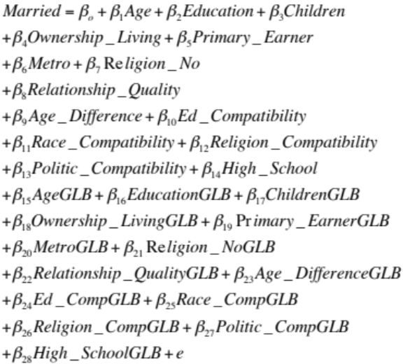

The result of the interaction model does not support the hypothesis that relationship quality is significantly different in determining likelihood of marriage for GLB couples, male or female. I do, however, find evidence to support the difference in effect of religion for GLB females and having attended the same high school for GLB males is statistically significant at the 5% and 1% levels respectively. Not identifying with a religion for GLB females decreases likelihood of marriage by 0.06 compared with non-GLB females. This difference indicates non-GLB females who do not identify with a religion see increases in likelihood of marriage whereas GLB females see decreases likelihood of marriage. Having attended the same high school predicts an increase in likelihood of marriage for GLB males by 0.08 less than for non-GLB males. Table 7 summarizes the statistically significant differences found between non-GLB and GLB couples.
These findings are interesting in light of recent popular discussion regarding sexual preference and marriage. While I find for some groups, the definition of marriage seems to be changing, and for all groups that love and compatibility plays a large role in marriage decisions, I find very little evidence that there are differences between non-GLB and GLB couples. I find no statistical evidence that production factors, such as home ownership, exhibit differences for these groups. This implies that variation that exists across groups is not necessarily due to variation in sexual preference. Hence, non-GLB and GLB couples are not that different.

VI. Accuracy of Empirical Model

To assess the accuracy of predicting marriage using the model of marriage with love proxy variables, the percent of accurate marriage predictions in the dataset was calculated. Figure 4 displays comparisons of model accuracy for each group. OLS and logistic regression models were considered for all groups with and without proxy love variables. The OLS and Logit bars show the frequency of correct predictions with each model. The Frequency of Marriage bars show the frequency of correct predictions if I had blindly guessed the marital status of a couple. Overall, the models without love proxy variables predict marriage more frequently than the models with them for all groups. Also for all groups, the models with and without compatibility measures showed significant improvements in predicting marriage compared to chance. This was determined by comparing model prediction frequency to frequency of marriage in each group.

VII. Conclusion

This paper set out to determine the role of love in non-GLB and GLB couples’ marriage decisions. It also investigates if different factors contribute more or less to marriage decisions between these groups. I find that for all groups, at least one of the love proxy variables has the most influence on marriage likelihood when included in the model. In other words, love matters. Relationship quality has a greater positive effect on marriage likelihood for GLB couples than non-GLB couples, although this effect is not statistically significant. Interestingly, race compatibility decreases likelihood of marriage for all groups except GLB males. This could be evidence of shifting definitions marriage, where race is not a factor. Despite the estimates, measures of compatibility were not formally found to improve the predictability of marriage likelihood.
Unfortunately, this paper is limited by its measure of love. Future research could expand on this model by improving the data collected for this variable, as well as home ownership and other potentially endogenous variables. Panel data could address this problem, by lagging independent variables by one time period. Looking at the interplay between religion and education would also improve upon the research in this paper. Moreover, considering other variables for compatibility is necessary to fully answer the question posed in this paper. Finally, investigating the incidence of marriage in relation to macroeconomic variables such as gross domestic product or unemployment would add to the existing research. It would be especially interesting to address the effect the subprime mortgage crisis had on marriages, as, for this group, ownership of living quarters was a dominant factor in determining marriage likelihood.

References

Becker, G. (1974). A theory of marriage. In Schultz T.W. (Ed.) Economics of the family: Marriage, children, and human capital (299-35). Cambridge, MA: UMI

Blau, F. D., Kahn, L.M., & Waldfogel, J. (2000). Understanding young women's marriage decisions: The role of labor and marriage market conditions. National Bureau of Economic Research. Retrieved from http://www.nber.org/papers/w7510

Campbell, A. (2010). More education means more faith, news report says. Retrieved from http://www.cnn.com/2010/LIVING/12/06/marriage.trouble.report/index.html

Freiden, A. (1974). The U.S. marriage market. In Schultz T.W. (Ed.) Economics of the family: Marriage, children, and human capital (352-74). Cambridge, MA: UMI

Fulop, M. (1980). A brief survey of the literature on the analysis of marriage and divorce. The American Economist 24(2), 12-18.

Greenwood, J., Guner, N., Kocharkov, G., & Santos, C. (2012). Technology and the
changing family: A unified model of marriage, divorce, educational attainment, and married female labor-force participation. National Bureau of Economic Research. Retrieved from http://www.nber.org/papers/w17735.

Hoffman, S. D., & Susan L. Averett, S.L (2010). Marriage and the family: An economic approach. In Women and the Economy: Family, work and play (2nd ed.) Addison-Wesley: New York.

Lundberg, S., & Pollak R.A. (1993). Separate spheres bargaining and the marriage market. Journal of Political Economy 101(6), 75-94.

Lundberg, S. & Pollak, R.A. (1996). Bargaining and distribution in marriage. The Journal of Economic Perspectives 10(4), 139-58. Retrieved from http://www.jstor.org/stable/2138558.

Manser, M., & Brown, M. (1980). Marriage and household decision-making: A bargaining analysis. International Economic Review, 21(1), 133-43. Retrieved from http://www.jstor.org/stable/2526238.

McElroy, M. B., & Horney, M. J. (1981). Nash-bargained household decisions: Toward a generalization of the theory of demand. International Economic Review 22 (2), 333-49. Retrieved from http:// http://www.jstor.org/stable/2526280

Rosenfeld, M. & Thomas, R.J. (2009). How Couples Meet and Stay Together (HCMST), Wave I 2009, Wave II 2010, Wave III 2011, United States. ICPSR30103-v3. doi:10.3886/ICPSR30103

Schwartz, C. (August 26th, 2011). Same-Sex Couples: Williams Institute Releases National Data On Gay Couples, San Francisco Tops List. Huffington Post. Retrieved from http://www.huffingtonpost.com/2011/08/26/same-sex-couples-williams-institute-nationaldata_n_938166.html#s340513&title=San_Francisco_CA

“To have and to hold, the trend toward giving homosexuals full marriage rights is gaining momentum”. The Economist. November 17th, 2012.

Watson, T. & McLanahan, S. (2009). Marriage meets the Joneses: Relative income, identity, and marital status. National Bureau of Economic Research. Retrieved from http://www.nber.org/papers/w14773.

Figures and Tables.
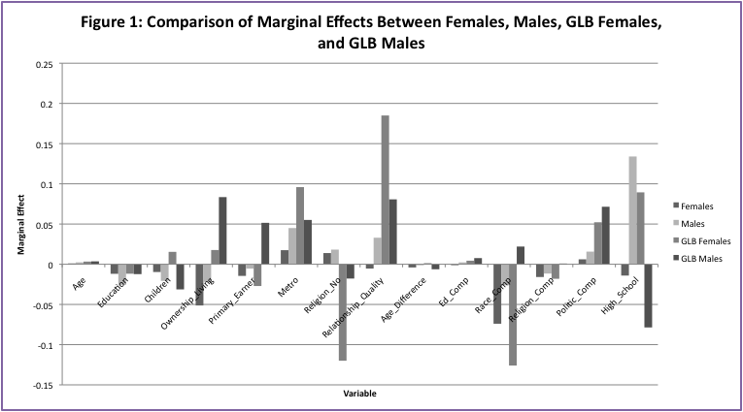
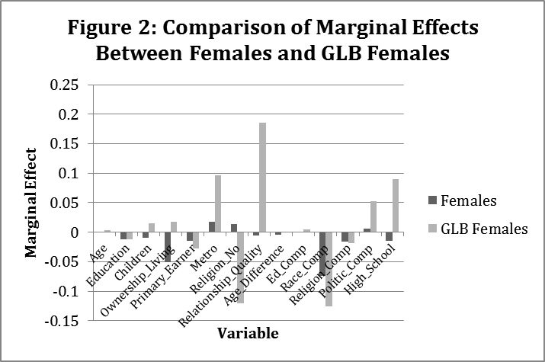
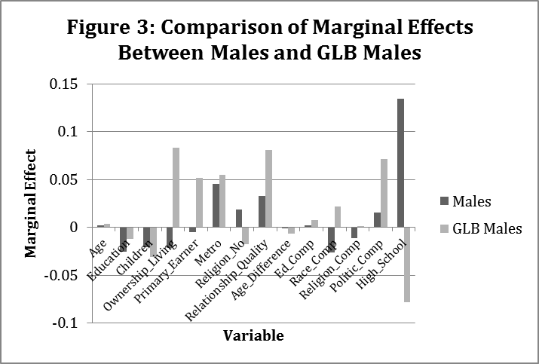
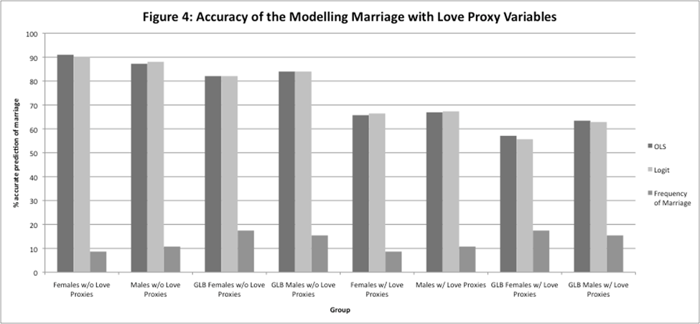

Table 1: Theoretical Concepts and Variable Names, Types, and Expected Signs
Theoretical Concept | Variable Name | Variable Type | Expected Sign
Age | Age | Continuous: Years | +
Education | Education | Continuous: Years | -
Children | Children | Continuous: Number children present in household | +
Income | Primary_Earner | Ordered Categorical:  1: partner earned more income in 2008  2: couple earned about the same income in 2008  3: respondent earned more income in 2008 | Females: -  Males: +  GLB Females: ?  GLB Males: ?
Cost of Marriage | Ownership_Living | Dummy:  1: Own living quarters  0: Rent living quarters | +
Religion | Religion_No | 1: identified as belonging to a religion  0: identified as belonging to no religion | -
MSA Status | Metro | Dummy:  1: Respondent lives in metropolitan area  0: Respondent does not live in metropolitan area | +
Love | Relationship_Quality | Ordered Categorical:  1: very poor  2: poor  3: fair  4: good  5: excellent | +
 | Religion_  Compatibility | Dummy:  1: Same religious affiliation  0: Different religious affiliation | +
 | Politic_Compatibility | Dummy:  1: Identify with same political party  0: Identify with different political party | +
 | Race_Compatibility | Dummy:  1: Same Race  0: Different Race | +
 | Age_Difference | Continuous: Years | -
 | Education_Compatibility | Continuous: Years of education difference | -
 | High_School | Dummy:  1: Attended same high school  0: Did not attend same high school | +

Table 2: Marginal Effects for non-GLB Females
Dependent Variable is Likelihood of Marriage; z- or t-statistic in parentheses; *** p<0.01 ** p<0.05 * p<0.1
Variables | Estimates
 | OLS mfx | OLS mfx with Love | Logit mfx | Logit mfx with Love
Age | 0.0017 | 0.0029* | 0.00045 | 0.00101
Age | (1.260) | (1.733) | (0.520) | -1.227
Education | -0.03*** | -0.03*** | 0.02*** | -0.01**
Education | (-3.955) | (-3.124) | (-3.368) | (-1.993)
Children | 0.00499 | -0.0189 | 0.00600 | -0.0097
Children | (0.224) | (-0.711) | (0.438) | (-0.609)
Ownership_ Living | -0.09*** | -0.0748* | -0.070** | -0.051*
Ownership_ Living | (-2.657) | (-1.859) | (-2.186) | (-1.647)
Primary_ Earner | -0.0109 | -0.0292* | -0.00854 | -0.0145
Primary_ Earner | (-0.729) | (-1.673) | (-0.820) | (-1.501)
Metro | 0.0960* | 0.0573 | 0.0463** | 0.0175
Metro | (1.936) | (1.019) | (2.374) | -0.871
Religion_  No | 0.0510 | 0.0214 | 0.0332 | 0.0139
Religion_  No | (1.119) | (0.390) | (0.834) | -0.433
Relationship_ Quality |  | -0.0143 |  | -0.00538
Relationship_ Quality |  | (-0.563) |  | (-0.466)
Age_ Difference |  | -0.00363 |  | -0.004*
Age_ Difference |  | (-1.328) |  | (-1.729)
Ed_  Comp |  | 0.00579 |  | 3.5E-05
Ed_  Comp |  | (0.658) |  | -0.0097
Race_  Comp |  | -0.111** |  | -0.074
Race_  Comp |  | (-2.258) |  | (-1.552)
Religion_  Comp |  | -0.0245 |  | -0.0159
Religion_  Comp |  | (-0.643) |  | (-0.873)
Politic_  Comp |  | 0.0272 |  | 0.00613
Politic_  Comp |  | (0.714) |  | -0.318
High_  School |  | -0.0602 |  | -0.0141
High_  School |  | (-1.110) |  | (-0.714)
Obs. | 288 | 207 | 288 | 207
Adj. R2 | 0.08 | 0.1 | - | -
SSR | 20.39 | 13.08 | - | -
F Statistic | 4.80 | 2.64 | - | -
LR Stat. | - | - | 32.0 | 33.42
Log Like. | - | - | -68.98 | -42.06

Table 3: Marginal Effects for non-GLB Males
Dependent Variable is Likelihood of Marriage; z- or t-statistic in parentheses; *** p<0.01 ** p<0.05 * p<0.1
Variables | Estimates
 | OLS mfx | OLS mfx with Love | Logit mfx | Logit mfx with Love
Age | 0.0042** | 0.004** | 0.003** | 0.0024*
Age | (2.588) | (2.009) | (2.419) | (1.934)
Education | -0.03*** | -0.04*** | 0.03*** | -0.03***
Education | (-2.831) | (-3.231) | (-2.831) | (-2.592)
Children | -0.0193 | -0.0378 | -0.0188 | -0.0207
Children | (-0.786) | (-1.345) | (-0.776) | (-1.036)
Ownership_ Living | 0.0169 | -0.0281 | 0.0141 | -0.0219
Ownership_ Living | (0.404) | (-0.581) | -0.421 | (-0.709)
Primary_ Earner | 0.00698 | -0.0039 | 0.0031 | -0.0054
Primary_ Earner | (0.431) | (-0.210) | -0.234 | (-0.544)
Metro | 0.0622 | 0.0922 | 0.0435 | 0.045*
Metro | (1.187) | (1.506) | (1.291) | (1.819)
Religion_  No | 0.0198 | 0.0520 | 0.0119 | 0.0182
Religion_  No |  | (0.4) | (0.883) | (0.446)
Relationship_Quality |  | 0.0493* | 0.737 * | 0.0330*
Relationship_Quality |  | (1.780) |  | (1.793)
Age_ Difference |  | -0.0013 |  | -0.0007
Age_ Difference |  | (-0.267) |  | (-0.242)
Ed_Comp |  | 0.00942 |  | 0.0023
Ed_Comp |  | (0.652) |  | (-0.309)
Race_Comp |  | -0.0463 |  | -0.0262
Race_Comp |  | (-0.920) |  | (-0.771)
Religion_ Comp |  | -0.0085 |  | -0.0116
Religion_ Comp |  | (-0.188) |  | (-0.450)
Politic_ Comp |  | 0.0285 |  | 0.0157
Politic_ Comp |  | (0.618) |  | (0.561)
High_ School |  | 0.162** |  | 0.134*
High_ School |  | (2.497) |  | -1.686
Obs. | 245 | 187 | 245 | 187
Adj. R2 | 0.035 | 0.096 | - | -
SSR | 0.06 | 2.408 | - | -
F Statistic | 21.79 | 14.93 | - | -
LR Stat. | - | - | 15.93 | 32.90
Log Like. | - | - | -74.93 | -47.15

Table 4: Marginal Effects for GLB Females
Dependent Variable is Likelihood of Marriage;z- or t-statistic in parentheses; *** p<0.01 ** p<0.05 * p<0.1
Variables | Estimates
 | OLS mfx | OLS mfx with Love | Logit mfx | Logit mfx with Love
Age | 0.005** | 0.0034 | 0.006** | 0.00331
Age | -1.997 | (1.027) | (2.050) | (1.136)
Education | -0.0035 | -0.016 | -0.0024 | -0.0118
Education | (-0.267) | (-0.94) | (-0.193) | (-0.801)
Children | -0.0068 | 0.0097 | -0.0038 | 0.0154
Children | (-0.208) | (0.223) | (-0.115) | -0.467
Ownership _Living | 0.0441 | 0.0237 | 0.0414 | 0.0177
Ownership _Living | -0.705 | (0.285) | (0.724) | -0.254
Primary _Earner | -0.038* | -0.025 | -0.037* | -0.0271
Primary _Earner | (-1.698) | (-0.85) | (-1.752) | (-1.123)
Metro | 0.101 | 0.133 | 0.105 | 0.0959
Metro | -0.938 | (0.956) | (1.607) | -1.579
Religion _No | -0.0828 | -0.15** | -0.0761 | -0.120**
Religion _No | (-1.385) | (-2.00) | (-1.539) | (-2.373)
Relationship _Quality |  | 0.16*** |  | 0.185***
Relationship _Quality |  | (3.454) |  | -3.781
Age _Difference |  | 0.0013 |  | 0.00136
Age _Difference |  | (0.195) |  | -0.261
Ed_Comp |  | 0.0080 |  | 0.0044
Ed_Comp |  | (0.403) |  | -0.294
Race_Comp |  | -0.098 |  | -0.126
Race_Comp |  | (-1.23) |  | (-1.367)
Religion _Comp |  | -0.031 |  | -0.0181
Religion _Comp |  | (-0.47) |  | (-0.329)
Politic_Comp |  | 0.0547 |  | 0.0522
Politic_Comp |  | (0.829) |  | -0.911
High_School |  | 0.0565 |  | 0.0894
High_School |  | (0.592) |  | -0.837
Obs. | 211 | 152 | 211 | 152
Adj. R2 | 0.02 | 0.0512 | - | -
SSR | 1.63 | 1.582 | - | -
F Statistic | 28.89 | 20.728 | - | -
LR Stat. | - | - | 12.19 | 25.63
Log Like. | - | - | -91.87 | -62.69

Table 5: Marginal Effects for GLB Males
Dependent Variable is Likelihood of Marriage; z- or t-statistic in parentheses; *** p<0.01 ** p<0.05 * p<0.1
Variables | Estimates
 | OLS mfx | OLS mfx with Love | Logit mfx | Logit mfx with Love
Age | 0.0029 | 0.00287 | 0.00307 | 0.00358
Age | -0.915 | (0.697) | (0.989) | -1.031
Education | -0.0062 | -0.0119 | -0.0066 | -0.0123
Education | (-0.516) | (-0.856) | (-0.567) | (-1.030)
Children | -0.0461 | -0.0385 | -0.0714 | -0.0313
Children | (-0.751) | (-0.393) | (-0.768) | (-0.348)
Ownership _Living | 0.103 | 0.0885 | 0.0961* | 0.0835
Ownership _Living | -1.555 | (1.092) | -1.901 | -1.632
Primary _Earner | 0.0366 | 0.0582* | 0.0362* | 0.0515**
Primary _Earner | -1.582 | (1.969) | -1.662 | -2.066
Metro | 0.0986 | 0.0629 | 0.0816 | 0.0551
Metro | -0.825 | (0.487) | -1.219 | -0.802
Religion _No | 0.0291 | -0.0138 | 0.0235 | -0.0178
Religion _No | -0.482 | (-0.176) | -0.407 | (-0.292)
Relationship _Quality |  | 0.0825* |  | 0.0807*
Relationship _Quality |  | (1.851) |  | -1.957
Age _Difference |  | -0.0074 |  | -0.00625
Age _Difference |  | (-1.178) |  | (-1.242)
Ed_Comp |  | 0.0112 |  | 0.00763
Ed_Comp |  | (0.716) |  | -0.598
Race_Comp |  | 0.0208 |  | 0.022
Race_Comp |  | (0.275) |  | -0.389
Religion _Comp |  | -0.0070 |  | 0.000859
Religion _Comp |  | (-0.097) |  | -0.0159
Politic_Comp |  | 0.0718 |  | 0.0715
Politic_Comp |  | (1.095) |  | -1.324
High_School |  | -0.117 |  | -0.0786
High_School |  | (-1.386) |  | (-1.542)
Obs. | 174 | 132 | 174 | 132
Adj. R2 | 0.0034 | 0.0068 | - | -
SSR | 1.08 | 1.06 | - | -
F Statistic | 21.81 | 15.67 | - | -
LR Stat. | - | - | 8.62 | 17.54
Log Like. | - | - | -70.78 | -49.07

Table 7: Most Influential Factors in Predicting Marriage Likelihood
Variable | Without Love Proxy Variables | With Love Proxy Variables
non-GLB Females | 1) Ownership of Living Quarters | 1) Racial Compatibility  2) Ownership of Living Quarter
non GLB Males | 1) Living in Metropolitan Area  2) Years of Education | 1) Attended Same High School  2) Living in Metropolitan Area  3) Relationship Quality
GLB Females | 1) Living in Metropolitan Area  2) Not Associated with a Religion | 1) Relationship Quality  2) Racial Compatibility  3) Not Associated with a Religion
GLB Males | 1) Ownership of Living Quarters  2) Living in Metropolitan Area | 1) Ownership of Living Quarters  2) Relationship Quality  3) Attended Same High School  4) Share Same Political Views

Table 8: Statistically Different Variables for GLB and non-GLB Couples
Dependent Variable is Likelihood of Marriage; z- or t-statistic in parentheses; *** p<0.01 ** p<0.05 * p<0.1
Variables | Estimates
 | All Females  mfx | All Males  mfx
Religion_No | 0.0312 | 0.0422
 | (0.511) | (0.702)
Religion_NoGLB | -0.0576** | -0.0364
 | (-2.203) | (-0.962)
High_School | -0.0387 | 0.185*
 | (-1.089) | (1.859)
High_SchoolGLB | 0.151 | -0.0768***
 | (0.820) | (-3.750)

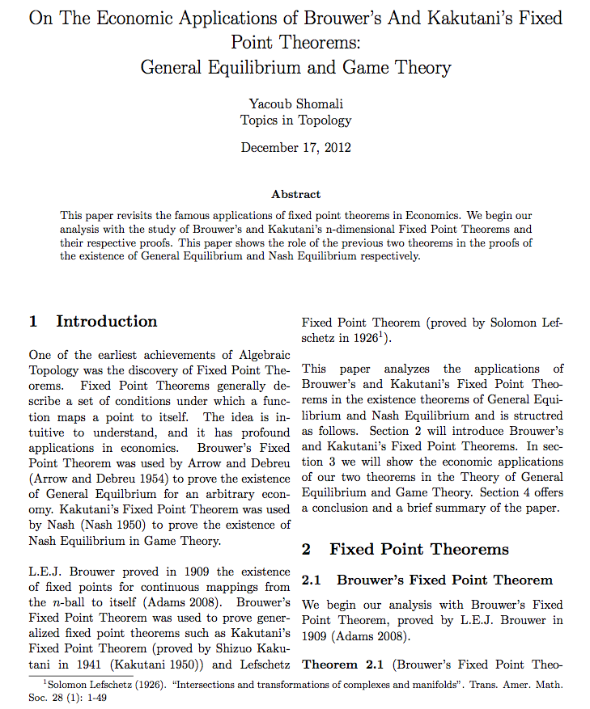

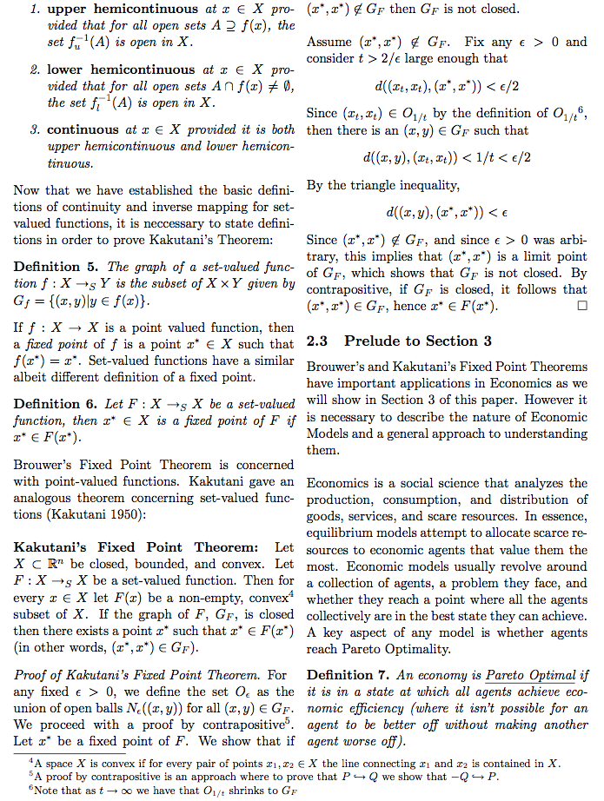
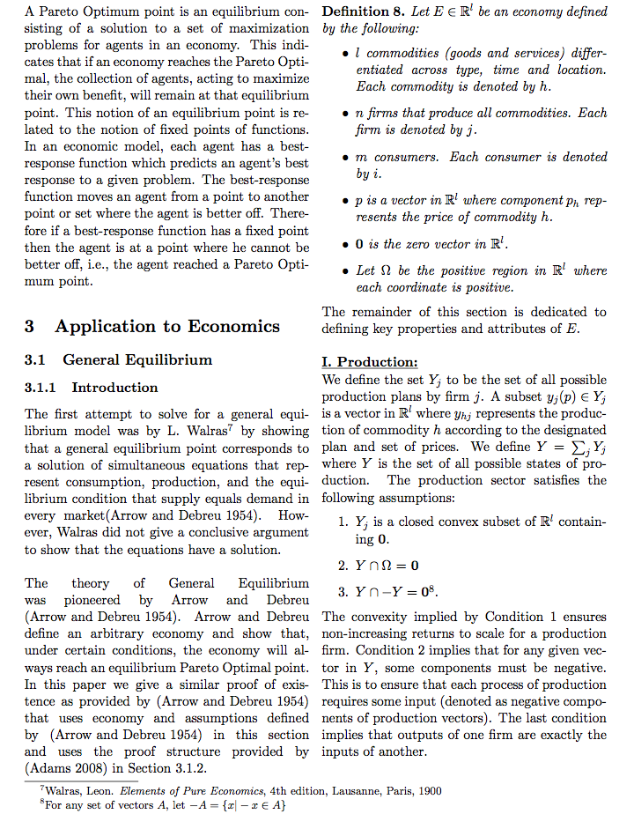
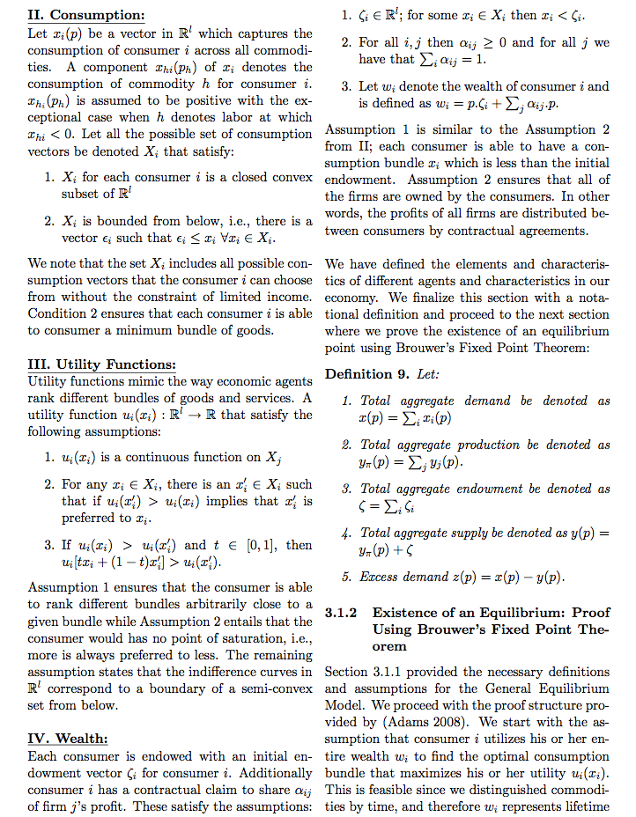
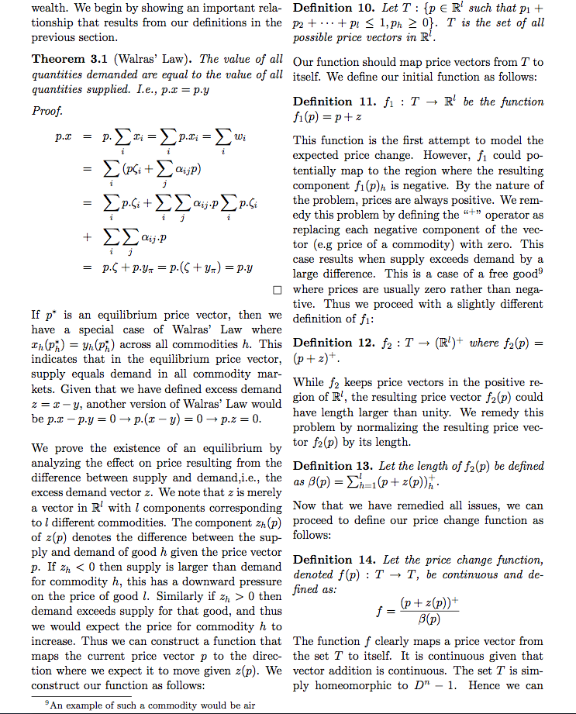


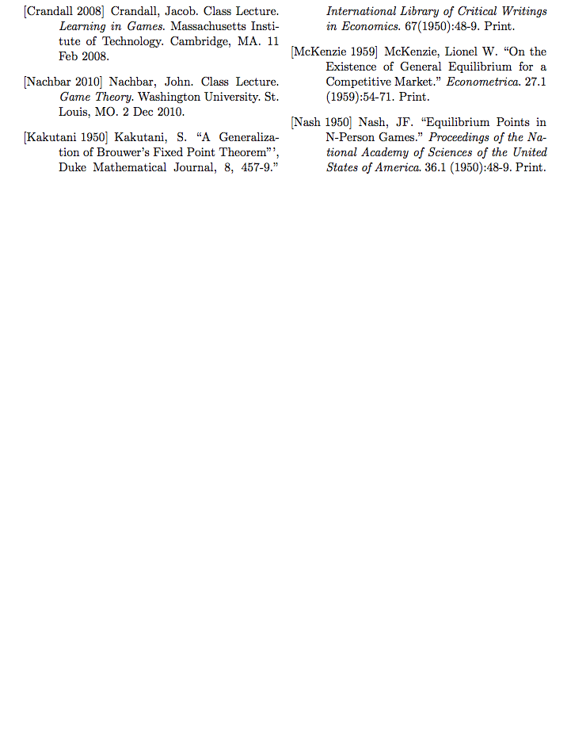

In October 2012, the unemployment rate (percent unemployed of labor force) was 25.2 percent (Unemployment rates by sex, age and nationality (%)).
These include their transitions from dictatorships to democracy in 1974-1975, the ascent to the European Community in 1986, and the introduction of European Monetary Union and the conversion to the euro currency in (2002) The European Community (EC) was the predecessor of the European Union (EU); the creation of the latter was in 1993 (“European Union”).
By Institution I mean the laws and practices that characterize Iberian labor markets. These typically include tax policies affecting wages, unemployment benefits programs, employment protect legislation, and collective bargaining practices.
For example, I regress the difference between Spanish and Portuguese unemployment (Spain’s value minus Portugal’s value) on the difference between Spanish and Portuguese net replacement ratios. See equation [6] for the complete guiding equation.
By ‘shocks’ I mean any macroeconomic shock such as a drastic supply shift or rapid inflation.
The replacement ratio is a key measure of unemployment benefits. It is defined as the cash unemployment insurance benefit received by an unemployed worker as a fraction of the worker’s wage when they were employed.
Bentolila and Jimeno follow a shocks and institutions model developed by Blanchard and Wolfers (2000) which measures union power by using measures of union coverage, union density, and wage bargaining coordination.
The EU15 is comprised of: Austria, Belgium, Denmark, Finland, France, Germany, Greece, Ireland, Italy, Luxembourg, the Netherlands, Portugal, Spain, Sweden, and the United Kingdom.
This model was also used by Bover, García-Perea, and Portugal (2000) in their comparison study. I give a more complete description of the model in Appendix I.
Game Theory is a theory of competition stated in terms of gains and losses among opposing players (here firms and workers). John F. Nash first proposed the general formulation of the maximand (Layard, Nickell, and Jackman 1991).
LNJ claim that the replacement ratio is “likely” to be exogenously set, but this is a strong assumption that could be relaxed in further research (Layard, Nickel, and Jackman, 1991, p. 106).
Consider the benefit B, to be the present-discounted value of unemployment benefits accumulated monthly over the maximum benefit duration. As maximum benefit duration increases, B and unemployment increase.
LNJ (1991) argue that union coverage has a positive relationship with unemployment, but Blanchard and Wolfers (2000) find different model specifications produce negative coefficients for coverage. They also estimate a negative coefficient for union density in one of their regressions.
See Appendix II for an explanation of the estimation issues.
For example, the correlation between the net replacement ratio and Spain is almost 99 percent and the average VIF for each covariate regressed on all others is 4536.
This result is likely due to scarce degrees of freedom left after the inclusion of so many variables and to multicollinearity. In one robustness analysis I exclude the EMR and EMR-Spain interaction.
A 10 percentage point increase in Portuguese union density (100 percentage point increase in squared union density) would correlate to an increase in the unemployment rate of 3 percentage points.
A transition from a low level of wage bargaining coordination to a high level would decrease Spanish unemployment by 4.6 percentage points.
A 1 percentage point increase in the EMR would increase unemployment in Spain by 5.8 percentage points.
I additionally utilize the estimated coefficients from the Portuguese model with the subset of Spanish data to predict unemployment in Spain. The residuals were unreasonably high and the mean standard error on the predicted unemployment was greater than ten, which clearly indicates that the coefficients are having a different effect on unemployment in Spain than in Portugal.
For example, I regress the difference between Spanish and Portuguese unemployment on the difference between Spanish and Portuguese net replacement rates.
If all other differences and the constant were zero and Spain minus Portugal’s union density were negative 10 percentage points, the difference between Spain and Portugal’s unemployment rates would be positive 0.3 percentage points (Spain would have higher unemployment). Conversely, if the difference in union density were positive ten, the difference between Spain and Portugal’s unemployment rates would be negative 0.3 percentage points (Portugal would have higher unemployment).
This conclusion is supported by the fact Spanish unemployment is always higher than Portugal’s and that there is a strong negative effect of high coordination on unemployment within Spain (Table 4 column (3)). Portugal’s unemployment might remain unaffected (as suggested by the lack of statistical significance for the coordination covariate in Table 4 column (2)).
For further explanation of $β$ and the Nash Maximand, see Layard, Nickell, and Jackman (1991) pages 99-101 and Annex 2.2.
The probability of employment and expected profit are decreasing in wage because as wage increases, firms hire fewer employees or realize lower profits or both.
For an explanation of the turnover and discount rates, see Layard, Nickell, and Jackman (1991) page 145.
Layard Jackman and Nickell (1991) page 103.
In other words, the bargained wage is that wage which maximizes $β\log\left(W_{i}-A\right)S_{i}+logΠ_{i}$. The authors invoke the envelope theorem such that ${∂Π}_{i}/{∂W}_{i}=-N_{i}$.
For an explanation of the Envelope Theorem, see "Envelope Theorem." The Penguin Dictionary of Economics. London: Penguin, 2003.Credo Reference. 28 Nov. 2007. Web. 26 Oct. 2012. <http://www.credoreference.com/entry/penguinecon/envelope_theorem>.
A demand index is simply a measure which helps scale a demand curve for a product. The higher the demand index, the more output demanded at any price, where output demanded increases multiplicatively with price.
For further detail, see Layard, Nickell, and Jackman (1991) page 102.
The likelihood ratio statistic (p-value) was 20.35 (0.0000).
The Wooldridge F-statistic (p-value) was 255.472 (0.0398)
The Fisher statistics (p-values) for the net replacement ratio, maximum duration, EMR, and coordination level 2 are 5.27 (0.26), 0.21 (1.00), 5.21 (0.27), 8.77 (0.07), respectively.
The correlation coefficients between squared union density and maximum benefit duration, squared union density and EMR, are -0.68, -0.59, respectively.
The VIF estimate for maximum benefit duration regressed on all other covariates is 2.51.
See Boshara 2003, Hogath and Anguelov 2003, Kennickell et al. 2000
The literature defines low-income as 300% of the US national poverty level, which in 2009 was 25,211 for a single parent household with four children (from the U.S. Census Bureau)
Institutionalized saving mechanisms include banks and saving plans such as 401(k) programs. Incentives are matching funds and tax breaks, whereas means-tested asset programs can act as a disincentive to saving. Facilitation includes automatic saving deductions from paychecks.
See Lusardi and Mitchell 2008, 2009, 2010; Beverly et al. 2003
For more on Pratt’s theory, see Leland (1968).
This survey claims to be the first extensive study dedicated to understanding financial literacy in the US.
Examining differences in our control variables before and after omitting these households reveals no substantial differences. From this, we conclude that use of the sample weights is still justified.
Saving may happen cyclically for low-income households: they may save for a specific goal and then deplete their savings to make the purchase. As a result, they may consider themselves “savers” even when they have little saved.
Income is not a continuous variable so quintiles are approximated. Quintile 1 = $0 - $24,999 (24% of the sample population); 2 = $25,000 - $49,999 (28%); 3= $50,000 - $74,999 (20%); 4 = $75,000 - $99,999 (12%); and 5= $100,000 or more (16%). We use the lowest quintile as representing “low-income” households.
Controlling for welfare allows us to isolate differential saving behavior of welfare recipients that may be induced by program restrictions, as means-tested programs like welfare can affect saving decisions (see Hubbard, Skinner, and Zeldes 1995). $19,200 per year is the estimated state-averaged TANF cutoff for a single parent of four children (http://www.acf.hhs.gov/programs/ofa/). As our variable includes families with 4 or more children and our measure of income includes public assistance some families could potentially fall above this cutoff as well.
These factors are studied by Hogarth and Anguelov (2003). As we are only interested in controlling for the financial security provided by insurance or family networks and not the individual effects of each measure, we combine these measures into a single dummy variable.
We use both stated and revealed measures to control for potential bias in self-reported financial literacy. This method was also used by Lusardi and Mitchell (2010) and Allgood and Walstad (2011). Though revealed measures may be more accurate, self-reported financial literacy can shed light on psychological factors such peer effects that may influence saving – e.g. an individual may rate themselves as literate in the context of their peer group.
Dummy variables are more useful here than using the continuous measure because the differences between values are likely not the same across individuals, whereas relative placement on the scale is more readily comparable.
If we assume normally distributed errors in addition to the classical OLS assumptions, then a logit model is most appropriate as a maximum likelihood estimator.
See “Demographics” in Empirical Approach for a list of these variables.
See Table 3 for these test ratios and their significance.
Note that this table only includes the variables of interest, even though the regressions were run with all of the variables present in step three. We do not include all variables in the table for brevity.
Multicollinearity between measures of demonstrated and stated levels of financial literacy is a concern. Making it necessary to insure that how an individual responds to one stated financial literacy question does not significantly explain how they will respond to the other set of questions. However, both correlation values and VIF tests indicate that these variables are not very correlated (the highest correlation coefficient is 0.3 and no VIF value above 4).
Note that the omitted category for all of these variables is the highest level, thus negative coefficients indicate that respondents with a lower score are less likely to save then otherwise similar respondents with higher scores.
UN uses the term adolescents for people between 10 and 19 years of age, although most researchers have focused primarily on the group of adolescents aged 15-19 years (WHO, 2011).
Reduction rate in Peru was 21.5%, compared to 22.2% in the world, 21% in Africa and 45.7% in North America for the same time period (UN Population Division, 2012).
Terms adolescent pregnancy, teenage pregnancy and early pregnancy will be used interchangeably throughout the paper.
Twelve countries: Bangladesh, India, Nepal, Turkey, Chad, Guinea, Kenya, Niger, Nigeria, Tanzania, Bolivia and Nicaragua.
Maximizing sample size (sample size would have been 30% smaller had the sample group been only women 15-19).
Including sexually inactive women does not make sense in this case given that their sexual behavior is not dynamic in terms defined by this paper, i.e. age and contraceptive use at first sexual intercourse information would be missing, as well as details on current contraception use since sexually inactive girls typically do not use contraception. Given that these are some of the key explanatory variables for this paper and that the corresponding values are missing for sexually inactive girls, they would have been dropped from the regressions in any case.
Includes traditional methods (periodic abstinence (rhythm), withdrawal, and country-specific folk methods), and modern methods (pill, injectables, IUDs, condoms, etc.).
OLS model did not adequately fit the data, so those results are not presented here.
Akaike’s information criterion (AIC) and Schwartz’s Bayesian information criterion (BIC): smaller values are preferred. See Cameron and Trivedi (2010), page 359.
In order to “normalize” the binary outcome regression coefficients for easier interpretation, logit coefficients are divided by 4, and probit by 2.5. See Studenmund (2006), p. 461.
It is expected that the coefficients increase in magnitude when new variables are added to the binomial outcome logit and probit models because the total variance increases. See Cameron and Trivedi (2010), chapter 14.
All these coefficients are significant at 1% level.
See Studenmund (2006), p.411.
All the women in this data set have at least primary education. Yet, 6.5% of mothers are in the “no education” category.
State governments do not necessarily recognize these marriages. The dataset that was used considers traditional marriages, civil unions, and domestic partnerships as marriages.
Individuals in romantic relationships are not necessarily married couples or sexual partners.
The expected sign applies to all groups (females, males, GLB females, and GLB males), except where noted.
This variable may be categorical, as the number of children is discrete.

