EFFECTIVE March 9, 2022, students wanting to change their advisor or add to their advising team should use the new automated Macalester College Advisor Selection Form found in the “Academic Records” box of their 1600grand.
To change your advisor, go to 1600grand and find the ‘Academic Records” box. Click on the “Academic Advising Team” button in that box and follow the instructions that come up. Your request will be forwarded to your new advising team for approval and then on to the Academic Programs and Advising Office for processing. You will receive an email notification when the change has been completed.
Questions should be directed to academicprograms@macalester.edu, 651-696-6036.

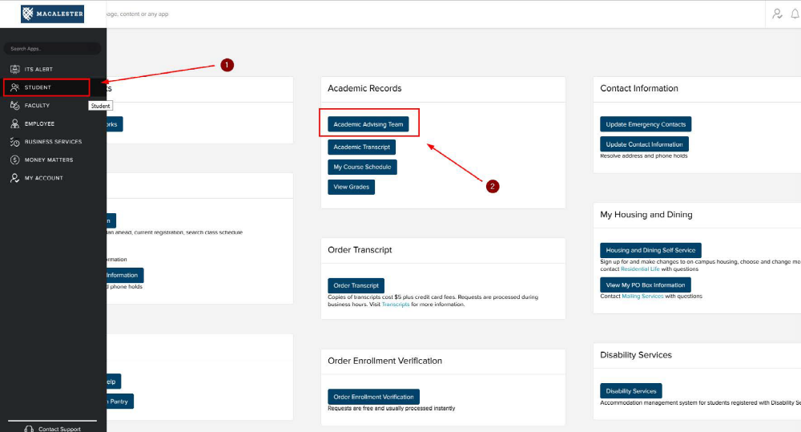
A paper form which can be filled in and emailed or printed is still available at Advisor(s) Selection Form (PDF).

