
Washington University

in St. Louis

GRADUATE STUDY IN

CLASSICS



The Department of Classics at Washington University in St. Louis invites applications to its M.A. and Ph.D. programs. For individuals with a strong undergraduate foundation in Latin and Greek, the M.A. degree is a solid basis for further graduate study in Classics and related fields. The Ph.D. trains candidates for careers in research and teaching on the Classical world, and Washington University’s program offers optional special tracks in Ancient Music, Performance, History, and Philosophy. Ph.D. candidates are fully funded with tuition remission and fellowships. M.A. students also receive some funding in both these forms.

The Department of Classics also cooperates with Washington University’s Department of Education to mentor students who choose to pursue the Latin track of the M.A.T. program run by Education.

In addition to listed Department Faculty, numerous Affiliated Faculty in Philosophy, History, Performing Arts and other areas participate in our graduate programs and Classics community.

Students will enjoy not just the resources of the Washington University campus, but also the inexpensive living and the vibrant arts and recreation scene of the city of St. Louis.

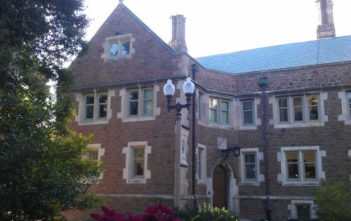

DEPARTMENT FACULTY AND

AREAS OF SPECIAL INTEREST

Assistant Professor Karen Acton: Roman history and historiography of the late Republic and early Empire; power and identity in the ancient world; Roman numismatics
Associate Professor William Bubelis: Greek history and historiography; the ancient economy and Greek social history; the Attic orators; Greek religion; epigraphy and numismatics; the ancient Near East
Professor Catherine Keane (Chair): Roman poetry and poetics; satiric genres; Greek and Roman drama; ancient literary criticism
Assistant Professor Tom Keeline: Latin prose; ancient education and scholarship; lexicography, metrics, and textual criticism
Professor Timothy Moore (John and Penelope Biggs Distinguished Professor of Classics): Greek and Roman comedy; Roman historiography; the Classical Tradition; ancient music
Assistant Professor Luis Alejandro Salas: Greek and Roman medicine and philosophy; ancient intellectual history; ancient psychology; philosophy of language
Associate Professor Zoe Stamatopoulou (Director of Graduate Studies): archaic and classical Greek poetry, the symposium, ancient biographies of poets, reception of archaic Greece in imperial Greek literature

A full description of the Department's degree programs, with lists of Affiliated Faculty, can be found at http://classics.artsci.wustl.edu/graduate

For details about the program and requirements, contact Zoe Stamatopoulou, Director of Graduate Studies: zoe.stamatopoulou@wustl.edu or
(314) 935-4018

For print materials and information on the application process, contact Cathy Marler, Administrative Assistant: classics@artsci.wustl.edu or
(314) 935-5123

Department of Classics - Washington University
Campus Box 1050, 1 Brookings Drive, St. Louis, MO 63130

