
Volume 26 Spring 2016
Published annually by the Macalester College Department of Economics and Omicron Delta Epsilon
Macalester Journal of Economics

Table of Contents

Foreword
……………..…………………………………………………Professor Mario Solis-Garcia 2

Explaining the Resource Curse in the DRC: Why Endogenous Theories are Insufficient and Institutional Explanations are Necessary
…………………………………………………………………………. Elizaveta Bekmanis 4

How Does the Announcement of a New Stadium Impact Property Values? …………………………….……………………...………… Mohammad Haroon Bokhari 16

Playing the Ultimatum Game with College Students and Refugee Women

…………………………………………………...……… Ryan Daly and Diana Rosenweig 34

Does Living Near Compatriots Increase Educational Attainment for Immigrant Children?
……………………………………………………………………..………..Stefan Faridani 50

What Rationale is Used by Boards of Trustees to Decide Raises for Not-for-Profit College Presidents?
………………………………………………………………...……...Nicholas Michalesko 70

Macalester Journal of Economics

Volume 26 Spring 2016

Omicron Delta Epsilon

Elizabeth Bacarella ‘16, President
Mohammad Haroon Bokhari ‘16
Caroline Johns ’16

Editors

Ian Calaway ‘16
Rachel Fehr ‘16
Cory Stern ‘16

Economics Faculty and Staff

Paul Aslanian  Emeritus Professor | Jeffery Evans  Professor (NTT) | Jane Kollasch  Department Coordinator | Sarah West  Professor
Amy Damon  Associate Professor | Peter Ferderer  Edward J. Noble Professor, Department Chair | Joyce Minor  Karl Egge Professor | Mario Solis-Garcia  Assistant Professor
Liang Ding  Associate Professor | Gary Krueger  Cargill Professor | Karine Moe  F.R. Bigelow Professor  (on leave) | Vasant Sukhatme  Edward J. Noble Emeritus Professor
Karl Egge  F.R, Bigelow Emeritus Professor |  |  | Samantha Cakir  Assistant Professor (NTT)
A Note from the Editors

During the spring of 2016, we had the pleasure of reading papers submitted by Macalester economics students for this edition of the Macalester Journal of Economics. The papers varied greatly in subject, but all served as a testament to the high level of academic excellence at Macalester, especially within the Economics Department. After much deliberation, we selected the following five papers. We believe they best capture the quality of economics research completed by students in the Macalester Economics Department.

We would like to thank all of the faculty for their integral roles in the development of these research projects. We would also like to thank Jane Kollasch for her support in the creation of this journal.

Ian Calaway ’16 Rachel Fehr ’16 Cory Stern ’16

Foreword

The Macalester College chapter of Omicron Delta Epsilon, the international honors society in economics, proudly edits the Macalester Journal of Economics every year. The editors – Ian Calaway ’16 (Dubuque, Iowa), Rachel Fehr ’16 (Iowa City, Iowa), and Cory Stern ’16 (Chicago, Illinois) – have carefully selected five papers on a variety of important topics. These papers are a sample of the research that our students produced in 2015.
Studies worldwide have documented what is known as the resource curse: countries that enjoy large endowments of natural resources typically exhibit poor economic outcomes. Elizaveta Bekmanis ’16 (Hannover, Germany) revisits the resource curse for the case of the Democratic Republic of Congo (DRC). Despite having large deposits of various precious minerals and oil, the country has experienced a dismal growth record: real GDP per capita has declined by 63.8% between 1960 and 2014. In her analysis, she first goes over the most common endogenous explanations for the resource course – namely, currency appreciation that drives out non-resource based exports and fluctuations in commodity prices – and finds that these factors are not enough to explain the poor performance of the DRC. Exogenous explanations – represented by the strength of a country’s institutions – appear to be a better candidate for explaining the pervasiveness of the bad economic performance in the DRC. In this sense, Elizaveta’s contribution supports the recent literature by concluding that institutions do matter.
Mohammad Haroon Bokhari ’16 (Lahore, Pakistan) asks how property values change when the project of a large stadium is announced – not when the project itself is concluded. Using the new stadium for the Minnesota Vikings as a case study, he carries out an analysis of the change in the price of houses (single-family homes) within a 5-kilometer range of the new stadium. He concludes that properties within this radius appreciate by 2.6% and that this value is statistically significant. He takes the analysis one step further and calculates the impact over house prices in five mutually exclusive rings around the stadium (e.g., 0 to 1 kilometer, 1 to 2 kilometers, and so on). Surprisingly, the positive effect found in the first part of the analysis is not homogeneous between the different areas: properties in the innermost ring appreciate by 9.9% while those in the outermost ring depreciate by 10.5%. These results should prove useful to both urban planners and urban economists alike.
Ryan Daly ’15 (Papillion, Nebraska) and Diana Rosenzweig ’15 (Livonia, Michigan) explore how cultural differences influence the outcomes in behavioral experiments. To understand their results, we need a bit of background. One of the most famous behavioral experiments is the ultimatum game: two players (the proposer and the respondent) are paired and the proposer is endowed with a sum of money. The proposer reaches out to the respondent with an offer on how to split the money. If the respondent agrees then the money is split out in the way the proposer suggested; if the respondent rejects, neither player receives a payment. Economic theory provides a clear prediction of the outcome: the proposer offers a minimal amount to the respondent – say, $1 out of $10 – and then the respondent, choosing between earning $1 or nothing at all, is happy to accept the proposer’s deal. However, experiments with real people show that this outcome is rarely (if never) observed: a typical offer gives 40% of the sum to the respondent. Ryan and Diana extend this experiment by targeting young Karen and Somali women living in the Twin Cities. They document substantial differences between the experimental outcomes in these groups and those of a control group. In particular, (a) it is more likely that Karen and Somali participants will agree to an initial proposal and (b) they are more likely to demand a higher share of the sum (in both cases, relative to the control group).
The topic of the achievement gap in educational outcomes has been hotly debated in policy and media circles. One particular dimension of this gap corresponds to foreign-born children enrolled in public schools; Stefan Faridani ’17 (Philomath, Oregon) asks whether children living in close proximity to neighbors that share the same national origin improves their academic outcomes. Using data from immigrant families living in San Diego and Miami in 1995, he shows that the proximity effect is consistent with an increase in high school student GPA of 0.15 to 0.26 points. While there are some limitations to his analysis, Stefan’s results are highly suggestive of the effect of immigrant networks, and could help education policy officials plan on how to reduce the gap between student groups.
Finally, Nicholas Michalesko ’17 (Skokie, Illinois) asks: how do boards of trustees decide on pay increases for (not-for-profit) college presidents? Are salaries tied to the opportunity cost of the individual (itself a function of the human capital of the president) or to a measure of performance or productivity? (And if so, how can we measure the productivity of a college president? Students who graduate every year? Average GPA? Post-graduation success?) Using economic theory and a bit of econometric work, Nicholas finds weak evidence linking performance and salary increases but statistically significant evidence that compensation is related to peer group salaries.
On behalf of my colleagues in the Economics Department, I am delighted to present the research of these talented students. I am confident that you will find it enlightening and be impressed by the value of a liberal arts education.

Mario Solis-Garcia
Assistant Professor of Economics
Explaining the Resource Curse in the DRC: Why Endogenous Theories are Insufficient and Institutional Explanations are Necessary

Elizaveta Bekmanis ‘16
World Economic History

The Democratic Republic of Congo (DRC) is one of the richest countries in terms of its natural resources. Despite this resource wealth, GDP growth in the DRC has fluctuated heavily since independence in 1960, GDP per capita has fallen, conflict is widespread and human development low. This paper assesses the most common endogenous and exogenous explanations of the resource curse, i.e. the phenomenon that natural resource wealth can paradoxically hinder growth. I establish that the economy of the DRC is in fact heavily dependent on the export of primary commodities and find that endogenous explanations of the resource curse are insufficient to explain the economic problems of the DRC. Instead, the country’s institutions act as a key determinant of its economic performance, and resource wealth obstructs the path to more inclusive institutions.
I. Introduction
The Democratic Republic of Congo (DRC) is one of the richest countries in the world in terms of its untapped natural resources. Despite its large deposits of copper, gold, diamonds, cobalt, uranium, coltan and oil; however, GDP growth rates in the country have fluctuated heavily since independence in 1960, and GDP per capita has even fallen from USD755 to USD284 between 1960 and 2014 (measured in constant 2005 USD) (World Bank, 2015). The DRC further ranks second to last in the United Nations Development Programme’s Human Development Index (HDI) (UNDP, 2015), suggesting that in addition to a low material standard of living, the population of the DRC has a low life expectancy at birth and limited access to schooling.
How can this paradoxical relationship between the DRC’s potential wealth and real poverty be explained? Economists have alternatively termed the phenomenon of low growth outcomes in resource-rich societies the paradox of plenty or the resource curse. Within the conceptual framework of the resource curse, there exist exogenous and endogenous explanations for why resource-rich economies underperform compared to economies that have relatively less natural resource wealth. Endogenous explanations focus on the effects of natural resources on the economic system itself, while exogenous theories of the resource curse place institutions and incentive regimes at the heart of the problem. This paper argues that endogenous theories of the resource-curse are insufficient to explain the dismal economic history of the DRC since independence, and that, rather, an examination of the DRC’s institutional framework is necessary to understand the country’s failure to develop economically.

II. Background
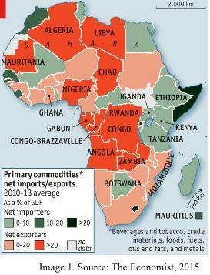
Large-scale exploitation of natural resources in the Congo began in the late nineteenth century under Belgian colonial rule, when rubber became a highly demanded commodity because of inventions such as car and bicycle tires (BBC News, 2015). The Congo Free State, established by Belgian King Leopold in 1885, was based in even more extractive institutions than the Kingdom of Kongo had been before colonization, perpetuating a pattern of enrichment of few at the expense of the masses (Acemoglu and Robinson, 2012) that was exacerbated with the beginning of the extraction of metals and minerals in the early twentieth century. At independence in 1960, Patrice Lumumba inherited a highly decentralized state with little authority over much of the DRC’s vast territory and diverse population but “the Congo had become, after South Africa, the most industrialized country in Sub-Saharan Africa, with 35 per cent of the adult population engaged in wage labor” (Trapido, 2015). Mobutu Sese Seko brought the country under his control in 1965 and renamed it Zaire in 1971 (BBC News, 2015). During the three decades of his rule, Zaire saw economic decline, and “industrial capitalism, however underdeveloped, ceased to be the dominant mode of production” (Trapido, 2015). Mobutu ruled with repression and plundered Zaire’s resource wealth to his benefit and that of a small political core of rent-seekers. Zaire plunged into the First and Second Congo Wars between 1996 and 2003, during which Mobutu was ousted, Joseph Kabila installed as president, and Zaire renamed the DRC in 1997. While economic performance has somewhat improved since then, the centuries old legacy of extractive institutions lives on, and rent-seeking, as well as capital flight, constitute major obstacles to growth (Trapido, 2015).
III. Theories of the Resource Curse
Endogenous theories of the resource curse focus on the effects which natural resources have on economic performance. The Dutch disease explanation constitutes the primary endogenous theory of the resource curse: because natural resource exports drive up the value of a country’s currency, its other exports become relatively more expensive and less demanded on the world market. Consequently, non-resource-based exporting sectors of the economy contract where they exist, or fail to develop altogether. Similarly, the volatility in world market prices for natural resources is an endogenous explanation of the resource curse: the governments of resource-dependent countries frequently increase spending as world market prices for commodities increase, but fail to contract spending when prices crash.
Exogenous theories of the resource curse focus primarily on institutions rather than other exogenous factors, such as geography. According to institutional theory of economic development, high rents derived from the export of primary resources create an incentive regime that induces rent-seeking and illicit trading in natural resources (Collier, 2007). Moreover, resource-rich societies are more likely to maintain autocratic political institutions, and less likely to develop economic institutions conducive to a free market, since stationary bandit rulers benefit greatly from a status quo in which they have control over the state and its recourses (North, Wallis and Weingast, 2010). This is because economic institutions that incentivize entrepreneurship and economic growth - a strong rule of law, enforcement of property rights, intellectual property rights, and contracts, protection of investors, and so on - “may simultaneously redistribute income and power in such a way that a predatory dictator and others with political power may become worse off” (Acemoglu and Robinson, 2012). Natural resource wealth then interferes with the basic institutional theory of economic development according to which economically less efficient equilibria, i.e. autocratic political institutions and economic institutions not conducive to a free market, are replaced by a more efficient equilibrium, i.e. democratic political institutions and economic institutions that are conducive to a free market, in a Coasian bargain when transaction costs are not too high. Resource wealth, however, can eliminate the growth advantage of democracy because it makes democracy malfunction: resource-rents incentivize politics of patronage by making corrupt ways of attracting votes more cost-efficient than fair competition, they make it more difficult to impose democratic checks and balances by providing the resources necessary for bribery, and disincentivize investment in public goods because politicians are primarily concerned with staying in power in order to maintain access to them (Collier, 2007). This growth disadvantage of democracy is only eliminated where sufficient checks and balances are successfully imposed, which suggests that transaction costs are frequently too high in resource-rich societies for a Coasian bargain to occur (Collier, 2007).
IV. Analysis: What’s Going on in the DRC?
In this section, I first provide an examination of the quantitative evidence for endogenous theories of the resource curse in the DRC before turning to an analysis of the evidence for exogenous, and specifically institutional, explanations. Image 1. shows African countries by their net imports or exports of primary commodities. The DRC is a net exporter, with primary commodity exports amounting to more than 20 per cent of GDP. In 2013, the DRC exported goods and services worth USD7.13 billion, where 33 per cent of exports consisted of refined copper, 19 per cent of copper ore, 12 per cent of crude petroleum, 8 per cent of Cobalt, 7.5 per cent of raw copper, 6.9 per cent of cobalt ore, and 3.2 per cent of cobalt oxides and hydroxides. The resource dependence of the DRC becomes evident when trends in GDP growth since independence are compared to the changes in world price of metals, minerals, and crude oil over time. Figure 1. shows these GDP growth and world commodity price trends between 1961 and 2014. GDP growth is given in percent on the right vertical axis, while the world price for metals and minerals, as well as crude oil, is given on the left vertical axis.
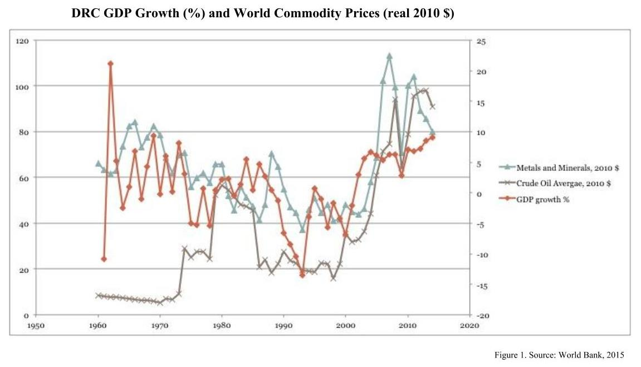
It can be established from these data that the economy of the DRC is in fact heavily dependent on natural resources, since there is a clear relationship between the movement on GDP growth and the movement of commodity prices over time. This relationship is especially strong for the average world price of metals and minerals, but is also apparent for crude oil. The relationship between GDP growth and the world price of metals and minerals has a correlation coefficient of r=0.51 for the period 1961-2014, while the relationship between GDP growth and the world price of crude oil has a correlation coefficient of r=0.33 for the same time period. Both results are statistically significant at a significance level of 0.05.
Does this volatility in GDP growth associated with world commodity prices shown in Figure 1. translate into government spending that easily expands when commodity prices are high and GDP grows, but fails to contract when prices fall and GDP growth declines as endogenous theories of the resource curse predict? Although government expenditure data for the DRC is not readily available for the entire period of the country’s independence, the World Bank provides government final consumption expenditure figures for the period of 1994-2014. Figure 2. shows these data together as annual growth in per cent together with annual GDP growth.
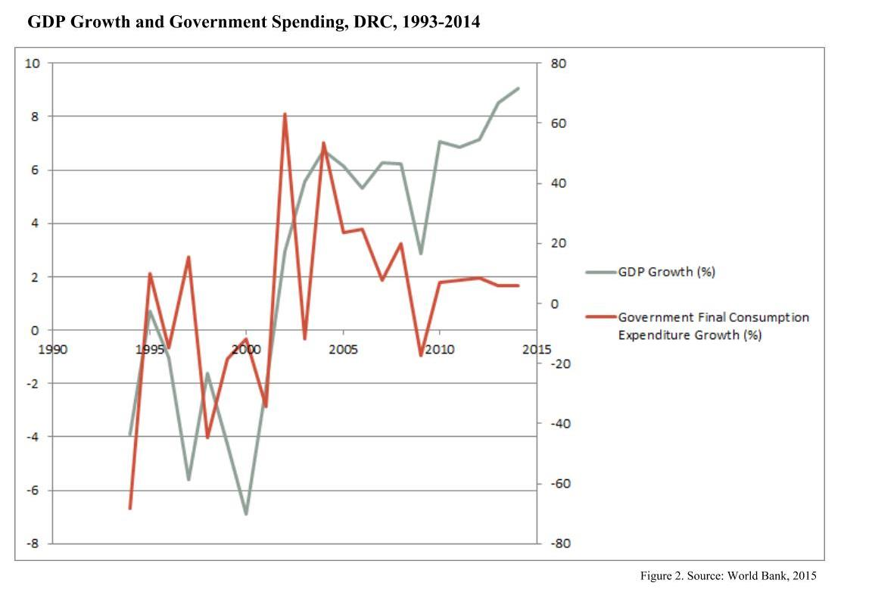
We can see that for some years, government expenditure trends do not match GDP growth trends. In 2002, for instance, GDP growth was at 3%, but government expenditure grew at 63.4%. Similarly, in 2004, GDP grew by 6.8%, but government expenditure by 53.4%. These results indeed suggest that as GDP growth increased from -2.1% to 6.8% between 2001 and 2004, expenditure expanded rapidly. We can, however, also see that contrary to the theory, government expenditure contracted rapidly at different times when GDP growth rates fell. Between 2008 and 2009, for instance, GDP growth decreased from 6.2% to 2.9% and government expenditure growth fell from 20% to -17.2%. It can therefore not be established that the government spending argument explains a sufficient portion of the DRC’s economic difficulties.
The final endogenous explanation of the resource curse that I will address is Dutch disease. Has the currency of the DRC indeed appreciated beyond expected levels when inflation is accounted for? Here, too, data is not available for the entire period of study; however, the World Bank provides the nominal exchange rate of the Congolese franc (CDF) per US Dollar (USD) from 1993, when the Congolese franc was introduced, to present. Figure 3. shows this nominal exchange rate on the right vertical axis, and the Consumer Price Index (CPI) on the left vertical access for the period 1993-2014.
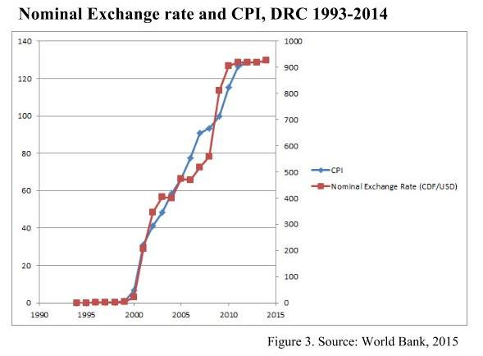
If Dutch disease were present during this period, we would expect the nominal exchange rate to appreciate more than CPI rises. We can, however, see that the nominal exchange rate and the CPI move very closely together, suggesting that the appreciation of the Congolese franc was caused primarily by inflation.
Despite the obvious resource-dependency of the Congolese economy, as shown by the volatility of GDP growth connected to fluctuating world market prices of primary commodities, endogenous theories of the resource curse do not provide a complete explanation of the DRC’s failure to generate and maintain economic development. Both the government spending and Dutch disease explanations do not hold true in the case of the DRC. Moreover, other heavily resource dependent countries in Africa have exhibited impressive growth and development outcomes. Botswana, for instance, has seen an increase in per capita incomes from $468.9 to $7,095.7 (measured in constant 2005 USD) between 1966, the year of its independence, and 2014. It ranks 109th in the Human Development Index (UNDP, 2015), whereas the Congo ranks 186th. Botswana has achieved these outcomes despite dependence on the export of diamonds, and a much less favorable geography for economic development than the DRC. Unlike the DRC, Botswana is landlocked, and the majority of its landmass is covered by desert. To explain these unfavorable growth and development outcomes in the DRC, it is necessary to look at the properties of political and economic institutions in the country and how they developed.
Even before the advent of colonialism in the DRC, its political and economic institutions were not conducive to entrepreneurial activity and, consequently, growth. The Kingdom of Kongo was organized as a centralized political community under the authority of the king, where regional governance was carried out by governors The authority of the state was absolute, taxation arbitrary, universal rule of law did not exist, and the expropriation of property common (Acemoglu and Robinson, 2012). The kingdom’s economy was based around slavery, both for the slave trade with European and the kingdom’s own plantations. These pre colonial political and economic institutions explain the poverty in the Congo described by Europeans upon their arrival in the fifteenth and sixteenth centuries compared to other locales on the African continent - there was no writing, no wheel, or plow (Acemoglu and Robinson, 2012). Because of how extractive the political and economic institutions in the Kingdom of Kongo were, where slaves were expropriated even of the proceeds of their own labor, there was little incentive to innovate since individuals would not have profited from being entrepreneurial. This becomes even clearer when we consider that when technological ideas entered the area from Europe, they were not readily adopted (Acemoglu and Robinson, 2012). The advent of Belgian colonial rule made matters worse. The institutions in the Congo remained extractive, but a new layer of the threat of violence was added as a part of the mass-scale extraction of Congolese Rubber. The Belgian policy of chopping hands by colonial agents to prove to the authorities that bullets had not been wasted on animals, which created a market for human hands, constitutes the most famous and gruesome example of such institutionalized violence (BBC News, 2015).
Historical institutionalists have argued that once institutions are created, they tend to persist and are difficult to change (Laursen, 2011). Can this idea, known as path dependency, explain the fate of the DRC? After all, endemic corruption and the enrichment of few at the expense of the many continue to be fundamental obstacles to growth and development in the Congo. Figure 4. shows GDP growth in the DRC from 1960 to 2014. Four points in time are highlighted which correspond to major historical events with the capacity to induce institutional change. These are: independence in 1960, seizure of power by Mobutu in 1965, the ousting of Mobutu in 1997, and, finally, the adoption of a transitional constitution in 2003.
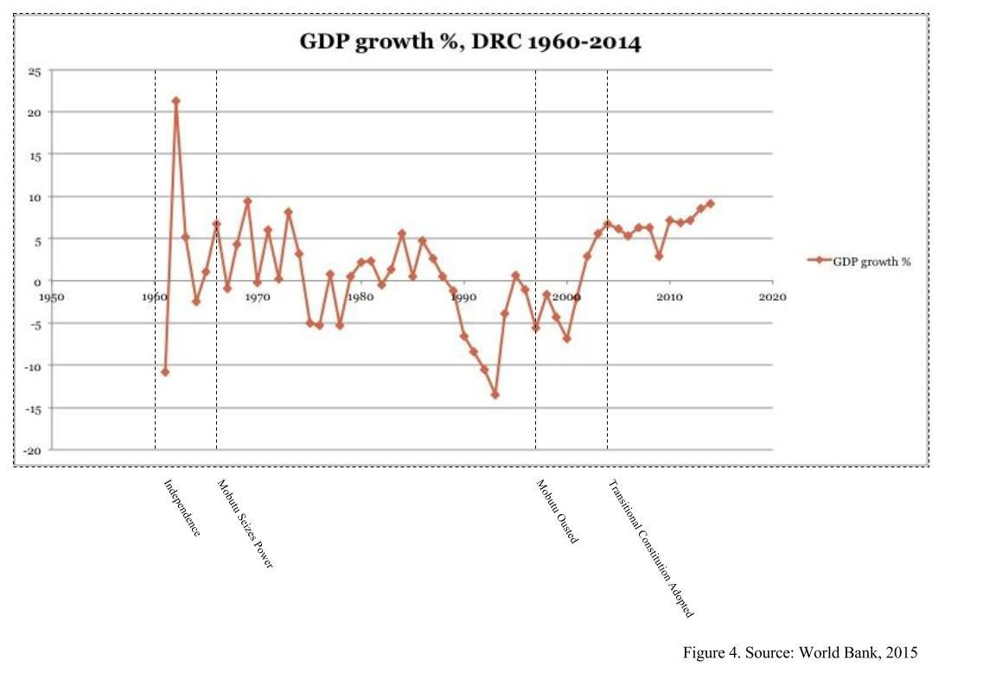
At independence, hopes in the DRC, as elsewhere on the African continent, were high. Joseph Kasavubu, the DRC’s first president, and Patrice Lumumba, the country’s first prime minister, inherited a country with its share of problems in terms of institutional makeup and political history. Yet, the DRC had enormous potential in terms of its resources and industry (Trapido, 2015). Despite the unfolding of the Congo crisis that entailed the assassination of Lumumba in 1961 (BBC News, 2015) and the centralization of power via an amendment of the 1960 provisional constitution that strengthened the presidency in 1964 (Constitutionproject, 2015), we can observe impressive economic growth between 1960-1961. This growth fluctuates as the Congo crisis and associated fighting unfolds. It is possible to say here that the potential possible effects of the first provisional constitution did not materialize as the country fell into conflict and the less extractive institutions enshrined in the provisional constitution did not materialize.
We can further observe that once Mobutu came into power in 1965, growth outcomes continued to fluctuate heavily but worsened in the long-term. This can be attributed at first to the further strengthening of presidential powers in 1967 (Constitutionproject, 2015), the nationalization of foreign firms in 1973-1974 (BBC News, 2015), which exemplified the volatility of property rights and discouraged investment, and a ban on multi-party politics that lasted until 1990 (BBC News, 2015). Acemoglu and Robinson have argued that extractive political and economic institutions can create a vicious cycle whereby a lack of provision of public goods and a strong rule of law on the political side will reinforce extractive economic institutions that hinder an environment conducive to growth through, for instance, weak property rights. This has been especially true in the Mobutu years, where, through neo-patrimonial networks, a small elite enriched itself at the expense of the majority of the citizens. Among other proceeds from corruption, in the years of his rule Mobutu had stolen nearly half of the IMF aid the DRC received - a staggering 6 billion USD (The Guardian, 2004).
Once Mobutu was ousted in 1997, we begin to see an overall upward trend in GDP growth. This is especially true after a provisional constitution was adopted in 2003, and later replaced by the permanent 2006 constitution (Constitutionproject, 2015). While conflict remains prevalent in the DRC, and state authority does not extend over the entire territory, progress has been made by the government with regards to gaining control of militia-held territories and mines, such as in the province of Katanga (Stratford, 2015), leading to a somewhat greater reach of state authority, and the enforcement of the rule of law and property rights. In addition better GDP growth outcomes; there has been a reduction of capital flight as well. In the period of 1997-2006, capital flight amounted to 3.5 billion USD; it totaled 5.3 billion USD between 1987 and 1996, and 6.6 billion USD between 1980 and 1986, a period three years shorter than the subsequent two. The political and economic situation in the DRC continues to be fragile, but the economic indicators show that with the recent institutional transitions a trend of improvement has begun.
V. Conclusion
In conclusion, it becomes evident that endogenous explanations of the resource curse do not fully explain the dismal growth and development outcomes in the DRC since independence. This paper has shown that while GDP growth is highly sensitive to the price of metals and mineral resources, there is not sufficient evidence for exaggerated government spending in high growth years that fails to contract when growth declines as a result of falling world market prices of primary commodities, or for the existence of Dutch disease. Moreover, other resource-dependent African countries, such as Botswana, have significantly outperformed the DRC in terms of growth and development despite less favorable geography. It is the makeup and historical evolution of political and economic institutions in the DRC, then, which solves the bulk of the resource curse puzzle in the DRC. Even before the establishment of exploitative colonial institutions under Belgian rule, the territory of the DRC was home to highly extractive political and economic institutions under the Kingdom of Kongo, which disincentivized innovation. After independence, a short period of hope was replaced by Mobutu’s authoritarian regime and decades of violent conflict, as a result of which the rule of law was diminished, corruption exacerbated and the country’s resources depleted without generating development. Outcomes have somewhat improved since Mobutu was ousted in 1997, but only time will show whether the institutional transformation envisioned in the 2006 constitution will fully materialize in the future.

References
Atlas.media.mit.edu,. (2015). OEC - Democratic Republic of the Congo (COD) Exports, Imports, and Trade Partners. Retrieved 7 December 2015, from http://atlas.media.mit.edu/en/profile/country/cod/
BBC News,. (2015). Democratic Republic of Congo profile - Timeline - BBC News. Retrieved 7 December 2015, from http://www.bbc.com/news/world-africa-13286306
BBC News,. (2015). EU referendum: 'No consensus' over UK welfare reforms, Donald Tusk says BBC News. Retrieved 7 December 2015, from http://www.bbc.com/news/uk-politics-35025160
Collier, P. (2007). The bottom billion. Oxford: Oxford University Press.
Constituteproject.org,. (2015). Constitute. Retrieved 7 December 2015, from https://www.constituteproject.org/ontology/chronology?lang=en
Data.worldbank.org,. (2015). GEM Commodities | Data. Retrieved 7 December 2015, from http://data.worldbank.org/data-catalog/commodity-price-data
Denny, C. (2004). Suharto, Marcos and Mobutu head corruption table. the Guardian. Retrieved 8 December 2015, from http://www.theguardian.com/world/2004/mar/26/indonesia.philippines
Global Financial Integrity,. (2015). Capital Flight from the Democratic Republic of the Congo « Global Financial Integrity. Retrieved 8 December 2015, from http://www.gfintegrity.org/report/capital-flight-democratic-republic-congo/
Hdr.undp.org,. (2015). Human development index (HDI) | Human Development Reports. Retrieved 7 December 2015, from http://hdr.undp.org/en/content/human-development-index-hdi-table
Kiewiet, D. (2010). Violence and Social Orders: A Conceptual Framework for Interpreting Recorded Human History. By Douglass C. North, John Joseph Wallis and Barry R. Weingast. New York: Cambridge University Press, 2009. Pp. xvii, 308.. $24.00, cloth. J. Econ. Hist., 70(01), 255. http://dx.doi.org/10.1017/s0022050710000203
Laursen, F. (2010). Comparative regional integration. Farnham, Surrey [England]: Ashgate.
Stratfor,. (2010). DRC: Looking to Capitalize on Katanga's Wealth. Retrieved 8 December 2015, from https://www.stratfor.com/analysis/drc-looking-capitalize-katangas-wealth
The Economist,. (2015). The twilight of the resource curse?. Retrieved 7 December 2015, from http://www.economist.com/news/middle-east-and-africa/21638141-africas-growth-being-powered-things-other-commodities-twilight
Trapido, J. (2015). Africa's Leaky Giant. New Left Review, 92.
Worldbank.org,. (2015). Democratic Republic of Congo. Retrieved 7 December 2015, from http://www.worldbank.org/en/country/drc

How does the announcement of a new stadium

impact property values?

Mohammad Haroon Bokhari ‘16

Introduction to Econometrics

A great amount of public funds are channeled into building new sports facilities worldwide and on a frequent basis. This paper focuses on how a stadium announcement can affect proximate housing values. We investigate the impact of the announcement of a new football stadium for the Minnesota Vikings by Governor Dayton on the 1st of March, on single-family homes in Minneapolis. We use a repeat sales transaction model to see how home prices within the stadium’s area of influence changed with respect to home prices not in the stadium’s impact area. We find a statistically significant positive stadium impact within a 1-kilometer range of the stadium. Our results also emphasize the role of stadium architecture in promoting positive spillover effects to the neighborhood.

- Introduction

This paper tries to answer the question of how a stadium announcement affects proximate property values by analyzing the new Minnesota Vikings Football stadium. In the last fifteen years, fifteen new NFL stadiums have been opened or announced. While new stadiums continue to be constructed there has always been a debate about the potential social and economic impacts of new stadia on the stadium communities. Proponents of new stadia argue for increased job opportunities, increased consumer spending, tourism and business. In addition, some say a multiplier effect also increases the positive impact of the stadium. On the other hand, critics contend that this multiplier effect is overestimated, while the negative externalities, substitution effects and the opportunity costs that go into building a stadium, are largely ignored.
Much of the economic literature is skeptic of the impacts of new stadia (Siegfried and Zimbalist, 2000, 2006), (Rappaport and Wilkerson, 2001). On the other hand very few such papers as Carlino and Coulson (2004) have identified positive stadium impacts of stadiums. Tu (2005) was the first one to analyze the effect of stadium construction by using transaction data on single-family homes when investigating the impact of FedEx field in Maryland, USA. Ahlfeldt & Kavetsos (2010) were the first ones to find that a stadium announcement can have impact on property values too. This is because real estate markets tend to value the stadium effects in anticipation.
This paper investigates the impact the announcement of a new football stadium by Minnesota Governor, Mark Dayton, for the Minnesota Vikings. On March 1st, 2012 Governor Dayton announced plans to build a new stadium as the same site as the Metrodome, the previous Minnesota Vikings stadium. The stadium is still in construction phase and is set to open on July 2016. The New Minnesota Stadium provides variation in external design and setting, but not in use and location, which allows us to control for these factors in our analysis.
We use a repeat sales model, using panel data and find evidence of increase in single-family homes in a 1-kilometer radius of the stadium following the stadium’s announcement.
The rest of the paper is organized as follows. Section II takes a look at the existing literature related to the topic and a few studies that have tried to answer the same question by looking at other stadiums. Section III presents a theoretical framework, which makes a prediction about the effect of a stadium on proximate housing values. Section IV reports summary statistics, how data were collected and some initial thoughts about the data. Section V analyzes the data using different functional forms, reports estimation issues and presents results. Section VI manipulates the data sets in order to see how robust the regression results are. Finally Section VII concludes the research on this topic, presents results and shortcomings of the current method, and gives direction for a future study.

II. Literature Review
There is a fair amount of literature on how sports stadiums affect local economy. These stadiums can help the local community by creating new jobs, attracting tourism, improving infrastructure and boosting community pride (Kavetsos and Szymanski, 2010). Other positive effects include spending by sports fans and increased aesthetic quality of the neighborhood (Ahlfeldt and Maennig, 2010a). These arguments have been used to support public spending on these stadiums. On the other hand, a significant portion of the literature has been skeptical of the new stadiums’ positive economic impacts on the community (Siegfried and Zimbalist, 2000, 2006), (Rappaport and Wilkerson, 2001).
In the last ten years a number of studies have emerged that have looked into the impact of these stadiums on property prices in the vicinity. Carlino and Coulson (2004) seems to be the first study to explore this topic. They try to gauge the impact of a National Football League (NFL) franchise on rent prices of nearby properties. They find that an NFL franchise increases annual rent prices by 8% in the city. When the analysis is repeated over a wider area the effect is halved. They also find that wages in the NFL host areas decrease by 2%.
Carlino and Coulson’s (2004) study does not make it completely clear whether the spike in rents is due to the stadium or the NFL franchise. Tu (2005) takes this into account, and performs a study of a new stadium, the FedEx Field in Maryland. He finds through his hedonic analysis that after the completion of each phase of the stadium, the price of nearby properties increased by a statistically significant amount of about 5%.
Some literature has also found that the announcement of a stadium alone has caused changes in property values. The assumption here is that the property market is completely efficient and reacts to the new relevant information. Dehring, Depken, and Ward (2007) examine a series of announcements of Dallas Cowboys’ new home stadium. They find a positive impact on Dallas City property values following a stadium announcement and negative impact when the project was cancelled. The announcement to relocate to Arlington, Texas, surprisingly caused a statistically significant 1.5% reduction in property values Arlington.
In a similar study, Ahlfeldt and Maennig (2010a) estimate the impact of two different stadiums, the Velodrom and Max Schmeling (MS Arena) on property values in Berlin, Germany. They use binary variables that determine the distance between the property and the stadium. They find that both stadiums positively impact land values for up to a three-mile radius. Similarly, Feng and Humphreys (2008) estimate the impact of two sporting facilities, the Nationwide Arena and Crew Stadium in Columbus, Ohio, on housing property values. They find that both stadiums have a positive impact on housing values, although the study focus only cross sectional data for the year 2000. Kavetsos (2009) studies the impact of the announcement of London being awarded the host rights for the 2012 Olympics. He finds a positive and significant relationship between the five host boroughs and properties within a 9-mile radius from the Olympic stadium.
The literature has not been able to differentiate whether the positive effects are due to the functionality of the stadium as a sports facility or the amenity effect through the design of the extremely large structures. Ahlfeldt and Kavetsos (2011) fill this gap by doing a study on the New Wembley stadium, which was built at the exact same site as the old Wembley stadium. The same site means many of the direct external effects such as pride, emotional attachment, noise and crime remain constant. The 15% increase in nearby properties is then most likely driven by a “visual amenity” effect, given the iconic architecture and a widely visible arch of about 130m high. In the same study Arsenal Football Club’s Emirates stadium is also examined. Emirates was built five hundred meters from the old location, which meant that there were both stadium functionality effects and negative externalities that influenced property prices in that region. Results show a 1.7% increase in property prices for any 10% decrease in distance to the stadium, highlighting that negative externalities can cancel out the positive stadium effects.
Property prices are affected by a number of other variables too. They are a function of the individual characteristics of the property, and a variety of location and neighborhood attributes. The individual characteristics can include items such as the number of bedrooms and area of the house. Neighborhood and location influencers include proximity to schools, parks, transport services, crime, noise and pollution level (Li and Brown, 1980). There is extensive literature on how these various attributes affect property values. Espey and Lopez (2000) study the impact of closeness to the airport and find a statistically significant negative relationship between airport noise and residential property values. Gibbons and Machin (2003) study the effect of education and schools on property prices and find that improvement in primary education has a positive impact on housing values. Hess and Almeida (2007) study the impact of transport innovations and find that a public transit system can increase housing prices.
This paper will add to the decade of literature on the impact of a stadium on property prices by doing a case study on the Minnesota Vikings new football stadium, known as the New Minnesota Stadium. The construction began on December 2013 and is set to be completed by July 2016. We will, therefore, be looking at how the stadium announcement affected proximate property values. Literature has shown that real estate market like any other market reacts to newly available information, which in this case will be the announcement. We will measure the impact on property prices up to a five-kilometer (approximately three-mile) radius. This range is based upon studies we have examined earlier (Tu (2005), Ahlfeldt and Maennig (2010a)). The fact that the New Minnesota Stadium is located on the same site as their previous home, the Metrodome, will allow us to control for direct external effects such as civic pride, proximity to the airport, noise and crime. Additionally we will be taking a different approach than previous studies have by studying a repeated home sales model than the hedonic price model. This will allow us to control for many of the location and neighborhood based characteristics such as the number of bedrooms, bathrooms and swimming pools, noise, pollution, median income level. We believe that this should give us a more accurate picture than the hedonic price model because we will be studying the same house before and after the stadium’s announcement.

III. Theory
In this section we will setup a model to see how the announcement of building a new stadium can affect the pricing of proximate homes.

i. Demand: Utility derived from housing
Households maximize their utility by trading non-housing goods for housing consumption.

Consumer utility = f(housing goods, other goods)
The utility derived from housing consumption can be split up into structural attributes, location and neighborhood attributes of a house. Structural attributes include e.g. area of house, number of rooms. Location and neighborhood attributes would include access to employment opportunities, racial composition, natural amenities such as greenery, environmental externalities, quality of schools, distance from rail stations. Stadiums are a neighborhood attribute. Given a perfectly competitive market, utility maximization implies that the utility derived from these characteristics fully capitalizes into a house’s price function.
$$Property price = f\left(S_{H}, L_{H}, N_{H}\right)$$
$$S_{H}=structural characteristics$$
$$L_{H}=location characteristics$$
$$N_{H}=neighborhood characteristics$$

Rosen (1974) was the first one to come up with the hedonic demand theory. Rosen concluded that the marginal utility of a characteristic, or the implicit price can be estimated by doing hedonic regression analysis of differentiated goods. Freeman (1979) similarly added to Rosen’s work by applying the hedonic demand theory to estimating the value of environmental amenities. Carlino and Coulson (2004) are the first ones to apply the hedonic demand theory to estimate how rents and wages are influenced by an NFL franchise. Tu (2005) is the first one to separate out a stadium’s effect on property values using the hedonic demand theory. Subsequent papers studying the impact of stadia on property values have used the hedonic regression analysis to explain the effect of stadia on property values.

ii. Supply of homes
As popular in the hedonic housing model literature, we assume that supply for homes is inelastic in the short run. This fits in well with our analysis on the New Minnesota Stadium, which is being built on the same location as the last stadium and no surrounding properties have been sold or demolished. In other words there has been no significant increase or decrease in housing supply. Our analysis will therefore focus on the demand side of the housing market.

iii. Splitting stadium utility
Following Ahlfeldt and Kavetsos (2011) example we separate out the stadium utility into a functionality effect, effect of locating closer to stadium, and a visual amenity effect. Functional utility of a stadium can include pride and emotional attachment to the team, while visual amenity effect is due to the iconic structure of the stadium. Possible negative utility is derived from the increase in taxes to pay for the stadium, noise, traffic and overly passionate fans. Our hedonic price function now looks like:
$$Property price = f\left(S_{H}, L_{H}, N_{H}\right)+g({F_{H},V}_{H})$$
$$F_{H}=stadium functionality effect$$
$$V_{H}=stadium visual amenity effect$$

Since the New Minnesota Stadium is being built on the exact same location as the last one, we assume that the stadium functionality effect such as additional civic pride caused due to stadium announcement is zero $(\frac{d\left(P_{H}\right)}{d\left(g\left(F_{H}\right)\right)}=0)$. This is following Ahlfeldt and Kavetsos (2011) analysis of the New Wembley stadium, which was built on the exact same location as the old stadium. Additionally for the New Minnesota Stadium there has been no increase in taxes except for a one-time tax on tobacco inventory to pay for the state’s yearly bond payment. As a result we will ignore taxes in our analysis.
Our analysis will then show us the visual amenity effect on home prices,$\frac{d\left(P_{H}\right)}{d\left(g\left(V_{H}\right)\right)}$ as a result of building the iconic structure of the New Minnesota Stadium. We propose that price of houses should go up because of this positive visual amenity effect. More people will want to move next to the stadium before of its state-of-the-art design and aesthetic structure. This home price increase is demonstrated through a demand supply model in Figure 1 below, where an increase in the visual amenity effect will cause the demand of houses around the stadium to go up, which will cause an increase in the price of houses around the stadium from $P_{0}$to $P_{1}$.
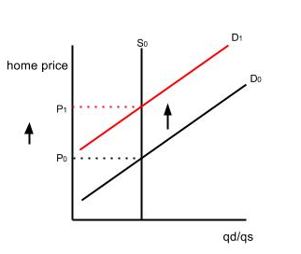

iv. Repeat Sales Model
Due to our assumption of inelastic supply all price changes in houses before and after the stadium announcement will be due to demand side shocks. These shocks are of two kinds. Macro-level shifts and neighborhood-specific shifts. Macro level shifts are affected by changes in economic conditions, while neighborhood specific shifts are in particular for the neighborhood, which would include shocks such as a change in the racial composition of a neighborhood or building of a new stadium.
Macro-level shocks can be controlled by using a difference in difference estimator, a method common in existing literature (Tu, 2005). By taking the difference in the change in price of area affected by stadium announcement and area not affected by the stadium announcement we can see the impact the stadium announcement had on housing prices. We use a difference in difference estimator on a repeat sales model. We will be looking at the change in price of houses that were sold before and after the stadium announcement. This method will allow us to control for home structural characteristics, location and neighborhood characteristics because we will be looking at the same house before and after the announcement. We will get rid of the omitted variable bias through this method. We are assuming that these characteristics remain constant before and after the stadium’s announcement. This might be an unrealistic assumption if there are e.g. remodeling efforts or a change in the neighborhood’s racial composition. Our guiding equation is:
$$lnP_{i, j,t}-lnP_{i,j,t-1}=α_{0}+β_{1}\left(distance from stadium\right)+ε_{i,j,t}-ε_{i,j,t-1}$$
$lnP_{i, j,t}$=price of house i, in neighborhood j after stadium announcement
$lnP_{i,j,t-1}$=price of house i, in neighborhood j before stadium announcement
$ε_{i,j,t}$=random error term after stadium announcement
$ε_{i,j,t-1}$=random error term before stadium announcement

IV. Summary Statistics

i. Datasets
Theory suggests that we need the real price of houses around the New Minnesota Stadium before and after the stadium announcement. Two datasets are used for this purpose containing the sales data and the parcels spatial data.
Sales data are collected from the City of Minneapolis’ Tax Assessment Office. These data compile all market transactions for single-family homes in Minneapolis from January 1983 to July 2014. Variables in this dataset are the Parcel Identification Number (PIN), which is unique to each parcel of land, the date the property was sold on and the amount paid for it in dollars. This data set has 129969 transactions for 57487 parcels of land.
Since the sales data are in nominal price, CPI data are collected from US Bureau of Labor website which uses 1982-84 as the base year of 100. All sales transactions are divided by their respective CPI for that year to give the real transaction price of the homes.
MetroGIS collects parcels data, which gives a picture in time of parcels of land in Hennepin County. This dataset includes the Parcel Identification Number for each parcel, its address and spatial location, how it’s used and which school district it lies in. This dataset is used to obtain the distance from the New Minnesota Stadium using GIS software.

ii. Distance variable and merging
A new distance variable is generated in GIS, which represents the straight-line distance from the New Minnesota Stadium. The Parcel Identification number is then used to merge the two data sets and give the respective distance from the New Minnesota Stadium. Our new merged data set now gives the PIN of the property, its address, sale price and the date of the transaction, and distance from the stadium.
We divide our data into two parts to study the effects of the stadium announcement on single-family home property value. The time Before Announcement is when there were no stadium plans or it was uncertain if the stadium would be built at its current site. The time After Announcement is the time period after March 1, 2012, when Governor Dayton announced an agreement for a new stadium to be built on the site of the Metrodome. Our before period will include single home transactions from 1-Jan 2000 to 29-February 2012. We take our before period to be from 2000 instead of 1983. This is done so that our assumption of no change in neighborhood or structural characteristics becomes more realistic. The after period will include all transactions occurring on and after 1-March 2012.
The before period includes 45868 transactions while the after period includes 5771 transactions. Out of these transactions about 6.5% lie within 1 km, 12.6% lie within 2 km, 17.0% lie within 3 km, 19.2% lie within 4 km, and 21.5% lie within 5 km. (shown in Table 1).
Finding conditional means of home prices based on distance to the stadium give us some interesting results. The results are shown in Table 2 when we consider the stadium’s vicinity to be 1 kilometer or less, 2 kilometers or less, 3 kilometers or less and so on. In all cases, where we consider the stadium’s vicinity to be 4 km or less prices of homes on average within the stadium area went down compared to the rest of Minneapolis after the stadium’s announcement. If we consider the stadium neighborhood to be 1 km, mean transaction price of a single-family home outside the stadium neighborhood had a premium of 9.3% on homes within the stadium neighborhood, after the stadium announcement. If we consider the stadium neighborhood to be 2 km this premium is 2.14%, for 3 km it is 0.64%, for 4 km it is 1.14% and for 5 km it is -0.18%. Only if we consider the stadium neighborhood to be 5 kilometers, then the price of houses within the stadium neighborhood increased more than price of houses outside of the stadium neighborhood. These results point to a negative impact on stadium proximate houses after the stadium announcement. It should, however, be noted that these means are for all houses within the before and after periods not the same set of houses before and after the announcement. To analyze the same set of houses before and after the announcement we move onto the Analysis section.

V. Analysis

i. Specification
We follow the methodology used by Natalie Camplair in her paper on the effect wind turbines have on property values (Camplair, 2012). We employ her methodology on our repeat sales data. We convert our data to panel data in order to test our guiding equation, which involves different time periods. We run all our regressions as fixed effect regressions in order to control for time invariant property and location characteristics. The model we use to run our regressions is:
$$ln\left({Price}_{ijt}\right)= α+β_{1}month+β_{2}year+β_{3}afterAnnouncement+β_{4}afterAnnouncement*{stadium}_{i}{+ε}_{ijt}$$

Price represents the transaction price of a single-family home. We include time dummy variables for each month to control for seasonality. Additionally we also include year dummy variables to account for the changes in the overall price level. ${Stadium}_{i}$ is a dummy variable for if the property lies within the stadium’s influence area.

ii. Estimation issues
We report robust standard errors for all our regressions, since the Modified Wald test that we run for group wise heteroskedasticity is significant showing heteroskedasticity. Multicollinearity is not issue in our regression since we only have one independent variable. We use the Wooldridge test for serial correlation and find no evidence for it. For nonstationarity we use the Fisher test and find no evidence for unit roots either.
iii. Methodology and Main Results
In our first approach to assess stadium impact we introduce a dummy variable representing a distance of 5km from the stadium. We consider the general neighborhood of the stadium to be the area within a 5000m radius, which had proved useful in the case of the FedEx Field (Tu, 2005). The coefficient $β_{4}$, the interaction term after announcement and the distance dummy, would then represent the approximate percentage change in values of single-family homes following the stadium's announcement for the average home within five kilometers of the stadium relative to the rest of Minneapolis. To find the actual percentages we use the formula
$100(e^{β_{4}}-1)$. The results are given in Table 3 below. Results for month and year are excluded due to a large number of coefficients for each month and year. We also include regression results for if we consider the general neighborhood of the stadium to be the area within 1000m, 2000m, 3000m and 4000m.
The results show a 2.6% increase in single-family homes following the stadium's announcement for the average home within five kilometers of the stadium relative to the rest of Minneapolis. If the stadium’s effect is considered to be a 1 km radius then this premium is 10.0%. Similarly it is 6.4% for a 2 km radius, 5.7% for a 3 km radius, and 4.5% for a 4 km radius. All four are significant at the 1% level.
Our next approach is to create mutually exclusive distance rings surrounding the stadium, also represented by dummy variables (Ahlfeldt and Maennig, 2010a). We construct five 1000m radius rings: 0-1000m, 1000-2000m, 2000-3000m, 3000-4000m and 4000-5000m. These rings are added to capture the effects across distance. The results are given in Table 4 below. The results show that the coefficient on the 0-1000m ring is positive and statistically significant at the 1% level. The coefficient on the 0-1000m is 0.094 meaning 9.9%($100(e^{0.094}-1)$) appreciation in home values occurred within a 1 km stadium radius following the stadium’s announcement compared to the rest of Minneapolis, which in this case is taken to be outside a 5 km radius from the stadium. Rings 1000-2000m, 2000-3000m are statistically insignificant but nonetheless positive. Ring 3000-4000m is negative and statistically significant at the 10% significance level, while 4000-5000m ring is negative and statistically significant at the 1% level. The coefficient on this ring is -0.111, meaning that houses within 4000-5000m from the stadium fell 10.5% (($100(e^{-0.111}-1)$) in value compared to the rest of Minneapolis.
To confirm these results, we introduce distance based variables: ${distance}^{2}$ and $\log{(distance)}$and run following regression:
$$ln\left({Price}_{ijt}\right)= α+β_{1}month+β_{2}year+β_{3}after+β_{4}distance+{β_{5}distance}^{2}+β_{6}log{(distance)}+β_{7}after*{distance+β_{8}after*{distance}^{2}+β_{9}after*log⁡(distance)+ε}_{ijt}$$

The home value premium as a function of distance would then be given by:

$$\% Premium = β_{7}*distance in meters +β_{8}*{\left(distance in meters\right)}^{2}+β_{9}log(distance in meters)$$

The results are given in Table 5 below. The results show that $β_{7},β_{8},β_{9}$ are all significant at the 1% level. $β_{7},β_{8}$ are both zero and $β_{9}$, which is the coefficient on the interaction after*log(distance) is -0.049. We use the above formula to calculate the housing premium. We find that doubling distance away from the stadium decreased the home value by 1.5%. So for example moving from 500m to 1000m decreased the value of a single-family home by 1.5% following the stadium’s announcement. In other words the closer the home to the stadium, the higher its value was following the stadium’s announcement.
Overall all three methodologies used here, in general, agree with the predictions made in the theory section. A visual amenity effect is responsible for the premium of single-family homes in the stadium’s vicinity following the stadium’s announcement.

VI. Robustness
In this section we will take subsets of our data and check if the results we found in the analysis section hold or not. We will take our before time period to be from time periods 2002, 2004, 2006, 2008, 2010. This is done in order to make sure the demographic and other variables that we did not include in our model such as the racial composition of the neighborhood did not change. So for example if we are looking at a repeat sales model from 2008 to 2014, we can be quite confident that the racial composition of the neighborhood that the particular house lies in did not change, than if we observe a dataset from 2000. We run the mutually exclusive ring regression and distance (regression 2 and 3 in the previous section) on each of the sub data sets. The results are given in the Table 6 and Table 7 below. The results for the original regression from 2000 are also given in the Tables for comparison.
Table 6 shows that the results of the ring regression still hold when applied to subsets of the data. In all cases up to the dataset starting from 2010, the interaction on after the stadium’s announcement and the 0-1000m ring are positive and significant at the 1% level. The 4000-5000m ring is negative and statistically significant at least at the 5% level in all sub data sets other than the one starting from 2008, which might be because of the housing crash during that period.
Table 7 shows the distance regression holds too in all sub data sets. The coefficients on all three interaction terms are statistically significant. The coefficient on the interaction of distance, and distance² with after the announcement is zero, while the interaction term for the log distance is approximately between -4.4% and 5.1% for the sub data sets 2002-2008, and -8.9% for the 2010 sub data set.

VII. Conclusion
We can conclude that the announcement of the New Minnesota Stadium did have a positive, statistically significant impact on homes within a 1-kilometer radius from the stadium. Our results show that homes in the 0-1000m range from the stadium increased as much as 9.9% compared to the rest of Minneapolis following the stadium’s announcement. Homes at a range of 4000-5000m show a statistically significant negative impact by the stadium. For the rest of the homes that lie within 1000-4000m of the stadium we are not able to get statistically significant results. We also show that increasing distance away from stadium resulted in statistically significant negative impact but this impact is relatively small. As we double the distance from the stadium, there is a 1.5% reduction in the price of single-family homes after the stadium announcement.
These results emphasize the role stadium architecture plays in providing spillover effects to the neighborhood. Since the new stadium is built on the same site as the previous one, we argue that the visual amenity effect of the New Minnesota Stadium with its state-of-the-art design and structure is responsible for premium of single-family homes within a 1-kilometer radius of the stadium.
This paper is the first to use a repeat sales model to analyze a stadium’s impact on the surrounding property values. The results could have been more conclusive and thorough had we used neighborhood control variables such as racial composition of the neighborhood, median income of the neighborhood etc. and controlled for their change before and after the stadium announcement. More sales transactions after the stadium would help too. If this study is done at a later stage, the results might be clearer given the greater number of data points for our repeat sales model following the announcement. In our analysis only two years of data are available after the stadium’s announcement, which is not enough for our repeat sales model. In addition our data only included single-family homes. To fully assess the impact of a stadium, multi-family homes, apartments and commercial properties should also be taken into account. A future study can also be done when the stadium construction is complete, to see how the stadium completion affects proximate housing values. To answer the question of the paper comprehensively other stadiums should be analyzed too.
References

Ahlfeldt, G.M. and Maennig, W. (2010a) Impact of Sports Arenas on Land Values: Evidence from Berlin. The Annals of Regional Science, 44(2), 205‐227.

Ahlfeldt, G.M. and Maennig, W. (2010b) Stadium Architecture and Urban Development from the Perspective of Urban Economics. International Journal of Urban and Regional Research, 34(3), 629‐646.

Ahlfeldt, G.M. and Maennig, W. (2009) Arenas, arena architecture and the impact of location desirability: The case of ‘Olympic arenas’ in Prenzlauer Berg, Berlin. Urban Studies, 46(7), 1343‐1362.

Ahlfeldt, G. M., & Kavetsos, G. (2010). Form or function? The impact of new football stadia on property prices in London. The Impact of New Football Stadia on Property Prices in London.

Carlino, G. and Coulson, N. (2004) Compensation differentials and the social benefits of the NFL. Journal of Urban Economics, 56(1), 25‐50.

Camplair, N. (2012). Does Proximity to Wind Farms Affect the Value of Nearby Residential Properties? Evidence from Washington and New York States.
Dehring, C., Depken, C. and Ward, M. (2007) The impact of stadium announcements on residential property values: Evidence from a natural experiment in Dallas‐Fort Worth. Contemporary Economic Policy, 25(4), 627‐638.

Espey, M., and Lopez, H. (2000). “The impact of airport noise and proximity on residential property values.” Growth and Change, 31(3), 408–419.

Feng, X. and Humphreys, B. (2008) Assessing the economic impact of sports facilities on residential property values: A spatial hedonic approach. International Association of Sports Economists, Working Paper 0812.

Freeman, A. M. (1979). Hedonic Prices, Property Values and Measuring Environmental Benefits: A Survey of the Issues. The Scandinavian Journal of Economics, 81, 2, 154-173.

Gibbons, S. and Machin, S. (2003) Valuing English primary schools. Journal of Urban Economics, 53(2), 197–219.

Hess, D., and Almeida, T. (2007). “Impact of proximity to light rail rapid transit on station-area property values in Buffalo, New York.” Urban Studies, 44(5-6), 1041–1068.
Kavetsos, G. (2009) The impact of the London Olympics announcement on property prices, SSRN working paper 1552322.

Kavetsos, G. and Szymanski, S. (2010) National Well‐Being and International Sports Events. Journal of Economic Psychology, 31(2), 158‐171.

Li, M.M. and Brown, H.J. (1980) Micro‐Neighborhood Externalities and Hedonic Housing Prices. Land Economics, 56(2), 125‐141.

Rappaport, J. and C. Wilkerson (2001). “What are the Benefits of Hosting a Major League Sports Franchise?” Economic Review, Federal Reserve Bank of Kansas City, First Quarter, 55-86.

Rosen, S. (February 01, 1974). Hedonic Prices and Implicit Markets: Product Differentiation in Pure Competition. The Journal of Political Economy, 82, 1, 34-55.
Siegfried, J. and Zimbalist, A. (2000) The economics of sports facilities and their communities. Journal of Economic Perspectives, 14(3), 95‐114.

Siegfried, J. and Zimbalist, A. (2006), The Economic Impact of Sports Facilities, Teams and Mega-Events. Australian Economic Review, 39: 420–427.

Tu, C. (2005) How does a new sports stadium affect housing values? The case of FedEx Field. Land Economics, 81(3), 379‐395.

Table 1: Share of sales by two periods and distance from stadium
Time period | Less than 1 km | Less than 2 km | Less than 3 km | Less than 4 km | Less than 5 km
2000-2012 | 6.2% | 12.0% | 16.3% | 19.0% | 21.4%
2012-2014 | 6.7% | 13.2% | 17.7% | 19.4% | 21.6%
Average | 6.5% | 12.6% | 17.0% | 19.2% | 21.5%

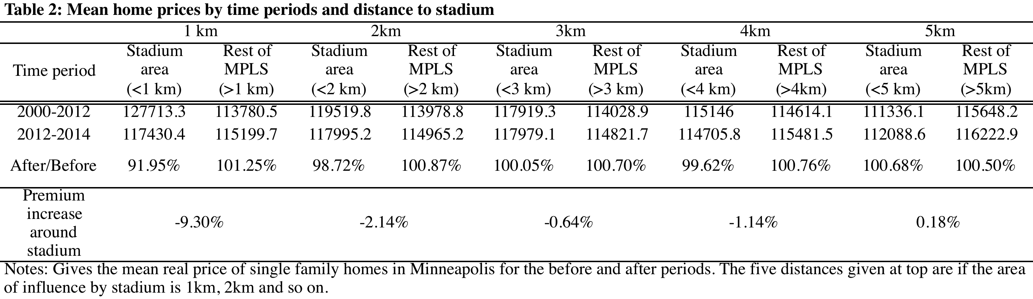

Table 3: Regression results for log prices including dummies for stadium influence
 | 1 km | 2 km | 3 km | 4 km | 5 km
VARIABLES | log price | log price | log price | log price | log price
after | 0.016 | 0.013 | 0.012 | 0.013 | 0.016
 | (0.033) | (0.033) | (0.033) | (0.033) | (0.033)
after*stadium | 0.095*** | 0.062*** | 0.055*** | 0.044*** | 0.026**
 | (0.020) | (0.014) | (0.013) | (0.013) | (0.012)
Constant | 11.183*** | 11.182*** | 11.183*** | 11.182*** | 11.182***
 | (0.009) | (0.009) | (0.009) | (0.009) | (0.009)
Observations | 51,639 | 51,639 | 51,639 | 51,639 | 51,639
R-squared | 0.359 | 0.359 | 0.359 | 0.359 | 0.359
Number of pin2 | 34,639 | 34,639 | 34,639 | 34,639 | 34,639
Robust standard errors in parentheses
*** p<0.01, ** p<0.05, * p<0.1

Table 4: Regression results with mutually exclusive distance rings
VARIABLES | log price
after*stadiumOne | 0.094***
 | (0.020)
after*stadiumTwo | 0.021
 | (0.017)
after*stadiumThree | 0.025
 | (0.027)
after*stadiumFour | -0.058*
 | (0.035)
after*stadiumFive | -0.111***
 | (0.024)
Constant | 11.182***
 | (0.009)
Observations | 51,639
Number of pin2 | 34,639
R-squared | 0.360
Robust standard errors in parentheses
*** p<0.01, ** p<0.05, * p<0.1

Table 5: Distance regression
VARIABLES | log price
after | 0.380***
 | (0.065)
after*distance | 0.000***
 | (0.000)
after*distance^2 | -0.000
 | (0.000)
after*log(distance) | -0.049***
 | (0.008)
Constant | 11.183***
 | (0.009)
Observations | 51,639
Number of pin2 | 34,639
R-squared | 0.360
Robust standard errors in parentheses
*** p<0.01, ** p<0.05, * p<0.1

Table 6: Mutually exclusive rings regression using sub data sets from 2002, 2004, 2006, 2008 and 2010
 | 2000 | 2002 | 2004 | 2006 | 2008 | 2010
VARIABLES | log price | log price | log price | log price | log price | log price
after | 0.016 | 0.018 | 0.051 | 0.015 | 0.008 | 0.110
 | (0.033) | (0.037) | (0.039) | (0.055) | (0.086) | (0.112)
after*(0-1000m) | 0.094*** | 0.085*** | 0.091*** | 0.083*** | 0.061* | 0.179*
 | (0.020) | (0.021) | (0.022) | (0.025) | (0.037) | (0.092)
after*(1000-2000m) | 0.021 | 0.029* | 0.032* | 0.038* | 0.026 | 0.014
 | (0.017) | (0.018) | (0.019) | (0.023) | (0.027) | (0.059)
after*(2000-3000m) | 0.025 | 0.044* | 0.028 | 0.014 | -0.043 | -0.140**
 | (0.027) | (0.024) | (0.028) | (0.029) | (0.031) | (0.065)
after*(3000-4000m) | -0.058* | -0.063* | -0.096** | -0.047 | 0.052 | 0.092
 | (0.035) | (0.038) | (0.045) | (0.063) | (0.050) | (0.110)
after*(4000-5000m) | -0.111*** | -0.109*** | -0.134*** | -0.152*** | -0.062 | -0.194**
 | (0.024) | (0.029) | (0.032) | (0.042) | (0.043) | (0.091)
Constant | 11.182*** | 11.440*** | 11.605*** | 11.634*** | 11.460*** | 11.354***
 | (0.009) | (0.009) | (0.013) | (0.023) | (0.029) | (0.052)
Observations | 51,639 | 41,753 | 31,426 | 20,995 | 14,013 | 9,646
R-squared | 0.360 | 0.279 | 0.280 | 0.223 | 0.085 | 0.133
Number of pin2 | 34,639 | 30,426 | 25,051 | 18,230 | 12,922 | 9,199
Robust standard errors in parentheses
*** p<0.01, ** p<0.05, * p<0.1
Table 7: Distance regression using sub data sets from 2002, 2004, 2006, 2008 and 2010
 | 2000 | 2002 | 2004 | 2006 | 2008 | 2010
VARIABLES | log price | log price | log price | log price | log price | log price
after | 0.380*** | 0.351*** | 0.421*** | 0.371*** | 0.306** | 0.709***
 | (0.065) | (0.071) | (0.073) | (0.092) | (0.129) | (0.257)
after*distance | 0.000*** | 0.000* | 0.000*** | 0.000*** | 0.000*** | 0.000***
 | (0.000) | (0.000) | (0.000) | (0.000) | (0.000) | (0.000)
after*distance^2 | -0.000 | -0.000 | -0.000 | -0.000* | -0.000*** | -0.000**
 | (0.000) | (0.000) | (0.000) | (0.000) | (0.000) | (0.000)
after*log(distance) | -0.049*** | -0.044*** | -0.051*** | -0.051*** | -0.044*** | -0.089***
 | (0.008) | (0.009) | (0.009) | (0.011) | (0.014) | (0.032)
Constant | 11.183*** | 11.440*** | 11.606*** | 11.636*** | 11.460*** | 11.362***
 | (0.009) | (0.009) | (0.013) | (0.023) | (0.028) | (0.050)
Observations | 51,639 | 41,753 | 31,426 | 20,995 | 14,013 | 9,646
R-squared | 0.360 | 0.279 | 0.280 | 0.223 | 0.087 | 0.128
Number of pin2 | 34,639 | 30,426 | 25,051 | 18,230 | 12,922 | 9,199
Robust standard errors in parentheses
*** p<0.01, ** p<0.05, * p<0.1

Playing the Ultimatum Game with College Students and Refugee Women

Ryan Daly ‘15

Diana Rosenzweig ‘15

Behavioral Economics

The Karen and Somali populations in the Twin Cities are rapidly increasing. Many among these populations are immigrants who come to the United States during their teen years and face a unique set of challenges. In order to inform programming and support systems for these populations, it is important to understand how individuals from these cultural groups frame economic decisions in the United States. Cultures vary in their Ultimatum Game (UG) play; however, there is dearth of literature about how immigrant and refugee populations play the game. We explored cultural differences in sense of fairness and taste for punishment by playing the UG with young Karen and Somali women in Girls Getting Ahead in Leadership (GGAL), a program designed to increase immigrant girls’ college readiness, and a control group of domestic undergraduate students. We find substantial differences in patterns of UG demands and acceptance between GGAL participants and our control.

- Introduction
The Karen and Somali populations in the Twin Cities are rapidly growing and evolving. As populations of each group increase, so do the number of social services and programs aimed at serving them. According to the Asian & Pacific Islander American Scholarship Fund (APIASF) Burma Bhutan-Report, special attention needs to be paid to Karen refugees who come to the United States during their teen years (Vang and Trieu 2014). The same logic may be applied to Somali refugees, many of whom also come to the United States during their teen years and face similar obstacles upon arrival, including language barriers and cultural adaptation patterns that differ from those of their parents.
In order to better inform programs and support systems for these specific immigrant populations, it is important to understand how individuals from these cultural groups frame economic decisions in the United States. Cultures vary in their economic decision-making processes (Henrich 2000; Henrich et al. 2005; Oosterbeek et al. 2004). According to Henrich (2000), if cultural differences influence economic behavior, then it is important to also explore cultural differences in sense of fairness and taste for punishment.
The literature is replete with information on how cultural factors affect the way individuals play the Ultimatum Game (hereafter UG); however, there is a gap in the literature regarding how immigrant and refugee populations play the game. We fill this gap by exploring how young Karen and Somali immigrant and refugee women in the Girls Getting Ahead in Leadership (GGAL) program play the UG. Our findings should provide insight into factors that might affect the way individuals from different cultures and socioeconomic backgrounds perceive fairness and reciprocity. We find substantial differences in patterns of UG demands and acceptance between GGAL participants and our undergraduate student control group.
This paper is divided into six sections. Section II provides an overview of the literature to date, including a description of the UG. Section III gives background on our unique study populations. Section IV details our methodology. Section V contains the results of the study, and Section VI concludes with a discussion of study limitations and suggestions for future research.
- Literature Review: The Ultimatum Game
The Ultimatum Game is a bargaining game widely studied in behavioral economics. In the simplest version of the game, there are two players, a proposer and a responder. The experimenter endows the first player (the proposer) with a sum of money and gives the proposer the option of sending a portion of this money to a second player, the responder. The responder chooses to either accept or reject the proposed allocation. If the responder accepts the offer, players keep their allotted portion. The responder receives the offered amount, and the proposer keeps the initial endowment less the offer. However, if the responder rejects the offer, each player receives nothing. For the purposes of this research, the roles of other players in the game remain unknown to all except the experimenters.
Neoclassical economic theory assumes that humans are rational, self-interested agents. Standard game theory predicts that proposers should offer the smallest nonzero amount to the responder, and responders should always accept this offer. In this study, the stake size for each round was $10 and the smallest allocation unit the dollar. The game theory prediction predicated on rational, self-interested econs is that each proposer will offer $1 to the responder and that the responder will accept this, as any nonzero offer is a choice between that offer and zero earnings. In this case, responders are given a choice between $1 and $0. This case represents the subgame perfect Nash equilibrium of the UG.
Human UG players deviate markedly from this prediction. In a meta-analysis of 37 papers and 75 UG results, Oosterbeek et al. (2004) find the average proposer offers 40 percent of the stake to the responder, or $4 in the $10 stake version of the game in the above example. The responder’s behavior also deviates from the prediction; responders rejected an average of 16 percent of offers (Oosterbeek et al. 2004). Such deviations from results predicted by game theory have led social scientists from a variety of academic backgrounds to develop potential explanations for this behavior.
Responders in the UG experience emotional responses to allocations that they perceive as unfair, which result in the desire to punish unfair proposers (Henrich 2001). In some societies, offers that seem too fair are also rejected out of anxiety surrounding gift-giving and reciprocity (Henrich et al. 2005). Sanfey et al. (2003) scan the brains of 19 UG responders using functional magnetic resonance imaging (fMRI) to determine what emotional and neurological processes correspond with the deviations from rational action. The authors find a statistically significant difference in the activity in regions of the brain associated with negative emotional states, possibly including “emotion-based disgust” if responders receive “unfair” offers of 10-20 percent ($9:1 or $8:1). Other experiments suggest the presence of powerful emotional factors that motivate the punishment of what is perceived as “unfair” behavior (Fehr and Gächter 2000).
Evolutionary biologists have developed their own explanation for the emotional response to unfair allocations, predicting an evolutionary advantage to pro-social behavior, such as sharing resources and punishing others’ non-cooperative actions (Henrich 2001; Henrich et al. 2005).
Two primary hypotheses attempt to explain the actions of players in the UG: the punishment (or fairness) hypothesis and the adaptive learning hypothesis (Abbink et al. 2001; Cooper and Stockman 2002). The punishment hypothesis predicts players’ utility maximization condition is a combination of monetary payoff and satisfaction from the fairness level of the division. This second aspect has been characterized as a taste for fairness. The adaptive learning hypothesis predicts players’ behavior is based on the outcomes of previous gameplay.
As only the second player has the power to punish in the UG, the punishment hypothesis relies on explaining the game’s outcome through the responder’s behavior. Adaptive learning may account for the decision-making process of either the proposer or responder. One way to illustrate this hypothesis is to consider each player endowed with an initial propensity to offer and to reject, that the combination of the players’ propensities yield the base condition found in the first round of play, and they learn in successive rounds which behaviors result in higher payoff. The higher the monetary gains, the more likely they are to continue the strategy.
These hypotheses are not mutually exclusive, but due to the differences in how they predict outcomes, they do not overlap entirely on theoretical grounds (Abbink et al. 2001). Abbink et al. (2001) find empirical support for the fairness/punishment motive in the responder but no statistically significant support for responder learning, while they do find support for proposer learning. This is unsurprising, based on the predictions and limitations of the hypotheses. Adaptive learning is a slow process, requiring multiple iterations to develop, if at all; responders may make punishment decisions instantaneously (Abbink et al. 2001). For this reason, the responder’s behavior may be characterized by a competition between two cognitive processes (Kahneman and Frederick 2001). One is quick and emotional, seeking to punish unfair behavior by the proposer. The slower, more analytical process attempts to apply deductive reasoning and analysis to maximize gains from gameplay. A potential reason for the absence of evidence of learning in UG responders is that most experimental versions of the game are not long enough to elicit learning behavior in the responders (Abbink et al. 2001).
This investigation focuses primarily on socio-cultural differences between groups and their impact on UG behavior. Henrich et al. (2005) find much of the behavioral variation across different cultural groups is due to differences in economic structure and social structure, focusing on variation across 15 small-scale societies. Our research interest lies in searching for differences in UG behavior between a control group, undergraduate volunteers, and a group of young immigrant and refugee women, many of whom spent much of their life in refugee camps, which we predict may affect their perceptions of fairness and reciprocity and UG behavior.
- Description of Participant Groups
Two main participant groups comprise our study population: undergraduate students at our undergraduate institution in Saint Paul, Minnesota, and young women from the Girls Getting Ahead in Leadership (GGAL) program. The GGAL participant group includes Somali and Karen high school students who are new to the United States. This study focuses on GGAL UG behavior; however, in order to make our study more easily comparable to the large literature of UG studies with college student study populations, we decided to play the game with students at our institution as well. See Figure 1 for a summary of relevant demographic information.
All undergraduate participants were domestic students and have grown up in the United States. All are White except for two; there is one Asian-American and one Hispanic student. The average age of the students is 20.7 years old. The gender distribution is much like our institution’s overall population: 61 percent of participants identified as female, and 39 percent identified as male. Undergraduate participants had on average less than one sibling. We will expand on the significance of this variable below. Our institution’s campus is small and close-knit; therefore, both authors were relatively familiar to study participants. It is important to note that we played the UG with two demographically similar groups of undergraduate students (one group of eight and another of 10).
Our immigrant population comprises young women from the Girls Getting Ahead in Leadership (GGAL) program at LEAP High School in Saint Paul, Minnesota. GGAL is one of four programs run by Women’s Initiative for Self Empowerment (WISE). WISE was founded in 1997 by a multiethnic group of women who believed that they could use more resources and community support. WISE works to empower immigrant and refugee girls to succeed, which they do in part by promoting awareness of immigrant women and girls’ issues and challenges. GGAL aims to increase immigrant high school girls’ college readiness and to improve and develop their leadership skills (Women of Wise). One of this study’s authors has volunteered with GGAL for two semesters and has built strong relationships with many of the young women in our study.
The program site at LEAP High School mainly serves Somali and Karen women and girls who are new to the United States. Participants have been living in the United States for between one and six years, and on average about three years. Sixty-six percent of students in our study identified as Asian, and 33 percent identified as African. The average age of the GGAL group was 19.5 years old, or about one year younger than undergraduate participants. The group differed from the undergraduate group in that all participants identified as female. The average GGAL participant had 3.66 siblings.
The Somali immigrant population in the Twin Cities
After the collapse of central government in 1991, daily life in Somalia became far more hazardous as levels of violence increased. Some fled to refugee camps in Kenya and Ethiopia. In 1992, the United States began granting refugee visas to Somalis, and many settled in the Twin Cities. Today, the Somali population in the Twin Cities, at approximately 18,000, is the largest Somali population in North America (Minnesota Compass 2012).
It is common in Somalia for extended families to be very close and involved in each others’ daily lives. As a result, Somali immigrants in the United States often live with extended family members and offer social and economic support to each other. Islam is an integral part of Somali culture and identity. Family closeness and Islam are integral parts of Somali culture in the United States and are therefore important for us to keep in mind throughout this study.
The Karen immigrant population in the Twin Cities
The Karen are an ethnic group from Burma (Myanmar), where they regularly experience persecution and violence as the result of a protracted civil conflict between them and the central government. Refugees go into hiding or cross the border into Thailand, where they live in one of 12 refugee camps. As a result of this, many of our study participants spent the majority of their childhood and early adult life in refugee camps outside of Burma. The Karen community in Saint Paul is the largest in the United States. Currently, over 6,500 Karen refugees live in Minnesota. The Karen community is growing rapidly and has a strong and active cultural organization, the Karen Organization of Minnesota (About KOM 2015).
In Karen culture, saying “no” is an expression of modesty. Furthermore, Karen culture values quiet and not imposing on others, and decisions are traditionally made by consensus. Karen society is matriarchal, though men are honored in the home. Like in Somali culture, it is common for many generations to live together, everyone in the community watches over children, and, historically, neighbors helped each other with farming (About KOM 2015).
- Methodology
Undergraduate student participants were recruited through posts on class year Facebook pages by members of those classes (so as not to skew our sample toward our friend groups) and via email to all students in the Economics department by way of the department coordinator. We emailed willing participants and assigned them randomly to one of two sessions. Participants were offered pizza and an opportunity to win a cash prize for their time.
Participants signed consent forms upon arrival. After signing the consent forms, participants logged in to Veconlab, an online platform for behavioral economics experimentation. Participants followed along while we read instructions aloud. Participants were asked to remain silent for the duration of the experiment. The first six rounds were played using random matching, in which participants were informed that they would be playing with a different partner each round). After six rounds, new instructions were read. The next six rounds were played in matched pairs. At the end of the experiment, participants filled out a brief demographic survey. We then asked participants what they thought of the game in general and asked them to reflect on their experiences. We then asked proposers and responders separately to talk us through their thought process and took extensive notes on their answers in a post-session debriefing. The experiments lasted approximately 25 minutes each, including reflection time.
The experiment with GGAL participants took place during the regularly scheduled GGAL program time. We made several modifications to the typical experimental procedures in order to address specific challenges of playing with GGALs. When the participants came to GGAL, they were greeted with thanks and offered desserts for participating. We introduced one experimenter who was unfamiliar to the group, and had each participant introduce herself in order to help us find common ground and build trust.
Next, we had participants log in to Veconlab. Following Henrich (2000), we took steps to make sure GGALs understood directions as clearly as undergraduates. We read instructions twice, the first time following the script used with undergraduate students, and the second time using simpler terminology. We also used hand gestures to indicate visually that the money would be sent from the first person to the second person and that the second person could reject. We further explained instructions to participants who requested further clarification. We have chosen to analyze only the six rounds from treatment 2 and have eliminated the six rounds in the first treatment due to potential differences in learning curves between participants. GGAL mentors, students from local colleges and universities, helped participants complete their demographic surveys but otherwise spent the duration of the experiment in a different room so as not to influence UG behavior.
We held a reflection period after the experiment with GGALs, in which we asked responder and proposer strategy questions identical to those we asked the undergraduate group. In addition, we also defined behavioral economics for the participants and led a discussion about what fairness means to them, where they first learned about fairness, and how they experience fairness in their everyday lives. We took extensive notes on the conversation, just as we did with the undergraduate group. The experiment lasted about one hour, including the reflection period.
We were the primary investigators in experiments with undergraduate students and GGALs. We both know many of the undergraduate student participants, and one of us is very familiar with the GGALs. Participants, therefore, expect to interact with one or both experimenters in the future. Henrich (2000) explains that in the typical UG experiments, subjects do not know the experimenter; however, like Henrich, if knowing the experimenter and expecting interaction with him or her in the future causes people to behave more fairly, we would expect that both groups would behave more fairly. It is possible that GGALs behaved especially fairly to “look good” for the experimenter, who was more of an outsider, despite our attempt to make him more familiar through an extensive introduction.
- Results
As described previously, all experiments consist of two six-round treatments. In treatment 1, participants are randomly assigned a new partner in each round; in treatment 2, participants are randomly assigned the same partner for all six rounds. Partners remain anonymous throughout. Based on cursory analysis and qualitative responses from post-session debriefings, we determined that treatment 1 contains several rounds of learning behavior as participants become comfortable with the game. For this reason, we base our final analysis only on results from treatment 2.
Henrich (2000) uses the Epps-Singleton nonparametric test (ES) and the Mann-Whitney nonparametric test (MW) to test for differences between population samples. Henrich suggests that ES test is more appropriate, given the discrete non-normal distribution typical of UG data. The MW test compares central tendencies, while the ES test compares overall distributional characteristics. For this reason, we employ ES tests when comparing the GGAL and undergraduate data that are presumed to be both non-normally distributed and non-binary.
While the MW test suggests central tendencies of proposer demand ($10 less the offer) between undergraduate and GGAL participants are not statistically different, the ES test reveals distributional differences in proposer demand significant at the 0.01 percent level. Both groups have median values of $6, with undergraduate participants’ mean demand at $5.85 and GGAL participants’ mean demand at $6.17. This fails to provide sufficient evidence for differences in average demands (p-value 0.367) given the MW. However, Figure 2 illustrates the distributional differences in the groups’ demands. Undergraduate students’ demands peak near the mean and median value, with a mode of $6; the GGAL participants’ demands peak at $5 and $8, with $5 the sample mode.
The post-experiment debriefing offers some insight into this behavior. One participant volunteered an explanation for her demand strategy, explaining how she finds it fair to demand $6 one turn, so long as she only demands $4 the next, so that the total share remains equal in the end. Several other GGAL participants agreed. We consider this to be a reciprocity-based strategy and a key difference between the groups’ gameplay. Undergraduate participants’ strategies seem quantitatively more like the behavior found in previous literature (Oosterbeek et al. 2004). Qualitative responses from the post-experiment debriefings corroborate this finding. Undergraduate participants made demands they thought responders would accept, with a few participants mentioning a desire for fairness. None of them suggested a reciprocity-based strategy of switching who receives the large payout each round.
Henrich (2000) finds differentiation among responder decision delineated by an industrialized/non-industrialized dichotomy. Employing the MW test, we test whether acceptance rates differ between the study populations in the extreme case, when proposers demand 80 percent or more of the sum ($8, $9, or $10). Responders from industrialized societies tend to reject extreme offers at a much higher rate, while those from non-industrialized societies tend to accept these offers (Henrich 2000). Undergraduate participants reject offers in which proposers demand 80 percent or more of the sum 75 percent of the time, although only 8 of 108 (about 7 percent) proposer demands met or exceeded this threshold. See Figure 3 for a visual comparison of these responses. GGAL proposers demanded extreme values far more often (26 of 72, or 36 percent), and they accepted them in 62 percent of cases, rejecting only 38 percent of the cases. Difference in the acceptance rates between undergraduate and GGAL participants are statistically significant at the 10 percent level (p-value=0.0745). Additionally, the difference in rates of extreme demands between the groups is statistically significant at the 0.001 percent level (p-value=0.0000). Figure 4 illustrates these differences.
We employ logistic regression to compare the logarithmic likelihood of both the responder decision and that a proposer demand is for 80 percent or more of the sum, dependent on the GGAL variable (GGAL=1). In the specification in column 1 of Figure 5 we control for proposer demand, age, and gender. We find an increase in the log odds of accepting a proposal of 1.841 for GGAL responders, which is statistically significant at the 5 percent level. In terms of odds ratios, the odds of a GGAL respondent accepting an offer is 6.3 times that of an undergraduate from our institution.
One major difference between undergraduate and GGAL participants is number of siblings. While the average number of siblings for a GGAL participant is 3.66, the average number of siblings for an undergraduate participant is below one, at 0.83. No undergraduate participant has more than two siblings, while GGAL participants have as many as six. The specification in column 2 includes this additional control variable. The GGAL bivariate appears to absorb the effect possibly attributable to family size, as the coefficient on number of siblings is small and insignificant. This is unsurprising, given the high level of multicollinearity between these two variables. In the specification in column 3, we drop the GGAL variable, and the number of siblings variable’s p-value rises to 0.114, though it fails to attain statistical significance. Its sign is reasonable, as individuals in households with many siblings must compete with one another to a greater degree than those with relatively fewer siblings. We expect this effect to be exacerbated by the deprivation and resource scarcity common in refugee camps; however, it is impossible for us to interact the two variables in this investigation, given that our sample lacks a sufficient number of individuals with both few siblings and refugee camp experience.
A similar series of logistic regressions can be found in columns 4, 5, and 6, with the choice whether or not to demand 80 percent or more of the sum as the dependent variable. Column 4 shows that the log odds of demanding 80 percent or more of the sum is 2.112 higher for GGAL participants than undergraduate participants, statistically significant at the 0.01 percent level. This result remains robust under the specification in column 5. The specification in column 6 drops the GGAL variable but includes the number of siblings. This time, number of siblings becomes statistically significant at the 5 percent level. Again, the sign on this variable is consistent with expectations. Each additional sibling increases the log odds of a proposer demanding 80 percent or more of the sum by 0.264. As family size increases, scarce resources may encourage a higher level of self-interest, leading them to more frequently demand high shares of the sum when playing as proposers in the UG.
Under punishment hypothesis predictions, individual utility maximization is a combination of both monetary payoff and satisfaction derived from fairness. Our analysis suggests that satisfaction derived from fairness may make up a lower proportion of derived utility for GGALs than for undergraduates. The reciprocity gameplay that resulted in major distributional differences in proposer demands between GGAL and undergraduate groups may support the adaptive learning hypothesis. Based on the qualitative results of post-session debriefing, GGAL participants entered the game with different offer and accept propensities than undergraduate participants. GGAL proposers were more likely to alternate between high and low offers than undergraduate students, yet the average division was not statistically different between the groups.
- Conclusion
This study faced several practical challenges, primarily regarding comprehension of game instructions. We excluded treatment 1 from our analysis to account for a possible learning curve and language issues. Henrich (2000) used “numerous examples” in order to ensure all participants understood the game. If we were to recreate this experiment, we would include examples to show how to play the game. Henrich (2000) also asked participants hypothetical questions to test how well they comprehended game rules. This might be a helpful approach to take whenever instructions are not given in participants’ primary language.
In order to explore how individuals from different cultures and socioeconomic backgrounds perceive fairness and reciprocity, we played the UG with undergraduate students at our undergraduate institution and young Karen and Somali immigrant women in the GGAL program. We find that GGAL responders are more likely to accept a proposer’s demand, and that GGAL proposers are more likely to demand 80 percent or more of the sum than undergraduate proposers. We find some evidence that family size plays a role in these differences, with an increase in the number of siblings resulting in an increased likelihood to demand a large share of the sum. Proposer strategies also differed between GGAL and undergraduate participants. Additionally, we speculate that living conditions within refugee camps may have induced a greater willingness to accept what is given and protect what is held, yielding a similar hypothetical effect as an increased family size. We expect that with a larger and more varied sample, it would be possible to investigate the interaction of these effects.
These findings have various implications for future research, policy, and social programs for refugee and immigrant groups in general, and more specifically for Karen and Somali immigrants and refugees who came to the United States during their teen years. For example, the fact that GGAL participants played amongst themselves means that this study could have implications for future research on enclave behavior in refugee and immigrant communities concentrated in America’s urban centers. Future studies would benefit from further demographic data, such as the length of time spent in one’s country of birth, the location and duration of refugee camp stays, and the time since settlement in the United States, to see how these factors might influence UG play and perceptions of fairness and reciprocity.
References
Abbink, Klaus, et al. 2001. “Adaptive Learning Versus Punishment in Ultimatum Bargaining” Games and Economic Behavior, 37:1. 1-25.

About KOM. 2015. Karen Organization of Minnesota (accessed May 6, 2015).

Cooper, David J. and Carol K. Stockman. 2002. “Fairness and Learning: An Experimental Examination” Games and Economic Behavior, 41:1. 26-45.

Fehr, Ernst and Simon Gächter. 2000. “Fairness and Retaliation: The Economics of Reciprocity” The Journal of Economic Perspectives. 159-181.

Henrich, Joseph. 2000. “Does Culture Matter in Economic Behavior? Ultimatum Game Bargaining among the Machiguenga of the Peruvian Amazon” American Economic Review. 973-979.

Henrich, Joseph, et al. 2005. “’Economic Man’ in Cross-Cultural Perspective: Behavioral Experiments in 15 Small-Scale Societies” Behavioral and Brain Sciences, 28:06. 795-815.

Kahneman, Daniel and Shane Frederick. 2002. “Representativeness Revisited: Attribute Substitution in Intuitive Judgment” Heuristics and Biases: The Psychology of Intuitive Judgment.

Oosterbeek, Hessel, Randolph Sloof, and Gijs Van De Kuilen. 2004. “Cultural Differences in Ultimatum Game Experiments: Evidence from a Meta-Analysis” Experimental Economics, 7:2. 171-188.

Sanfey, A. G., et al. 2003. “The Neural Basis of Economic Decision-Making in the Ultimatum Game” Science (New York, N.Y.), 300:5626. 1755-1758.

Somali Foreign Born Population. 2015. Minnesota Compass (accessed May 7, 2015).

Vang, Chia Y. and Monica M. Trieu. 2014. “Invisible Newcomers: Refugees from Burma/Myanmar and Bhutan in the United States” Asian & Pacific Islander Scholarship Fund.
Figure 1: Summary Statistics

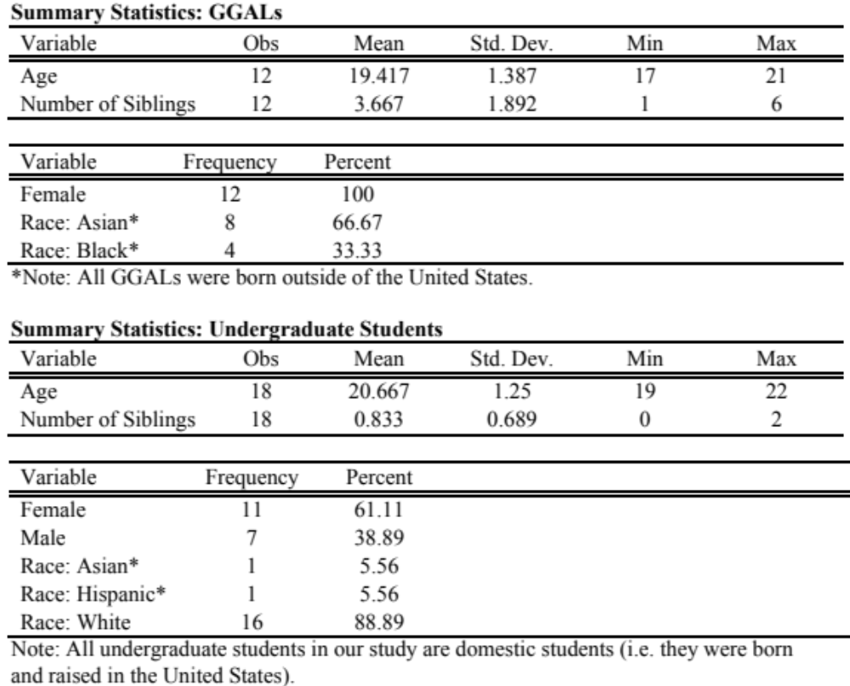

Figure 2:
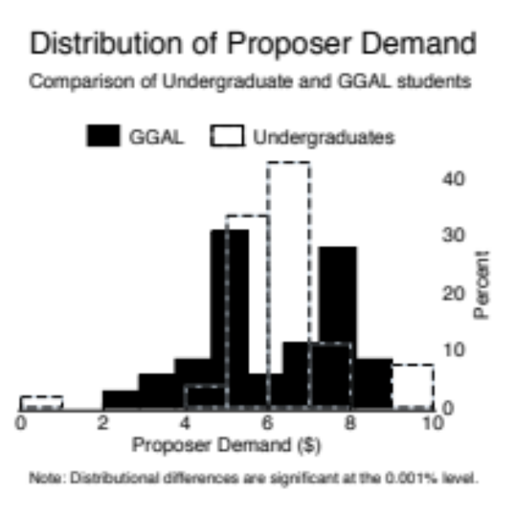

Figure 3:

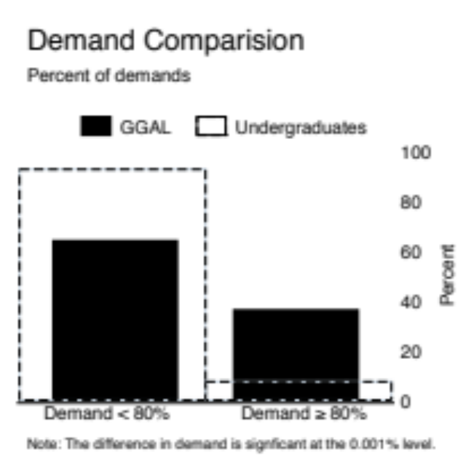

Figure 4:

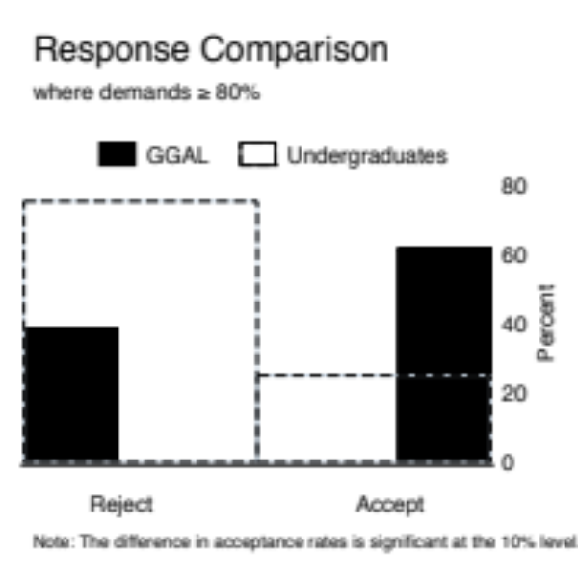

Figure 5:
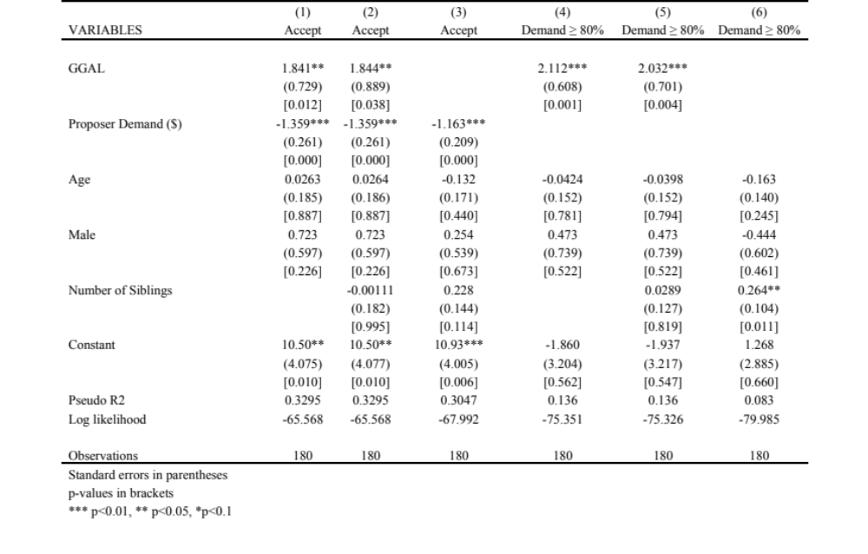

Does living near compatriots increase educational attainment for immigrant children?

Stefan Faridani, ‘17
Introduction to Econometrics

As the United States continues to take in migrant populations, how foreign-born children fare in American public schools is of important policy concern. This paper asks whether living near neighbors from their own country improves academic performance for immigrant children. To test this hypothesis, I conduct a battery of ordinary-least-squares regressions on survey data of immigrant families in San Diego and Miami from 1995. I find that proximity of compatriots in the neighborhood improves high school GPA by 0.15-0.26 points. Tests for whether the source of the difference was increased access to educated members of a child's own ethnicity were ambiguous.

- Introduction
The United States has received almost a million new permanent residents per year for the past decade (Dept Homeland Security, 2013). Nearly a quarter of these are younger than sixteen. Among the many consequent policy questions is how to ensure these children's success in American public schools. This paper examines the hypothesis that living near compatriots improves academic performance for immigrant children.
In Section 2, I review the relevant literature. In Section 3, I propose a simple theoretical framework. In Section 4, I present descriptive statistics of my data sample. In Section 5, I present six regressions that seek to answer my question. In Section 6, I analyze those regressions. In section 7, I draw conclusions and point out shortcomings. Residual plots and tables of elasticities are included in the appendices.
II. Literature Review
In his well-known survey of the immigration literature, Borjas (1994) identified the welfare of immigrants upon arrival as one of three central questions facing the research community. Most analysis of this topic considers only adults of working age. Some studies however, have considered trends for persons who migrate as children. Of particular interest is the ability of migrant children to acquire human capital in the host nation.
Economists typically model educational attainment as the output of a production function (Bowles, 1970). The inputs of the production function are personal, family, and school characteristics, such as the quantity of reading material available in a student’s home, teacher skill, and quality of science lab facilities. Output is measured by a standardized test score or grade point average.
Immigrant children are a special case where an additional set of inputs merit consideration. Within the literature there is a fair amount of consensus as to the factors that affect educational success of immigrants. Borjas (1995) conceives of ethnic capital---the mean skills of adult members of an ethnic group. He uses neighborhood characteristics to predict educational attainment of adults and finds that growing up in a segregated neighborhood increases the importance of ethnic capital and decreases the importance of parental skills. Bohlmark (2008) and Cortes (2006) find that the age at which children arrive to be an important determinant of academic achievement in the host country. Van Ours and Veenman (2006) ask whether immigrating at a younger age affects the probability of completing different levels of schooling. Using log-likelihood parameter estimation, they analyze a 1998 cross-sectional survey of immigrant children in Denmark to find that immigration at an older age decreases the probability that a youngster will finish a given level of school. However, the child's origin matters in determining the magnitude of the effect. Santos et al. (2011) corroborate these results using very similar methods on a cross-sectional sample of second-generation immigrant children in France.
However, there is also a recent body of research that examines peer effects on educational attainment. Students are not isolated individuals. They exist in social and residential networks. Each pupil's performance may be tied to his or her peers--independent of their own characteristics. Ammermueller et al. (2006) examine peer effects using a classical educational production function. To estimate peer effects, they include the average performance of other students in the classroom and school. However, this specification must be transformed to account for the "reflection effect"—student “i” influences student “j” who then influences student i back in turn. The result is that peer effects are endogenous, but measurable. They use data from the Progress in International Reading Literacy Study from six European countries to find that a one standard deviation increase in peer's achievement boosts an individual's achievement by 0.17 standard deviations.
The question of how these sorts of peer effects determine immigrant children's achievement is especially important when considering the tendency of immigrant groups to concentrate into enclaves. One branch of work revolves around ethnic concentration in schools. Cortes (2006) uses simple OLS estimations of educational production functions on cross-sectional data from the United States to find that concentration into ethnic enclave schools has no significant effect on standardized test scores. She controls for various personal characteristics of the children, e.g. home ownership and family structure. A recent study of cross-sectional data from Denmark (Jensen et al, 2015) begins by using OLS to predict student test scores of immigrant children using the local ethnic concentration. They add 21 control variables including length of stay and parental education to avoid omitted variable bias. Jensen et al. then point out potential endogeneity caused by parents sorting into neighborhoods with many fellow countrymen. They repeat using ethnic concentration in the wider geographic area as an instrument for local ethnic concentration. They find overall that greater ethnic concentration in a school worsens test scores for both immigrant and native students.
A second branch of study focuses on peer effects within residential neighborhoods. In particular, these studies ask whether living near compatriots increases a child's access to educated members of their own ethnicity. In this sense, the ``peers'' are adult neighbors. Building on the concept of ethnic capital introduced by Borjas (1995), Aslund et al (2011) uses Swedish immigrant settlement policies to examine the effects of neighborhood makeup on immigrant children's GPA percentile. He uses an OLS estimator on a cross-section of Swedish refugee children to predict a child's ranked GPA percentile by the size and education of their local ethnic community. His finds that the proximity of highly educated adults of the immigrant child's own ethnicity significantly boosts the youngster's GPA percentile.
One question raised by Aslund is how to disentangle peer effects within neighborhoods from those within schools. This may not be possible to accomplish directly. However, further study of both kinds of peer effects may shed light on the issue. Furthermore, much of the empirical work has been concentrated within northern Europe. These needs indicate that it may be timely for further study of the residential peer effects on academic attainment of immigrant children within the United States.
III. Theoretical Approach
I will make use of Bowles' (1970) concept of an educational production function. I propose that a measure of academic attainment $y$is a function of a child's personal characteristics, as well as those of his or her family, school, and neighborhood.

$$y=f(personal, family, school, neighborhood)$$

For this study, I seek greater clarity on how the ethnic composition of a neighborhood affects educational attainment. Borjas (1995) hypothesizes that access to educated members of one's own ethnicity---ethnic capital---is an important educational input. In this study, I hypothesize that living near compatriots increases a child's access to ethnic capital and therefore is an important neighborhood effect with a positive influence on educational attainment. With this in mind, I modify the educational production function to emphasize the role of ethnic capital. The effect of neighborhood becomes a function $N$ of proximity to compatriots $c$ and ethnic capital, $K_{e}$. This second function is the basis of the fifth and sixth regressions in section 5.

$$y=f(personal,family,school,N(K_{e},c))$$

Thus, I expect living near compatriots and ethnic capital to have positive effects on educational attainment. Unfortunately, any attempt to measure access to ethnic capital via neighborhood ethnic concentration will be muddied by omitted variable bias. If immigrants have certain characteristics, these characteristics affect a child's educational attainment, and families facing with these characteristics tend to be concentrated into the same neighborhoods, then the measurement of access to ethnic capital will be biased. To address this, I include as many personal and family controls in my models as possible.
Two important controls are family wealth and length of stay in the United States. Based on Cortes (2006) and Aslund (2011), I expect measurements of wealth to have positive signs and measurements of length of stay to have negative signs.
IV. Summary Statistics
I make use of a cross-sectional sample of survey data from 5262 children in Miami and San Diego (Alejandro & Rumbaut, 2006). The dataset consists of several waves beginning in 1992 and ending in 2006. Approximately half the children were not born in the United States. Of those, I am forced to omit those who were not in high school in 1995 and those who do not have answers for some of the important variables. Since I control for school attended, I drop all observations for which fewer than 10 attend the same school. This leaves me with 1090 cross-sectional observations.
For my measurement of educational attainment, I will use each child's grade point average in 1995. Figure 1 shows a density plot of GPA for all 1090 students.

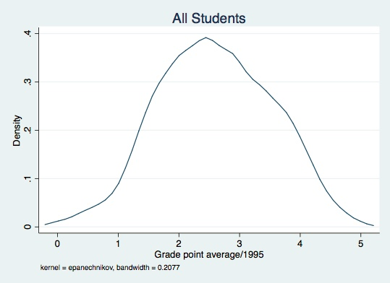
Figure 1: GPA for all Students

To distinguish students who live near compatriots from those who do not, I use a survey question from the study. The question asks the parent of the child to answer whether the following statement is true or false ``Many people from my country live in this neighborhood." Figure 2 shows the GPA densities for students whose parents answered True or False respectively.

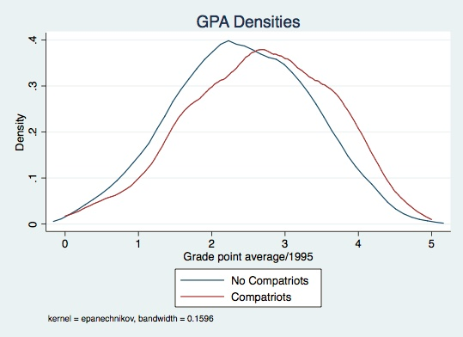
Figure 2: GPA by Compatriots

Additionally, I have constructed a crude measurement of ethnic capital. The survey measured educational attainment of parents using a simple ranking system. Table 1 shows how the system ranks each parent by educational attainment. Not unlike Borjas (1998), I create an index of ethnic capital by averaging the sum of educational attainments of both parents of every child within each national origin. Thus, if a child is Cuban, their ethnic capital is the average sum of the educational attainments of all parents of Cuban children in the sample. Figure 3 shows the ethnic capital value associated with each region of origin.

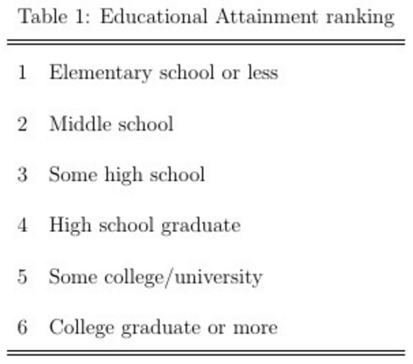

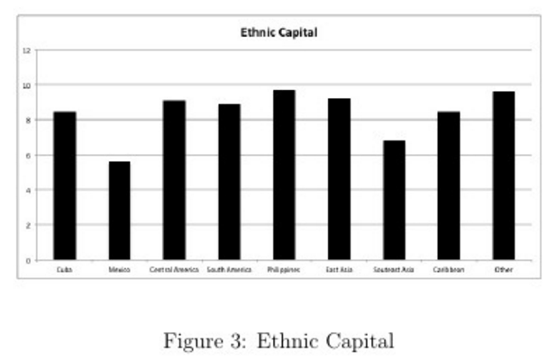

I will attempt to avoid omitted variable bias by controlling for each students' personal and family characteristics. These include age, grade in school, gender, length of stay, family structure, parental birthplace, parental education, and an index of Socio-Economic Status (SES) that includes factors such as home ownership and income. Tables 2 and 3 summarize the features of the data for all students, those living near compatriots, and those not living near compatriots. I have selected these controls based on Cortes (2006), who uses the parts of the same dataset for her analysis of the effects of enclave schools.

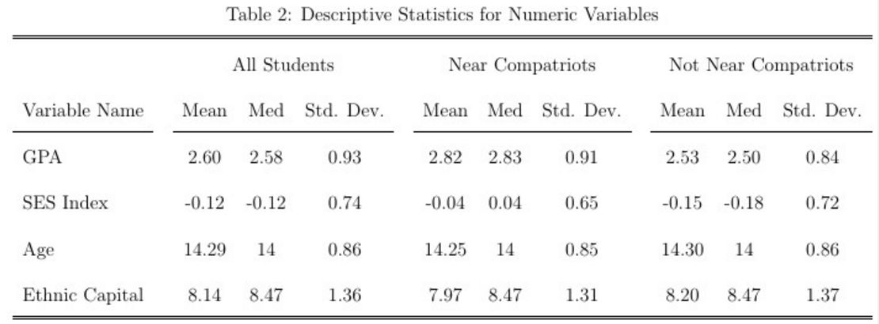

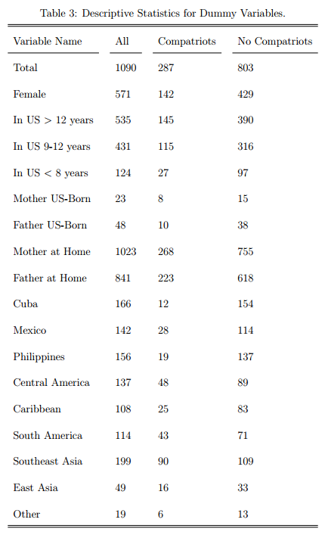

V. Regressions
In this section I will describe six Ordinary Least Squares regressions that examine the effect of living near compatriots on immigrant children's grade point average. Each regression uses 1995 GPA as the dependent variable. The regressions are organized into two waves. The first wave examines whether living near compatriots is associated with higher GPA and finds evidence that it is. The second wave takes into account the theoretical argument that living near compatriots matters only because of increased access to ethnic capital. Table 4 contains the four regressions for the first wave.
For models 1-4, I use OLS estimation to test whether having many neighbors from an immigrant child's home country has a positive effect on grade point average. I begin with a simple 1-variable model and then progressively add controls. Model 1 has no controls at all. Model 2 adds a dummy variable for each school and a dummy variable for each grade in school. Model 3 adds the family and personal characteristics including sex, age, the socio-economic status index, dummies for length of stay, dummies for parental educational attainment, which parent(s) live with the child, and which parent was born in the United States. Model 4 adds a dummy variable for each of the nine national origin categories, as described in Section 4.
Models 5 and 6 take into account ethnic capital, which is the average level of education of adults in a child's ethnic community. In particular, these models seek to test the theoretical justification for the Compatriots variable, which is that living near fellow countrymen increases educational attainment because of greater access to ethnic capital. Model 5 includes all of the controls from Model 4, adds the Ethnic Capital index, and replaces the Compatriots dummy with an interaction between Ethnic Capital and Compatriots. Model 6 adds the Compatriots dummy back in. To conserve space, coefficients and t-values for sex, age, and SES index are not shown. The omitted category for length of stay in the United States is greater than 12 years.
Since Ethnic Capital is the same for all children with the same origin category, this variable is linearly dependent with the national origin dummies. Therefore, one of these is dropped from the regression. This is why Model 5 has a K of 62 instead of 63.
I include tables of elasticities and residual plots in the Appendices.
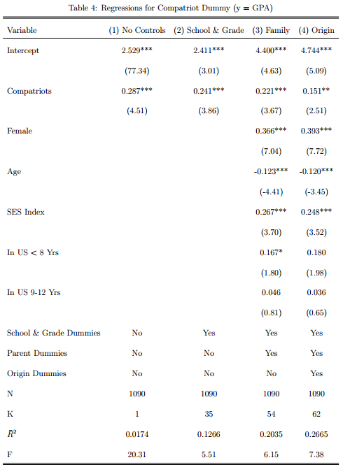
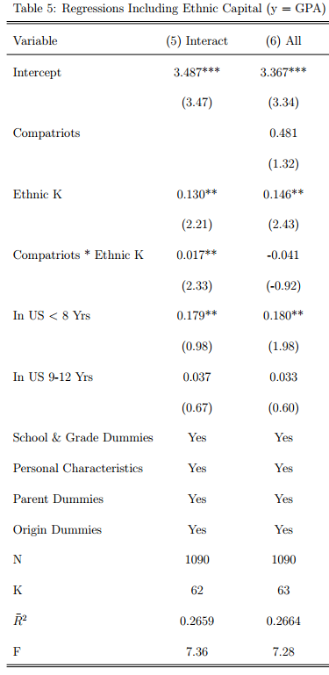
VI. Analysis
To determine whether living in a neighborhood with many compatriots is associated with an increase in an immigrant child's grade point average, I will analyze models 1-4 summarized in Table 4. Model 1 indicates that immigrant children who live in neighborhoods with their compatriots tend to average 0.29 GPA points above those who do not. This coefficient is positive, significant, and large.
Unfortunately, Model 1 cannot be trusted. There are 31 schools in the sample and each may tend to hand out higher or lower GPA's than the others. The theoretical educational production function from Section 3 claims that school characteristics are an input into academic attainment. Furthermore, the children are mostly in the 9th and 10th grades and different grades may tend to get different marks. To account for these, I add a dummy variable for each school and a dummy variable for each grade. The result is Model 2. Now, living near compatriots is associated with an increase in GPA of 0.24 points. Notice that this is only a little smaller than the coefficient for Model 1. Furthermore, its t-statistic is still high even though we have added 34 control variables. Of my six regressions Model 2 is the most parsimonious that gives a meaningful answer to my question.
There is still a very real danger of omitted variable bias. Theory indicates that personal and family characteristics will influence GPA. Perhaps living near compatriots is a privilege of the wealthy and high incomes are associated with good grades. This would bias the compatriots coefficient upward. In order to account for the many possible sources of bias, I add a large number of control variables. Section 5 lists the personal and family characteristics that I add. The result is Model 3. The compatriots coefficient has fallen only slightly to 0.22. Furthermore, it still has a high enough t-statistic for significance at the 1-percent level. Unfortunately, the dummies for length of stay have unexpected positive signs.
In Model 4, I account for national origin. I add a dummy variable for each of nine origin regions---the same regions used by Cortes. These turn out to be quite important. The coefficient for compatriots drops to 0.15 and the t-statistic shrinks. Yet, the coefficient still is significant at the 5-percent level and in accord with theory.
I interpret models 2-4 as progressively pressuring the result in Model 1 by adding waves of control variables that clean up more and more of the omitted variable bias. By Model 4, I have included all of the controls and the coefficient for Compatriots has kept its positive sign and is significant. Furthermore, the coefficients for models 1-4 are all in the same ballpark. Additionally, plots of residuals (included in the appendix) seem to indicate that these results are not due to outliers or distorted by heteroskedasticity. This evidence supports the hypothesis that living near compatriots has a positive influence on an immigrant child's grade point average.
Next, I test how closely this result matches the theory. Borjas (1995) and Aslund (2011) theorize that the reason living near compatriots matters is that it gives a child greater access to educated members of their own background. Thus, if a child is of an ethnicity with many educated adults, then living near compatriots will have a larger positive effect than if the child is from a background with few educated adults.
To test this, I construct Model 5. This regression includes all the controls from Model 4. It adds the crude measurement of ethnic capital described in Section 5. It also removes the compatriots dummy and replaces it with the product of ethnic capital and the Compatriots dummy. The goal of Model 5 is to test 1) whether ethnic capital matters and 2) whether living near compatriots affects the amount that ethnic capital matters. The coefficients of both are positive and significant at the 5-percent level, as expected.
However, Model 5 must be interpreted in the light of Model 6. In Model 6, I add the Compatriots dummy variable back in. Now both Compatriots and the interaction term are insignificant and the interaction term is negative, contrary to the theoretical prediction that living near compatriots grants greater access to ethnic capital. I believe that this is the result of strong multicolinearity between Compatriots and Compatriots * Ethnic Capital.
There are two ways to interpret the results in Model 5 and Model 6. The first is that living near compatriots only affects a child's GPA by increasing their access to ethnic capital. Thus, the positive, significant coefficients in Model 5 are exactly what they appear to be. The insignificant results in Model 6 are the result of multicolinearity between compatriots and its interaction term.
The second interpretation is that living near compatriots has some other influence on GPA beyond access to ethnic capital. The significant coefficients in Model 5 for the interaction term is therefore the result of bias caused by omitting the compatriots variable, not an ethnic capital access effect.
It is difficult to distinguish between these two interpretations because the multicolinearity between Compatriots and Compatriots * Ethnic Capital in Model 6 renders both coefficients insignificant. If only Compatriots was insignificant, then I would conclude that ethnic capital access was the only channel by which living near compatriots affects GPA. If only the interaction term was insignificant, then I would not find evidence that ethnic capital access is affected by living near compatriots.
Thus, I find evidence in support of my hypothesis that living near compatriots increases an immigrant child's educational attainment. However, whether this increase is in fact the result of increased access to ethnic capital as theory predicts is not clear.
VII. Conclusion
In this paper, I asked whether an immigrant child's educational attainment benefits from having many neighbors from his or her own country. Theory indicated that educational attainment is a function of personal, family, school, and neighborhood characteristics. Living near compatriots increases access to more educated members of a child's own ethnicity and therefore is an important component of the neighborhood input. The empirical study by Aslund (2011) finds evidence that living near compatriots does increase GPA percentiles of immigrant children.
I test this hypothesis using Ordinary Least Squares estimation on a set of 1090 cross-sectional observations of immigrant children and find evidence that living near compatriots increases an immigrant child's GPA by 0.15-0.26 points. This is a substantial amount. However, when I tested whether it was access to ethnic capital that was responsible for this effect, the evidence was inconclusive.
This study had several shortcomings. First, the most important independent variable---the dummy indicating that a child lives near compatriots---is a survey question and inherently subjective. Second, I was forced to omit 80% of the original survey observations because of missing data. Third, Cortes (2006) finds that length of stay is positively correlated with academic attainment. However, I find the opposite. The t-scores for length of stay are often insignificant, but the consistency of the bad signs is worrying, especially when they defy common sense. Finally, even though I control for dozens of variables, there is still the possibility that the Compatriots dummy is picking up the effects of an omitted variable.
Future studies on the effects of neighborhood choice on the grades of immigrant children would be enlightening. In particular, a sample that did not require 80% omission, included more family control variables and that was large enough to avoid having its standard errors too badly inflated by multicolinearity would be helpful. Most importantly, a better measure of ethnic capital developed within the sample would go a long way toward sorting out whether the positive influence of nearby compatriots is the result of greater access to highly educated countrymen or some other effect.

Appendix I: Elasticities:

Table 6 includes elasticities at the means for selected variables in Models 1-6. See Tables 4 and 5 for full descriptions of the regressions. For the dummy variables, the elasticity is the percent change in GPA resulting from an increase of 1 unit in the dummy variable. For the numeric variables, the elasticity is the percent change in GPA resulting from a percent change in the numeric variable. Note that the Socio-Economic Status index and Ethnic Capital are constructed indices and their magnitudes do not have direct interpretations. Also notice that the sign for the elasticity of the SES is negative even though the coefficient is positive. This is because the SES index is negative at its mean. See Table 2 for summary statistics regarding SES.

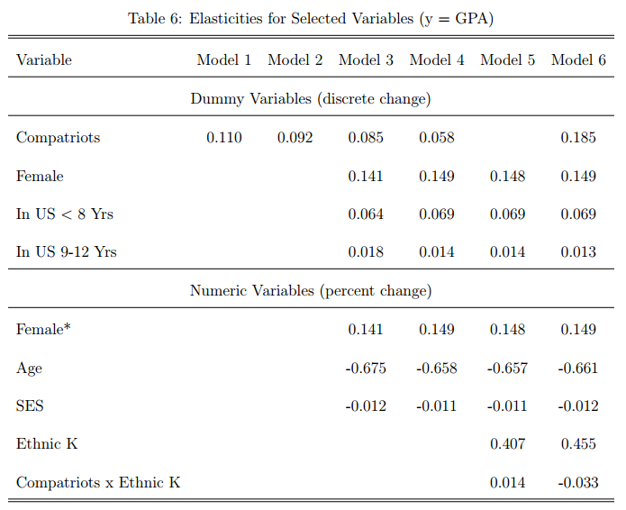

Appendix II: Residual Plots

Figures 4-9 show plots of the residuals vs. the fitted values for regressions 1-6. Notice that the residuals appear to become mostly normally distributed once I add personal and family controls starting in Model 3.

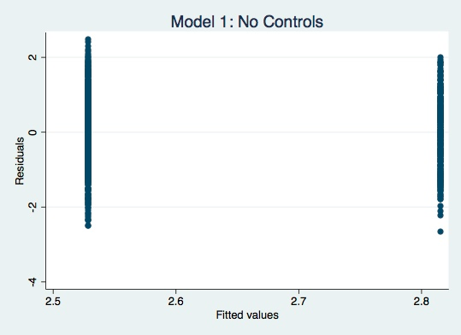
Figure 4: Residuals for Model 1

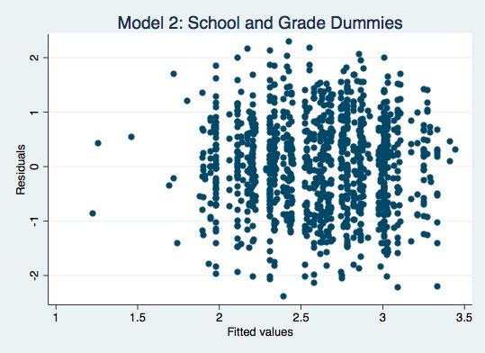
Figure 5: Residuals for Model 2

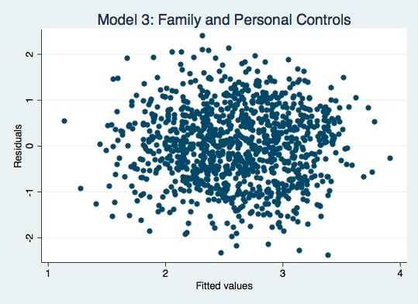
Figure 6: Residuals for Model 3

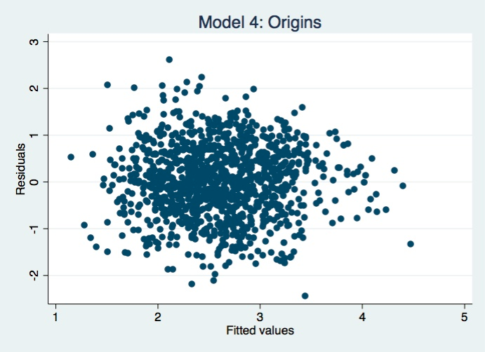
Figure 7: Residuals for Model 4

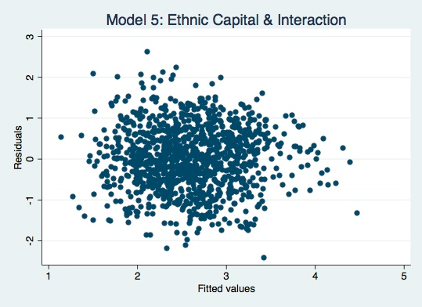
Figure 8: Residuals for Model 5

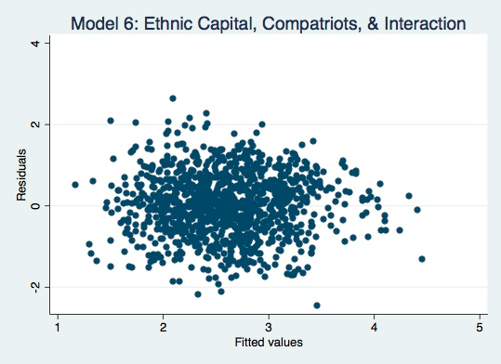
Figure 9: Residuals for Model 6

What Rationale is used by Boards of Trustees to Decide Raises for Not-for-Profit College Presidents?

Nicholas Michalesko ‘17
Introduction to Econometrics

Studying executive compensation is central to our understanding of the linkage between productivity and pay. The connection in the not-for-profit sector, specifically in the case of college presidents, is especially important. Peer-reviewed studies have blamed boards of trustees for the increases in college presidents’ compensation packages. This paper uses a hedonic demand specification of performance indicators derived from a linear dynamical system of ordinary differential equations to explain this situation theoretically. Previous studies often use cross-sectional data and have had little luck in finding significance in performance indicators. This paper analyzes the pay-to-performance relationship using panel data and random effects regressions from over 500 different private college presidents using several performance indicators. The analysis gives minimal indication of such a relation. The regression also tests and finds statistically significant evidence that president compensation responds to compensation among peer groups.

I. Introduction
Along with growing attention to income inequality in general, the public’s spotlight has been directed at the pay of college presidents. Several mainstream news sources have joined in on reporting the issue. The Huffington Post noted that the number of private college presidents making more than $1 million increased from 36 in 2011 to 42 in 2012 (Kingkade 2013). Also, referencing a study published by the think tank the Institute for Policy Studies (IPS), The New York Times reported a link between increases in student debt and president pay (Lewin 2014).
Due to these developments, presidents and boards of trustees alike appear to be protecting their image. For example, the President of Kentucky State University Raymond Burse cut his own salary by a quarter to give to the lowest paid workers at his college a raise (Cunningham 2014). The trustees of Massachusetts Bay Community College also made a move to tie their president’s salary to measures of his performance (Trounson 2013).
This begs the question: do trustees actually take performance into account when deciding their president’s salaries, or is Massachusetts Bay an outlier? If performance is not used, what drives these increases in pay? I will answer these questions beginning with relevant literature in section II, a theory based on a hedonic demand equation that uses a linear dynamical system of ordinary differential equations in section III, unbalanced panel data from 2006-2012 in section IV, and finally a random effects regression of these data in section V.
II. Literature Review
Analogous to the interest among economists looking for a connection between performance and pay for CEOS of private firms, economists also study the compensation patterns of higher education institutions. There is no agreed upon measure for the overall productivity of college presidents, unlike the study of CEO compensation that commonly uses indicators of firm performance to show productivity, such as the accounting rate of return on capital (Bertrand and Mullainathan 2001). So far, papers find evidence of compensation being demonstrated by characteristics of the institution the president heads and some indirect measures of human capital, yet, none find significance in measures of the performance of colleges.
The characteristics of institutions college presidents preside over are shown to determine pay. Most of these variables align with attributes of the college including if the school is private or public, the size of the school’s endowment, the type of institution, the school’s expenditures and percentage of the school’s revenue that come from gifts. Other significant variables deal with the human capital of the president such as the president’s time in the position, if the president had a prior presidency, and if the president is a member of the clergy (Pfeffer and Ross 1988; Tang 2000; Ehrenberg, Cheslock and Epifantseva 2001; Bartlett and Sorokina 2005; Galle and Walker 2014). The actual job that the president is doing is not taken into account by these variables.
Variables that are meant to be indicators for performance are not found to be significant (Ehrenberg, Cheslock and Epifantseva 2001; Pfeffer and Ross 1988; Bartlett and Sorokina 2005; Galle and Walker 2014). While it is true that certain institutions that are more complex require greater amounts of work from a president – which can be approximated from characteristics such as the size and the type of college – it does not necessarily indicate if president is better or worse. One model uses the fact that the president of a college plays a decisive role in a school’s fund-raising success as a variable to show the marginal revenue product. To explain this, the authors of this paper use the total amount of gifts and changes in the endowment, but for reasons including the rate of return and the spending rate of the endowment, there are many factors outside of the president’s control in terms of the endowment. Regardless, their performance measures did not end up being statistically significant (Ehrenberg, Cheslock, Epifantseva 2001). While the productivity variables these papers use do not comprise all of the responsibilities of a president, the fact that none of the disparate methods has found a verifiable link between pay and performance may possibly point to such a link’s lack of existence.
In contrast, Tang (2000) finds a significant relationship between performance and pay controlling for traits of the school such as academic reputation, the type of institution, and the school’s expenditures. The issues with these conclusions come from the fact that other papers use these variables to control for differences across schools, and not to measure performance. Furthermore, this paper asserts that these large salaries were completely deserved since schools are in competition with private employers for talent (Tang 2000). Bradford (2002) seems to support this conclusion by showing that elite private schools attract presidents with skills and experience that are comparable to top corporate CEOs, but on average college president compensation is less than 5% of the manager of a top private firm. Instead of implying that college presidents are irrational for working in the not-for-profit sector, Galle and Walker (2014) explain this phenomenon with the various non-monetary rewards received by presidents, which could include fame and satisfaction of working in the non-profit sector. Any type of competition difference between not-for-profit organizations and private corporations can then be explained by the satisfaction of working in this sector, shown by the fact that presidents who have similar expertise as CEOs choose to work for much smaller remuneration, and commonly for longer tenures.
How then do boards of trustees decide their president’s salary? Taking into account the difficulty that several economists have had in answering this question, it is uncertain if trustees have a better method. Finding out the exact marginal revenue product is costly and the boards are often unpaid and only meet a few times per year. In fact, in a survey of private institutions, it was found that almost 20 percent of schools that answered did not require a performance review of their presidents (Ehrenberg, Cheslock, Epifantseva 2001).
One important facet of the board’s decision comes from Intermediate Sanctions regulations issued by the IRS in January 2002. The regulations force boards of trustees of not-for-profits to provide a defensible methodology to back-up executive compensation. The result, due in part by the costliness of alternative methods, is the widespread use of competitive benchmarking using peer groups (Galle and Walker 2014). As Frumkin and Clark (1999) note, when deciding the salary of their CEO, most non-profits begin with the compensation of institutions believed to be similar. Combine this with many boards not wanting their own president to be considered “underpaid,” which means targeting the 50th, 75th or even 90th percentile of their peer group, and the result is skyrocketing pay year to year for presidents (Elson and Ferrere 2012). By using an interaction between a year dummy starting in 2001 and peer group data, Galle and Walker (2014) find statistically significant evidence that the compensation of presidents accelerated after the IRS added these rules. Benchmarking using peer groups could also explain a lack of productivity gains to justify the president salary increases.
Boards of Trustees likely turn to these methods due to difficulties in separating out performance from luck. Using a case study of the oil industry, Bertrand and Mullainathan (2001) find that CEO compensation goes up when the price of crude oil increases but does not always decrease when the price of oil decreases. This study is furthered by Bizjak, Lemmon, and Naveen (2008) who find that private managers are insulated from bad luck, and the use of peer groups cause pay increases that are not substantiated by any improvement in firm performance. Even if just some boards of trustees look for performance measures to decide presidential compensation, and reward their presidents for it, this will cause even greater increases for any schools that use the successful school in their peer group. The entangling of performance and luck may cause even greater compensation raises when combined with competitive benchmarking between peers.
The effects of benchmarking have been alluded to in president compensation literature but thus far they have not been directly studied. Another area for new research is in regards to the determinants of pay raises instead of using total compensation data. I will use a theory based in ordinary differential equations and hedonic demand and test this theory using panel data.
III. Theory
A board of trustees is the deciding agent of a president’s compensation. Boards of trustees are the greatest stakeholders in not-for-profits and their main task is to maximize the value of a college. I will denote the value of a college using the letter V in equation (1) below. There are several components that work together to decide a college’s value: prestige (P), effectiveness (E) and revenue (R).
(1)
$V(P,E,R)$
A college’s prestige is its overall reputation and name-recognition. Boards of trustees value prestige to attract top students and professors. Effectiveness includes the college’s quality in performing the duties students pay tuition for. This could include graduating students on time and making sure students are prepared for life afterwards. The last parameter within a college’s value is the amount of revenue that is generated. A steady revenue stream is imperative for the sustainability and operations of a college. Since presidents are the top managers of colleges, changes in the overall value of colleges ultimately rest in their hands.
Trustees also have a few constraints in their decision, which I will use C to express in equation (2) below. These include constraints of time and effort (T), and measurement (M).
(2)
$C(T,M)$
Trustees are constrained by time and effort because they only meet a few times per year. This parameter also includes the principal-agent problem caused by trustees’ absence of consequences for their decisions, since the colleges they govern are not-for-profits and they are not direct shareholders in the college. Although trustees certainly want to optimize the value of a college, they often have other jobs, and are unpaid. Another difficulty is the measurement of the performance of executives. Following Bertrand and Mullainathan (2001), the factors determining a managers’ performance are not always easily separated by luck. Therefore, trustees only have a bounded rationality in determining a college president’s salary.
Thus, a board of trustees optimizes ϕ in equation (3) below to maximize the value of the college V given constraints C, which have weight $λ$ on them.
(3)
$$ϕ_{max}=V\left(P,E,R\right)- λC\left(T,M\right)$$
Guiding Equation
The optimization of ϕ results in a benchmarking effect variable. Equation (4) shows what the effect of benchmarking might be for a president compensation x₁ in a peer group of n schools. The peer group variable comes from both parameters of the constraint time and effort (T) and measurement (M). The use of peer groups is prevalent in not-for-profit as well as private CEOs because it is quick and also gives a seemingly objective valuation of a president as is required by IRS intermediate sanction regulations.
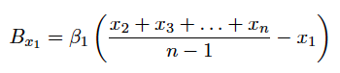
The optimization of ϕ also results in other factors shown in the system of hedonic demand equations (5) with weights β on each factor that determine the rate of change of compensation for each president in a peer group N of n schools. The effects of benchmarking have the weight β1 on them. The next weight β₂ is the unwillingness of trustees to decrease their president’s compensation if it is above the average of their peer group. Therefore, the elements η in the vector that is scaled by β₂ are 1 if the president has an above average compensation and 0 if the president does not.
(4)
The actual competence of presidents is measured by the sum of performance and luck denoted p with weight β ₃. We must include the luck parameter because of boards’ measurement limitations M. These values would express the ability of presidents to contribute to a college’s value, which is made up of prestige, effectiveness and revenue.
Trustees also commonly reward presidents for continued time in service, because this is another seemingly objective measure of human capital, because presidents are believed to gain experience from a continued tenure. β ₄ is the weight trustees put on the time in position factor t.
The final result of optimization is a vector for institutional characteristics c. Since different schools are more or less complex to manage, the resulting compensation should reflect these facts. The boards of trustees must pay presidents more for demanding roles in order to attract them (Pfeffer and Ross 1988). Therefore, the true equation for president compensation is:
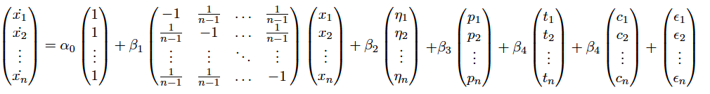
(5)
The outcomes of different weights in equation (5) are shown in the phase portraits of president compensation in Figure 1. The first panel, Figure 1.1, shows the intended outcome of the IRS’s intermediate sanction, which is a “regression to the mean” (Frumkin and Clark 1999). This occurs with the conditions 𝛽₁ > 0, 𝛽₂ = 0, ∀ ẋ ∈ N: ɑ₀+ 𝛽₃ p + 𝛽₄ t + 𝛽₅ c = 0, or when all of the other factors are zero and the only criteria trustees use is benchmarking to peer institutions. There is a stable fixed point at the mean salary of all institutions in this scenario.
Another outcome is shown in Figure 1.2 with the conditions 𝛽₁ > 0, 𝛽₂ = 0, ∃ ẋ ∈ N: ɑ₀+ 𝛽₃ p + 𝛽₄ t + 𝛽₅ c > 0. This would be the outcome if at least one board of trustees rewarded their president for another factor aside from benchmarking. As can be seen, the long-term behavior is following an unstable manifold towards infinity. Since all other colleges benchmark to this school, their pay ratchets upwards as well. The last Figure 1.3 has the conditions 𝛽₁ > 0, 𝛽₂ > 0, ∃ ẋ ∈ N: ɑ₀+ 𝛽₃ p + 𝛽₄ t + 𝛽₅ c > 0. This has the same effect as the last scenario with salaries approaching infinity in the long-term, except that above average president salaries are not cut initially as they are in Figure 1.2.
IV. Summary Statistics
i. Choices of Measurable Variables
Since the true equation does not have readily available data to measure each factor, I use proxies for my regression analysis. For performance and luck, I use changes in the endowment per student, private gifts per student, freshman ACT/SAT scores, graduation rates and retention rates. According to theory, a college’s value is made up of prestige, effectiveness and revenue. Changes in endowment per student and private gifts per student measure the performance and luck of presidents at gaining revenue for the school. The freshman test scores indicate the improvement of a college’s prestige. Lastly, the effectiveness of a college is marked by its graduation rates and retention rates.
Institutional characteristics are also measured using proxies. These include tuition, endowment per student, Carnegie Classification, region data and enrollment. The differences between schools in these areas could point to more complexity or more wealth for schools.
Boards of trustees do not release information on whether they use peer groups or not and what their peer groups are for each year. I can estimate this effect by subtracting the current year’s average compensation in each Carnegie class by the compensation of the president from the year before.
My specification for raises in college president compensation is then:
$$Δ{Compensation}_{it}= α_{o}+ β_{1}Δ{Endowment}_{it}+ β_{2}Δ{Private gifts}_{it}+ β_{3}Δ{Freshman ACT/SAT Scores}_{it}+β_{4}Δ{Graduation Rate}_{it}+ β_{5}Δ{Retention Rate}_{it}+ β_{6}({{Average Compensation}_{t}-{Compensation}_{t-1})}_{i}+ {β_{7}Time in Position}_{it}+ β_{9}{Enrollment}_{it}+ β_{10}{Endowment per Student}_{it}+ β_{11}{Tuition}_{it}+ β_{12}{Carnegie Classiciation}_{it}+ β_{13}Region+ ε_{i}$$
IPEDS Data
I use unbalanced panel data in my regression analysis. The data come from two online databases: the Chronicle of Higher Education and IPEDS (Integrated Postsecondary Education Data System). The Chronicle of Higher Education is used to find data about presidents including total compensation and the lengths of president’s tenure at each institution. IPEDS is used for every other variable, which were endowment assets, graduation rate, retention rate, SAT scores, tuition, enrollment, region and Carnegie Classification. I choose to use data from 2006-2012, because 2012 is the most recent year that data were available for compensation and the SAT replaced their verbal portion for a critical reading section in 2006, so this gives the most homogeneous data set possible. All data reported are in real terms using CPI with base year 2012.
IPEDS is an integrated database that houses data from surveys conducted by the U.S. Department’s National Center for Education Statistics (NCES). IPEDS is able to get their data through the Higher Education Act of 1965, which requires any school that participates in federal financial aid programs (like Pell grants and federal student loans) to fill out these surveys. Therefore, all of the data from IPEDS are self-reported by colleges, which could be biased if colleges try to inflate their performance results. The surveys include data about enrollment, graduation rates, finances, tuition prices, and many other criteria. Some of the variables used in this paper are not required by the Higher Education Act of 1965 however, so of the 7,500 schools that complete IPEDS surveys each year, many less have complete data sets (IPEDS 2015). Due to this issue I removed any colleges that did not have complete data sets for all variables used.
Schools are required to report financial data to IPEDS, of which I use endowment assets, private gifts and tuition. The endowment data I use are the gross endowment assets at the beginning of the fiscal year. It also includes any funds functioning as the endowment and any funds from affiliated organizations. The next financial variable is private gifts, which include gifts made by alumni as well as grants and contracts. These could be funds used for research projects, training programs, or building projects (IPEDS 2015). I divide both of these variables by enrollment to control for larger schools having more assets. These two variables as well as the percent change are reported in Table 1.
Test score data are also taken from IPEDS. IPEDS reports both SAT critical reading and Math, as well as ACT data, of which both were collected (IPEDS 2015). Whenever possible, I use the sum of SAT critical reading and math scores, but for schools that only report the ACT I convert into SAT scores. The scores reported are those in the 25th and 75th percentile from each school. Galle and Walker (2014) use the 75th percentile variable in their data, and have a mean of 1293, which is very close and well within one standard deviation of the 75th percentile mean in my data of 1258. Following the specification of Ehrenberg, Cheslock, and Epifantseva (2001), I average the two total SAT percentiles together, which I display in Table 1. Averaging them together gives a better sense of both the bottom and the top end of students, instead of just accounting for one end.
The graduation and retention rate data come from IPEDS as well. Graduation rate data became required in IPEDS surveys after the Student Right-to-Know legislation came about in 1997, so these data, like all other IPEDS data, are self-reported. The graduation rate takes into account the entire student body and is determined by the percentage of students that complete their program within 6 years. The mean for graduation rate of 67% and standard deviation of 16% are shown in Table 1. The graduation rate data is incredibly close to Galle and Walker (2014) who have a mean of 69% and standard deviation of 16%. The retention rate measures the percentage of first-time degree-seeking students from the previous fall who enroll again in the current fall. The average and standard deviations of these variables are reported in Table 1.
Other variables that are used to control for institutional characteristics are tuition, enrollment, region and Carnegie classification. The tuition and fees data represent the amount charged to a typical student for a full-time credit load. Of course, this may not be the same for all students, but it gives the best representation and easiest comparison between schools. Any of the fees included in these numbers are ones that only outliers do not pay. Next, total enrollment includes full and part-time students, undergraduates as well as post-graduates. The region variable includes eight different regions of America (IPEDS 2015). The averages and standard deviations for these variables are displayed in Table 1.
Finally, the General Carnegie Classification is reported, which uses 8 different types of schools that include: baccalaureate college, including arts & sciences and diverse fields; doctoral/research universities; small, medium and large master’s colleges and universities; and research universities with high or very high research activity. In order to determine their classification, the Carnegie Institution uses data from the NSF Survey of Research and Development expenditures at colleges and universities and IPEDS data to determine their categories that are based on size, focus and research activity (IU Center for Postsecondary Research 2014).
ii. Chronicle of Higher Education Data
Data about presidents come from the Chronicle of Higher Education. The Chronicle of Higher Education compiles a list of hundreds of salaries of college presidents, which come from the IRS form 990 that all not-for-profit organizations must publicly release. One issue with the IRS form 990 data is that the IRS changed a few of the filing rules in 2008. Another problem with the Chronicle’s reporting is that in 2010 it switched from reporting fiscal year compensation to calendar year compensation (Chronicle of Higher Education 2014). Ehrenberg, Cheslock, Epifantseva (2001) note that IRS990 forms sometimes undervalue or misreport compensation and also do not report the compensation presidents receive from sitting on any boards, even if they are required for the position. Because only not-for-profit organizations are required to file IRS990 forms, I constrained my sample to private not-for-profit colleges. The Chronicle of Higher Education choose presidents to report based on IPEDS reporting of the 500 largest endowments in 2012 and before 2012 it reported all private non-profits with expenditures greater than $50 million. Any information about each president’s tenure comes from college websites, university offices, or newspaper archives (Chronicle of Higher Education 2014).
Compensation data include the total compensation presidents receive from colleges, including benefits, deferred compensation, housing, etc. as well as their base pay. I exclude any presidents that did not receive compensation, which mostly includes members of the clergy who have taken vows of poverty (Chronicle of Higher Education 2014). Total Compensation varies widely as seen in Table 1 with a mean of $454,956 and standard deviation of $361488.5. Similar to other financial variables, it varies greatly due in part by the recession, regional differences, and institutional differences. The compensation data lie within one standard deviation of the mean Galle and Walker (2014) report for 1998-2007, which is $404,127 in 2007 dollars. The compensation for presidents has increased a great deal insofar that less recent data, such as that given by Ehrenberg, Cheslock and Epifanstseva (2001) or Pfeffer and Ross (1988), even after adjusting for inflation, are many magnitudes smaller than the mean in my data set.
The raises in compensation are even more volatile than total compensation with a mean raise in pay for presidents of $46,609 and standard deviation of $287,674. Many presidents receive negative changes in compensation. One example is the University of Chicago’s president Robert J. Zimmer whose 2011 compensation of $3,358,723 decreased to $1,369,856 in 2012. This decrease in compensation is shown in Table 1 as the minimum of the change in compensation. Large decreases like this are rare and only occur with presidents whose salaries are already quite sizable. Ehrenberg, Cheslock and Epifanstseva (2001) calculate their average change in compensation as 25.5%. They do not report their standard deviation, but this value is quite far from what my average percent increase would be of 9.7%. This could be due to the difference in years, of which Ehrenberg, Cheslock and Epifantseva (2001) use data from 1992-1996. It could also be due to differences in sample size, since my dataset has 1710 observations and theirs has 269.
The last variable from the Chronicle of Higher Education is time in position. Some presidents start as interim presidents and then become permanent presidents, making their years active technically -1, but I changed these very few cases to 0 for simplicity. Table 1 shows that the average time in position is 7.1 years with a large standard deviation of 6.5. Tenures seem to have increased in the past decades, since Pfeffer and Ross (1988) report an average tenure of 5.85 years, although 7.1 years is within a standard deviation of this value. Galle and Walker (2014) have a very close average of 7.3 years.
V. Analysis
i. Estimation Issues
Before going over the main results of my regressions I outline a few estimation issues that I encounter. Since my analysis involves panel data, I look for multicollinearity, heteroskedasticity, serial correlation and non-stationarity.
I first check for multicollinearity and find only one case where there is severe multicollinearity. The correlation coefficients between variables are shown in Table 2. Most variables only have moderate correlation besides the peer group effect variable and the above average compensation dummy variable that have a correlation of -0.6536, which is to be expected because the dummy is derived from the peer groups variable. I run multiple regressions with and without this variable to compare the effects of including it.
The next check I do is for heteroskedasticity. Using the Stata add-on xttest3 I perform a modified Wald statistic that checks for group-wise heteroskedasticity. The result is rejecting the null of homoscedasticity with a p-value of 0.0000, signaling severe heteroskedasticity. This violation of a classical assumption is ameliorated by reporting robust standard errors.
Another common estimation issue in panel data is serial correlation. Using the Wooldridge test for autocorrelation in panel data by implementing the xtserial add-on, I discover first-order serial correlation by rejecting the null of no serial correlation with a p-value of 0.0130. Along with the heteroskedasticity problem, the robust standard errors that I use also fix autocorrelation.
The final common estimation issue that I check for is non-stationarity. Using a modified Dickey-Fuller test and a trend term, the total compensation variable is shown to have a unit root due to a failure to reject the null with a p-value of 0.1973. This is not a problem, however, because I am using the change in total compensation. This differenced variable does not have a unit root.

ii. Main Results
My regression results are listed in Table 3 below. Regression (1) excludes the peer group variable and above average compensation dummy. I add in the peer group variable in (2) and then the above average compensation dummy for regression (3).
I choose to use a random effects regression in order to control for constant individual differences between presidents and within effects over time, since theory dictates that president compensation likely depends on both of these types of variation. I perform a Hausman test and the results show no correlation between the error term and explanatory variables, so I can move forward with this approach.
I begin by analyzing the effect of the peer group variable. The peer group variable (the average compensation in each Carnegie class of schools in a year subtracted by the compensation of the president from the year before) is included in regressions (2)-(3) and has a similar magnitude in each, as well as being both positive and statistically significant. This means that for each dollar that a president’s salary from a year earlier is lower than the peer average causes a president’s compensation to be 0.46 dollars higher in the case of regression (3) (or 0.46 dollars lower if the president’s compensation is above the peer group). The peer group variable also appears to be a confounding variable for time in position and tuition, since when it is included in regression (2) these two variables become significant.
The next variable of interest is the above average compensation dummy variable. As expected, when it is included in regression (3) the sign is positive. The magnitude of this variable is 105,672, which means that trustees are on average willing to counteract the mean regression of their peer group up to $105,672. Another effect of adding this variable is that tuition is no longer statistically significant and time in position is only borderline statistically significant. This is likely due to the strong multicollinearity between this variable and the peer group variable, which is a confounder to tuition and time in position.
Also, performance measures do not appear to link to greater pay increases. The performance variables were all of those that measured the change in values, including the changes in graduation rate, retention rate, private gifts per student, endowment per student and SAT scores. None of these are statistically significant and it appears changes in graduation rates were inversely related with change in compensation, changes in retention rate was positive for both, changes in endowment per student was positive and changes in SAT scores were positive as well. The lack of significance for these variables points to a possible lack of consideration of these criteria by trustees.
iii. Robustness
I perform a few robustness checks in order to see which results can hold. The first test I did was changing from percent changes to differences in regression (1) of Table 4. The signs, significance and overall fit remain the same, which means this different specification leads to the same results.
Regressions (2)-(4) use a fixed effects panel estimator on the same specifications as the original table. In regression (4), which includes all of the variables in my guiding equation, the above average compensation dummy is no longer significant, but the performance measures of change in endowment, change in private gifts, and tuition become statistically significant. Surprisingly, the sign on the change in endowment variable is negative, but the sign on the change in private gifts variable is positive. Another difference between this regression and random effects is that the peer group variable has a much larger magnitude of 1.152 instead of 0.46.
VI. Conclusion
Similar to other papers that have analyzed the determinants of college president compensation, I only find weak evidence for a link between performance and pay (Ehrenberg, Cheslock, Epifantseva 2001; Pfeffer, Ross 1988; Bartlett, Sorokina 2005; Galle, Walker 2014). I only find significance for the change in endowment and change in private gifts using a fixed effects regression, and not a random effects regression. The random effects regression is possibly more accurate because there is likely some within variation that needs to be controlled for, since my time period overlaps with the great recession wherein many college’s financial assets were effected. This is especially important for the two variables that ended up being significant, since the value of the endowment and the amount private gifts given to schools are sensitive to macroeconomic conditions.
An important takeaway is the significance of the peer group effect. Along with the weak evidence for the performance measures linking to raises, the significance and magnitude of this variable shows that the increases in pay for presidents that lie below the mean of the peer group may not be substantiated by increases in productivity. Furthermore, the significance, positive sign and large magnitude of the above average compensation variable in the random effects regression shows a possible insulation of presidents with salaries above their peer mean from the peer group effect. This gives evidence for the long-term behavior of president compensation possibly falling somewhere between Figure 1.2 and Figure 1.3 from theory. Following theory, an explanation for the evidence of peer groups could large constraints on time and measurement, but the necessity to produce “objective” results to the IRS.
An important addition to this research that future papers could use are data for the actual peer groups that colleges use. This could be useful for the IRS in order to assess the impact of their intermediate sanctions regulations. My results show that the IRS’s regulations may have the ironic opposite effect of their intent to limit non-profit compensation that Frumkin and Clark (1999) allude to.
Further research in this area could also explore the competitiveness of the market for presidents. Another possible explanation for the significance of the peer group variable could be collusive compensation setting. A model that takes into account the president’s relationship with the board of trustees could possibly answer some of these questions.

References
Bartlett, Robin L., and Olga Sorokina. 2005. Determinants of presidential pay at national liberal arts institutions. Review of Higher Education 29 (1): 53-68.
Bertrand, M.,Mullainathan, S.,. 2001. Are CEOs rewarded for luck? the ones without principals are. The Quarterly Journal of Economics the Quarterly Journal of Economics 116 (3): 901-32.
Bizjak, John M., Michael L. Lemmon, and Lalitha Naveen. 2008. Does the use of peer groups contribute to higher pay and less efficient compensation? Journal of Financial Economics 90 (2) (11): 152-68.
Bradford, Cornell. 2002. Compensation and recruiting: Private universities versus private corporations. UCLA Finance Working Paper.
Chronicle of Higher Education. Executive compensation at private colleges. in The Chronicle of Higher Education [database online]. 2014 [cited March/20 2015]. Available from http://chronicle.com/factfile/private-ec-2014/?cid=inline-promo#id=table.
Cunningham, Lillian. 2014. Kentucky state president to share his salary with school's lowest paid workers. The Washington Post2014.
DeFond, Mark L., and Chul W. Park. 1999. The effect of competition on CEO turnover. Journal of Accounting and Economics 27 (1) (Feb 1999): 35-56.
Ehrenberg, Ronald G., Cheslock, John Jesse,Epifantseva, Julia,. 2001. Paying our presidents: What do trustees value? Review of Higher Education 25 (1): 15-37.
Elhagrasey, Galal M., J. Richard Harrison, and Rogene A. Buchholz. 1998. Power and pay: The politics of CEO compensation. Journal of Management and Governance 2 (4): 309-32.
Elson, Charles M., and Craig K. Ferrere. 2012. Executive superstars, peer groups, and overcompensation: Cause, effect, and solution. J. Corp L.
Frumkin, Peter, and Alice Andre-Clark. 1999. Nonprofit compensation and the market. 21 Hawaii L. Rev. 21 (Winter).
Gabaix, Xavier, and Augustin Landier. 2008. Why has CEO pay increased so much? Quarterly Journal of Economics 123 (1) (Feb 2008): 49-100.
Galle B., Walker D. I.,. 2014. Nonprofit executive pay as an agency problem: Evidence from U.S. colleges and universities. Boston Univ.Law Rev.Boston University Law Review 94 (6): 1881-934.
Gritsko, Natalia, Valentina Kozlova, William Neilson, and Bruno Wichmann. 2013. The CEO arms race. Southern Economic Journal 79 (3) (Jan 2013): 586-99.
IPEDS. Integrated postsecondary education data system. in National Center for Education Statistics [database online]. 2015 [cited March/20 2015]. Available from http://nces.ed.gov/ipeds/.
IU Center for Postsecondary Research. Carnegie classification of institutions of higher education. in Indiana University [database online]. Bloomington, Indiana, 2014 [cited March/20 2015]. Available fromhttp://carnegieclassifications.iu.edu/.
Kingkade, Tyler. 2013. 42 private college presidents make more than $1M, and harvard's isn't one of them. The Huffington Post2013.
Lewin, Tamar. 2014. Study links growth in student debt to pay for university presidents. The New York Times2014.
Malmendier, Ulrike, and Geoffrey Tate. 2009. Superstar CEOs. Quarterly Journal of Economics 124 (4) (Nov 2009): 1593-638.
Manny, Jill S., 2007. Nonprofit payments to insiders and outsiders: Is the sky the limit? Fordham Law Review / 76 (2): 735.
Pfeffer, Jeffrey, and Jerry Ross. 1988. The compensation of college and university presidents. Research in Higher Education 29 (1): 79-91.
Pindyck, Robert S., Rubinfeld,Daniel L.,. 2013. Microeconomics. Boston: Pearson.
Tang, Thomas Li-Ping, David Shin-Hsiung Tang, and Cindy Shin-Yi Tang. 2000. Factors related to university presidents' pay: An examination of private colleges and universities. Higher Education 39 (4): 393-415.
Westphal, J. D., Zajac,E.J.,. 1994. Substance and symbolism in CEOs' long-term incentive plans. Administrative Science Quarterly 39 (3): 367.

Figure 1: Benchmarking Effect Phase Portraits
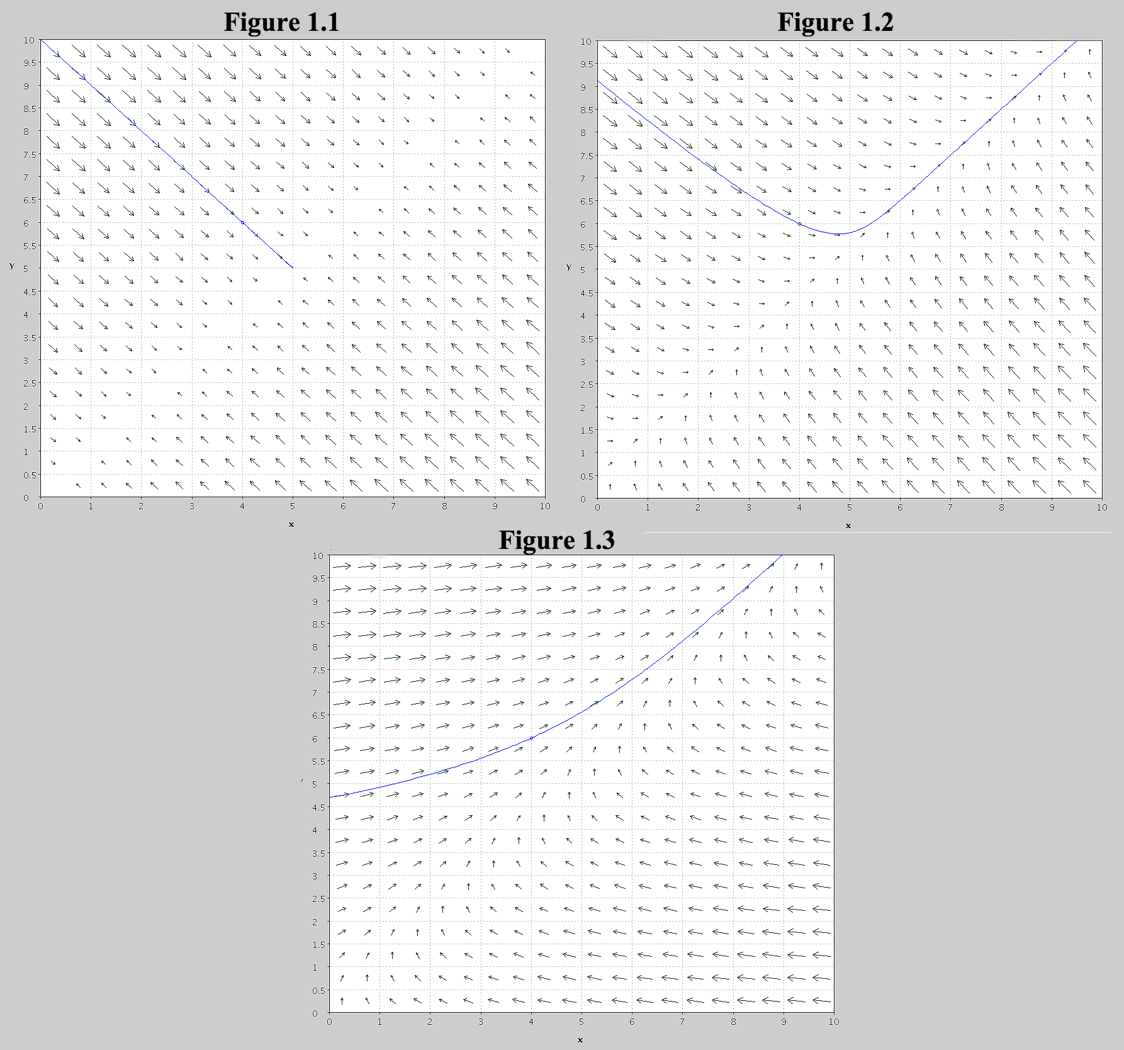

Table 1: Summary of Variables
Variable | Observations | Mean | Std. Dev. | Min | Max
Compensation | 2432 | 454956.7 | 361488.5 | 1281.236 | 7143312
ΔCompensation | 1659 | 51235.66 | 282227.7 | -1921008 | 5426080
Time in Position | 2432 | 7.180921 | 6.513423 | 0 | 44
Enrollment | 2432 | 5084.81 | 5626.168 | 244 | 44516
Retention Rate | 2432 | 81.82936 | 9.541746 | 46 | 100
%ΔRetention Rate | 1659 | 0.0019152 | 0.1015136 | -0.5104167 | 0.6607143
Graduation Rate | 2432 | 67.32031 | 15.75699 | 24 | 98
%ΔGraduation Rate | 1659 | 0.006676 | 0.0847354 | -0.4861111 | 0.8461539
Gifts per Student | 2432 | 6001.611 | 24568.48 | 0 | 1141238
%ΔGifts per Student | 1653 | 0.6520315 | 17.19452 | -1 | 696.4339
Endowment per Student | 2432 | 100162 | 207670.9 | 34.0285 | 2431641
%ΔEndowment per student | 1659 | 0.8263678 | 21.28015 | -0.9990651 | 699.7087
Average SAT | 2432 | 1671.614 | 217.5946 | 1055 | 2260
%ΔSAT | 1659 | -0.0004975 | 0.0273887 | -0.1895735 | 0.2368421
Peer Group | 1659 | 26801.75 | 239027.8 | -2356445 | 880066.3

Table 2: Correlation Between Regressors
 | Time in Position | Change Grad. Rate | Change Ret. Rate | Change Gifts | Change Endow. | Change SAT Score | Endow. per Student
Time in Position | 1
Change Grad. Rate | 0.0144 | 1
Change Ret. Rate | 0.0077 | 0.0647 | 1
Change in Gifts | -0.019 | 0.0053 | 0.0029 | 1
Change Endowment | -0.0203 | -0.0313 | 0.0243 | -0.0006 | 1
Change SAT Score | 0.0284 | -0.006 | -0.0382 | 0.0093 | 0.0083 | 1
Endowment per Student | -0.045 | -0.0107 | 0.0718 | -0.0041 | -0.0122 | 0.0414 | 1
Gifts per Student | 0.0042 | 0.0024 | 0.0481 | 0.0133 | -0.0101 | 0.0509 | 0.3093
Tuition | -0.1234 | -0.0323 | 0.1082 | 0.0013 | -0.0043 | 0.0581 | 0.3379
Enrollment | -0.0075 | 0.0146 | 0.0145 | -0.0074 | -0.01 | 0.047 | 0.0663
Peer Group Effect | -0.1832 | 0.0094 | -0.0362 | -0.0026 | -0.007 | -0.0159 | -0.0058
Above Average Dummy | 0.1665 | 0.0137 | 0.039 | -0.016 | 0.0444 | 0.0407 | 0.0852

 | Gifts per Student | Tuition | Enrollment | Peer Group Effect | Above Average Dummy
Gifts per Student | 1
Tuition | 0.1244 | 1
Enrollment | 0.0245 | 0.1789 | 1
Peer Group Effect | 0.038 | -0.1235 | -0.0637 | 1
Above Average Dummy | 0.0467 | 0.2369 | 0.0706 | -0.6536 | 1

Table 3: Main Results (Random Effects Regression)
Dependent Variable: Change in President’s Total Compensation | (1) | (2) | (3)
Time in Position | 332.7 | 2,741** | 2,147*
 | (1,097) | (1,254) | (1,201)
%ΔGraduation Rate | -54,708 | -57,129 | -69,028
 | (42,411) | (41,192) | (42,629)
%ΔRetention Rate | 2,243 | 12,608 | 16,922
 | (84,006) | (76,753) | (75,405)
%ΔPrivate Gifts per Student | -20.28 | -13.80 | 39.26
 | (37.33) | (38.79) | (45.16)
%ΔEndowment per Student | 12.80 | 56.25 | -42.23
 | (88.77) | (93.29) | (79.49)
%ΔSAT Score | 58,929 | 70,585 | 40,631
 | (130,296) | (120,661) | (120,997)
Endowment Per Student | -0.0352 | -0.000539 | -0.0171
 | (0.0318) | (0.0489) | (0.0459)
Private Gifts Per Student | 0.166 | 0.241 | -0.0344
 | (1.064) | (1.257) | (1.262)
Tuition | -0.208 | 3.010** | 1.560
 | (1.066) | (1.197) | (1.049)
Enrollment | 1.386 | 6.269 | 5.363
 | (2.894) | (4.318) | (4.305)
Peer Group Effect |  | 0.337*** | 0.460***
 |  | (0.0940) | (0.109)
Above Average Compensation Dummy |  |  | 105,672***
 |  |  | (30,253)
Constant | 58,662 | -91,260* | -75,033
 | (38,732) | (54,373) | (51,454)
Observations | 1,653 | 1,653 | 1,653
Within R-squared | 0.0001 | 0.3283 | 0.2896
Overall R-squared | 0.0164 | 0.0825 | 0.0992
Region dummies Prob > χ² | 0.1859 | 0.1087 | 0.0832*
Carnegie Classification dummies Prob > χ² | 0.3903 | 0.9932 | 0.8552
Number of Presidents | 538 | 538 | 539
Robust standard errors in parentheses
*** p<0.01, ** p<0.05, * p<0.1

Table 4: Robustness Regressions
Dependent Variable: Change in President’s Total Compensation | (1) | (2) | (3) | (4)
Time in Position | 2,181* | -11,090 | -2,393 | -3,328
 | (1,201) | (7,496) | (5,063) | (5,213)
%ΔGraduation Rate |  | -73,928 | -55,948 | -62,011
 |  | (47,378) | (44,649) | (45,765)
%ΔRetention Rate |  | -52,839 | -30,715 | -30,976
 |  | (108,382) | (82,085) | (81,840)
%ΔPrivate Gifts per Student |  | -29.08 | 72.49* | 107.3**
 |  | (46.77) | (41.15) | (49.67)
%ΔEndowment per Student |  | -158.5*** | -46.90*** | -84.84***
 |  | (28.89) | (15.63) | (27.47)
%ΔSAT Score |  | -55,560 | -78,006 | -103,680
 |  | (230,087) | (198,093) | (194,458)
ΔGraduation Rate | -1,267
 | (874.7)
ΔRetention Rate | 156.4
 | (987.2)
ΔPrivate Gifts per Student | -5.43e-05
 | (0.000129)
ΔEndowment per Student | 6.72e-06
 | (6.81e-06)
ΔSAT Score | 21.24
 | (81.21)
Endowment per Student | -0.0237 | 0.0359 | 0.121 | 0.123
 | (0.0464) | (0.142) | (0.0984) | (0.0981)
Private Gifts per Student | 0.0879 | -0.471 | -1.301 | -1.282
 | (1.271) | (0.991) | (1.187) | (1.168)
Tuition | 1.653 | 2.065 | 15.70*** | 15.29***
 | (1.027) | (4.893) | (5.430) | (5.458)
Enrollment | 5.386 | 30.74 | 19.74 | 21.15
 | (4.305) | (43.66) | (30.47) | (30.30)
Peer Group Effect | 0.459*** |  | 1.125*** | 1.152***
 | (0.109) |  | (0.0705) | (0.0698)
Above Average Compensation Dummy | 105,169*** |  |  | 40,699
 | (30,035) |  |  | (28,437)
Constant | -78,465 | 156,404 | -187,005 | -200,434
 | (50,789) | (242,479) | (203,815) | (199,206)
Observations | 1,659 | 1,653 | 1,653 | 1,653
Panel Effects Estimator | RE | FE | FE | FE
Within/Overall R-squared | 0.2906/0.0992 | 0.008/0.0033 | 0.348/0.0315 | 0.349/0.0352
Number of Presidents | 539 | 538 | 538 | 538

From official New Minnesota Stadium website: http://www.newminnesotastadium.com/
New Minnesota Stadium is the working title for a new stadium under construction for the Minnesota Vikings
Data collected from Macalester Economics Honors student, Clemens Pilgrim
Assisted by Clemens Pilgrim, who helped with finding distances from the stadium to the parcels of land using GIS
We would like to give special thanks to Girls Getting Ahead in Leadership program coordinators and to all of our participants for volunteering their time to help make this research possible.

