

Table of Contents

Foreword
……………..…………………………………………………Professor Mario Solis-Garcia 3

Does increasing police manpower or making more arrests lead to reductions in crime?
…………………………………………………………………………………... Rachel Fehr 4

Order, Separability, and Pizza Preferences …………………………….……………………...…………………………… Ian Calaway 23

Can the Costs of Education Explain the Shape of the Income Distribution?

…………………………………………………...………………………… Stefan Faridani 45

The Development of Healthcare in Canada: A Comparative Economic Approach
……………………………………………………………………..……… Benjamin Goren 63

SUPERVALU, INC: The Needle in a Slow-Growth Industry Haystack
………………………………………………………………...……................ Jacob Simons 75

A Blessing or a Curse? The Effect of Oil Abundance on Economic Growth
………………………………………………………………...……............ Sariyya Atasoy 107

Volume 27 Spring 2017
Published annually by the Macalester College Department of Economics and Omicron Delta Epsilon
Macalester Journal of Economics

Macalester Journal of Economics

Volume 27 Spring 2017

Omicron Delta Epsilon

Muath Ibaid ‘17, President
Eleanore Fuqua ’17, Vice-President
Margaret Abeles ’17, Vice-President
Caroline Chinhuru ’17, Secretary
Editors

Ibrahima Dieye ‘17
Esha Datta ‘17
Aaron Haefner ‘17
Sarah Henrickson ‘1

Economics Faculty and Staff
Paul Aslanian  Emeritus Professor | Jeffery Evans  Professor (NTT) | Jane Kollasch  Department Coordinator | Sarah West  Professor
Amy Damon  Associate Professor | Peter Ferderer  Edward J. Noble Professor, Department Chair | Joyce Minor  Karl Egge Professor | Mario Solis-Garcia  Assistant Professor
Liang Ding  Associate Professor | Gary Krueger  Cargill Professor of International Economics | Karine Moe  F.R. Bigelow Professor | Vasant Sukhatme  Edward J. Noble Emeritus Professor
Karl Egge  F.R, Bigelow Emeritus Professor | Samantha Çakir  Visiting Assistant Professor | Lucas Threinen  Visiting Assistant Professor
A Note from the Editors
During the spring of 2017, we had the pleasure of reading papers submitted by Macalester economics students for this edition of the Macalester Journal of Economics. The papers varied greatly in subject, but all served as a testament to the high level of academic excellence at Macalester, especially within the Economics Department. After much deliberation, we selected the following six papers. We believe they best capture the quality of economics research completed by students in the Macalester Economics Department.

We would like to thank all of the faculty for their integral roles in the development of these research projects. We would also like to thank Jane Kollasch and Professor Mario Solis-Garcia for their support in the creation of this journal.
Ibrahima Dieye ’17 Esha Datta ’17 Aaron Haefner ’17 Sarah Henrickson ’17

Foreword
The Macalester College chapter of Omicron Delta Epsilon, the international honors society in economics, proudly edits the Macalester Journal of Economics every year. This year’s editors – Ibrahima Dieye ’17 (Dakar, Senegal), Esha Datta ’17 (Palo Alto, California), Aaron Hefner ’17 (Mequon, Wisconsin), and Sarah Henrickson ’16 (Chanhassen, Minnesota) – have carefully selected six papers on a variety of important topics. These papers are a sample of the research that our students produced in the last academic year.
The events that we’ve witnessed in the early months of 2017 have proved that health care remains an important policy topic in the United States (and worldwide). Along these lines, Benjamin Goren ’19 (Holt, Michigan) offers a historical comparison between the health care systems of the United States and Canada: two developed economies that share many traits yet are fundamentally different in their policy approach to health. Benjamin takes a dive in history and tracks the evolution of both systems from the 1920s to date, arguing that the differences in health care have been an outcome of historical factors, missed opportunities, and political realities.
Can the costs of higher education shape the income distribution? This question has been asked many times: in a celebrated paper, Jacob Mincer (1985) conjectures that differences in income are a function of differences in training and opportunity costs – understood as foregone income while getting said training – are the main determinant of length and quality of training. Stefan Faridani ’17 (Philomath, Oregon) goes one step further and asks whether including an additional cost, tuition, can change the results of the original paper. Perhaps not surprisingly, he finds that tuition costs do matter and, under certain conditions, a model with tuition and opportunity costs can match the observed income distribution of the United States.
Although it rarely receives the attention it deserves, research in the economics of crime has been active throughout the past decades. Rachel Fehr ’16 (Iowa City, Iowa) asks whether crime responds to increases in police manpower or the number of arrests made. Intuitively, both of these policies should increase the expected cost of committing a crime and, consequently, reduce the incidence of actual crimes since the expected payoff from breaking the law is now lower. Using U.S. state-level data from 2000 to 2014, Rachel finds that an increase in per capita arrests results in a small but significant increase in the number of violent and property crimes. Similarly, increasing the size of the police force generates a higher number of crime incidents (and the effect becomes stronger as more policemen are added to the police force).
Many economists have explored the resource curse – an empirical regularity that suggests that countries with abundant natural resources tend to experience worse development outcomes relative to resource-scarce economies. Sariyya Atasoy ’18 (McLean, Virginia) takes a novel approach to this topic by look at the connection between oil and development after controlling for a country’s oil abundance and oil dependency separately. Her results suggest that oil abundance has an overall positive effect over development, though this conclusion doesn’t hold for some regions of the world.
Ian Calaway ’16 (Dubuque, Iowa) presents a paper that appears trivial at first sight but packs deep insights into decision theory and its policy implications. Ian asks whether order effects matter when also taking separability effects into the mix; in plain English: whether the way in which a question is ordered when presented to the respondent, paired with the inability of the respondent to provide their conditional preferences, can yield suboptimal outcomes when aggregating the votes across all respondents. Ian finds that individuals whose preferences are not separable are more prone to order effects, and that order effects are more prevalent when the more popular question takes precedence over the rest.
The paper by Jacob Simons ’17 (Oconomowoc, Wisconsin) seems to be different from the others, yet it’s the result of an impressive amount of work and attention to detail. Jacob’s paper, an Equity Research Report is the apex of Joyce Minor’s Introduction to Securities Analysis class. The class focuses on equity securities analysis (stocks) from the perspective of institutional (Wall Street) investors, and this project culminates all major aspects of the class including industry analysis and forecasting, financial statement analysis, fundamental company analysis, and valuation metrics. Jacob’s paper presents his take on an actual Equity Research Report, typically written by an Equity Research Analyst working for an investment bank, in order to offer recommendations to buy or sell a stock.
On behalf of my colleagues in the Economics Department, I am delighted to present the research of these talented students. I am confident that you will find it enlightening and be impressed by the value of a liberal arts education.

Mario Solis-Garcia
Assistant Professor of Economics

Does increasing police manpower or making more arrests lead to reductions in crime?
Rachel Fehr ‘16
Economics of Public Policy

The economic costs of crime range from $480 per victim of theft to $737,517 per murder, and the total social costs are even higher (McCollister et al., 2009). However, there are also substantial costs to fighting crime; a single conviction for theft costs the criminal justice system $2,879 and a murder conviction costs $392,352 on average (McCollister et al., 2009). In addition to these direct costs, crime-fighting measures can impose significant costs to offenders, their dependents, and the communities being policed in the form of lost income, police violence and the possibility of prison having a “criminalizing” effect on offenders. Thus, the key to reducing crime efficiently is to weigh the costs of crime against the costs of crime-reduction strategies. This is not a straightforward task, particularly when focused on policing rather than conviction or incarceration, since there is so little conclusive evidence on the effectiveness of policing strategies (Levitt 2002; Levitt, 2004). This ambiguity leaves ample room for misallocation of resources and implementation of ineffective crime-reduction policies.
Starting with the seminal contribution of Gary Becker (1968), economic frameworks have increasingly been used to analyze both the causes of crime and the optimal policies to reduce crime. Even with this theoretical foundation and continual advances in empirical techniques, it is still an open question as to whether increased numbers of police or increased reliance on arrests actually lead to decreases in crime. Further, despite the growing body of evidence that there are diminishing returns to incarceration (Liedke et al., 2006; Roeder et. al, 2015), I know of no studies that examine whether police manpower and arrests are less effective as they grow in magnitude. Thus, this study aims to answer two interrelated questions: can crime be reduced by increasing police manpower or by increasing the number of arrests made? If so, are there diminishing returns to these strategies?
I find that a one percent increase in the number of police leads to a 1.11 percent and 1.39 percent increase in violent and property crime respectively, and that this effect increases as police manpower grows. The elasticity of violent crime with respect to violent crime arrests is .022, and the corresponding elasticity for property crime is .017. I do not find evidence of either increasing or diminishing marginal returns to arrests for either type of crime.
In section I, I propose a modified version of Becker’s 1968 crime theory that focuses on citizen interactions with police rather than conviction. In section II, I summarize crime and policing trends across states and over time. Section III presents my empirical specification, which includes highway maintenance workers as an instrument for police to reduce simultaneity bias. Finally, section IV presents my estimates of the relationship between crime, arrests, and police manpower.

- Theoretical Model
The following model of the relationship between police manpower, arrests, and crime closely follows Becker (1968) with one major alteration: I move the "point of punishment" from conviction (as in Becker's model) to the point of contact with police. Thus, while p represents the probability of conviction in Becker's model, here it represents the probability of coming into contact with a police officer. Similarly, while f is the severity of a sentence in Becker’s model, here it is the severity of the action a police officer takes upon contact with a civilian (including both offenders and those who are not committing any crime).
When the police stop someone, there are several possible "punishments" they can inflict. The variable f captures the severity of this punishment. If f = 0, the encounter results in no punishment, as should be the case if the citizen was not violating the law in any way. More severe punishments (and, thus, higher values of f ) could include verbal warnings, being "stopped-and-frisked," written warnings, the issuance of a ticket or a fine, physical violence, or an arrest. Given this range of possible "punishments," it would be ideal to measure f by converting each form of punishment into a monetary equivalent and weighting each by the frequency with which it is employed. Since this is infeasible, I simply model f as an increasing function of arrests (a), for a given crime rate.
The total social cost of punishments includes both the cost to offenders ( f ) and the cost to others (for example, the harm to the offender's dependents). The private cost of punishments is related to the social cost ( F ) as follows:
F=bf,
where b is a constant. The other important variable in this model is the probability that a person will come into contact with the police, p. I model this probability as an increasing function of the number of police ( M ):
p = p (M)
The average values of both f and p are key determinants of the overall level of criminal activity:
O=O[p(M), f(a), u]
where u is a vector of demographic and economic variables that affect crime rates; u can also include post-conviction punishments and the probability of conviction after arrest. If manpower and arrests deter crime, then O_{p} < 0 and O_{f} > 0. If so, it is also true that O_{M} < 0 and O_{a} < 0. If there are diminishing returns to both manpower and arrests, then O_{MM} > 0 and O_{aa} > 0. The presence of diminishing returns to these factors could mean that there is a point where additional police or additional arrests made will actually lead to increases in crime [see Figures 1 and 2].
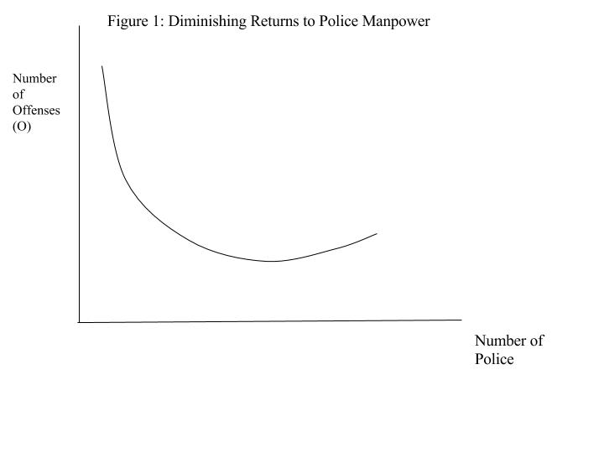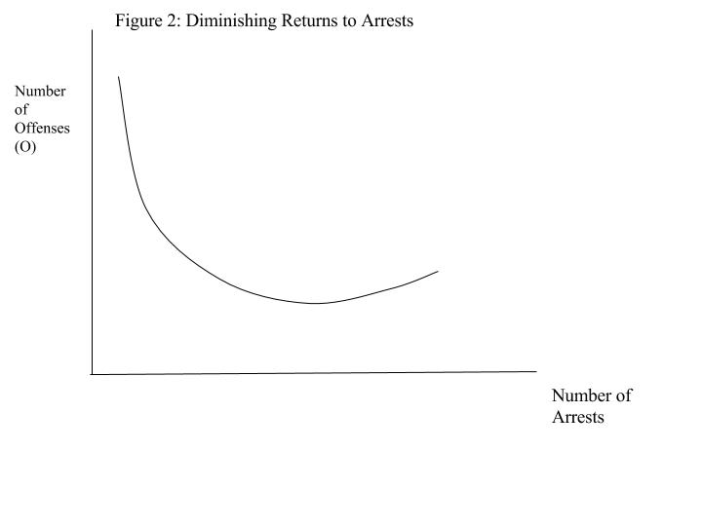
The criminal activity function above allows us to model a social welfare function where M and a are chosen with the aim of minimizing social losses from criminal offenses:
where D is the social damage inflicted by criminal offenses and C is the social cost of fighting crime.
An important point here is that the optimal values of M and a are most likely not the values that eliminate crime completely. At a certain point, the additional costs of increasing either p or f outweigh the social gain from decreasing crime. The optimal values of p and f can be found by taking the first order conditions of L :
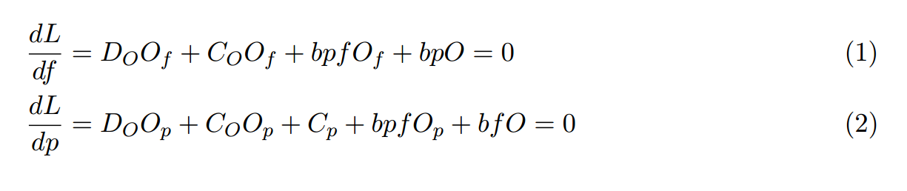
Assuming neither O_{f} or O_{p} are equal to zero, dividing both FOCs by these terms yields more intuitive expressions:
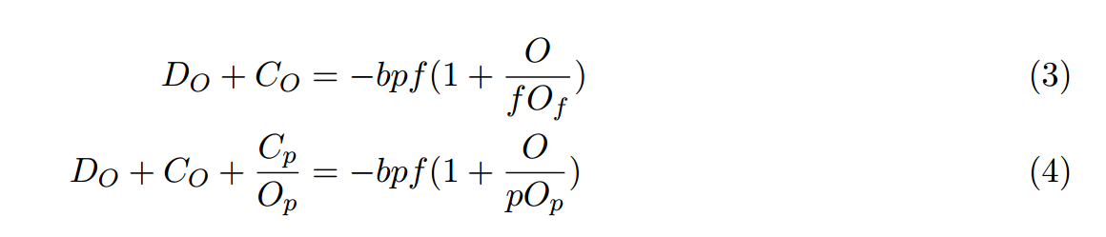
where the left hand sides of each expression represent the marginal costs of an additional crime through a reduction in f and p, respectively. The right hand side of each equation gives the marginal benefits of making fewer arrests or reducing police manpower. Since the expected social loss of punishment is equal to the term bpf , the marginal benefit of not punishing someone (in other words, the benefit of allowing an additional crime) grows as this term increases. This benefit will be larger if the elasticity of crime with respect to changes in arrests or police is smaller.
Assuming, as in Becker (1968), that C_{p} > 0 and O_{p} < 0 in Equation 4, the marginal cost of increasing O through f is larger than through p. Thus, the equilibrium marginal benefit from p is less than the benefit from f. This result indicates that under this model, offenders are risk-loving, since an increase in the probability of running into the police has a greater deterrent effect than an increase in the punishment if they do (Becker, 1968). If O_{p} > 0, on the other hand, crime can be reduced more efficiently by increasing arrests than by increasing police manpower, which implies that criminals are risk-averse.
II. Summary Statistics
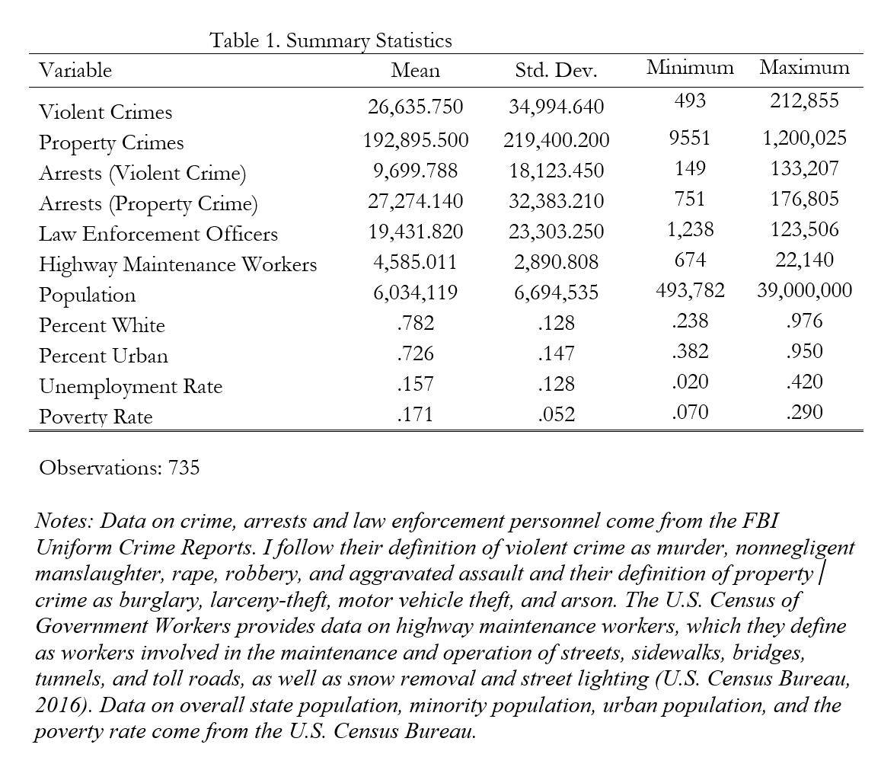
The national average annual number of both property and violent crimes fell fairly consistently between 2000 and 2014, aside from a spike in both types of crime during the Great Recession [see Figures 3 and 4]. Arrests for violent crimes have decreased slightly while arrests for property crimes have increased and the average proportion of property crimes that result in arrest is considerably higher than the corresponding proportion of violent crimes.
The average number of law enforcement officers reached a peak in 2008 and fell steadily after that point [see Figure 5]. This likely reflects the impact of the Great Recession on municipal police budgets; the U.S. Department of Justice estimates that between 12,000 and 15,000 officers were laid off as a direct consequence of the Great Recession (Office of Community Oriented Policing Services, 2011). This trend underscores the importance of time fixed effects and state effects, since the Recession did not have equal impact on all U.S. states.
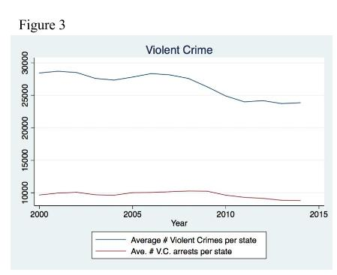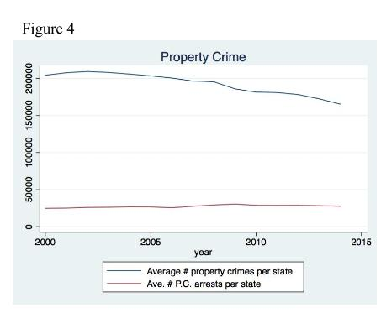
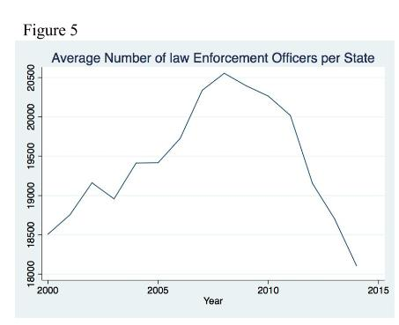
These national trends mask significant variation across states. Violent crime rates tend to be higher in the southern half of the country, and in states like Michigan and Illinois that have large populations of urban poor [see Figure 6]. While the spatial distribution of violent crime arrests corresponds roughly to the distribution of violent crime, Illinois and Michigan have relatively low arrest rates considering their high rates of violent crime [see Figure 7].
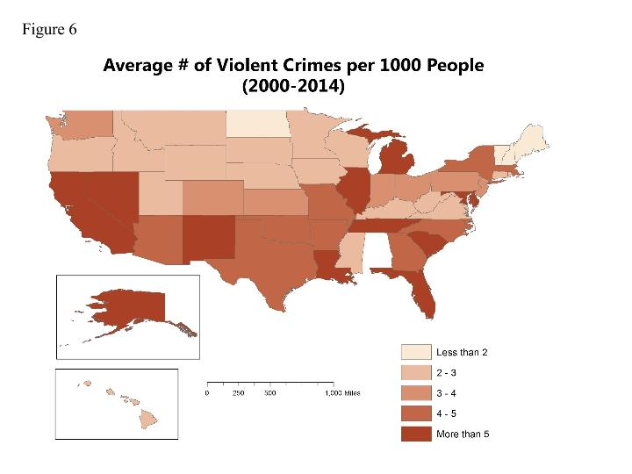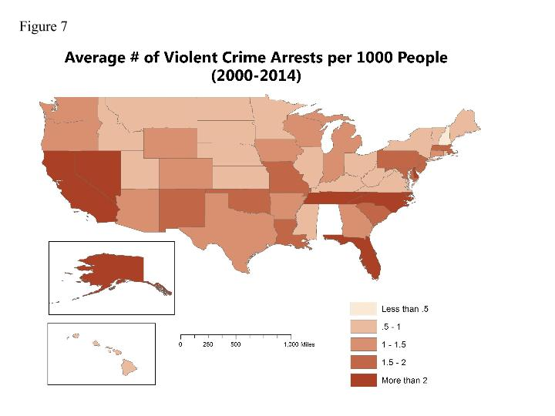
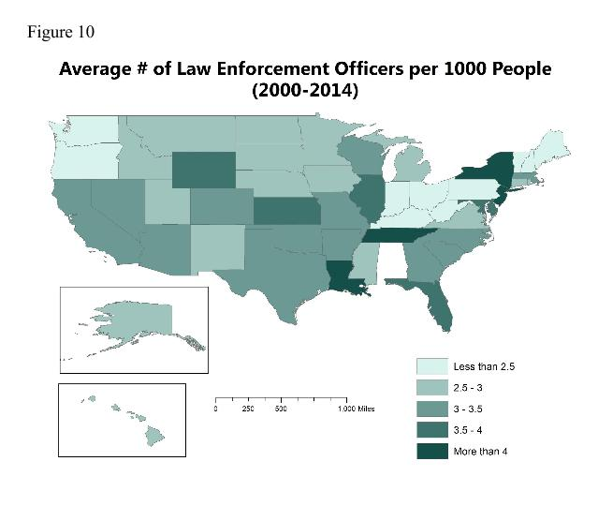
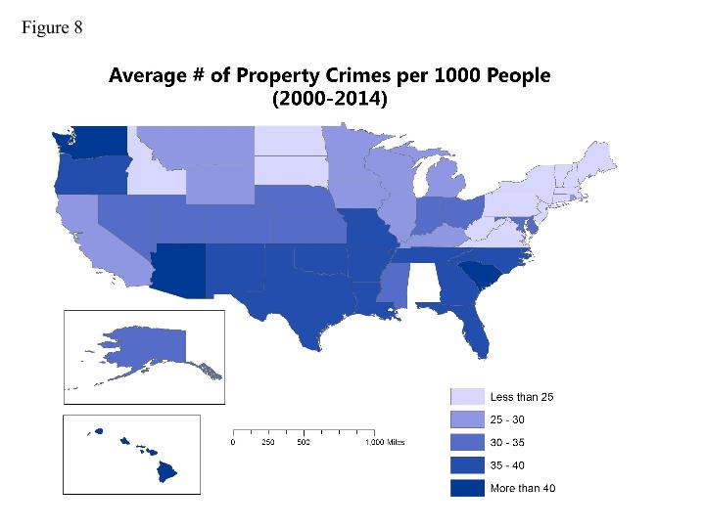
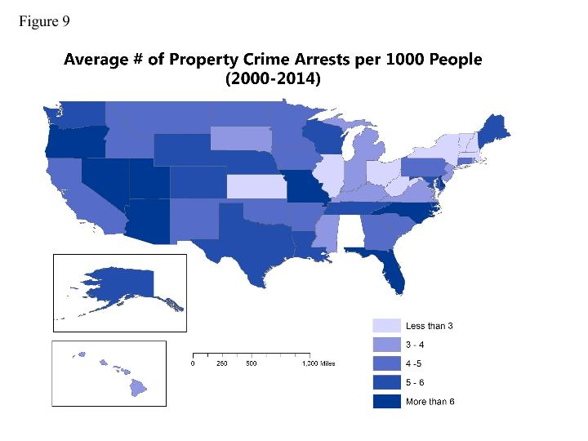
Property crime rates are also higher in the southern states, on average [see Figure 8]. A few states, including California, Alaska, and Washington, stand out as having high rates of violent crime but relatively low rates of property crime. The distribution of property crime arrests does not appear to be closely correlated with the pattern of property crime rates [see Figure 9].
Washington state has the fewest police per capita, followed by Maine, Pennsylvania, and West Virginia. New Jersey has the highest number of police, followed by New York, Louisiana and Tennessee [see Figure 10]. This pattern is likely related to crime rates in some cases (Maine, Pennsylvania with low crime, New York and Louisiana with high crime) but in others - particularly West Virginia - it is more likely related to budget constraints.

III. Empirical Model
The ideal way to determine whether there are diminishing returns to arrests and to police manpower would be to use a panel dataset including all U.S. police precincts. However, precinct-level data are not available for areas with relatively low populations due to privacy concerns. The next-best option is city-level data but, particularly for the cities with the largest populations, data on personnel and arrests are only available intermittently. Thus, this study uses state-level data for the period of 2000 to 2014. The use of state data may mask significant variation within states. Additionally, using aggregated data under a theoretical framework that focuses on individual decisions to commit offenses is problematic. However, there is a strong precedent for the use of state level data in examining crime fighting strategies.
Ideally, this study’s specification would include all determinants of crime, including drug use, police resources, policing strategies and residents’ trust in police. Unfortunately, drug use and police budget data are unreliable and difficult to obtain, and comprehensive nationwide data on levels of trust in police do not exist. Further, this specification does not capture the differences in policing ideologies between states (e.g. community policing, broken windows policing, and use of COMPSTAT). The ideal dependent variable would include all incidences of crime but, as this is infeasible, I measure crime through the FBI’s data on “offenses known to law enforcement”. It would also be ideal to look at each type of crime individually, rather than the broader groups of violent and property crime, but this data is not available. Finally, an ideal specification would include only those officers who spend most of their time on street patrol, but my dataset on law enforcement personnel also includes those who primarily do desk work.
Simultaneity is a serious problem in modeling police’s effects on crime; while an increase in the number of police may reduce crime, more police are hired when crime rates are high. In many cases, a researcher’s results can change dramatically depending on their methods for dealing with endogeneity. I control for endogeneity by using a two-stage least squares specification with highway maintenance workers as an instrument for law enforcement officers, since the number of highway workers has significant predictive power over the number of police but is unrelated to changes in crime rates. I model the first-stage relationship between highway maintenance workers and police under the following specification:
ln(LawEnforcementOfficers)_{it}=𝜷₀+𝜷₁ln(HighwayWorkers)_{it}+𝜷₂ln(OwnCrimeArrests)_{it-1}+
𝜷₃ln(OwnCrimeArrests)²_{it-1}+𝜷₄ln(OtherArrests)_{it-1}+𝜷₅ln(Population)_{it}+𝜷₆(UnemploymentRate)_{it}+ 𝜷₇ (%Urban)_{it}+𝜷₈ (%White)_{it}+𝜷₉(PovertyRate)_{it}+ 𝜹_{i}+𝝀_{t}+𝝐_{it}
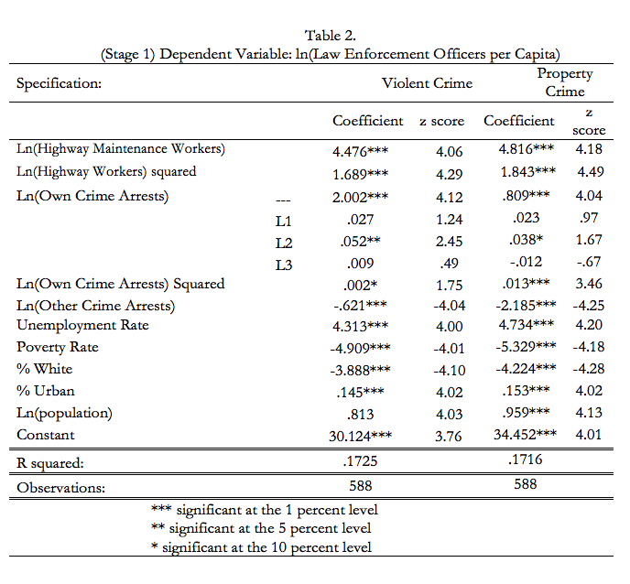
where i indexes states and t indexes years. Law enforcement officers, highway workers, and arrests are in per capita terms. Own-crime arrests correspond to the type of crime used as a dependent variable in the second stage (property or violent crime). I mitigate omitted variable bias through the inclusion of state and year fixed effects ( 𝜹_{i} and 𝝀_{t} respectively). Including fixed effects in my specification allows me to give each state a unique intercept, which results in coefficient estimates that more closely capture the influence of the variables of interest rather than the unobserved influence of omitted factors. The results of this first-stage regression indicate that highway maintenance workers are a suitable instrument for law enforcement personnel [see Table 2]. The elasticity of police with respect to highway workers is either 4.48 or 4.82 depending on the covariates included, and this relationship is highly statistically significant. The second stage involves modeling crime as a function of police (technically, the expected number of police based on the number of highway maintenance workers and other covariates):
ln(Crime)_{it}=𝜷₀+𝜷₁ln(OwnCrimeArrests)_{it-1}+𝜷₂ln(OwnCrimeArrests)²_{it-1}+𝜷₃ln(OtherArrests)_{it-1}+
𝜷₄ln(LawEnforcementOfficers)_{it}+𝜷₅ln(LawEnforcementOfficers)²_{it}+𝜷₆ln(Population)_{it}+
𝜷₇(UnemploymentRate)_{it}+𝜷₈ (%Urban)_{it}+𝜷₉ (%White)_{it}+𝜷₁₀(PovertyRate)_{it}+ 𝜹_{i}+𝝀_{t}+𝝐_{it}
The squared police and arrest terms will indicate whether there are diminishing marginal returns to these factors. If 𝜷₁ and 𝜷₄ are negative, showing that arrests and police reduce crime, the presence of diminishing returns will be indicated by positive values of 𝜷₂ and 𝜷₅ respectively.

IV. Results
I find that when per capita violent crime arrests increase by 10 percent, per capita violent crime increases by .21 percent. The squared arrests term is not significant, indicating that arrests have neither diminishing nor accelerating marginal effects on violent crime. This estimate is only slightly higher than the .015 elasticity of murder with respect to murder arrests found by Levitt (1998), although Levitt found negative elasticities for the other crimes included in the violent crime category. Likewise, Corman and Mocan (2000) found that the growth rate of arrests had a positive effect on assaults but a negative relationship with all other types of crime.
When per capita property crime arrests increase by 10 percent, per capita property crime increases by .17 percent. The squared arrests term in this model is equal to zero, and is of borderline statistical significance. There is no precedent for positive estimates of the relationship between property crime and arrests. However, the data used in both Levitt (1998) and Corman and Mocan (2000) stopped in the mid-1990s. Thus, their results could be consistent with mine if there were diminishing marginal returns to arrests during that period and we have since passed the point where the relationship between arrests and crime flips from negative to positive [see Figures 1 and 2].
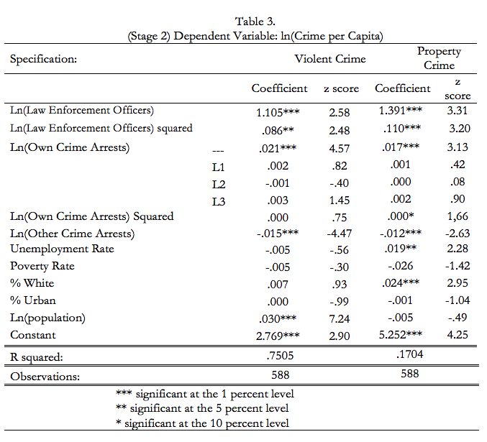
These weak positive relationships between arrests and crime are consistent with the criminogenic effect (Chen and Shapiro, 2007; Vieraitis et al., 2007; Bhati and Piquero, 2008; Gaes and Camp, 2009). The criminogenic effect is usually described in relation to incarceration, but based on the safe assumption that there is a positive relationship between the number of arrests and the incarcerated population, it can apply here as well. The criminogenic effect refers to the positive relationship between incarceration and crime that occurs when offenders are “criminalized” while in prison. This effect, along with the limited economic opportunities available to criminals after release, may push lower-level offenders to commit more crimes. Additionally, those who depend on those offenders are left with less income when they go to prison, and may turn to crime to support themselves (Raphael and Winter‐Ebmer, 2011; Gaes and Camp, 2009). This effect likely explains the positive relationship this study finds between arrests and crime, since some proportion of those who are arrested are later convicted and imprisoned. Even those who are not convicted or do not serve jail time could conceivably be “criminalized” as a result of such a negative interaction with the criminal justice system. There is considerable evidence that police arrest the most serious offenders first; thus, as police make more arrests per capita, they begin apprehending lower-level offenders or even mistakenly arresting non-offenders (Liedke et al., 2006; Roeder et al., 2015). Thus, any crime-reduction effects that arrests may have had diminish and the relationship becomes positive.
My results indicate that employing more law enforcement officers actually leads to increases in both violent and property crime and that this effect grows stronger as police manpower grows. There is certainly some degree of endogeneity still present; while it is possible that there is a positive relationship between police and crime, it is unlikely that a 1 percent increase in police could cause violent and property crimes to rise by 1.11 and 1.39 percent respectively.
Running this test without using an instrument for police yields a larger positive relationship between police and crime. This implies that the use of a perfect instrument for police would result in either a smaller elasticity or a negative elasticity depending on the degree of endogeneity still present in my results. If it turns out that there truly is a positive relationship between police and crime this could again be explained through a modified version of the criminogenic effect. For example, if there is a higher likelihood of police brutality when levels of police manpower are high, this could “criminalize” victims. Additionally, police violence can decrease an entire community’s level of trust in the criminal justice system, which makes future policing less effective.
If there truly is a positive relationship between crime and police, this will require a major reinterpretation of theories of crime based on Becker (1968). Becker’s model implies that criminals are risk-loving and that changes in the probability of punishment reduce crime more than changes in the severity of punishment. However, if O_{p} > 0, this implication is reversed; criminals respond more to changes in the severity of punishment (in this case, changes in arrests) than they do to changes in the probability (here, changes in police manpower). This would imply that criminals, like the population as a whole, are risk-averse.

V. Conclusion
I find that two of the most common crime-reduction strategies, making more arrests and increasing police manpower, actually lead to increases in crime. The elasticity of violent and property crime with respect to arrests are .021 and .017 respectively. I do not find evidence of diminishing or increasing returns to arrests. The elasticity of crime with respect to police is 1.105 and 1.391 for violent and property crime respectively. Further, I find that the criminogenic effect of police grows with the size of police manpower.
This study fills a gap in the literature on crime-fighting strategies by testing for diminishing returns to arrests and police. This study also pioneers the use of highway maintenance workers as an instrument for police. Finally, this study updates the existing literature by analyzing policing in the period of 2000 to 2014; this is crucial, as most of the previous literature focuses on the 1990s, when crime rates were so high that the relationship between crime and policing strategies may have been fundamentally different.
These results should be viewed with a great deal of caution, however. Highway maintenance workers are not a perfect instrument for police; there is certainly some degree of remaining endogeneity between crime and police. It remains unclear whether a perfect instrument would result in a weaker positive effect of police on crime or a negative relationship. An important objective for future research is to find a more exogenous instrument for police than firefighters or highway maintenance workers, but one that induces more variation in police hiring than that caused by the electoral cycle (Levitt, 2002).
The inclusion of state and year fixed effects is not sufficient to fully control for omitted variable bias [see Appendix for residual plots]. While I have controlled for population by putting variables in per capita terms and including population as a covariate, this model still overpredicts crime in states with very low populations [see Appendix]. Future researchers should find a viable way to account for the differences in policing strategies across states, including broken windows policing, data-driven policing or COMPSTAT, and community policing. Finally, future research should reevaluate which demographic variables need to be controlled for. If future researchers adequately address these issues and still find that police and arrests have a positive effect on crime, policymakers will have to fundamentally restructure the way that they think about crime. If they fail to do so, police’s efforts to reduce crime may have precisely the opposite effect.

References
Becker, G. S. (1968). Crime and Punishment: An Economic Perspective. Journal of Political Economy, 76, 169-217.

Benson, B. L., Kim, I., & Rasmussen, D. W. (1994). Estimating deterrence effects: a public choice perspective on the economics of crime literature. Southern Economic Journal, 161-168.

Benson, B. L., Rasmussen, D. W., & Kim, I. (1998). Deterrence and public policy: trade-offs in the allocation of police resources. International Review of Law and Economics, 18(1), 77-100.

Bhati, A. S., & Piquero, A. R. (2007). Estimating the impact of incarceration on subsequent offending trajectories: Deterrent, criminogenic, or null effect? The Journal of Criminal Law and Criminology, 207-253.

Chen, M. K., & Shapiro, J. M. (2007). Do harsher prison conditions reduce recidivism? A discontinuity-based approach. American Law and Economics Review, 9(1), 1-29.

Corman, H., & Mocan, H. N. (2000). A time-series analysis of crime, deterrence, and drug abuse in New York City. The American economic review, 90(3), 584-604.

Gaes, G. G., & Camp, S. D. (2009). Unintended consequences: Experimental evidence for the criminogenic effect of prison security level placement on post-release recidivism. Journal of Experimental Criminology, 5(2), 139-162.

Langlais, E. (2006). Criminals and risk attitude. Available at SSRN 900524. Retrieved from https://mpra.ub.uni-muenchen.de/1149/1/MPRA

Levitt, S. D. (1997). Using electoral cycles in police hiring to estimate the effect of police on crime. The American Economic Review, 270-290.

Levitt, S. D. (1998). Why do increased arrest rates appear to reduce crime: deterrence, incapacitation, or measurement error? Economic inquiry, 36(3), 353-372.

Levitt, S. D. (2002). Using electoral cycles in police hiring to estimate the effects of police on crime: Reply. The American Economic Review, 92(4), 1244-1250.

Levitt, S. D. (2004). Understanding why crime fell in the 1990s: Four factors that explain the decline and six that do not. The Journal of Economic Perspectives, 18(1), 163-190.

Liedka, R. V., Piehl, A. M., & Useem, B. (2006). THE CRIME‐CONTROL EFFECT OF INCARCERATION: DOES SCALE MATTER? Criminology & Public Policy, 5(2), 245-276.

McCollister, K. E., French, M. T., & Fang, H. (2010). The cost of crime to society: New crime-specific estimates for policy and program evaluation. Drug and alcohol dependence, 108(1), 98-109.
McCrary, J. (2002). Using electoral cycles in police hiring to estimate the effect of police on crime: Comment. The American Economic Review, 92(4), 1236-1243.

Marvell, T. B., & Moody Jr, C. E. (1994). Prison population growth and crime reduction. Journal of Quantitative Criminology, 10(2), 109-140.

Mungan, M. C., & Klick, J. (2015). Identifying Criminals’ Risk Preferences. Available at SSRN 2567048. Retrieved from http://scholarship.law.upenn.edu/cgi/

Press, S. J. (1971). Some effects of an increase in police manpower in the 20th precinct of New York City. Retrieved from http://www.rand.org/pubs/reports/R0704.html

Raphael, S., & Winter‐Ebmer, R. (2001). Identifying the effect of unemployment on crime. Journal of Law and Economics, 44(1), 259-283.

Roeder, O. K., Eisen, L. B., Bowling, J., Stiglitz, J. E., & Chettiar, I. M. (2015). What Caused the Crime Decline? Available at SSRN 2566965. Retrieved from http://www.brennancenter.org/sites/default/files/analysis/What_Caused_The_Crime_Decline.pdf

Trumbull, W. N. (1989). Estimations of the economic model of crime using aggregate and individual level data. Southern Economic Journal, 423-439.

United States Department of Justice Community Oriented Policing Services. (2011, October). The Impact of the Economic Downturn on American Police Agencies. Retrieved from http://www.ncdsv.org/images/COPS_ImpactOfTheEconomicDownturnOnAmericanPoliceAgencies_10-2011.pdf

Vieraitis, L. M., Kovandzic, T. V., & Marvell, T. B. (2007). The criminogenic effects of imprisonment: Evidence from state panel data, 1974–2002.Criminology & Public Policy, 6(3), 589-622.

Appendix: Residual Plots
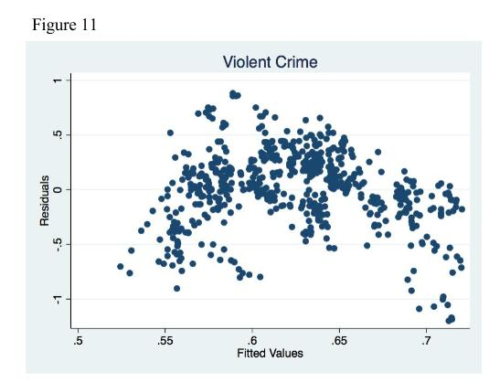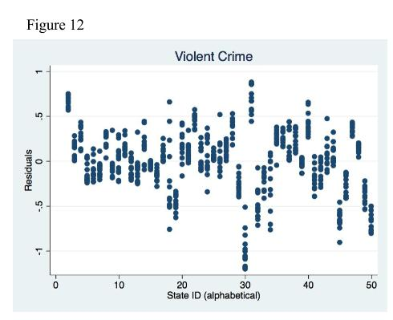
The nonrandom residuals in Figure 11 indicate that the model for violent crime is subject to omitted variable bias. There also appears to be some nonlinearity that is not adequately controlled for by the squared arrests and police terms. Figure 12 indicates that the model significantly underpredicted violent crime in Alaska and New Mexico, and overpredicted in New Jersey, Vermont and Wyoming.
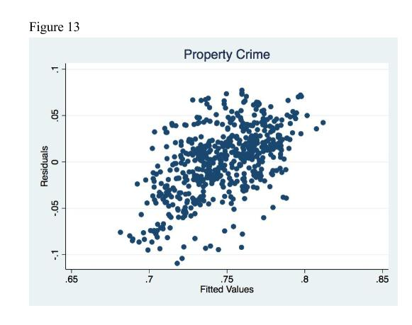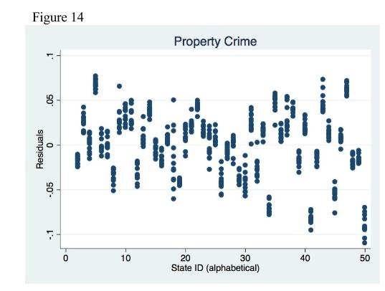
The residuals for the property crime specification are somewhat random, but show some positive correlation with the model’s predicted values of property crime. Figure 14 indicates that the model significantly underpredicted property crime in California and Washington, and overpredicts in North Dakota, South Dakota and Wyoming.

Order, Separability, and Pizza Preferences

Ian Calaway ‘16

Behavioral Economics

Introduction
As humans, we like to believe decision making is a part of free will and that arbitrary
factors and stimuli do not affect our choices. However, a growing body of research in behavioral economics is challenging this notion and we challenge this idea in this paper as well [9]. Specifically, we explore the influence of question order on pizza preferences using a split-ballot order experiment on a sample of 255 individuals. However, we diverge from previous research on question order influence by discussing the role separability plays within it. That is, we aim to understand how the influence of question order may vary depending on the separability characteristics an individual's preferences possess.
We begin our paper by discussing literature on the influences of question order in surveys and elections, also known as order effects, and follow it with a discussion on the research mathematicians have performed on separability in referendum elections. We then provide an overview of separability in binary contexts and theorize how order effects and separability might interact. This overview is followed by a discussion of our three treatment experimental design. Afterwards, we report our results and investigate possible explanations for interesting findings. In our conclusion, we summarize this paper and discuss its limitations.
The primary goal of this paper is to connect order effects and separability. Through our experiment, we provide evidence that the presence and magnitude of order effects is related to separability. Specifically, our results suggest that individuals whose preferences are not separable are more susceptible to being influenced by question order. This result and the new theory surrounding it provides a foundation for future research regarding the intersection of order effects and separability.

Literature Review
This paper combines research on order effects and separability in binary contexts. While most research in both of these areas allude to the influence of the other, little, if any, research has been on the intersection of them. Because of this, we will discuss the literature on order effects and that on separability in binary contexts, individually.
Research regarding order effects first began among marketing researchers attempting to ensure unbiased survey results over sixty years ago. In their 1949 article “Questionnaire Preparation and Interviewer Technique," A.B. Blankenship et al outline a few ways in which question order can influence participant response. They briefly touch on the potential for an earlier question to influence the response of a later question, but do not provide much detail [1]. The hypothetical case they offer is strictly an example of priming. A few years later, the National Opinion Research Center helped organize research on order effects with market researchers and sociologists. In 1964, Bradburn and Mason systematically approached questions related to order effects through experimentation. They identified four distinct types of order effects. In their experiments they find responses “are relatively unaffected by order," but state this result is “impossible to generalize with any degree of confidence to other situations" [12].
In their book published in 1981, “Questions and Answers in Attitude Surveys," Schuman and Presser provide an in depth analysis of order effects. They present seven experiments, mostly split-ballot order experiments, exploring these effects. In many of these experiments participants' responses to questions are greatly influenced by question order. They add further specificity to order effects by distinguishing between part-whole combinations of questions and part-part combinations of questions. Part-whole combinations of questions deal with questions of different levels of specificity i.e. “Do you like pizza?" and “Do you like sausage on your pizza?" Part-part combinations of questions deal with questions with the same level of specificity i.e. “Do you like sausage on your pizza?" and “Do you like pepperoni on your pizza?" They argue that order effects can be “very large" and that even with their more specific framework for understanding order effects, they “are difficult to predict" [7]. Responding to their book, Smith offers some further enhancements to the split-ballot order experimental design and encourages further creativity in experimental design in order to isolate specific order effects [13][14].
A significant amount of research in the area of question order followed the work of Schuman and Presser, but most relevant to this paper is the research related to elections. While gathering data on approval ratings for the president and for the governor of Ohio in the early 1980's, Alspach and Bishop identified significant order effects, which were replicated with a split-ballot experiment [15]. Similarly, Crespi and Morris analyzed two polls regarding the gubernatorial and senatorial races in the 1982 Connecticut elections and found extremely significant order effects. These two polls differed only in the order of questions, yet one poll indicated that in the senatorial race the challenger had a 5% lead while the other poll found the incumbent had a 16% lead. Contrasting the large 21% difference found between the polls for the senate race, the two polls differed by only 5% for the gubernatorial race. Using a split-ballot experiment, their results were similar to the original polls. Further, they found that the strength of the order effect seemed to be dependent on respondents' overall preferences [8]. Our experiment will most closely follow their split-ballot approach.
Towards the end in the 1990's, mathematicians working in social choice theory began observing instances in which referendum elections yielded undesirable outcomes. Two examples include a Los Angeles County referendum election in 1990 and the Colorado presidential election ballot in 2004 [4][10]. These outcomes were found to be caused by individual voters having preferences which were not separable. While voting in a referendum elections, voters are unable to communicate their conditional preferences potentially leading to paradoxes. This is known as the separability problem [3][4][16]. Lacy and Niou provide another empirical example and argue that, “[w]hile referendums increase the number of participants in decision-making, they decrease the quality of participation by preventing voters from coordinating votes and voting issue-by-issue" [11].
Over the past decade, much of the research on the separability problem has focused on understanding the different ways a voter's preferences could exhibit the separability problem. Hodge has been heavily involved with this research and has developed a framework for categorizing such preferences which will be discussed later in this paper [3][5][6]. While much of this research focuses on referendum elections, there are many areas where the separability of binary preferences is relevant [5].

Theory
In this section we provide a brief explanation of separability in binary contexts as it relates to pizza preferences. We then connect order effects and separability in hopes of understanding the former with insight from the later.
Consider the following situation. An economics class is trying to order a pizza to celebrate the end of the semester. Naturally, debate ensues as the class discusses possible toppings, specifically, pepperoni and sausage. With respect to these toppings, there are four possible pizzas: pepperoni & sausage pizza, pepperoni pizza, sausage pizza, and cheese pizza. They decide to hold a referendum with two proposals:
- Do you want pepperoni on your pizza? (yes/no)
- Do you want sausage on your pizza? (yes/no)
The result is that both pepperoni and sausage fail to pass and the resulting winning pizza is a cheese pizza. The vegetarians rejoice, but the rest of the class is confused once they learn that cheese was the least favorite choice for more than half the students in the class.
The previous hypothetical situation is an example of a paradox caused by the separability problem. In this context, separability is very easy to understand. We do not offer a rigorous definition here, but rather an intuitive understanding and some related examples. Informally, separability is preference independence. That is, a voter's preference on a proposal is separable, if regardless of the outcomes on other proposals, their preference on that proposal is consistent. Consider the following rankings of four individuals from the economics class example.

Alice’s Ranking

Pepperoni & Sausage Pizza > Pepperoni Pizza > Sausage Pizza > Cheese Pizza
Alice's ranking is separable with respect to sausage. If she was offered a pizza without pepperoni, she would want to add sausage. If she was offered a pizza with pepperoni, she would want to add sausage. That is, the presence, or lack of, pepperoni does not influence her opinion on sausage. Similarly, her ranking is separable with respect to pepperoni.
Bob’s Ranking
Sausage Pizza > Pepperoni Pizza > Pepperoni & Sausage Pizza > Cheese Pizza
Bob's ranking is not separable with respect to sausage. If he was offered a pizza without pepperoni, he would want to add sausage. If he was offered a pizza with pepperoni, he would not want to add sausage. Similarly, his ranking is not separable with respect to pepperoni.

Charles’ Ranking
Pepperoni & Sausage Pizza > Pepperoni Pizza > Cheese Pizza > Sausage Pizza
Charles's ranking is not separable with respect to sausage. If he was offered a pizza without pepperoni, he would not want to add sausage. If he was offered a pizza with pepperoni, he would want to add sausage. In contrast, his ranking is separable with respect to pepperoni. If he was offered a pizza without sausage, he would want to add pepperoni. If he was offered a pizza with sausage, he would want to add pepperoni.

Daniel’s Ranking
Sausage Pizza> Cheese Pizza > Pepperoni & Sausage Pizza > Pepperoni Pizza
Daniel's ranking is separable with respect to sausage. If he was offered a pizza without pepperoni, he would want to add sausage. If he was offered a pizza with pepperoni, he would want to add sausage. His ranking is also separable with respect to pepperoni. If he was offered a pizza without sausage, he would not want to add pepperoni. If he was offered a pizza with sausage, he would not want to add pepperoni.
From these four rankings, we can see that separability, or lack of separability, on one item does not imply anything about the separability of the other. Additionally, these are just four rankings of the possible twenty-four (2^2!) rankings. We can categorize these rankings based on separability as is shown in Figure 1.

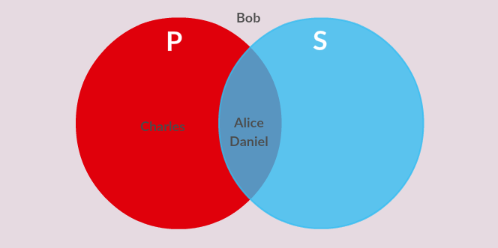

Figure 1: This Venn diagram represents the different separability structures that can be expressed in this situation. The set P represents the set of rankings separable with respect to pepperoni, while the set S represents the set of rankings separable with respect to sausage. The positions of Alice, Bob, Charles, and Daniel's rankings with respect to these sets are shown as well.
Of the 24 rankings, 8 are not separable with respect to either pepperoni or sausage, 4 are separable with respect to only pepperoni, 4 are separable with respect to only sausage, and 8 are separable with respect to both pepperoni and sausage.
In this case, we can actually be even more specific than Figure 1. The set P is the set of rankings separable with respect to pepperoni. These rankings correspond to individuals that either always want pepperoni (pepperoni lovers) or never want pepperoni (pepperoni haters). So we can partition P accordingly and do that same for S. The result of this is visualized in Figure 2.


Figure 2: A more specified version of Figure 1. The sets PL and PH represent rankings separable with respect to pepperoni, but PL corresponds to pro-pepperoni rankings while PH corresponds to anti-pepperoni rankings. The sets SL and SH correspond in a similar manner.
Now we return to economics class example, we ask, what happens if we switched the order of the pepperoni proposal and the sausage proposal? Would this impact they way students voted, that is, is there an order effect? If so, does the order effect impact students with all types of rankings equally, or are some preferences more influenced than others? Once again, there is little research describing separability and order effects explicitly, but some research certainly alludes to relationships.
There is evidence that the magnitude of the order effect is related to separability. Crespi and Morris found that in the 1982 Connecticut elections, “question order did not have an across-the board effect but, rather, was restricted to those who expressed a preference for the Democratic gubernatorial candidate" [8]. This seems to suggest such a connection, but does not offer much insight. Later in their paper, they argue their “analysis suggests that asking first about the race in which a party's candidate is stronger has a coattail effect among adherents” [8]. If we consider the existence of a “pro-meat party” and a “anti-meat party,” we may find a similar coattail effect with voters whose preferences are not separable on sausage if pepperoni, the more popular “candidate” of the meat party is asked about first.
We argue that order effects will be minimal for voters with rankings that are separable for both pepperoni and sausage. These individuals have stronger, most consistent, preferences on these toppings and so will less likely be influenced by question order. For example, consider vegetarians; regardless of question order, they will always say “no" to meat. In line with this, we expect order effects will be largest for voters with rankings that are not separable on either pepperoni or sausage. These voters have conditional preferences and could be influenced by the split of pepperoni question and sausage question, if they ignore the interactions between them.

Experimental Design
Our experiment consisted of three treatments in the form of three distinct Google surveys and utilized a between subject design. For the two non-control treatments we use a split-ballot design. We shared our experiment on Facebook, where participants consented to take a survey during which they must disclose their preferences on a variety of pizza related questions. Participants filled out exactly one of the three surveys based on their birth month: January-April birthdays received treatment 1, May-August birthdays received treatment 2, and September-December birthdays received treatment 3. To incentivize participants to complete the entire survey as honestly as possible, we informed them that they would be entered into a lottery to receive a free pizza based on their choices. Our data includes the 255 participants, the first 85 respondents of the three surveys.

Treatment 1: No Survey
This treatment was the control. Participants were asked to rank four pizzas: pepperoni & sausage pizza, pepperoni pizza, sausage pizza, and cheese pizza. No indifference was allowed. The order in which the pizzas were given was randomized. Unlike the other treatments, no questions were asked before. This treatment provides the true frequencies for rankings.

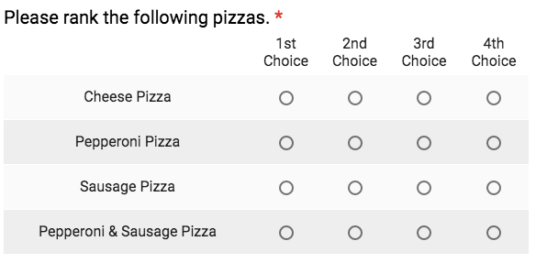
Figure 3: Question showing how participants were asked to rank pizzas in treatment 1, treatment 2, and treatment 3.

Treatment 2: Pepperoni Survey
This treatment was composed of three parts: ordering a pizza, ranking pizzas, and reflection. During the first part, participants were asked to respond to a series of yes or no questions pertaining to a pizza order. In order these questions were:
- Do you want pepperoni on your pizza?
- Do you want a beverage with your pizza?
- Do you want fast delivery?
- Do you want your pizza to be gluten-free?
- Do you want sausage on your pizza?
- Do you want garlic butter on the side?
- Do you want ranch on the side?

The questions were all on the same page and participants were able to switch their answer on any of the questions as they progressed through them. It is critical to notice that only the first question (the pepperoni question) and the fifth question (the sausage question) affected the toppings of the pizza.
The second part is ranking the four pizzas: pepperoni & sausage pizza, pepperoni pizza, sausage pizza, and cheese pizza. This was done identically to Treatment 1.
The final part of Treatment 2 was reflection. Participants were asked whether or not they switched their answer for any question during part one. If they answered ``yes" to this question, they were then asked which question they changed their response to and why.

Treatment 3: Sausage Survey
This treatment was identical to Treatment 2, except the pepperoni question and the sausage question were swapped. That is, the pepperoni question was the fifth question and the sausage question was the first question.

Results
First, we must determine whether or not there were order effects in our experiment. We begin by looking at how many participants voted for each topping in treatment 2 and treatment 3, the two treatments which involved a referendum, or survey, before ranking the pizzas.

 | Treatment 2 Survey | Treatment 3 Survey
Pepperoni (Yes) | 40 votes | 49 votes
Pepperoni (No) | 45 votes | 36 votes
Sausage (Yes) | 29 votes | 33 votes
Sausage (No) | 56 votes | 52 votes

Relative to the pepperoni survey, more participants voted “yes" for pepperoni and “yes" for sausage in response to the sausage survey. If we consider pepperoni and sausage to be part of the “meat party," this result is actually counter to what previous research suggests which is that having the stronger candidate first, pepperoni in this case, has a coattail effect [8]. One possible reason for this contrast with previous research can be explained anecdotally. After taking the sausage survey, one participant informed me that upon seeing the pepperoni question at the end they realized they “had no more topping to choose from," and so they voted for pepperoni. The phenomenon could be true for many other participants. Regardless, it seems the coattail effect is still occurring, but is manifesting itself differently. We further analyze participants' responses by observing how they voted on both questions together.

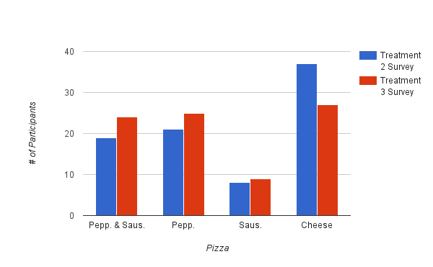
Figure 4:Clustered bar graph demonstrating the pizzas voted for by participants in the treatment 2 survey and treatment 3 survey.
In Figure 4 we see that significantly fewer participants voted “no" on both the pepperoni and sausage questions in response to the sausage survey. In contrast, more participants voted for each of the meat pizzas when comparing the sausage survey to the pepperoni survey. These results are clearly related, but the direction of causality is challenging to ascertain.
When we compare how participants responded to the surveys and what their top choices were while ranking the pizzas we find a particularly intriguing and troubling result.

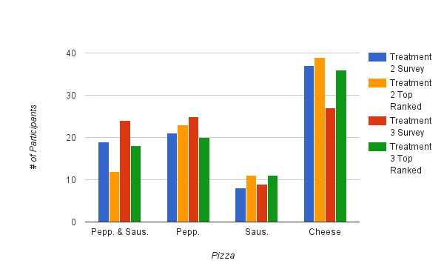
Figure 5: Clustered bar graph comparing the pizzas voted for by participants in the survey section of treatment 2 and treatment 3 and the top choice of participants in the ranking section of treatment 2 and treatment 3.
Figure 5 shows that while filling out the survey many participants did not actually “order" the pizza that they later ranked as their top choice. That is, their survey responses did not reflect their preferences. If they did, the treatment 2 survey (blue bars) and the treatment 2 top ranked pizza (yellow bars) would be identical as would the treatment 3 survey (red bars) and the treatment 3 top ranked pizza (green bars). It seems that by separating the pepperoni and sausage questions in the survey, many participants ignored the interaction between the two in their preferences, but later, either consciously or unconsciously, recognized the interaction while ranking the options. This ignorance suggests that separability has a role in the order effects here.

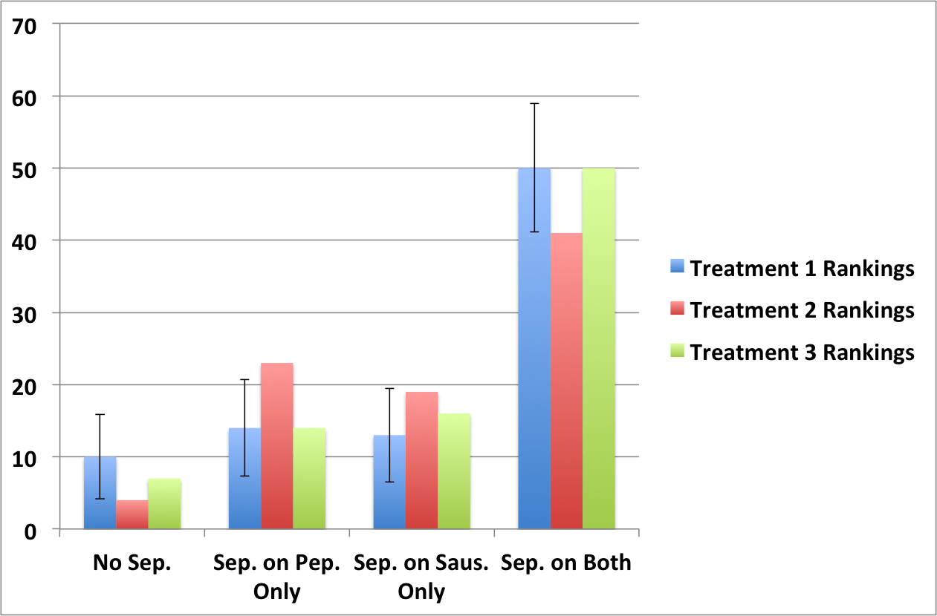
Figure 6: Clustered bar graph comparing the number of rankings with specific separability characteristics among the three treatments. See Figure 1 for a reminder of these categories. The corresponding standard deviations are, in order: 2.97, 3.41, 3.31, and 4.537.

We treated treatment 1 as representative of the true frequencies of pizza rankings, so the aggregations of the rankings in treatment 1 by type of separability provides us with the “true” frequencies of these separability types. We display these, and those from the other treatments in Figure 6. For treatment 1, we display error bars corresponding to 95% confidence intervals in order to test hypotheses.
For both treatments 2 and 3, the number of rankings that are not separable with respect to either pepperoni or sausage is below what we would expect given treatment 1. This difference is statistically significant for treatment 2. This result seems to suggest that by splitting the questions and imposing an order on them in the surveys, we have, in some sense, changed the preferences of these voters. This is consistent with our expectation that individuals whose preferences are not separable are particularly susceptible to order effects.
In treatment 2 the number of rankings separable with respect to pepperoni and not sausage is more than we expect and the difference is statistically significant. A similar, not statistically significant result is found in treatment 3 for sausage. One explanation for these results is that some voters whose rankings were not separable with respect to either topping, could have unknowingly switched their preferences in response to the survey. For this explanation, the data suggests their preferences switched to be separable on whatever topping was asked about first.
Finally, we do not see a statistically significant difference for the number of rankings separable with respect to both toppings for either treatment 2 or 3. This is consistent with our theory that people with such preferences have “stronger" preferences on pepperoni and sausage and are, thus, less likely to be influenced by question order.

Conclusion
In this paper, we investigated the relationship between order effects and separability in a binary context by performing a variation of a split-ballot experiment. We developed a new theory by integrating insights from order effect and separability literatures and provided new evidence of order effects in surveys that elicit choices about pizza toppings. Specifically, our new theory predicts that individuals with preferences that are not separable are more susceptible to order effects. It also suggests that overall, order effects are more significant when the more popular question is asked first.
Exploring order effects and separability together is a new approach and so our experiment and analysis has limitations and weaknesses. An obvious limitation is the sample size. With only 85 participants in each treatment, it is difficult to make significant conclusions and we are unable to perform analysis at the granular level shown in Figure 2. Additionally, we forced participants to rank the four pizzas without indifference. Some participants, some vegetarians for example, disliked this greatly as they were unable to show their true preferences. Finally, the structure of a split-ballot experiment makes hypothesis testing challenging. Regardless, we are optimistic about this research and we recognize that by understanding the influence of separability on order effects, we can identify the groups of people most likely to be affected by them. With this knowledge we can take the appropriate actions to prevent order effects from biasing surveys and election results.

References

[1] Albert B. Blankenship, Archibald Crossley, M. S. H. H. H. A. K. (1949). Questionnaire preparation and interviewer technique. Journal of Marketing, 14(3):399-433.

[2] Beals, B., Calaway, I., and Hodge, J. (2014). A graph theoretical approach to the admissibility problem, bead graphs and character construction.

[3] Bradley, W. J., Hodge, J. K., and Kilgour, D. M. (2005). Separable discrete preferences. Mathematical Social Sciences, 49(1):335-353.

[4] Brams, S. J., Kilgour, D. M., and Zwicker, W. S. (1997). Voting on referenda: The separability problem and possible solutions. Electoral Studies, 16:359-377.

[5] Hodge, J. K. (2011). The mathematics of referendums separable preferences. Mathematics Magazine, 84(4):268-277.

[6] Hodge, J. K. and TerHaar, M. (2008). Classifying interdependence in multidimensional binary preferences. Mathematical Social Sciences, 55(2):190-204.

[7] Howard Schuman, S. P. (1981). Questions and Answers in Attitude Surveys: Experiments on Question Form, Wording, and Context. Academic Press.

[8] Irving Crespi, D. M. (1984). Question order effect and the measurement of candidate preference in the 1982 Connecticut elections. Public Opinion Quarterly, 48(3):578-591.

[9] Kahneman, D. (2011). Thinking Fast and Slow. Farrar, Straus and Giroux.

[10] Karp, J. A. and Banducci, S. A. (2007). Reforming the electoral college by initiative: Assessing the relative importance of strategic choice and proportional outcomes. Party Politics, 13(2):217-234.

[11] Lacy, D. and Niou, E. M. (2000). A problem with referendums. Journal of Theoretical Politics, 12(1):5-31.

[12] Norman M. Bradburn, W. M. M. (1964). The effect of question order on responses. Journal of Marketing Research, 1(4):51-61.

[13] Smith, T. (1982). Conditional order effects. National Opinion Research Center.

[14] Smith, T. (1991). Context effects in the general social survey. Measurement Errors in Survey, pages 51-61.

[15] Steven E. E. Alspach, G. F. B. (1991). Question-order effects of presidential approval ratings on gubernatorial approval ratings: A research note. Social Forces, 69(4):1241-1248.

[16] Steven J. Brams, D. Marc Kilgour, W. S. Z. (1998). The paradox of multiple elections. Social Choice and Welfare, 15(2):211-236.

Appendix A

Professional Soccer in Dubuque, Iowa
Due to the increasing popularity of soccer in Dubuque, the city has become interested in having their own professional soccer team and possibly a new stadium. They hold a referendum with the following three proposals:
- Proposal 1: Have a professional women's soccer team.
- Proposal 2: Have a professional men's soccer team.
- Proposal 3: Build a new stadium.
The percent of citizens voting for a given outcome is shown in Table 1.

Outcome | Percent of Vote
NNN | 26%
NNY | 0%
NYN | 10%
YNN | 10%
YYN | 0%
YNY | 15%
NYY | 15%
YYY | 24%

Table 1: The table indicates the percentage of voters voting for a specific outcome on the three proposals in the Dubuque referendum.
While the outcome with the most votes is “no" on all proposals with 26% of the votes, the winning outcome is determined by counting up votes on all of the proposals individually. Counting votes by proposal indicates that:
- Proposal 1 fails 49% Yes to 51% No.
- Proposal 2 fails 49% Yes to 51% No.
- Proposal 3 passes 54% Yes to 46% No.

The winning outcome is therefore NNY. This is an interesting result because, as we can observe in Table 1, this outcome received 0 votes. If policy makers were bound by the referendum in the previous example they would be forced to construct a new stadium despite not having a professional team, an expensive and useless result. The failure of this referendum to produce a desirable result is due to voters' preferences being interdependent. The voters in this election likely perceived connections among the proposals. We can see one connection in Table 1. Every voter that voted for the stadium also voted for one or both of the professional soccer teams; they only wanted a stadium if there was a team to play in it. This connection indicates that some of the voters preferences were likely interdependent. This is the source of the separability problem arising in this case.

Can the costs of education explain the shape of the income distribution?
Stefan Faridani ‘17
Economics of Public Policy

- Introduction
Rising income inequality continues to gather attention in the mainstream policy debate. In 2008, the top 10% of earners in the United States had incomes 15 times greater than the bottom 10%. Five years later, that ratio had grown to nearly 19 (OECD, 2013). Alarm at the wideness of the income distribution ought to be tempered by an understanding of the causes. Economists have proposed a broad diversity of theories that seek to explain the shape of the income distribution. In this paper, I will present a theoretical model of education costs that generates income distributions mostly consistent with actual distributions.
Clearly, greater levels of education open access to higher paying occupations. The costs of education are great, both in terms of lost wages during the school years and the price of tuition. Thus, we would expect that occupations with demanding educational requirements to pay wages that compensate for the costs of attaining these prerequisites. Then, the greater the opportunity costs of education, the wider the difference in wages for educated and uneducated occupations.
Economists observe that the income distribution has a log-normal shape (Battisten et al. 2009). This implies that if the determinants of income are normally distributed, then their relationship with income itself should be such that absolute differences in determinants cause percent differences in income. Jacob Mincer (1958) develops a theory that explains the log-normal shape of the income distribution. Particularly, Mincer hypothesizes that absolute differences in years of education are associated with percent differences in income. Mincer mentions in a footnote how tuition costs might be added to his model. In this paper, I provide a rigorous proof of how this is done. I then use that result to extend Mincer’s model. Finally, I compare the distributions generated by his original model and the extension to census data detailing the actual income distribution in 2014. I find that both models yield reasonable approximations of the observed distribution and that the extension’s predictions are more accurate at discount rates under 30%.
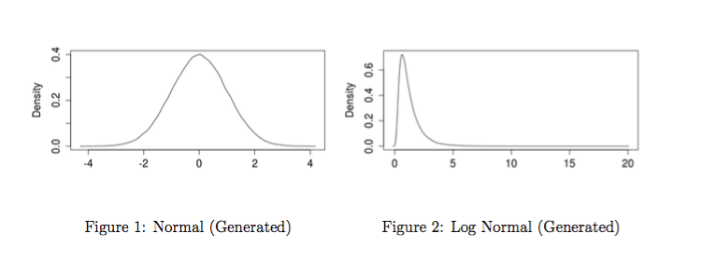
In Sections 2 and 3, I summarize the mathematics and assumptions underlying Mincer’s model. In Section 4, I extend Mincer’s model by adding tuition costs. In Section 5, I use the original model and its extension to generate income distributions for several discount rates and compare them to the observed distribution in the United States. In Section 6, I comment on the value of the extension and the role of the choice of discount rate. Section 7 concludes.

- Mincer’s Model
The skewed shape of the income distribution has long been a puzzle to economists. Since most human traits are distributed normally, if income were based on some natural ability, we would expect it to follow a bell-curve shape (see Figure 1). In reality, income is distributed log-normally (see Figure 2). That is to say, the logorithm of income is a bell curve. The classical models explain this fact by attributing it to random percentage shocks in the incomes of individuals (Sahota 1978). However, these models say little of where such shocks come from and often predict an eternally widening income gap at odds with historical trends. Jacob Mincer (1958) introduces a systematic model that explains the log-normality of the income distribution without resorting to stochastic processes.
Mincer begins by assuming that all individuals have identical abilities and equal opportunities to pursue any amount of education. Occupations differ in the amount of training they require. Under these assumptions, differences in income are attributable to differing amounts of training. The only cost of training is the opportunity cost: no income is earned during the training period. Those who train are compensated for the cost by earning more after their education is completed. Mincer assumes that the lifetime discounted earnings of each worker are the same. The difference is how much of the income is earned later in life. Mincer begins the derivation of his model with an expression for lifetime wealth discounted to its present value.
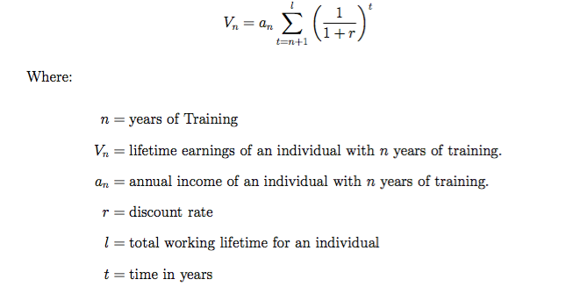
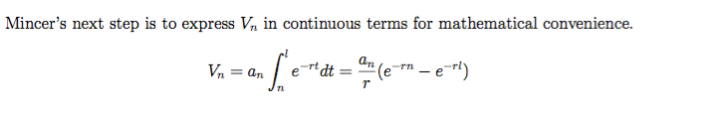
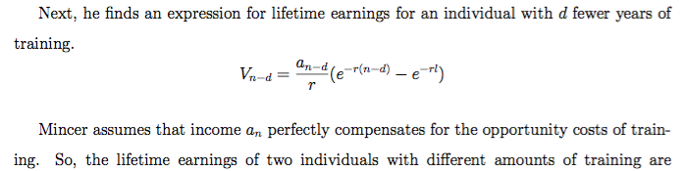
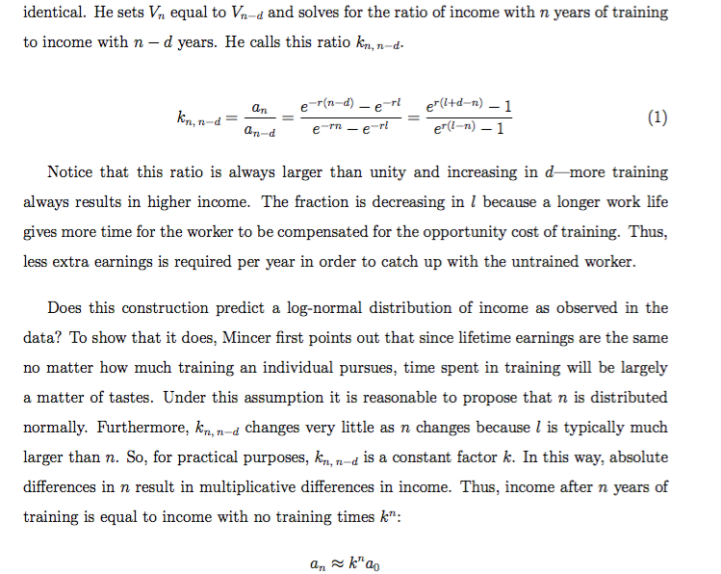
Since $n$ is normally distributed, $k^{n}$ will by definition be log-normally distributed. So, $a_{n}$ is also distributed log-normally as the data suggest.
- Justifying the uniformity of lifetime wealth
The keystone holding Mincer’s model together is his assumption that all workers can expect the same discounted lifetime earnings regardless of their educational choices. Clearly, lifetime earnings in the real world are not uniform and assuming that they are seems at first blush to defeat the purpose of studying the income distribution in the first place.
Mincer (1958) justifies his assumption that $V_{n}=V_{0}$for all $n$ with a single sentence: “If individuals with different amounts of training are to be compensated for the costs of training, the present values of life-earnings must be equalized at the time a choice of occupation is made.” This statement seems less peculiar when we consider the assumptions that Mincer’s model is built upon: individuals have uniform abilities and equal educational opportunities.
Still, a more rigorous justification is needed. Why must workers be compensated for the opportunity costs of education? If workers expect that an additional year of education will not be worth it, then they will not pursue that year. Why don’t we expect the income distribution to have “gaps” for the education levels that do not provide adequate compensation?
To resolve this paradox, I turn to Sattinger’s (1993) interpretation of the uniformity of lifetime earnings. Sattinger justifies Mincer’s assumption that $V_{n}=V_{0}$ by proposing that the long run labor supply curve for workers with n years of education must be horizontal.
Here is the intuition behind Sattinger’s argument. If $V_{n}<V_{n+1}$, every worker with $n$ years of training will, in the long run, be compelled to seek one more year of education. Similarly, if $V_{n}>V_{0}$, then every worker considering $n+1$years of training will instead stop after $n$ years.
This implies that if lifetime earnings for $n$ years of education are lower than for other education levels, the number of workers with education level n will drop to zero in the long run. On the other hand, if lifetime earnings for $n$ years of education are higher than for other levels, labor will flow into level $n$ without limit. Thus, the long run labor supply curves for each education level are horizontal.
- Extension: Tuition
Jacob Mincer (1957) refers in a footnote to the consequences of adding explicit tuition costs to his model. Here I provide my own mathematical proof of this result.
Suppose that workers must pay tuition p for each year of their training. Lifetime wealth is now:
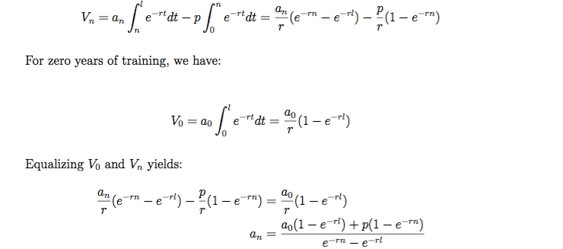
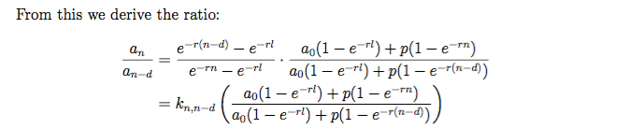
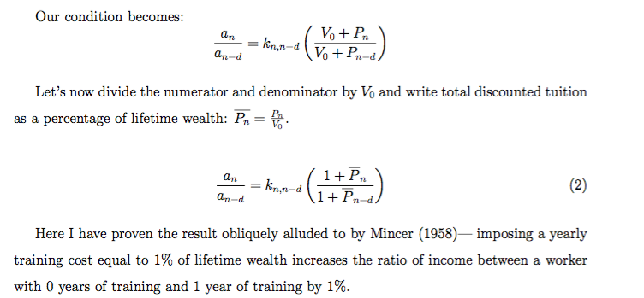
- Testing the Extension
In this section I will use the models in Sections 3 and 4 to generate predictions of the entire income distribution. To evaluate the accuracy of these predictions, I will compare them to census data on the actual distribution of households with income less than $200,000 per year. Figure 3 shows a density plot of the observed income distribution in 2014 (US Census Bureau, 2015). The x-axis is yearly income in dollars and the y-axis is the density of households in the data with a given amount of income.
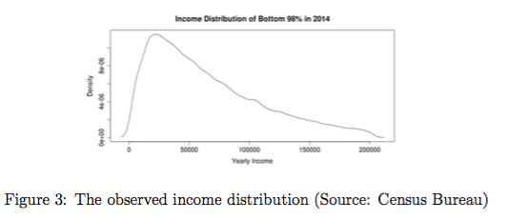
- Parameters and Data
Here I will provide and justify specific values for each parameter in the model. Krueger et al. (2014) estimates that a 18-year-old male can expect to spend 38.72 years in the workforce. The predictions of the model are not very sensitive to worklife expectancy. Using the number for females, 32.91 has very little effect on my results.
I define an education distribution using Census data on degree attainment (2014). I also make use of the College Board’s estimates of average yearly tuition for public universities in 2014, which was $8,743 at the end of 2014.
The model is highly sensitive to the choice of discount rate. The interest rate on a student loan between 1992-2015 varied from 4% to 9% depending on the type of loan and the year (Delisle, 2012). However, in order to generate realistic income distributions, I need to include discount rates in excess of 25%. I defend the validity of such high rates at the end of this section.
- Defining the Education Distribution
In order to use Mincer’s original model to generate the density plot of an income distribution, I first need to define what it means to have “zero years of education.” I choose to count a high school diploma as zero years of education because this is the cutoff point between traditionally free education and tuition-charging education in the United States. Under this assumption worker who drops out at 17 will have “negative one years of education” and a worker with an associate’s degree will have “two years of education.” Since I assume that tuition is not charged for K-12 schooling, the extension will predict the same ad as the original model for $d≤0$.
The next hurdle is to define the distribution of education. Mincer’s model hinges on the assumption that education is distributed normally. The Census data (2014) in Table 1 include only the type of degree or diploma earned. This creates a series of sharp discrete jumps that
might not capture the continuous reality of educational attainment. In order to generate a log-normal predicted income distribution, I must assume that education is distributed normally. Since the education data are not in a bell-curve, I replace the empirical educational distribution with a normal distribution with the same mean and standard deviation as the observed educational distribution. Figure 4 shows the actual and normalized distributions. The fact that the bell curve is such a poor fit is a major weakness of this model.
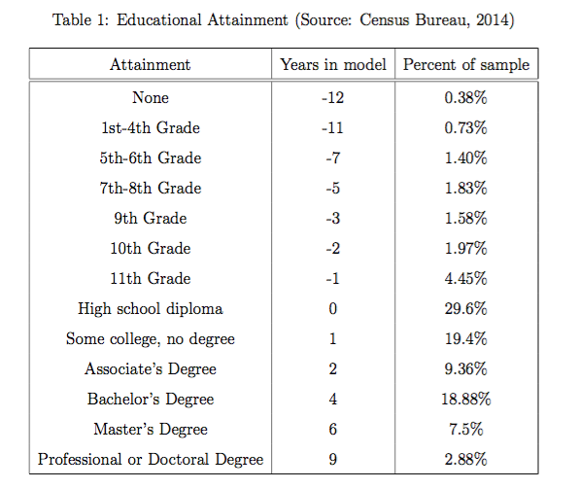

- Results: the Actual and Predicted Income Distributions
With these major assumptions addressed, I will now use Mincer’s original model and its ex- tension to generate theoretical income distributions. I begin by generating 100,000 numbers using the normal distribution described in the previous paragraph. Each of these values represents a quantity of education d in years. For each of these educational attainments $d$, I calculate its corresponding predicted income $a_{d}$.
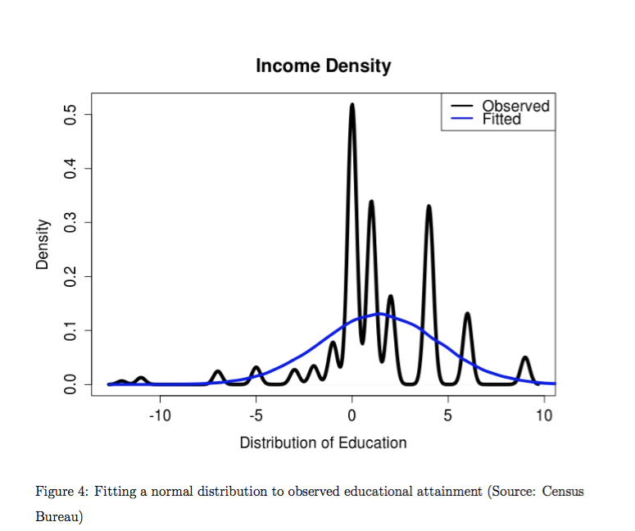
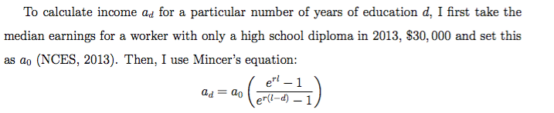
This yields 100,000 incomes. To get the income distribution (blue line), I generate the density plot of these 100,000 generated incomes. Figures 5, 6, 7, and 8 show the results for 11 discount rates.
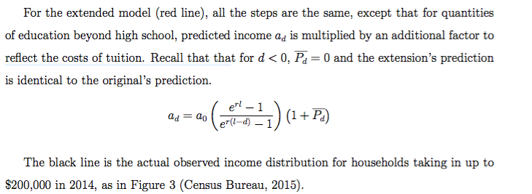
Figures 5, 6, 7, and 8 show the generated income distributions for four different discount rates. I include the 30% and 25% rates because they generate distributions that best fit the Census data. However, both of these discount rates are very high. So, I also include two lower rates for illustrative purposes. 6.8% is included because it was the unsubsidized Stafford Loan rate for undergraduate and graduate school loans from 2006 to 2010 and fairly representative of the ballpark for government student loan rates (US Department of Education, 2016). To bridge this lower rate with the higher ones, I also include a figure for a 15% discount rate. Note that the scales for Figures 6, 7, and 8 are the same. See the next section for an interpretation of the effect of a low discount rate and a defense of my choice of 30%.
- Interpretation
In this section, I will discuss the features of the generated income distributions in Figures 5-8. Specifically, I will discuss the overall fit of the model to the data, the flattening effect of high discount rates, the validity of considering a 30% rate, and the value of adding tuition to the model.
By construction, the generated distributions feature a single peak and long right tail similar to the empirical distribution. Encouragingly, the peaks of the generated distributions end up very close to the observed one. Furthermore, at high discount rates, the model’s left and right tails both seem to match the empirical tails in support and height.
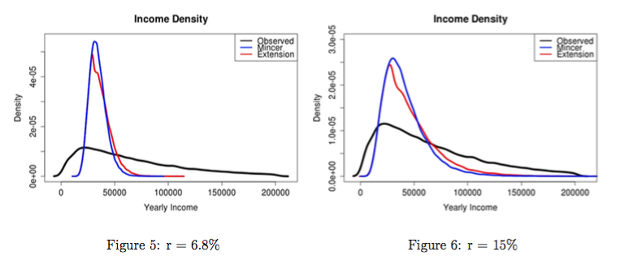
However, there is a clear systematic difference between the generated and observed distributions. The predicted densities consistently overestimate the peak and underestimate the right tail. In general, the model predicts a more equal distribution of income than existed in 2014. This may be indicative of some deeper problem in the theory. Does Mincer’s generated distribution actually tell us anything about the ways income is distributed or is this simply a case of over fitting? One explanation is that the model is too simple to account for every distributional pattern. For example, the right tail might be underestimated because the model assumes homogeneous workers. Perhaps some real workers face higher education costs than others. In spite of these issues, the clear visual similarity between the rigorously justified theory and the empirically observed census data is too close to easily ignore.
Both generated distributions are very sensitive to the choice of discount rate. At low discount rates, the predicted income distribution loses density in its tails and gains a taller peak. This is essentially a consequence of the fact that the training period is assumed to occur at the beginning of life. The higher the discount rate, the more weight is given to the early years of life. Compare the opportunity cost of an additional year of training at a low discount rate to the opportunity cost at a high rate. When $r$ is low, this year’s income is not much more valuable than any future year’s income. So, this year’s income is a small portion of total lifetime wealth. If a worker gives up this year’s income, her future pay need only increase a small amount to compensate her. Each additional year of education carries only a small amount of compensation. This causes the income distribution to be very narrow, with most pay grades clustered near the high school diploma level. However, if $r$ rises sharply, this year’s pay becomes much more valuable than next year’s and assumes a very large portion of lifetime wealth. If a worker trains this year instead of working, she needs a very large increase to her future pay in order to be compensated. This widens the income distribution because each year of training is more costly.
In order to achieve realistic predictions of the income distribution, we need to use very high discount rates—as high as 30%. At first glance, this seems uncomfortably high. How- ever, there is experimental evidence that individual discount rates can achieve such levels. For example, a field study by Harrison et al. (2002) reported that the average elicited discount rate in their random sample of 262 individuals was over 28%. The authors actually consider this rate to be low compared to the prevailing literature.
Extending Mincer’s model by considering tuition costs yields a more accurate overall prediction for discount rates. In Figures 5-8, the distribution generated by the extension is closer to the observed distribution at most points. Specifically, including tuition ameliorates some of Mincer’s model’s weaknesses by lowering the peak and thickening the right tail. Tuition has this right-stretching effect because increasing the cost of a year of education today demands higher levels of compensation tomorrow. This is similar, but not mathematically identical, to increasing the discount rate. In general, including tuition costs allows the model to achieve more a longer, more accurate tail at discount rates under 30%.
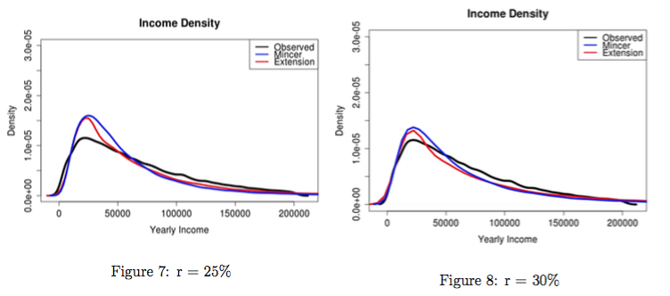
- Conclusion
The goal of this paper has been to explain the shape of the income distribution in terms of the costs of education. To do this, I turned to Jacob Mincer’s (1958) model, which claims that incomes differ in order to compensate workers for the costs of their education. I then proved a result alluded to in one of Mincer’s footnotes, which adds tuition costs to the model. Then, I used both the original model and its extension to simulate the income distribution. I found that the results are very sensitive to the discount rate and are only accurate at high rates. However, accuracy at the lower rates is improved by considering tuition costs. For this reason, I consider the extension an improvement.
The weaknesses of this approach lie principally in its assumptions. Mincer’s original model assumes that all workers are alike, that they have full and equal access to education, that labor is the only source of income, and that job compensation is purely in the form of pay. These clearly do not hold in the real world. These assumptions may explain why the model generates very equal distributions at low discount rates (see Figure 5). Furthermore, Mincer provides little theoretical justification of his claim that education is normally distributed. My data are not encouraging on this point (see Figure 4).
A helpful revision to the tuition extension would be to allow for heterogeneity in educational opportunities available to workers. Consideration of the income distribution is usually embedded in the context of questions of equity. Assuming total equality of opportunity $a$ priori seems to defeat the purposes of these kinds of discussions.

References
[1] Battisten, E., Blundell, R., Lewbel, A. (December 2009) Why is Consumption More Log Normal Than Income? Gibrats Law Revisited Journal of Political Economy 177(6), 1140-1154 Retrieved from: http://www.jstor.org/stable/10.1086/648995
[2] The College Board, Annual Survey of Colleges. (2015) Tuition and Fees and Room and Board over Time (Unweighted) Retrieved on: April 6th, 2016. Retrieved From: http://trends.collegeboard.org/college-pricing/figures-tables/tuition-fees- room-board-over-time-unweighted
[3] Mincer, J.. (1958) Investment in Human Capital and Personal Income Distribution. Journal of Political Economy, 66(4), 281-302. Retrieved from http://www.jstor.org/stable/1827422
[4] Delisle, Jason (2012) Federal student loan interest rates: history, subsidies, and cost. New America Foundation.
[5] Organisation for Economic Co-operation and Development. (2016). OECD In- come Distribution Database. Retrieved on: April 4th, 2016. Retrieved from: http://www.oecd.org/social/income-distributiondatabase.htm
[6] Harrison, G., Lau, M., & Williams, M. (2002). Estimating Individual Discount Rates in Denmark: A Field Experiment. The American Economic Review, 92(5), 1606-1617. Retrieved from http://www.jstor.org/stable/3083267
[7] Sahota, G. S. (1978) Theories of personal income distribution: A survey. Journal of Economic Literature, 16(1), 1-55. Retrieved from http://ezproxy.macalester.edu/login?url=http://search.proquest.com/docview/56113105? accountid=12205
[8] Sattinger, M. (1993). Assignment Models of the Distribution of Earnings. Journal Of Economic Literature, 31(2), 831-880.
[9] Krueger, K. V. and Slesnick, F. (2014) Total Worklife Expectancy . Journal of Forensic Economics 25(1), 51-70
[10] National Center for Education Statistics. (2013). Fast Facts: In- come of young adults.
[11] Federal Student Aid. United States Department of Education. Retrieved on: 19. June 2016. Retrieved from: https://studentaid.ed.gov/sa/types/loans/interest-rates
[12] U.S. Department of Labor. Workers Under 18. Retrieved on: May 8, 2016. Retrieved From: https://www.dol.gov/general/topic/hiring/workersunder18
[13] U.S. Census Bureau. (2014). Current Population Survey, 2014 Annual Social and Economic Supplement. Table 1. Educational Attainment of the Population 18 Years and Over, by Age, Sex, Race, and Hispanic Origin: 2014.
[14] U.S. Census Bureau. (2015). Current Population Survey, 2015 Annual Social and Economic Supplement. Table HINC-06. Retrieved from: https://www.census.gov/hhes/www/cpstables/032011/hhinc/new06 000.htm

The Development of Healthcare in Canada: A Comparative Economic Approach

Benjamin Goren ‘19
World Economic History
- Introduction

The United States remains the only major developed country without universal healthcare. President Obama’s key policy achievement of the last eight years, the Patient Protection and Affordable Care Act (PPACA), did not result in universal coverage, and the future of even that is in jeopardy. Proponents of universal healthcare argue that a system such as Canada’s nationalized single payer health insurance is not only more economically beneficial than the market based alternative, but it is also ethically responsible for a government to provide healthcare to all of its citizens. Opponents argue that it is government overreach into the rights of healthcare consumers and providers, and that by interfering with healthcare markets governments are reducing the efficiency of the ‘free hand.’ In both Canada and the US, opponents of universal healthcare propositions have derided them as ‘socialized medicine,’ and in the US the American Medical Association called Harry Truman’s proposal ‘un-American.’ Truman responded by asking “is (it) un-American to visit the sick, aid the afflicted or comfort the dying? I thought that was simple Christianity.” (Markel, 2014.) In the US, efforts by Truman, Johnson, and Clinton to pass universal single-payer healthcare have died in committee or been hit with compromises. In Canada, a massive overhaul of the health insurance system occurred between 1959 and 1971, resulting in a system where the national government covers all healthcare costs, but services are still provided by private non-profit hospitals and small clinics. The US and Canada have relatively similar political cultures and levels of socioeconomic development (Blankenau, 2001), and both countries have democratic regimes that aim to represent the interests of the people, so what factors led to a great divergence in healthcare systems?
Healthcare and insurance systems have developed differently in almost every country for a variety of political and economic reasons, and are never truly settled (Batinti, 2016; Thomasson, 2000; Ward and Zuerbruegg, 2000). The employer based US health insurance system is unusual among developed countries and very different from the Canadian system despite highly comparable political and economic histories surrounding insurance in the two countries. In this paper, I synthesize perspectives from political and economic history, behavioral economics, and health economics to compare the American and Canadian health systems. Building on the work of Batinti et al., I argue that the socially optimal health insurance system is one that maximizes benefits and minimizes costs for the median citizen or voter, but political ideologies and conditions reduce the chances of the optimal system being implemented. From this and the work of Blankenau on parallel streams of insurance in the US and Canada, I argue that the failure of any party to pass single payer health insurance in the US is better explained by differences in the median voter’s ideology, and the absence of a window of opportunity. The median voter in the US is warier of government overreach into private lives, and opponents of healthcare reform have used the perceived cold war communist threat and other opportunistic distractions to slow reform movements. I will begin my analysis by briefly summarizing the evolution of health insurance in the US and Canada, which I use to evaluate the arguments of Batinti et al. and Blankenau.
The feasibility of an institution that offers insurance relies on it being able to attract healthy individuals, who are relatively cheap to insure, in order to cover the costs of the unhealthy individuals. The two major theoretical problems with insurance are adverse selection and moral hazard - those individuals with high risk will be more likely to seek insurance (adverse selection), and once losses are covered by insurance, individuals are more likely to take higher risks. In the health insurance market, therefore, individuals with preexisting conditions are more likely to seek health insurance, and those in good health are less likely. A company providing insurance in a competitive market would benefit from denying coverage to high risk clients, but in a modern world where preventative care can save lives and mitigate treatment costs in the long run, there is a strong moral argument that healthcare is a right for all. This moral argument was part of the justification behind the passage of the PPACA.
History of Health Insurance in the US and Canada
The contemporary US healthcare system stems largely from a payment system developed by hospitals in the 1920s and 1930s to guarantee prepayment for hospital services. To increase demand for regular services during the Great Depression, hospitals created a system of small monthly payments in exchange for free medical services when they were needed, which was marketed to groups of employees. This evolved into Blue Cross, and the employer based system was solidified when the Supreme Court ruled that employer contributions to employee healthcare were tax deductible (Bloomberg and Davidson, 2009; Thomasson, 2000).
Democratic Presidents from Franklin Roosevelt to Bill Clinton have pushed for universal single payer healthcare where the federal government is the single payer for all healthcare costs, but their efforts have resulted in compromise or fallen entirely flat. When President Roosevelt pushed for universal healthcare in 1943 as a part of the second new deal, it never made it out of committee, overshadowed by wartime concerns. Truman supported a new version of the bill in 1946, but that same year republicans took control of both houses of congress, and with opposition from the AMA and waning public support of government involvement in the economy, the democrats changed their efforts towards only funding healthcare for the poor and elderly (Markel, 2014). In 1964, congress finally achieved a compromise when Johnson signed into law a bill creating Medicare and Medicaid, government funded health insurance for the elderly and poor.
The most recent attempt at single payer was during the Bill Clinton administration in a move led by then First Lady Hillary Clinton, which failed to pass a Republican House led by Newt Gingrich, and never gained the support of the American public who were bombarded with TV ads paid for by health insurance lobbyists instilling concerns about ‘big government’ (Cornwell, 2016). At the state level, several liberal leaning states have attempted to create single payer systems, with Vermont being the closest to success, but even the home state of Bernie Sanders had to halt their implementation due to a lack of funds and concerns about the economic impact of higher taxes (Wheaton, 2014). Finally, in 2009, President Obama seized on a Democratic supermajority (60 seats) in the senate to pass the PPACA. The PPACA revoked the right of insurance companies to deny health insurance based on preexisting conditions, and mandated that all Americans be insured or face a fine of $695 (Moomau and White, 2010). Based on the partisan division created with the passage of the PPACA, requiring a hard fought 60 votes in the senate to override a filibuster and fighting over amendments on controversial measures such as whether the new law would cover abortions, it is difficult to imagine that the democrats would have succeeded at passing single payer had they attempted in this window.
Before 1962, the Canadian health insurance system was mostly privately run, similar to the US system (Bernard, 1993; Health Canada, 2012). In the 1920s, there was great need for a system to pay for newly available primary care, which led to innovation in rural towns. Sarnia, Saskatchewan, for example, levied ‘medical taxes’ to pay doctors on a salary, rather than fee for service schedule. Major hospitals in the cities of Saskatoon and Regina adopted these methods of payment, but kept the fee based payment schedule (Ostry, 2008). Fee for service health insurance has the effect of making individual treatments (from a routine physical to chemotherapy) act more like commodities in the free market. The modern Canadian healthcare system is built heavily on these innovations.
The development of nationalized single payer healthcare in Canada occurred largely between 1947 and 1971, resulting from reciprocal positive reinforcement between provincial and federal governments. In 1947, the province of Saskatchewan passed a bill aimed at universal health coverage. The federal government responded in 1948 by creating a grant system to support provincial healthcare systems, leading British Columbia and Alberta to expand their state health insurance systems (Health Canada, 2012). With the rising costs of elderly care and high likelihood of illness among Canada’s poor and uninsured, the public saw the need for change at the national level, and Saskatchewan’s model seemed like a good solution. According to a 1949 Gallup poll, 80 percent of the population supported federally funded health insurance (Ostry, 2008). In 1957, parliament passed the Hospital Insurance and Diagnostic Services Act (HIDSA) with popular support, despite a conservative majority and opposition from the Canadian Medical Association (Blankenau, 2001). The bill created a 50/50 healthcare cost sharing structure between provinces and the federal government, and every province signed on by 1961. When Saskatchewan was the first to implement the federally aided system, physicians within the province went on strike in protest. The strike prompted even the previously sympathetic press to turn against the physicians and further entrenched support for nationalized healthcare in Canada. By 1971, every province had implemented universal healthcare with 50/50 cost sharing between the federal and provincial governments. It is important to note that although they gave in to increased transparency and government scrutiny, doctors and hospitals in Canada retained their independence and their right to charge fees for service. Elaine Bernard, Director of the Harvard Trade Union Program, describes the Canadian Health system as a “publicly-funded, privately-provided, universal, comprehensive, affordable, single-payer, provincially administered national healthcare system” (1993).
- Theories of Health Insurance

There exists a wide variety of theories that attempt to explain why healthcare systems develop differently across countries and what the social optimum is for the citizens of those countries. As noted earlier, the political culture, levels of socioeconomic development, and other factors such as ethnic diversity and urbanization are relatively similar between the US and Canada, so it would make sense that the socially optimal healthcare system would be similar in both countries (Blankenau, 2001). Batinti et al. make the case that healthcare systems in a democracy should reflect the preferences of the median voter. I argue that they undervalue the influence of political preferences and leanings of voters, which are largely shaped by accidents of history. Additionally, I argue that institutions, such as the distribution of power between state (or provincial) and federal governments, can at least partly explain differences in how the US and Canadian systems have developed.
Batinti, Congleton, and Pietratonio (2016) use the median voter theorem to argue that the median voter will choose the healthcare system best for them. Wealthy and healthy voters who can afford out of pocket medical expenses, or who are at low risk of needing expensive health services, are more likely to prefer private, incentive based insurance systems in which insurance companies offer lower premiums due to lower risk. Voters who are poor or at risk of health problems such as the elderly would benefit under a health insurance system funded by income tax, under which those with high incomes or those who do not use their share of healthcare effectively subsidize the poor and unhealthy through the government (Batinti et al., 2016). It is hard to determine where the median voter falls on this spectrum. Batinti et al. (2016) develop a model in which they assume that the costs of a private system are based on personal risk, the costs of health services, and the cost of the overhead of a private system. As risk increases in an aging population or the costs of healthcare go up due to the development of an expensive treatment, for example, preference shifts towards a publicly funded system. When these costs become greater than potential income tax revenue, a publicly funded system should become the preference of the median voter.
The economic preference model may be useful in explaining why Roosevelt and Truman were not successful in passing universal healthcare in an environment of already high taxation, because the potential to raise money through an increase in taxation was very low. It does not, however, explain why the Clinton administration was unable to get a single payer bill out of committee when the average tax burden for households was around 21 percent (Tax Policy Center). Batinti et al. (2016) accommodate for this with two important acknowledgements. The first is that “[H]ealthcare systems are rarely adopted whole cloth,” which is best reflected in Johnson’s compromise to pass a version of single payer via the creation of Medicare and Medicaid, which are for the elderly and poor only. The second is that voters receive utility from the representation of their ideologies, which may not reflect their personal interest, in public policy. An exploration of both can explain why Canada adopted universal healthcare in the 1960s, while the US is still fighting over it.
An exploration of the history of healthcare in the US and Canada showed that in both countries the liberals have supported the adoption of a universal single payer system. The Co-operative Commonwealth Federation (CCF), a Canadian third party, passed single payer in Saskatchewan before allying with labor to form the New Democratic Party (NDP) which achieved healthcare reform at the federal level in the 1950s and 1960s (Ostry, 2008). The Democratic party in the US had similar popularity from the 1940s through the 1960s, but missed their window of opportunity to pass universal healthcare during the New Deal reforms due to already high taxation and preoccupation with the war effort (Markel, 2014; Thomasson, 2000). I argue that the strategies pursued by the democrats in these early attempts at passage of universal healthcare ultimately doomed their effort.
Recipients of government funded healthcare in the US were viewed as charity cases due to the provision of insurance to the poor, most of whom paid little taxes through Medicaid. In Canada, on the other hand, public health insurance grew to support the working poor, and those who paid for the nationalized health insurance system through their income taxes directly saw the benefit (Bernard, 1993). Perhaps the framing of universal health insurance as a form of good Christian charity by its proponents such as Harry Truman (Markel, 2014) ultimately doomed its chances at success. Government funded health insurance in the US became the government taking ‘our’ hard earned dollars to benefit the poor out of altruism, whereas in Canada government run healthcare is seen as a fair exchange of payment via taxation for services.
Scholars on both sides of the debate over healthcare reform acknowledge that misrepresentation of the benefits of public or privately funded systems is rampant. On one side, government officials stand to benefit from measures that expand government authority, leading them to obscure information that may change voter preferences (Twight, 1997). On the other, doctors and insurance companies may see universal healthcare as an infringement upon their rights to practice independently, or a potential threat to their profits. This is reflected in heavy lobbying by both the AMA and CMA against universal healthcare, deriding it as “socialized medicine” and expressing concerns about overreach on their rights to practice. Concerns among doctors about lost earnings seem to have been incorrect in retrospect. Duffin (2006) finds that since the implementation of single payer in Canada, physicians incomes have grown faster than those of US physicians, and physician remains the highest paid profession in either country. In the 1950s and 1960s, there was little lobbying from insurance companies on the matter, perhaps because the industry was not well founded at the time, but as the debate has continued in the US. Insurance companies have used their power to keep the profitable private system in place (Kelly, 2003). One advantage of the Canadian system to the consumer is that it consolidates the bureaucracy of insurance groups under one roof, greatly reducing overhead costs. The effects of this are huge: in 1993, 15 percent of US healthcare costs were spent on overhead, compared to 3 percent of costs in Canada (Bernard, 1993).
Some might argue that if the adoption of universal healthcare in Saskatchewan in 1947 spread to the rest of Canada within 25 years, all it will take is for one state to create a similar system in the US to start a domino effect resulting in the national adoption of a single payer universal healthcare system. Why then did the passage of such a program in Vermont fail so quickly? First, Vermont did not have the backing of the federal government. The CCF in Saskatchewan was backed up by a liberal majority in Ottawa which quickly passed a bill to help fund Saskatchewan’s program. In the US, the separation of powers between the executive and legislative branch made it difficult for the Democratic president to back the state. President Obama was busy fighting a Republican congress to keep his own healthcare law from being repealed, which would not happen with the Canadian system where the prime minister is of the party which controls parliament. Second, the Canadian federal structure is more decentralized (Blankenau, 2001), and a smaller number of states hold more power. Even tiny Saskatchewan had a population in 1947 equal to about 7 percent of the national population. The same is true for New York today. That is to say, it would take a larger state than Vermont to start a domino effect leading to national universal healthcare in the United States.
- Conclusion

When writing about an issue that has been debated on the central stage of national politics in the US for years, it is difficult to avoid the normative. In this paper, I attempt to provide an explanation for the current state of healthcare in the US through historical, behavioral, and cross-country analysis. It is hard to determine what healthcare system is socially optimal for any country, or whether the efficiency benefits of a single payer system outweigh the tradeoffs of overreach into the free market. Instead, I argue that the US system is not in place because it is socially optimal or best for the median voter. What better explains the still evolving US healthcare system is a complex history, a mismatch of desire and opportunity for change, and the ideological preferences of individual voters. One major conclusion is that the median US voter perceives socialism as more of a threat than the Canadian voters, as attacks of single payer as “socialized medicine” have died out in Canada, but live on in the US.
Perhaps the most elucidating quote on the Democrat’s lack of success at passing single payer in the US comes from Hillary Clinton’s 2003 book “Living History” in which she writes: "our most critical mistake was trying to do too much, too fast. That said, I still believe we were right to try." Her transition from the biggest proponent of single payer in 1994 to a sharp critic in the 2016 Presidential campaign confirms the closing of the Democrat’s latest window of opportunity. I admit that I agree with Harry Truman and Hillary Clinton that the government has a moral obligation to ensure access to healthcare for all of its citizens, as it does with clean water, safe streets, and quality public education. What remains unclear is whether what is best for the public can be achieved under a private insurance system, or whether a public system can adequately meet the diverse demands of healthcare consumers.
References
Auerbach, D., Holtzblatt, J., Jacobs, P., Minicozzi, A., Moomau, P., & White, C. (2010). Will Health Insurance Mandates Increase Coverage, Synthesizing Perspectives from Health, Tax, and Behavioral Economics. National Tax Journal NTJ, 63(4, Part 1), 659-679. doi:10.17310/ntj.2010.4.03

Batinti, A. (2016, August 3). The Electoral Politics of Complex Healthcare Systems. SSRN Electronic Journal. doi:10.2139/ssrn.2838984

Beattie, A. (2007). The History Of Insurance. Retrieved November 2, 2016, from http://www.investopedia.com/articles/08/history-of-insurance.asp

Bernard, E. (1993). THE POLITICS OF CANADA'S HEALTHCARE SYSTEM: Lessons for the US. Retrieved November 2, 2016, Radical America, 24 (3).

Blankenau, J. (2001). The Fate of National Health Insurance in Canada and the United States: A Multiple Streams Explanation. Policy Studies Journal, 29(1), 38-55. doi:10.1111/j.1541-0072.2001.tb02073.x

Blumberg, A., & Davidson, A. (2009, October 22). Accidents Of History Created U.S. Health System. Retrieved December 12, 2016, from http://www.npr.org/templates/story/story.php? storyId =114045132

Cornwell, S. (2016, June 06). From 'Hillarycare' debacle in 1990s, Clinton emerged more cautious. Retrieved December 10, 2016, from http://www.reuters.com/article/us-usa-election-hillarycare-idUSKCN0YS0WZ

Duffin, J. (2011). The Impact of Single-Payer Healthcare on Physician Income in Canada, 1850–2005. American Journal of Public Health, 101(7), 1198-1208. doi:10.2105/ajph.2010.300093

Health Canada (2012, September). Canada's Healthcare System. Retrieved December 12, 2016, from http://www.hc-sc.gc.ca/hcs-sss/pubs/system-regime/2011-hcs-sss/index-eng.php

Kelly, D. (2003, November). Health Insurance Groups Merging to Gain Lobbying Clout. Best's Review,13-14. Retrieved from EBSCOhost.

Markel, H. (2014, November 19). 69 years ago, a president pitches his idea for national healthcare. Retrieved December 11, 2016, from http://www.pbs.org/newshour/updates/november-19-1945-harry-truman-calls-national-health-insurance-program/

Ostry, A. (2008, December 7). The Foundations of National Public Hospital Insurance. University of Victoria Press. Retrieved December 11, 2016.

Tax Policy Center. (2015, January 20) Historical Average Federal Tax Rates for All Households.. Retrieved December 12, 2016, from http://www.taxpolicycenter.org/statistics/ historical-average-federal- tax-rates-all- households

Thomasson, M. A. (2000). From Sickness to Health. The Twentieth-Century Development of the Demand for Health Insurance. J. Eco. History The Journal of Economic History, 60(02), 504-508. doi:10.1017/s0022050700025213

Twight, C. (1997). MEDICARE’S ORIGIN: THE ECONOMICS AND POLITiCS OF DEPENDENCY. Cato Journal,16(3). Retrieved December 11, 2016, from Cato.org.

Ward, D., & Zurbruegg, R. (2000). Does Insurance Promote Economic Growth? Evidence from OECD Countries. The Journal of Risk and Insurance, 67(4), 489. doi:10.2307/253847

Wheaton, S. (2014, December 20). Why single payer died in Vermont. Retrieved December 12, 2016, from http://www.politico.com/story/2014/12/single-payer-vermont-113711

SUPERVALU, INC: The Needle in a Slow-Growth Industry Haystack
Jacob Simons, ‘17
Introduction to Securities Analysis

This paper is the apex of Joyce Minor's Introduction to Securities Analysis class. The class focuses on equity securities analysis (stocks) from the perspective of institutional (Wall Street) investors, and this project culminates all major aspects of the class including industry analysis and forecasting, financial statement analysis, fundamental company analysis, and valuation metrics. An Equity Research Report is created by an Equity Research Analyst, typically at an investment bank, in order to offer recommendations to buy or sell a stock.
SUPERVALU, INC.

The Needle in a Slow-Growth Industry Haystack

Initiating Coverage With a 1-BUY Rating

- An $8.60 Target Price Implies a 53% Return by 2017. SuperValu shares have struggled due to short-term investor worries and we believe this leaves a great investment opportunity for 2016. SuperValu’s EPS has been increasing significantly as of late and we expect a continued earnings increase with of 28% increase in 2016 to $0.86 with a conservative revenue growth estimate of 1.5% and an 18bps increase in operating margins in 2016.

- Adaptability and Relationship Integrity Will Withstand Headwinds of a Slow-Growth Industry. SuperValu is diversified across the United States in both retail and wholesale markets and has competed in the challenging retail environment since the 1950s. With distribution to over 2,000 locations and 1,500 more retail operations, a history of success ensures the competitive edge with a longstanding reputation for excellence.

- Growth Potential Coupled With New Management Breeds Room for Multiple Expansion. Peer group comparisons show SVU is significantly undervalued by the industry. A new management team in a transition stage for the company opens opportunities for SuperValu success.

- Point 2

- Point 3
May 2, 2016

Grocery Stores & Supermarkets

1-BUY

Ticker: SVU
Price (4/28/16): $5.62
Price Target: $8.60

Exchange NYSE
S&P 500: 2065.30

Jacob Simons
1-262-443-1321
jsimons@ssonsgroup.com

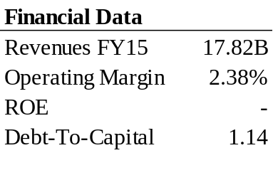
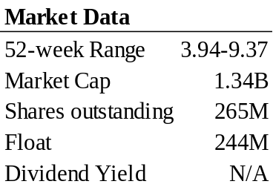

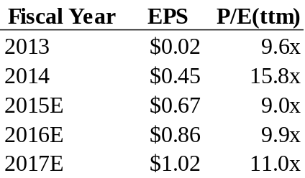

Source: Ycharts

INVESTMENT THESIS We are initiating coverage of SuperValu with a 1-Buy rating with an $8.60 target price, implying a possible 53% return by 2017. SuperValu shares have been pushed down over the last year and we believe they are significantly undervalued by the market’s short-term volatility and uncertainty. SuperValu’s EPS has been increasing significantly from $0.02 in 2013 to $0.45 in 2014 and are expected to increase again in 2015 to $0.67 (FY2015 ends February 28, 2016 with earnings reports out late April or early May). We expect this continued earnings increase with a 28% increase in 2016 to $0.86 with a conservative revenue growth estimate of 1.5% and an 18bps increase in operating margins in 2016.

A strategically selected management team coupled with a valuable company in a transition phase will position SuperValu for continued success. Industry outsider, Mark Gross, has been hand-picked by the SuperValu independents-driven Board of Directors as CEO of SuperValu. The Board has a history of strategic management selections and Mark Gross has extensive M&A experience and helped lead C&S to a $20 billion company in the early 2000s. We believe the company is well-positioned for continued earnings growth and will continue to compete for sales revenue in a challenging and competitive environment in the grocery store space with fully integrated wholesale and retail spaces across the country.

COMPANY PROFILE Overview
SuperValu is one of the largest wholesale grocery distributors in the country, operates an extensive hard discount grocery retailer and owns five regionally-based traditional grocery store retail banners. Founded in the 1920s as a wholesale distributor based in Minnesota, SuperValu has prided itself on its grocery innovation and adaptability to flexible industry standards for over 90 years. The company now spans 41 states across America with several other international relationships and partnerships. Since the establishment of its retail businesses in 1942, SuperValu has been vertically integrated in the grocery space for over 60 years.
In 2014, SuperValu generated $17.82 billion of revenue throughout its three reported business segments. SuperValu is classified by management into three major business segments: Independent Business, Save-A-Lot, and Retail Food. These segments are three distinct businesses. The Independent Business is SuperValu’s wholesale distributor and provides logistics service solutions to over 2,000 independent retail stores through 17 country-wide distribution centers. The Save-A-Lot format provides high-volume and low-priced items to individual customers through its 1,336 hard discount grocery stores in the southern and eastern United States, with new markets in the west. The Retail Food segment consists of nearly 200 stores organized under regional grocery retail brands including Cub Foods, Shoppers Food & Pharmacy, Shop’n Save, Farm Fresh, Hornbacher’s, and two Rainbow Foods stores.

Figure 1: SuperValu
Operating Margins by Business

Source: Company Documents

Figure 2: SuperValu
Revenue by Business
Source: Company Documents

Since 2007 SVU shares have been extremely volatile. After a large acquisition of Albertsons and other store formats SuperValu lost over 90% of its share value from $49 in 2007 to under $3 2012. The company hired Wayne Sales to take over the executive position and lead the company back to high-level performance. In 2013 Supervalu participated in a desperate divestiture of five of its retail grocery banners – Albertson’s, ACME, Jewel-Osco, Shaw’s, and Star Market – to Cerberus Capital Management in order to consolidate company performance. The March, 2013 deal included $100 million cash and $3.2 billion in assumed debt totaling $3.3 billion. The company has focused on its other profitable business segments since the deal, but revenues declined 52.6% the following fiscal year from $36.1 billion to $17.1 billion. After restructuring and improved margin growth SVU jumped to $11.90 in April 2015. However, after a revenue miss in April 2015 and subsequent same store sales declines through the third quarter of 2015 (reported January 2016), SVU has lost over 50% of its value since the 2015 highs.

Figure 3: SuperValu
Historical Stock Price Since ‘05

Souce: YCharts
Figure 4: SuperValu
Annual Revenue & Profit Margins
Billions $
Margin
Source: Company Documents
SuperValu offers a wide selection in the growing all-natural and organic segments of the millennial-owned market. IBIS World estimates millennials are becoming the most important population for the consumer base in the United States and will soon be the largest source of revenue for food retail. The growing generation of millennials demands a more high-quality, all-natural, organic, non-GMO, and local product than their Generation X predecessors. In order to succeed in a changing market environment SuperValu has re-introduced and improved their Wild Harvest private-label brand offering more than 600 products in 60 categories, all of which are free from over 100 undesirable ingredients like natural and artificial flavors, and 70% are USDA Organic certified according to the company news reports. In March, 2016 the company announced a transition to 100% cage-free eggs to all its grocery retail sites. In 2015 the Cub Foods banner was also the first grocer in the Twin Cities to offer Caroline Carts designed for special needs children and disabled adults.

In 2013 and 2014 Supervalu completed transitional service agreements with Cerberus and Haggen’s. In March, 2013 SuperValu divested several retail banners to Cerberus Capital Management. As part of the deal, SuperValu agreed to a transitional service agreement (TSA) to provide services and resource support for the divested Albertson’s. The contract will expire in September 2016. SuperValu also agreed to a similar TSA agreement with Haggen’s 164 stores in December 2014. This contract will expire in December 2016. SuperValu receives fee income from these agreements totaling $176 million in 2013 and $72 million in 2014. There is an option at maturity to renew these contracts but we conclude this is unlikely. Our earnings forecasts in Figure 13 do not reflect any income from these transactions for conservativism and unpredictability issues.

In July 2015 SuperValu announced a potential spin-off of Save-A-Lot, its discount grocery chain and primary business segment. After beating profit and revenue growth expectations in July, 2015, Sam Duncan, then President and CEO, announced that spinning off this segment will enable SuperValu to focus on growth in its other retail grocery stores and wholesale business, while unlocking shareholder value from the spin-off. On January 7, 2016 SuperValu filed a Form 10 with the SEC for the possible spin-off, indicating that Save-A-Lot would be more competitive and SuperValu shareholders would receive at least 80% of the new public entity, according to the SEC filing. The Save-A-Lot segment has been considered the growth driver for SuperValu over the last several years in the competitive landscape. The deal is not certain, but is in the deeper stages of development.
Market Positioning
SuperValu has been an industry leader for over sixty years and willl withstand the headwinds of this slow-growth industry. SuperValu is diversified across the United States in both retail and wholesale markets and has competed in the challenging retail environment since the 1950s. Independent Business distributes to over 2000 store formats annually and SuperValu operates another 1500 stores in Save-A-Lot and Retail Food. The long history of success for SuperValu ensures a competitive edge with a longstanding reputation for excellence.

Competition on price and private-label product selection are the top two main differentiators in the industry; both are SuperValu’s expertise. Supermarket News’s 12th Annual Center Store Performance Survey asked retailers in 2015 how companies can best compete with their competitors on sales. Of the surveyed retailers, 26% responded with price as the most important while 23% agreed on private-label branding. That’s 49% of retailers across the United States stating their competitive peers succeed most if they win the price competition and private-label branding battles. SuperValu’s business segment, Save-A-Lot is the largest hard discount retail format in the country and their Independent Business is highly successful in their private-label branding strategies, paving the road for future success in this highly competitive environment.

Management & Major Shareholders
Supervalu’s management has recent success in hiring industry outsiders and has appointed another, Mark Gross, to replace retiree Sam Duncan. In 2012 SuperValu discovered a major problem with their 2006 acquisition and hired a new CEO and industry outsider, Wayne Sales, to lead the company. He guided the company through that divestiture in 2012 and left to allow his successor and other industry outsider, Sam Duncan, to lead operations. Under Duncan margins improved, the debt load alleviated and SVU climbed from a low of $2.41 to almost $12 in 2015. Duncan announced his retirement in mid-2015 to step down in February 2016. SuperValu’s management appointed new outsider Mark Gross as President and CEO on February 6th, 2016. We believe the management team has a strong history of appointing strategic CEO’s and this is no exception. On April 19, the company also hired industry outsider and long-time business partner of Mark Gross, James Wiedenheimer.

Mark Gross, new CEO of SuperValu, has a growth and transactional history that will add significant shareholder value. Mark Gross previously worked with C&S Wholesale Grocers Inc. from 1997-2006 serving his later years as Co-President. Mark helped C&S grow from $3 billion in revenue to over $20 billion and develop C&S Wholesale Grocers into the seventh largest private company in the United States. Afterwards he built a strategic consulting firm with a partner at Surry Investment Advisors, providing strategic and operational advice to food retail and wholesale distributors throughout the country. We see the hire by SuperValu as a strategy to finalize a Save-A-Lot spin-off to unlock significant shareholder value and to lead SuperValu back to improving operations in its wholesale business.

SuperValu’s competitive director compensation lures top independent management with a wide range of business experience. SuperValu’s Board of Directors is composed of 90% independents, as a strict rule in their filings. The only currently SuperValu employee on the board is Mark Gross, President and CEO. The 9 independent board members average an annual incentive pay of $250,000, composed of slightly more stock options than cash awards. The annual retainer for the mandatory Non-Executive Chair is double the cash award for other board members in order to attract top independent talent.

Named Executive Officers are highly motivated for future success with strategic compensation plans. SuperValu’s compensation plans for top management are based 42% on long-term performance and 58% short-term, of which the annual bonus is composed heavily by strict financial metrics. The CEO pay has a “Pay for Performance” philosophy, as determined by the board, and is mixed with half regular and restricted stock options and half cash and bonus awards. The CEO bonus is primarily tied to financial goals and considers the median peer group compensation. Mark Gross started with 65% of the previous CEO’s base pay and is especially compensated through long-term goals.

Growth Strategy
In a mature, commodity-based industry acquisitions have been a hesitant growth strategy for SuperValu’s recent past. The grocery industry has proven to be a competitive and saturated market, largely based on rivalry in pricing. Due to consumer trends and preferences, we see geographic location as a key driver for grocery and supermarket sales lending to efficient strategies through acquisitions and penetration into new markets. In 2006 SuperValu acquired several new store formats to more than double the size of the company to almost $45 billion in revenue, mostly through debt financing. The majority of this acquisition was finally divested in 2013 to eliminate over half of their more than $6 billion in debt and unstable margins. Management is in a transition stage with acquisitions growth and has been more focused on organic growth through cost leadership in improving margins and major miscellaneous expenses.

SuperValu’s Save-A-Lot format has driven organic growth in recent years and continues to deliver the highest margins in the business. SuperValu opened 46 new Save-A-Lot stores in 2014, of which 23 are corporate-owned and 23 are licensee stores. Management is aware of the neutral to bleak outlook for the supermarket industry and has invested in more corporate stores in recent years, despite significant deflationary meat headwinds. In the fiscal year ended February 28, 2015 total retail square-footage of Save-A-Lot increased 13.8%, due largely to acquisitions of licensed stores, and it still plans to add 90 new stores in FY 2016 (reporting May/April 2016) with the majority being corporate-owned. Some of these stores are also anticipated to be in new US markets, but have not been specified yet. Save-A-Lot also delivers the highest operating margins over the three business segments at 3.3%, still low compared to the peer company average of 4.3% (Yahoo) and has significant room to improve with new management in Mark Gross, and a potential spin-off to unlock shareholder value.
Figure 5: SuperValu
Store Count Percentage

Source: Company Documents

Deflationary headwinds and pricing trends threatened Save-A-Lot sales in 2015, but are expected to stabilize to normal levels. Save-A-Lot’s same store sales increase of 5.8% was a financial highlight of 2014, but has seen recent declines from the deflationary meat headwinds in beef and pork as of late. This deflation is some of the worst Save-A-Lot has experienced and significantly contributed to the recent negative ID sales growth in Q2 Fiscal 2016 and Q3 Fiscal 2016 (Fall and Winter 2015). Figure 6 below shows the recent trend of total red meat and pork production since 2010 from the USDA Economic Research Service. It is clear that prices are quickly stabilizing and we will see positive ID sales growth continue for Save-A-Lot in 2016 (FY2017). The industry as a whole has also been pressured to lower prices for meat and dairy products but management continues to reiterate belief about Save-A-Lot’s pricing and its healthy competition with peers.
Figure 6: SuperValu
Historical Red Meat and Pork Supply

Source: USDA Economic Research Service

Private-label brands deliver underlying success in SuperValu sales numbers. According to IBIS World’s industry research, private-label brands have been a growing industry trend for millennial consumers, as well as the organic and all-natural food trends. According to the same report more than 42% of millennials believe private-label brands are of better quality than branded products. SuperValu adapts well to these challenges. In Independent Business the company re-introduced their Wild Harvest brand while also adding more than 200 extra products in the expansion in 2014. Private-label sales from Independent Business have been drastically increasing and Save-A-Lot private-label brands penetration is at an all-time high of 60% of corporate store sales. IBIS World’s Healthy Eating Index also shoes an upward trend in 2016, driving demand for these premium products and, ultimately, top line revenue expansion.

EARNINGS OUTLOOK Earnings Forecast
Moderate store growth and expected management effectiveness in operating expenses will produce an increase in EPS to $0.86 in 2016, implying a 28% upside. IBIS World forecasts an annual increase of 1.7% over the next five years for the grocery and supermarket industry with a GDP forecast of 2.2% over the same period. Due to moderate store growth and 2015 industry headwinds we are expecting a 1% increase in revenue for 2015, with a gradual return to the industry average at a conservative 1.5% in 2016 and ultimately edging closer to GDP growth to 2% growth in 2017. This increase is primarily due to moderate store growth guidance at 1.5-2% for 2016 and Mark Gross as talented industry outsider with extensive experience in revenue growth. We are also forecasting a continued 50bps decrease in SG&A expenses in conjunction with this revenue expansion. We expect a conservative operating margins growth of 20bps per year as Mark Gross and James Wiedenheimer aim to streamline operations. There is ample room for growth in the industry as shown Table 1 below. With a 20bps operating margins improvement and the 1.5% revenue growth in 2016 we expect a 2016 EPS at $0.86. Figure 7 contains a detailed earnings model of these projected earnings for 2016 and 2017.

Table 1: SuperValu
Industry Operating Margins
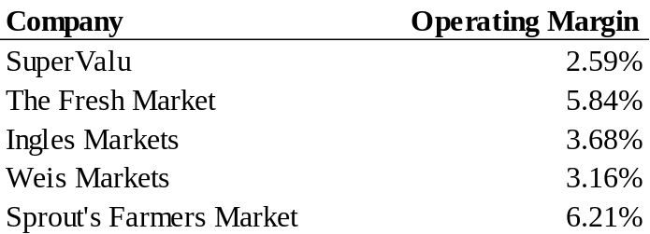
Source: Google Finance

Figure 7: SuperValu
EPS Estimates

Source: Simons & Sons Forecasts

Capital Structure
SuperValu is committed to reducing the debt load in order to allow future strategic opportunities for growth. SuperValu has been reducing heavy debt burdens for several years after a failed integration of their 2006 acquisition of Albertson’s, et. al and has been committed to reducing this level in order to allow more room for strategic positioning in the industry, primarily through M&A transactions facilitating growth. Mark Gross has extensive knowledge of M&A markets in grocery retail and wholesale businesses and we expect him to not only continue this Save-A-Lot divestiture but also position the company for new acquisitions in the future. We forecast increasing earnings growth trends to $271 million in 2017 but also stable cash flows. We anticipate the company will use a considerable portion of this new income to pay down heavy debt burdens to $1,654 million in 2017, a decrease of 25% from $2,218 million on 2015. The Debt-To-Capital Ratio will decrease by 10% during the period with stable cash reserves of about $120 million. Figure 8 below shows this debt schedule.
Figure 8: SuperValu
Long-term Debt Forecasts

Source: Simons & Sons Forecasts

VALUATION A strong positive earnings stream growth and new management lead to a one-year price target for SVU of $8.60 implying a 53% premium to their April 28th close price of $5.62. We rate the stock a 1-Buy. A series of negative events plunged SuperValu’s valuation in recent years. We are confident that Mark Gross and the new management team can improve this recent drought of revenue growth and lead the company back to improving the Independent Business and Retail Food segments. We expect gradual integration of these principles over the next three years and a return to a historical normal P/E of 15x, in Figure 8 below. In 2016 SVU will experience a conservative 10% increase in P/E (ttm) to 10x with our EPS estimate of $0.86 yielding an $8.60 price target.

SuperValu’s growth potential and new management breeds room for EBITDA multiple expansion. Compared to its peer group of IMKTA, TFM, SFM and WMK SuperValu is at a significant discount with several multiples, as seen in Table 2 below. Because SFM is a multiplier outlier in this peer group, we used the median multiples to more accurately value SuperValu among its competitors. SuperValu has traded at a discount to peers for some time but we believe the share price for SVU is significantly undervalued because its clear earnings growth potential and new and experienced management team. We are confident that SuperValu can make up at least 7% of this discount by the year end and return to a 15% discount implying a 5.68 EV/EBITDA multiple with SVU shares at $7.40 per share; still a 30% increase and 1-Buy rating from their April 28th close price.

Figure 8: SuperValu
Historical PE (ttm) Ratio
Source: YCharts, Simons & Sons Forecast

Table 2: SuperValu
Valuation Multiples

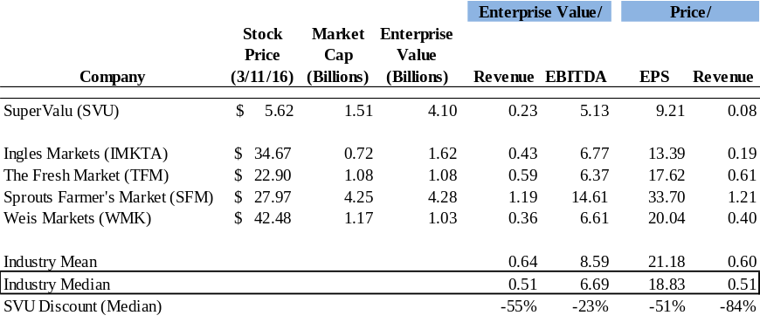
Source: YCharts

Unlocked shareholder value in Save-A-Lot spin-off is not properly priced into the stock. Mark Gross is an expert in M&A for the grocery space and we expect he is an integral component to the finalization of the Save-A-Lot deal. In January 2016 SuperValu mentioned that if the deal were to close, current SVU shareholders wll receive at least 80% of the newly public entity, with SuperValu retaining the remaining shares. Save-A-Lot has been the key organic growth driver for SuperValu and with meat deflation expected to reside, we see significantly positive shareholder value in this entity and believe the success of the management team and spin-off is not correctly priced into the stock. We anticipate SuperValu can exceed short-term expectations.
INDUSTRY ANALYSIS Industry Structure
A price-centered industry driven by commodities drives a high level of industry rivalry. According to IBIS World there are over 42,000 grocery stores throughout the Unites States, deeming the industry saturated and mature. Figure 9 below shows the market fragmentation fundamentals. Due to the commodity-based product of the industry this competition is heavily price-centered; an unattractive form of rivalry. The IBIS World estimated low annualized growth of 1.7% through 2021 also does very little to mute this rivalry effect. The low profitability of this industry is a strong indicator on its rivalry with an average profit margin of 1-2% as stated by IBIS World. Figure 10 shows these margins. Overall, the grocery store and supermarket industry has a high threat of rivalry.
A low threat of new entrants has been a recent concern for integration penetration into the grocery retail space. The average grocery store requires, on average, $6 million with another $3 million in maintenance-related expenses according to Supermarket News. These low fixed costs together with low government regulation provide ample opportunity for forward integration from wholesalers into the retail space or sideways integration from traditional supercenters. This has been a problem for the industry lately as we have seen market share acquired by Wal-Mart through its sideways integration from the supercenter format and through forward integration from stores like Costco. We do not consider Costco or Wal-Mart in the grocery and supermarket industry. The commodity-based industry also experiences easy product access and low brand-loyalty further adding to the high threat of new entrants.
Figure 9: SuperValu
Industry Market Share

Source: IBIS World

Figure 10: SuperValu
Costs as a Percentage of Revenue

Source: IBIS World
A commodity-based industry offers grocers some buyer power over inventory purchases. There are more than 24,500 wholesale businesses throughout the United States. This coupled, however, with more than 42,000 retail businesses (IBIS World). This may seem to indicate strong supplier power due to the relative 2:1 ratio, but according to First Research’s supermarket industry report retailers issue dozens of relationship contracts mitigating this effect. These retailers have relatively low switching costs to suppliers and maintain domestic and international relationships to mitigate this risk, as well. Two caveats are with specialty products like non-GMO or USDA Organic certified foods and brand-labeled products like General Mills. These product wholesalers may have some bargaining power in this industry due to their differentiation and specialty appeal. Overall, the supplier power in this industry is moderate to low.
A radical industry trend in the millennial population requires a flexible product line and trustworthy branding. Buyers in this industry also have high power due to the commodity-based goods and price-centered rivalry. A recent Deloitte study cited that consumer purchasing decisions are primarily based on price, with low switching costs from the buyer’s perspective. The industry is also subject to consumer trends and must adapt in order to achieve sales growth and capture market share. These factors force grocers to be flexible with product offerings with trend and demographics changes, as we are seeing with the millennial population in the United States. This ability to adapt costs grocers extra time and money, allowing buyers to dictate which products will be sold and at what price. Although specialty stores may mitigate some of this risk, we are seeing a large increase in non-GMO and USDA Organic offerings at all store fronts across the country and anticipate this trend will be the norm in due time. This reactive industry implies a high level of buyer power.

A mature, defensive industry is difficult to impose innovation and is subject to substitutes and price ceilings. With a consumer staple like grocery stores and supermarkets we do not see room for consistent innovation and product adaptation as with other industries, thus allowing for a range of substitutes. The fast-casual dining restaurant space has been a growing industry trend and has been a small threat to the grocery industry in recent years due to the increase in consumer discretionary income as cited by IBiS World. We are also seeing a growing trend in online platforms like Blue Apron that offer an entire food experience at home, but we do not see a major industry shock in this area. Overall, threat of substitutes we rate as moderate to low.
Growth Analysis & Opportunities
Private-label brand penetration and consumer trend adaptation are two key factors that position SuperValu well in this competitive landscape. Supermarket News’s 12th Annual Center Store Performance Survey asked retailers in 2015 how companies can best combat their competitors on sales. Of the surveyed retailers, 26% stated price as the most important while 23% agreed on private-label branding. We foresee corporations that can take advantage of one of these areas to elicit strong revenue numbers in future years as the millennial demographic ages into spending years. SuperValu is strongly positioned for these factors.

Consolidation continues to be a key growth driver for the supermarket industry. Over the past few years we have seen significant consolidation of the grocery store industry through large market names like Kroger and Albertson’s. Geographic reach is an extremely important factor in the industry and M&A seems to be commonplace to widen this reach. We expect companies to continue to find new strategic opportunities by maintaining lower debt levels.

RISKS SuperValu has been exposed to debt concerns in recent years and may limit their ability to grow through M&A. In 2006-20012 SuperValu had more than $6 billion in long-term debt obligations, derailing them from any further acquisition opportunities for industry growth. Management has been monitoring this risk and is working toward reducing the debt levels as fast as possible to continue to spearhead opportunities in the industry.

The grocery store and supermarket industry is subject to volatile food price changes as we saw in 2014-2015, and could affect SuperValu’s margins in the future. SuperValu is vertically integrated in the grocery store industry which allows them to mitigate some food price risk. However, a hard discount retail store like Save-A-Lot is especially subject to this risk. IBIS World does, however, forecast a significant decrease in the Agricultural Price Index through 2021. A price decrease allows grocery stores like SuperValu to improve margins by keeping food prices stable in-store.

New management has not had a track record with SuperValu and may limit SuperValu’s ability to grow. Industry outsider, Mark Gross, joined the company in February and we cannot make detailed numbers-based assumptions based off of him. We are confident in Gross’s past performance and anticipate he will become an an invaluable member of the SuperValu management team through his extensive industry knowledge and expertise.
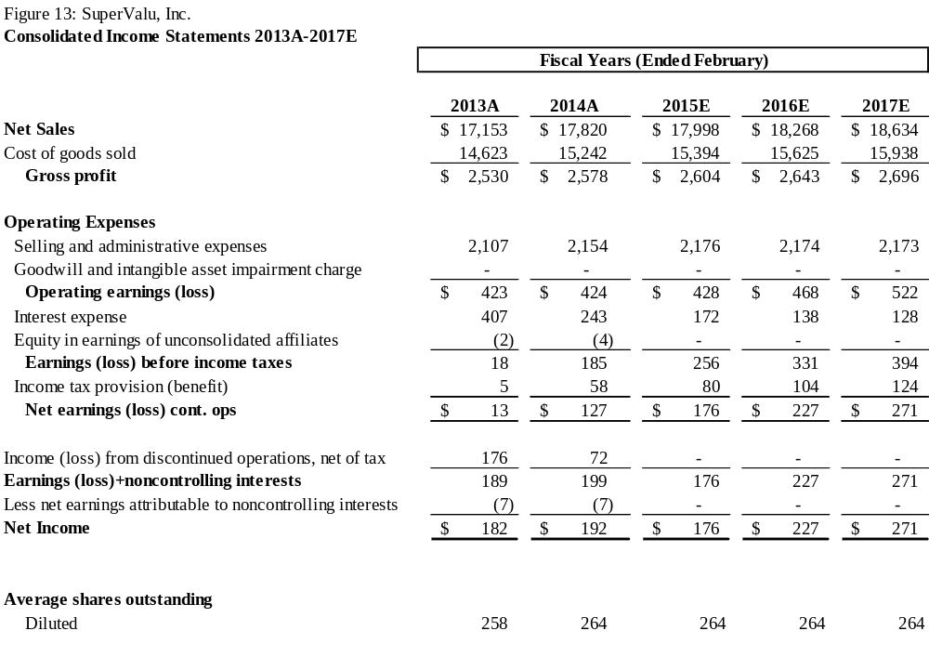
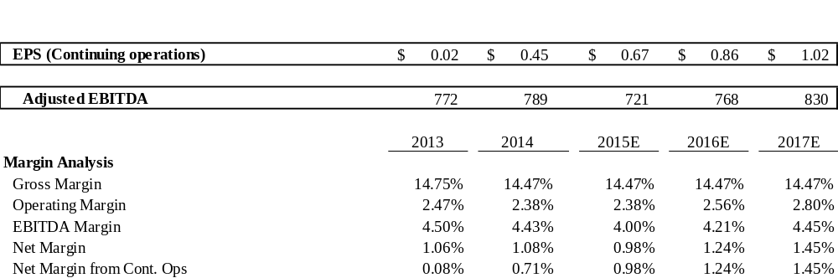
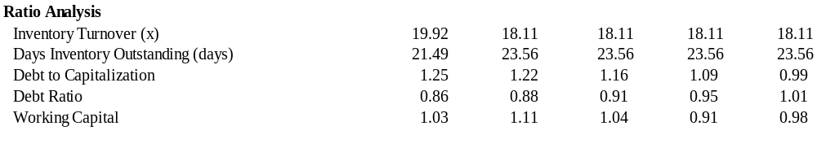



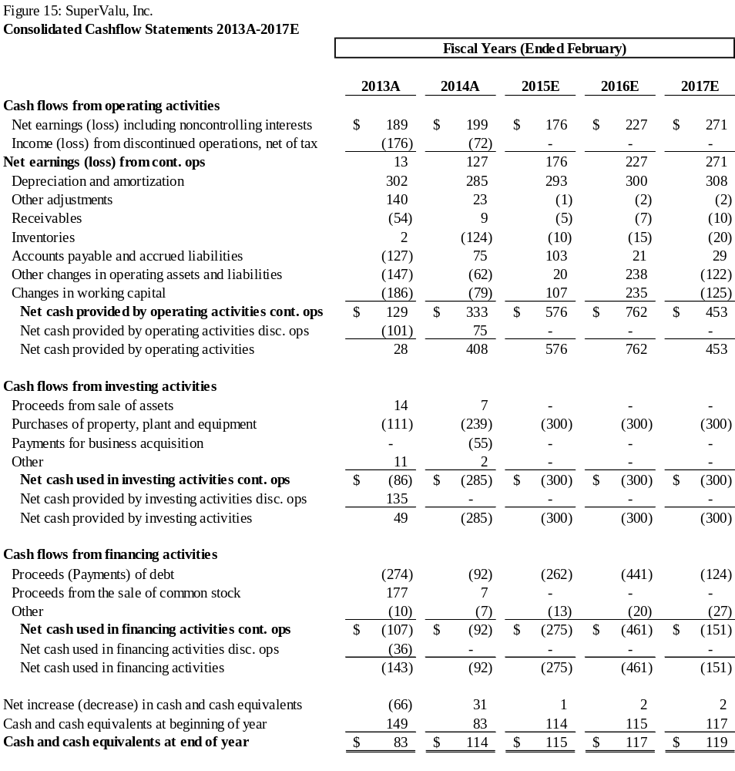

A Blessing or a Curse? The Effect of Oil Abundance on Economic Growth
Sariyya Atasoy, ‘18
Introduction to Econometrics

- Introduction

Is being an oil-abundant country a blessing or a curse? The abundance of natural resources is intuitively expected to enhance economic growth. However, for many countries it seems to be the opposite – more of a curse than a blessing. Developmental economists in particular have paid special attention to theories behind natural resource abundance because in terms of economic growth, resource-poor countries tend to outperform resource-rich countries. As evident in the economic theory, it is not oil abundance itself that is detrimental to economic development; rather, it’s the economic distortions that oil abundance results in that undermine performance. The scope of this paper is to investigate the extent to which resource poor countries outperform resource rich countries, measured through economic growth.
In this paper, I first introduce the theoretical model and what past literature has deemed to be important explanatory variables for determining economic growth. Next, using methodology developed by Alexeev and Conrad (2009), and Brunnschweiler and Bulte (2008), I look at the effects of oil abundance and oil dependence on GDP per capita growth. I do this separately in order to address the question of whether institutions are a major barrier for a country experiencing positive economic growth. My conclusions, which support past literature, find evidence of an overall positive effect on economic growth across countries in my data sample.

- Literature Review

In principle, the abundance of natural capital is favorable to economic growth, measured by GDP growth per capita. In testing multiple growth theories, Durlauf, Kourtellos and Tan (2008) lay out the most important and commonly used determinants of growth: demographics, worker productivity, macroeconomic policy, religion, geography, fractionalization, institutions, and unexplained regional heterogeneity. As part of growth theory, oil resources are expected to expand the production possibilities in the economy through the accumulation of oil rent revenues, contributing to an increase in GDP per capita (Okoro, 2014). As Canuto and Cavallari (2012) note, natural capital “combines with unskilled labor and existing intangible wealth” to generate income, create wealth, and boost investment. Since becoming an important raw material traded internationally, oil was perceived to be an unambiguous blessing, leading to rapid capital accumulation. However, the observed underdevelopment in oil-producing countries has lead to people blaming deteriorating growth rates on the discovery of oil. Figure 1 shows that oil rents as a percentage of GDP have a generally positive trend from 1970 until 2015, peaking in 1980. This relationship is also similar across regions (see Figure 2 in Appendix A), with countries in Africa and the Middle East region generally having a higher amount of oil rents as a share of their GDP. Theory states that oil abundance suppresses development by crowding-out some growth-driving activity (x). The question of what x is and how this transmission mechanism occurs has been the focus of the majority of literature.

Past Literature
A vast body of literature has examined how resource-poor countries outperform resource-rich countries. The most significant initial contribution to this literature was made in 1995 by Sachs and Warner who published a paper discussing a significant negative relationship between natural resource abundance and economic growth. They lay out two main political and market-based channels for the “resource curse” phenomenon: rent-seeking, and the Dutch disease model. Rent-seeking behavior occurs when the governments take advantage of rents earned by oil endowments, while the Dutch disease model shows that an overdependence on oil crowds out the non-oil trade sector, reducing the demand for labor and capital in the production of manufactured goods.
Sachs and Warner (1995) construct their hypotheses based on these theories and include additional variables in their model: the effectiveness of bureaucracy, initial GDP, terms of trade volatility, trade policy, and investment rates. Using regressions with cross-sectional data, they first include only initial GDP and share of primary exports (their preferred measure of resource intensity) as explanatory variables to show that economies with a high ratio of natural resource exports to GDP tend to maintain a lower growth rate for 20 consecutive years. This relationship remains significantly negative once they control for trade policy, openness, investment, and level of bureaucracy. A more recent paper by Fuinhas, Marques and Couto (2015) uses macro panel data and includes oil consumption as one of the explanatory variables. Similar to Sachs and Warner, they find that oil rents depress growth both in the short-run and long-run, although they do find that oil prices can have a positive effect on growth in the short-run.
Robinson, Torvik and Verdier (2006) and Mehlum, Moene and Torvik (2006) emphasize that institutions, through their impact on macroeconomic policies and indicators, define whether oil abundance is a blessing or a curse. Using restrictive institutions as a proxy for institutional quality, Wiens (2014) argues that oil-dependent countries with low-quality institutions are more vulnerable to the negative economic impacts of oil abundance. Meanwhile Robinson, Torvik and Verdier (2006) treat low institutional quality as the main variable of interest that explains an inefficient use of oil revenue and reinvestment with limited expenditure on human capital development. Additionally, once Sala-i-Martin and Subramanian (2008) control for institutions, they find that the impact of oil on growth is small and sometimes even positive.
Contradicting past findings, Alexeev and Conrad (2009) argue that the effect of oil abundance on a country’s long-term economic growth is overall positive. By measuring long-term growth via GDP per capita, they find that not only is oil neutral with respect to institutional quality, but it also enhances long-term economic growth. According to them, oil abundant countries are expected to have good institutions. Because the institutions of oil-rich countries are relatively poorer than those of industrialized countries, however, the coefficient on oil wealth turns out to be negative. As such, rather than claiming that oil abundance has deteriorated institutions like other scholars have done, they conclude that oil abundance simply has not improved institutions.
Following Alexeev and Conrad’s (2009) methodology, Brunnschweiler and Bulte (2008) run OLS and 2SLS estimation techniques to find that resource abundance and institutions determine resource dependence. While resource dependence does not affect growth, resource abundance does positively affect growth and institutional quality. By differentiating between oil abundance and oil dependence, they use an exogenous measure of resource wealth, and do not treat resource dependence as an exogenous variable. Brunnschweiler and Bulte (2008) first test whether oil abundance has a negative impact on institutional quality, then study the relationship between oil abundance and dependence, and lastly test the direct effect of oil abundance on economic growth. In order to solve the endogeneity problem, they use latitude as the main instrumental variable to find whether oil abundance erodes the institutional quality, and contrary to much of the past literature, find that there is a positive relationship between oil abundance and institutional quality.
Primary production and oil-based industries typically do not require high levels of human capital, which may have an impact on economic growth. Using cross-section and panel data, Behbudi, Mamipour and Karami (2001) show that oil abundance first impedes an increase in human capital, then has a negative effect on growth. This implies that in major petroleum-exporting countries, oil abundance has a negative impact on economic growth vis-a-vis human capital. Conversely, Matsuyama (1992) demonstrates that resource-deficient countries rely on the production and exportation of manufactured goods and require higher skills levels, which creates a higher demand for and investment in education. Taking a more broad theoretical approach, Durlauf, Kourtellos and Tan (2008) lay out growth models and find that initial income, investment, and macroeconomic policies affect growth. While institutions, geography, and ethnic fractionalization do not significantly affect growth, they find robust evidence in support of “unexplained region-specific heterogeneity.”
The existing body of literature finds evidence of both positive and negative relationships between oil abundance and economic growth, and shows different mechanisms to explain this relationship. Following the methodology employed by Brunnschweiler and Bulte (2008), I examine the relationship between oil abundance, oil dependence, and economic growth across a longer time span between the years 1970-2015. Moreover, I use additional variables not included in prior models, such as oil prices and exchange rates, in order to control for additional factors that might contribute to fluctuations in GDP per capita growth.

- Theoretical Model

This section introduces a pathway to explore the relationship between oil abundance growth. Despite mixed ideas in the literature on what the ideal model is, the following theoretical model encompasses all significant independent and control variables used by Sachs and Warner (1995), Alexeev and Conrad (2009), and Brunnschweiler and Bulte (2008):

$$Economic Growth= f (Oil Abundance, Institutional Quality, Initial GDP,Control Variables)$$

The sample size should include oil-rich and oil-poor developing and developed countries. This helps to compare the effect of oil abundance in developing and developed countries separately, as well as conduct a cross-country comparison. Furthermore, countries should also be divided into separate regions in order to undertake cross-regional comparison. Using the same base year for the sample fails to capture the overall effect of oil abundance on growth from the year of initial extraction to the present day. Hence, the starting year should date back to before 1950 to capture the initial extraction date for the major oil exporters such as Saudi Arabia (1944), Canada (1920), and Mexico (1901), (Alexeev and Conrad, 2009). Since these are panel data that compare different countries across time, the date range should be constant across all countries for more accurate results, and should range from the early 1900’s to the present. In a theoretical model, economic growth (the dependent variable) is measured by GDP per capita growth as used by Alexeev and Conrad (2009), while Brunnschweiler and Bulte (2008) use logged GDP per capita growth as a proxy. The data on GDP per capita should range from the year oil was extracted to the present for each country.
Although prior literature including Sachs and Warner (1995) use an oil rents indicator (to measure oil dependence), one should use the stock of oil reserves extracted from the ground as a more accurate indicator of oil abundance in order to eliminate endogeneity issue that exists between oil dependence and institutional quality (Brunnschweiler and Bulte, 2008). Existing theory treats institutions as an exogenous variable (Wiens, 2014). It is important to divide institutional quality indicators into three categories and include separate indicators for: 1) the means through which authority came into power (election system, voice, and accountability), 2) the state’s ability to implement policies (government effectiveness), and 3) the effectiveness of rules and regulations (to control for corruption) (Brunnschweiler, 2008). Most of the models include initial GDP, or GDP in a base year, as an important indicator of the subsequent fluctuations in GDP per capita. The inclusion of other control variables, including trade openness, population diversity, investment, human capital and oil price, helps to eliminate other exogenous effects on GDP per capita. The proxies for these control variables would be the fraction of years that a country is integrated into the global economy (trade openness), ethnic fractionalization (population diversity), investment to GDP ratio (investment), the average years of schooling for the population 15 years and older (human capital), and the price of oil in U.S. Dollars (USD) for the given 65 year time-span (oil prices).
Unfortunately, my data are far from the ideal measures and proxies identified in the theoretical model. Following Brunnschweiler and Bulte’s (2008) study, I include a set of 60 oil-exporting countries from 5 regions: Europe, North America, Central and South America, Africa and the Middle East, and Asia and Oceania (see Figure 12 in Appendix C). The data range from 1970 to 2015, since these are the years for which most of the data on oil reserves are available (this is due to the fact that each country started oil extraction in a different year). This prevents me from observing the overall effect on GDP per capita growth from the time of initial oil extraction for each country. For oil reserves, I use OECD Data to find the quantity of crude oil production (measured in thousands tonne of oil equivalent). One of the limitations of using crude oil production as a measure for oil reserves is that it includes liquids other than oil, with data on only oil production not available. I obtain most of my data from the World Bank Data Source, including GDP per capita (in current USD), oil rents (as a percent of GDP), net portfolio investment (the balance of payment in current USD), the number of both males and females enrolled in secondary education, balance of trade (in constant local currency units), and trade (as a percent of GDP). I use the Quality of Government Institute to find data for corruption pervasiveness (ranging from 0 to 1) and ethnic fractionalization (ranging from 0 to 1). I obtain data on the average annual crude oil prices (in USD per barrel) from OPEC, and the data for latitude (measured in decimal degrees) come from the study done by Nunn and Puga (2012).
Another limitation of my data is using corruption as a proxy for institutional quality. Because of a lack of data available on more accurate indicators of government effectiveness for all countries (such as rule of law, voice or accountability as discussed in the theoretical model), I am unable to capture significant factors such as the type of regime or citizens’ role in the elections. Despite this limitation, the corruption variable still captures the pervasiveness of political corruption and gives a sense of what the political climate is like in a given country. Lastly, I use portfolio investment (i.e. balance of payments) instead of the investment to GDP ratio as a proxy for my investment variable.
Actual Model
Guided by the model that Brunnschweiler and Bulte (2008) introduce, I use the following model as a starting point to explore the relationship between oil abundance and growth:
G = β₀ + β₁OA^{i} + β₂OD^{i} + β₃IQ^{i} + β₁Z^{i} + ε^{i}
where, OA is oil abundance, OD is oil dependence, IQ is institutional quality, Z encompasses all other control variables (investment, balance of trade, trade openness, ethnic fractionalization, initial GDP per capita, oil price, and exchange rate), and ε is the error term. As discussed earlier in the theoretical model, an ideal measure for oil abundance would be oil reserves. Following Brunnschweiler and Bulte (2008), I use two proxies for oil abundance in my model - oil reserves (oil abundance) and oil rents (oil dependence). I do this in order to examine Brunnschweiler and Bulte’s hypothesis that oil abundance is positively associated with GDP per capita growth, as well as test Sachs and Warner’s (1995) hypothesis on the negative relationship between oil abundance and economic growth.
Before discussing the results, it is important to first examine the expected sign for each independent variable in this model. The signs for both oil rents and oil reserves coefficients are expected to be positive. Based on the findings in Alexeev et al. (2005) and Brunnschweiler and Bulte (2008), oil abundance enhances long-term economic growth, and there is no evidence to support the idea that oil abundance deteriorates institutional quality (Alexeev and Conrad, 2009). The sign for initial GDP is expected to be negative because, according to prior literature, countries with a higher initial GDP per capita tend to grow at a slower rate in subsequent years. The signs for the variables controlling for investment and schooling are expected to be positive, as higher investment induces growth, and higher education levels imply a more skilled and productive workforce. The signs should be negative for the balance of trade (since lower exports implies that the country is relying on the consumption of imported goods and there is little room for expansion and growth), positive for oil prices (assuming that increased prices boost supply, an increase in oil prices will increase oil exports which contributes to GDP growth), and negative for both corruption and ethnic fractionalization. As argued by both Sachs et al. (1995) and Alexeev (2005), increased corruption implies weak governance and macroeconomic policies, which suppress growth in the long-run. Similarly, highly fragmented population can be a source of instability, having an adverse effect on growth.
- Results

Figure 3 shown below presents my results for three estimation techniques: OLS, random effects, and fixed effects models, where gdpgrowth is my dependent variable and my main variables of interest are OilRents and OilReserves. After running my initial regression using OLS (see Figure 8 in Appendix B), I add regional dummy variables for five regions, and make a residual plot for the residuals vs. fitted values for GDP per capita (see Figure 4 in Appendix A). For the most part the residuals are clustered around zero, with Ghana and Argentina having noticeably higher residuals. This could be due to the fact that both countries had a rather drastic change in GDP per capita in the early 1970s, likely due to unobserved and country-specific exogenous effects that are not controlled for in this model.
Figure 2
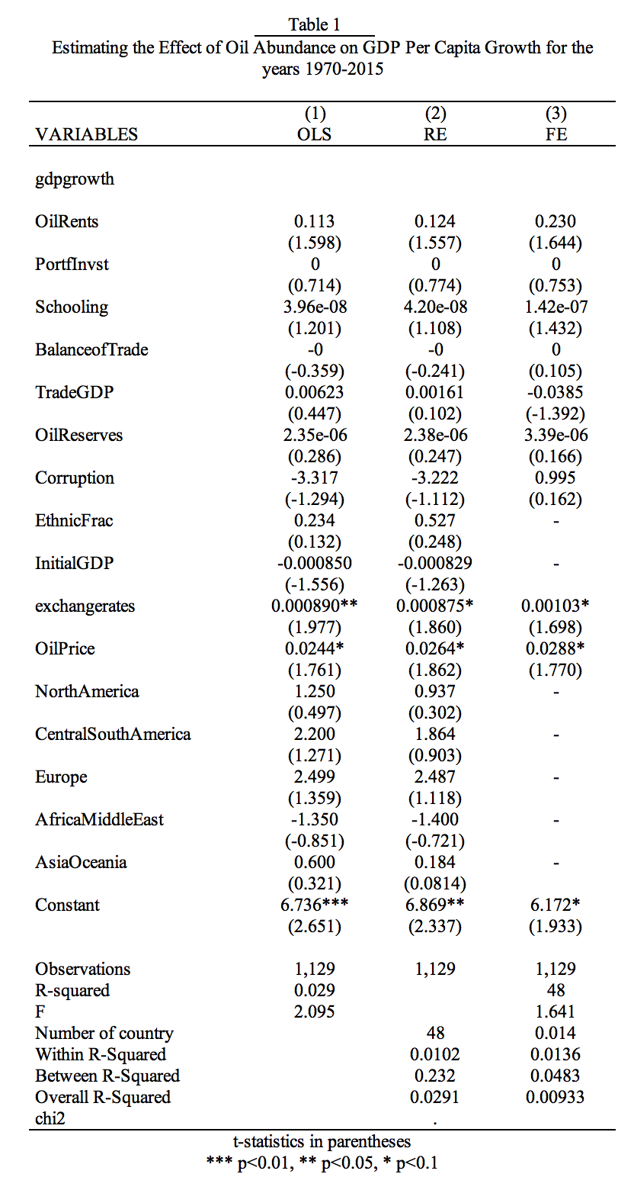

I include the exchange rate and dummy variables for five regions to control for the effect of oil abundance on growth across different regions. The signs on my main variables of interest, OilRents and OilReserves, are both relatively small but positive. They imply that a one unit increase in oil rents results in a 0.13 increase in GDP per capita growth, and a one unit increase in oil reserves has a near-zero effect on GDP per capita growth.
Both random effects (RE) and fixed effects (FE) models are consistent with the results from the OLS regression, with the signs of both variables of interest remaining positive. Of the three models, the random effects model is more effective in estimating the relationship between oil abundance and economic growth. As such, the results are in accordance with the findings from Alexeev et al. (2005) and Brunnschweiler and Bulte (2008): evidence from all 60 countries from 1970 to 2015 supports the theory that oil abundance has an overall positive effect on GDP per capita growth. The purpose of the differentiation between oil abundance (OilReserves) and oil dependence (OilRents) was to eliminate the endogeneity problem that, according to the literature, exists between oil rents and institutions (where the sign tends to be negative). My results, however, indicate that oil reserves (i.e. crude oil production) have virtually no effect on GDP per capita growth. Furthermore, since the sign on oil rents remains positive across the three models, I observe no initial signs of endogeneity. I test the direction of causality between oil rents and GDP per capita growth using the Granger Causality test, and find that the changes in oil rents precede the latter, so the causality runs as expected – from oil rents to growth.
The majority of the signs of the control variables align with the expected signs. Only ethnic fractionalization has a sign different than theory predicts. The sign on initial GDP remains negative across three models, which supports the theory that countries that start at a higher GDP per capita tend to grow at a slower rate. The signs on exchange rates and oil price match the expected signs and are statistically significant at the 10% level (except for exchange rate in the OLS model, which is significant at the 5% level). Once I control for regions, the signs for all regions are positive (except for Africa and the Middle East), and are consistent with the overall positive effects of oil rents on GDP growth. Once I add a time dummy variable, I see no major improvements in the results, and conclude that the relationship does not change significantly over time. At the same time, as Figure 9 in Appendix B shows, time variables in the early 1980s and from 2007 through 2011 are statistically significant. This may be due to a recession or other exogenous factors that my model does not control for.
Some results are less significant than others, with measures of oil dependence, oil abundance, GDP and corruption not statistically significant at 5% significance level. The only variables that are significant are oil prices and exchange rates, which implies that these variables are more significant driving forces in GDP per capita fluctuations in the sample. The insignificance of the main variables of interest (oil reserves and rents) may be due to the shorter time span my data include. Since oil extraction for some countries started well before 1950s, as argued by Alexeev and Conrad (2009), initial oil extraction could have had a more significant positive effect in the short-term, and the effect might have faded away in the long-run due to the depletion of natural resources.

Robustness Check
One method to check the robustness of my findings is to eliminate the outliers (Ghana and Argentina) and observe any changes or improvements in the model. Once I remove these two countries, the residual plot improves significantly and is more clustered around zero, with the residuals ranging between -40 and 40 as opposed to -100 and 100 in the original plot (compare Figure 5 to Figure 4 in Appendix A). However, once I run a regression with the exchange rates, the model shows no major improvement.
Another check of robustness is to exclude all of the variables that are insignificant in the model. I run a fixed effects model with only oil rents as my independent variable, which yields a major improvement in the significance level and a stronger positive relationship between oil abundance and economic growth. This model is very simple, but because it is a fixed effects GLS model, the differences for intercepts are already accounted for across different countries. Furthermore, Figure 6 (in Appendix A) shows a plot for the residuals over time, with the vast majority of them clustered around zero.

- Conclusion

My results suggest that across the 60 countries in all five regions in the sample, oil abundance has an overall positive effect on GDP per capita growth. My findings contradict the results of Sachs and Warner (1995) who find a negative relationship. They are consistent, however, with both Alexeev and Conrad (2009) and Brunnschweiler and Bulte (2008) in supporting the hypothesis that oil abundance increases growth in the long-run. This leads me to conclude that oil abundance is likely more of a blessing than a curse. Furthermore, I find evidence suggesting that institutional quality is not a driving factor in determining whether oil is a “resource curse,” and I find no signs of an endogeneity problem. However, since my results do not show significant deterministic evidence of a direct positive relationship, the question of whether oil abundance is a “resource curse” still remains. Since the analysis suggests that some regions such as Africa and the Middle East experience a negative relationship between oil abundance and growth, policy implications will likely be region specific. They may include ensuring higher transparency within the government with regards to oil extraction, especially for low-income countries, in order to reduce corruption. This could help to disincentivize rent-seeking behavior practiced by interest groups and governments. Another approach could be improving fiscal policies to promote wealth accumulation and improve processes to transform oil wealth into “produced capital” (Canuto and Cavallari, 2012). Lastly, countries that rely on oil exports to increase GDP growth should promote their manufacturing sector and invest more in education to help boost workforce participation and enhance long-term growth.

References
Alexeev, M. & Conrad, R. (2009) The Elusive Curse of Oil. The Review of Economics and Statistics, 91(3), 586-598.

Behbudi, D., Mamipour, S., & Karami, A. (2010). Natural Resource Abundance, Human Capital
and Economic Growth in the Petroleum Exporting Countries. Journal of Economic
Development, 35(3), 81.

Bravo-Ortega, C., & De Gregorio, J. (2005). The Relative Richness of the Poor? Natural
Resources, Human Capital, and Economic Growth.

Brunnschweiler, C. N. (2008). Cursing the Blessings? Natural Resource Abundance, Institutions,
and Economic Growth. World Development, 36(3), 399-419.

Brunnschweiler, C. N., & Bulte, E. H. (2008). The Resource Curse Revisited and Revised: A
Tale of Paradoxes and Red Herrings. Journal of Environmental Economics and
Management, 55(3), 248-264.

Canuto, O., & Cavallari, M. (2012). Natural Capital and the Resource Curse. The World Bank:
Poverty Reduction and Economic Management (PREM) Network, 83.

Durlauf, S. N., Kourtellos, A., & Tan, C. M. (2008). Are Any Growth Theories Robust? The Economic Journal, 118(527), 329-346.

Fuinhas, J. A., Marques, A. C., & Couto, A. P. (2015). Oil Rents and Economic Growth in Oil Producing Countries: Evidence from a macro panel. Economic Change and Restructuring, 48(3-4), 257-279.

Gylfason, T., & Zoega, G. (2006). Natural Resources and Economic Growth: The role of investment. The World Economy, 29(8), 1091-1115.

Matsuyama, K. (1992). Agricultural Productivity, Comparative Advantage, and Economic Growth. Journal of Economic Theory, 58(2), 317-334.

Mehlum, H., Moene, K., & Torvik, R. (2006). Institutions and the Resource Curse. The
Economic Journal, 116(508), 1-20.

Nunn, N., & Puga, D. (2012). Ruggedness: The Blessing of Bad Geography in Africa. Review of
Economics and Statistics, 94(1), 20-36.

Oseweuba, O. (2014). Oil Abundance and Economic Growth: A Simple Analysis of Economic Trends. Global Journal of Engineering Science and Researches, 1(7), 76-85.

Robinson, J. A., Torvik, R., & Verdier, T. (2006). Political Foundations of the Resource Curse. Journal of Development Economics, 79(2), 447-468.
Rodrik, D., Subramanian, A., & Trebbi, F. (2004). Institutions Rule: the primacy of institutions over geography and integration in economic development. Journal of Economic Growth, 9(2), 131-165.

Sachs, J. D., & Warner, A. M. (1995). Natural Resource Abundance and Economic Growth. (No. w5398). National Bureau of Economic Research.

Sala-i-Martin, X., & Subramanian, A. (2008). Addressing the Natural Resource Curse: An illustration from Nigeria. In Economic Policy Options for a Prosperous Nigeria, 61-92.

Smith, B. (2015). The Resource Curse Exorcised: Evidence from a panel of countries. Journal of Development Economics, 116, 57-73.

Wiens, D. (2014). Natural Resources and Institutional Development. Journal of Theoretical Politics, 26(2), 197-221.

Williams, A. (2011). Shining a Light on the Resource Curse: an empirical analysis of the relationship between natural resources, transparency, and economic growth. World Development, 39(4), 490-505.

Appendix A
Figure 1
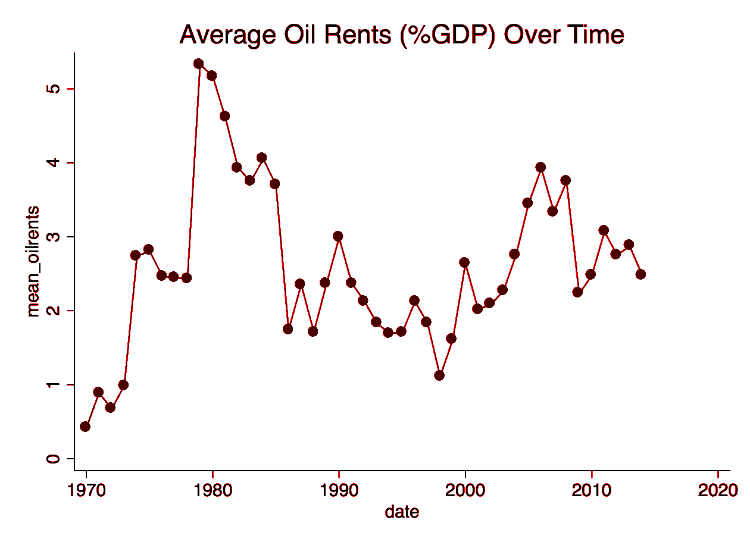
Figure 2
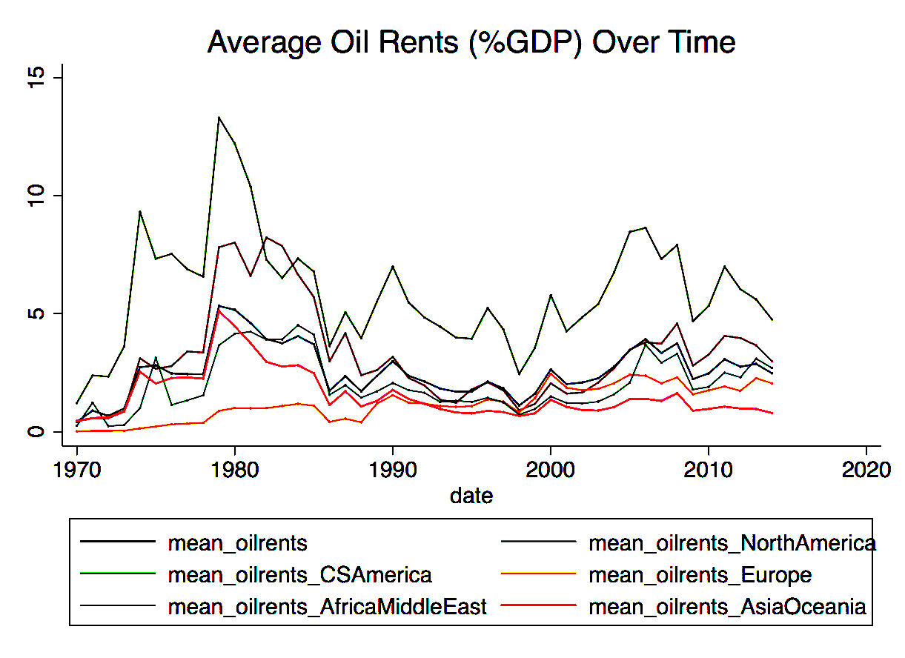

Figure 4
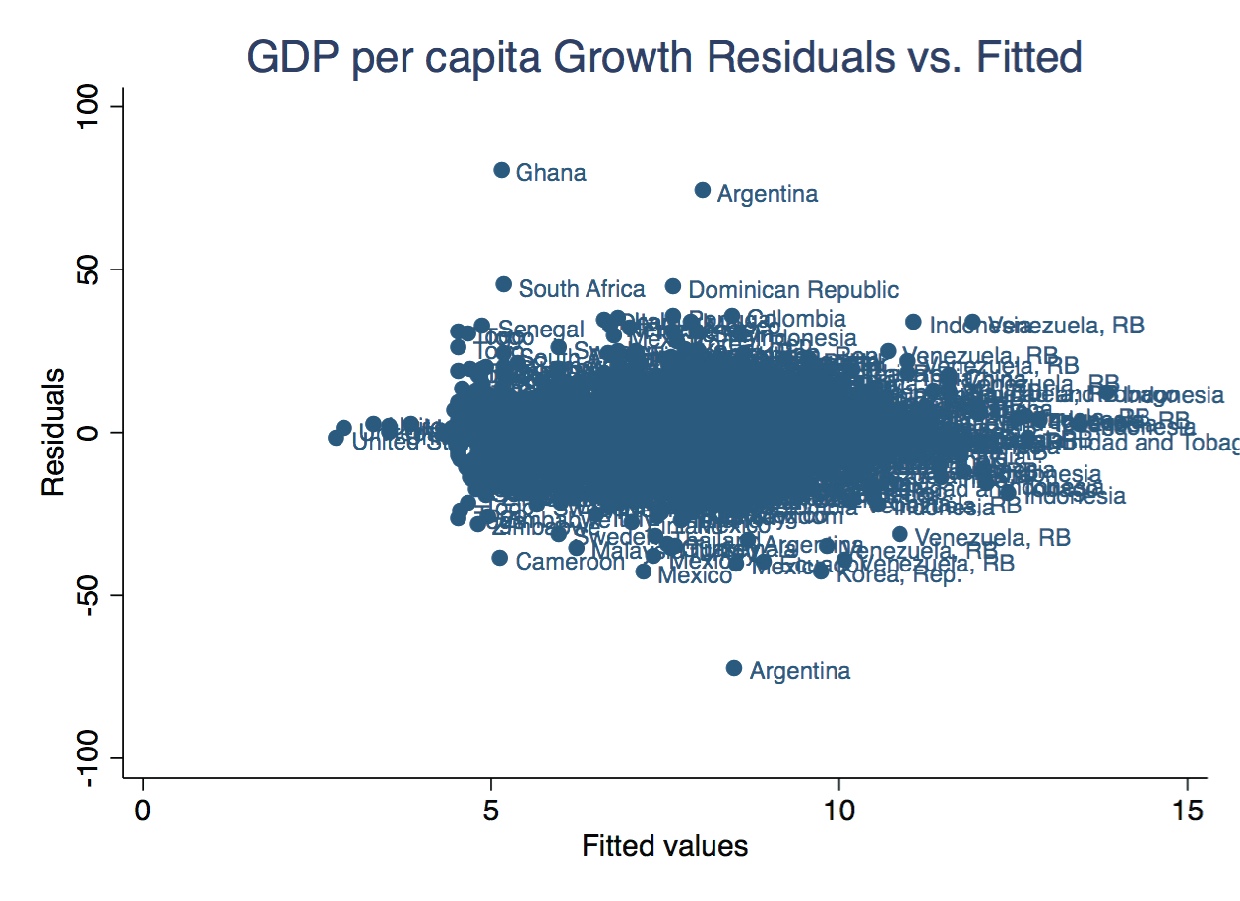
Figure 5
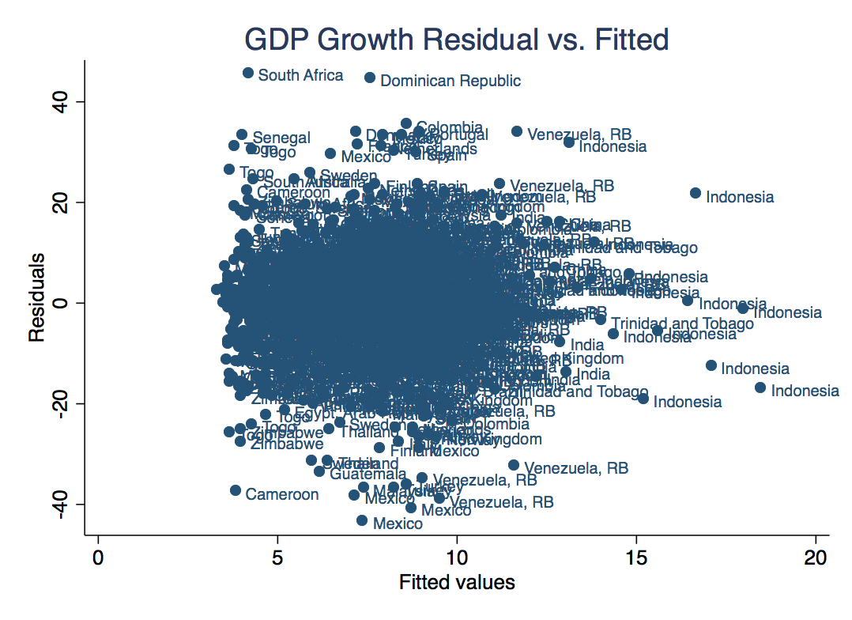

Figure 6
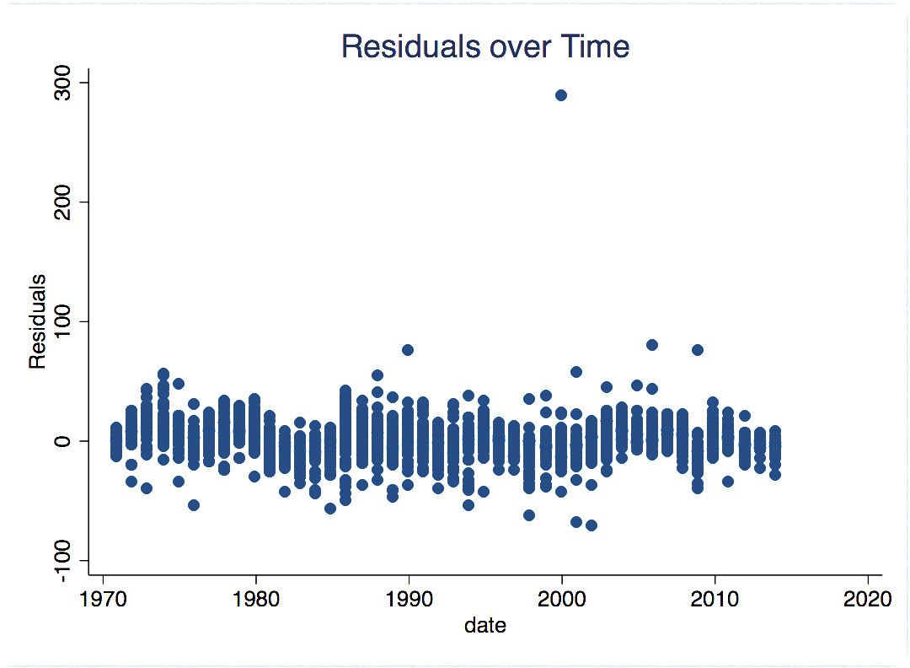

Figure 7
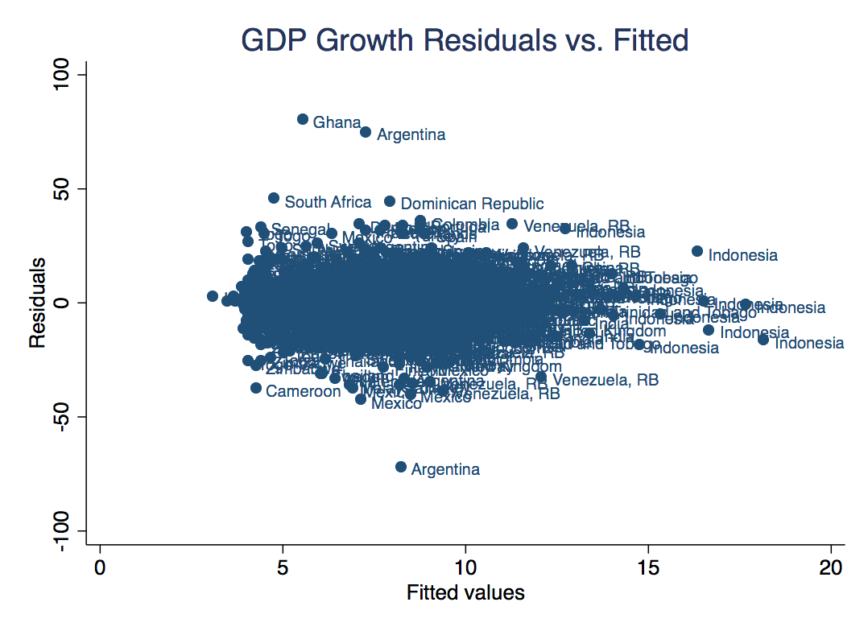

Appendix B
Figure 8
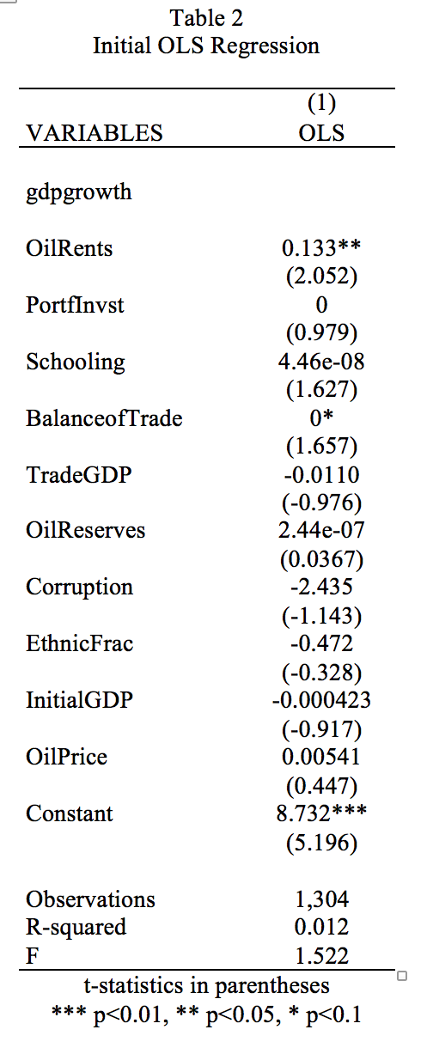
Figure 9
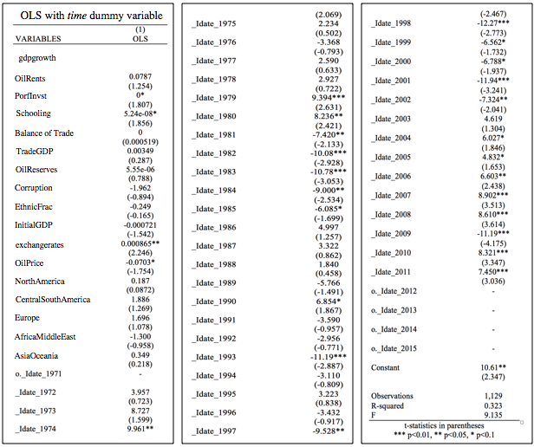
Figure 10
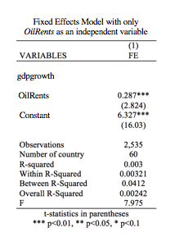
Appendix C
Figure 11
Overview of the Major Contributions to the Literature
Paper | Dependent Variable | Main Independent Variable | Main Control Variables | Methodology | Results
Sachs and Warner (1995) | GDP | Share of primary exports (SXP) | Initial GDP, trade openness, investment/GDP ratio, level of bureaucracy, terms of trade, inequality (income share top 20 to bottom 20%) | Cross-country growth model for the years 1970-89 | Negative statistically significant relationship between share of exports and growth
Alexeev and Conrad (2005) | GDP per capita | Point source oil resource | Latitude, regional dummies (Europe, Latin America, East Asia), institutional quality, ethnic fractionalization | Income-level regressions | No evidence of slow growth; find positive impact of oil abundance on economic growth
Brunnschweiler and Bulte (2008) | Log of GDP per capita | Oil reserves and oil rents (as a percent of GDP) | Bureaucracy quality, latitude, log of subsoil assets, elections, rule of law, trade openness, mineral exports | OLS and 2SLS estimation techniques | Both oil reserves and oil rents have a significant positive effect on GDP per capita growth

Figure 12
Overview of the Countries and Regions
Europe | North America | Central & South America | Africa & the Middle East | Asia & Oceania
Austria  Belgium  Denmark  Finland  France  Greece  Ireland  Italy  Netherlands  Norway  Portugal  Spain  Sweden  Turkey  United Kingdom  Russia | Canada  Mexico  United States | Argentina  Bolivia  Brazil  Colombia  Dominican Republic  Ecuador  Guatemala  Honduras  Jamaica  Peru  Trinidad and Tobago  Venezuela | Benin  Cameroon  Congo  Cote d’Ivoire  Egypt  Ghana  Jordan  Mauritania  Morocco  Senegal  Sierra Leone  South Africa  Togo  Tunisia  Zambia  Zimbabwe | Australia  Bangladesh  China  India  Indonesia  Japan  Korea  Malaysia  Nepal  New Zealand  Pakistan  Phillippines  Thailand

I know of no studies that empirically estimate the magnitude of the social costs of policing and incarceration; this is an important direction for future research.
While a few studies find that police deter certain types of crime (Marvell and Moody, 1994; Corman and Mocan, 2000; Zimring, 2011), several others find that there is no statistically significant relationship between police and crime (McCrary, 2002; Levitt, 2002; Roeder et al. 2015). The limited body of literature on crime-reduction power of arrests also have mixed results. While Levitt (1998) finds that arrests deter most types of crime but actually lead to increases in murder, Corman and Mocan (2000) find that arrests lead to lower levels of robbery, burglary, theft and murder but not assaults.
The marginal costs of increasing O by reducing p or reducing f [the left hand sides of Equations 3 and 4] are identical except for the additional term C_{p} / O_{p}. Since this term is negative, the marginal cost of reducing p must be less than the MC of reducing f.
Langlais (2006) tests this claim empirically, and finds that offenders do respond more to probability of punishment than severity of punishment. However, Mungan and Klick (2015) argue that this finding does not necessarily imply that criminals are risk-loving.
A corner solution where p = 0 is not possible as crime is likely to get out of control if people know there is no chance of them coming into contact with the police. A solution where f = 0 , or where all civilians stopped by police are released with no charge, will also lead to levels of crime that are higher than the optimal level. If police have no power to punish offenders in any way or even to forcibly stop a crime in progress, police presence is unlikely to deter crime no matter how many officers there are.
Most empirical studies that use precinct focus on a single city (Tauchen et al., 1994; Corman and Mocan, 2000). There are relatively few studies that use cross-city comparisons (Levitt, 1997; Levitt, 2002); many seminal studies on crime use state-level data (Marvell and Moody, 1994; Liedke, Piehl and Useem, 2006; Western and Travis, 2014; Roeder et al., 2015).
Researchers have used Granger causality (Marvell and Moody, 1994), instrumental variables (Levitt 1997, 2002) and monthly time-series data (Corman and Mocan, 2000) to control for simultaneity bias.
Although it is likely that there is some degree of endogeneity between arrests and crime, several studies find that arrests are largely exogenous, and are not closely related to police resources (Trumbull, 1989; Benson et al., 1994; Benson and Rasmussen, 1998) or to police manpower (Press, 1971; Benson and Rasmussen, 1998).
A Breusch and Pagan Lagrangian multiplier test confirms the presence of random effects, indicating that Ordinary Least Squares is not an appropriate test, or that state and year effects must be included. A Hausman test confirms that a random effects model is more appropriate than a fixed effects model.
It is possible that the high degree of multicollinearity between arrests and arrests squared is inflating the standard errors on the squared terms.
My results do not change significantly when dummies for states with large positive or negative residuals, or with large fixed effects, are included.
This result could also indicate multicollinearity between police and arrests, although several studies (Press, 1971; Benson and Rasmussen, 1998) have found no relationship between these two variables. Further, the correlation between police and arrests is only .21 and .16 for violent crime and property crime arrests respectively.
The residual plots also indicate that the presence of heteroscedasticity. However, this is unlikely to pose a serious issue, since a covariance matrix of coefficients shows that standard error variances are not highly correlated with any independent variables.
Most of the coefficients on the covariates in this model (unemployment rate, poverty rate, percent white and percent urban) are insignificant for both crime categories. These covariates are commonly included in crime models, although they often turn out not to be significant (Corman and Mocan, 2000; Levitt, 2002; Liedke et al., 2006)
A between subject experiment where two treatment groups answer the same questions but in different orders.
In one the voters were asked to respond to the senatorial question before the gubernatorial question, in the other the opposite was true.
An example is given in Appendix A.
Consider baskets of goods chosen from a list of possible goods. A good is in any given basket or not, making the basket binary. So a preference ordering of all the baskets is analogous to ordering the outcomes of a referendum election.
In [5] a quick, but mathematically rigorous explanation of separability in binary contexts is offered.
Rankings without indifference
Note that if we treated these surveys as referendum elections, cheese pizza would win the pepperoni survey and pepperoni pizza would win the sausage pizza.
Despite evidence that some participants ignored the interaction in their preferences, in the reflection section a number of people responded by saying they switched they answer on the pepperoni/sausage question when they later saw the sausage/pepperoni question. This response implies these participants realized an interaction between the two and adjusted their answers accordingly.
Shown by comparing the confidence interval with the other bars.
This example was created with Jon Hodge and Brea Beals at the 2014 Grand Valley State University REU [2].
Of course, the costs of education might be compensated for by benefits other than extra future pay. If non-income compensation is substantial, we would expect the generated income distribution to be more equal than the actual one. I find this to be the case for low discount rates.
If X is normally distributed and absolute differences in X lead to percent differences in Y, then Y will be log-normally distributed.
Mincer, 1958, p. 284
See the end of this section for details.
Primary care is aimed at preventing illness before it occurs, secondary care is aimed at preventing the development of illness once it occurs, and tertiary care is aimed at treating it once it has set in. Advances in the medical field in the 19th century made primary care effective, creating a market for regular health checkups and more common use of health services (Health Canada, 2012).
Pi * H (1 + d0) < t * Yi. Where Pi = Personal Risk (probability), H = Healthcare Services (dollar amount), d0 = Private Overhead (dollar amount), t = the Tax Rate (percentage), and Yi = Personal Income (dollar amount). See Batinti et al. (2016).
See Appendix A.
See Figure 11 in Appendix C for a summary of major contributions to the literature.
As cited by Brunnschweiler and Bulte (2008).
As Alexeev and Conrad (2009) mention, it is possible that the effect on economic growth is positive at the time of oil extraction, and has a different effect long-term when the resource depletes.
Such a large time-span can be sensitive to external effects (such as wars), so additional control variables should be added to control for these effects.
Alexeev and Conrad (2009) mention that the use of GDP per capita growth rate has a risk of “reflecting a relatively slow growth of oil producers that have partly depleted their resources,” and their solution is to look at the levels of GDP per capita instead.
To compare GDP per capita growths prior to and after oil extraction, one can also obtain data on GDP per capita before the initial oil extraction. This is not included in my theoretical model because, according to the literature, immediate effects of oil on GDP per capita are unlikely and it takes time for the effects to show.
Instead of using GDP per capita for the base year as a proxy, Alexeev and Conrad (2009) use exogenous geographical factors to estimate GDP per capita prior to oil extraction. They later use this estimation as a control variable.
This is a measure developed by Sachs and Warner (1995) who say that a country is integrated if it maintains low tariffs and quotas, and SOPEN (i.e. measure of openness) equals 1 for every year that an economy is open.
Alesina et al. (2003), as cited in Brunnschweiler and Bulte (2008), use ethnic fractionalization on a scale from 0 to 1 (where 0 = perfectly homogenous, 1 = highly fragmented).
This is the proxy used by Barro and Lee (2001), as cited in Brunnschweiler and Bulte (2008).
Brunnschweiler and Bulte (2008) look at 59 countries. I use their countries in addition to Russia in my study.
The quantity of oil extracted from the ground includes crude oil, natural gas liquids (NGLs), and additives.
Ethnic fractionalization is defined as the probability that two randomly selected people from a given country will belong to different such groups (the Quality of Government Institute).
I use publicly available data used by Nunn and Puga (2012) in their study: “Ruggedness: The Blessing of Bad Geography in Africa”.
I add exchange rate as an additional control variable after running my first OLS regression in order to control for the outliers that were present in my residual plot. This is discussed in more detail in the results section.
When running fixed effects model using xtreg, I was unable to obtain the value for chi2.
A detailed description with the results for my initial regression using OLS can be found in the Appendix B in Figure 8.
After performing a Hausman test between random and fixed effects models, I find a 32.9% chance of the null hypothesis being true, with the null being random effects.
Granger Causality showed that there is a 0.03% chance that oil rents does not “Granger” cause GDP growth, while a 26.1% chance that oil reserves does not “Granger” cause GDP growth. Therefore, I reject the null and conclude that oil rents causes a change in GDP growth while oil reserves alone does not.
The negative sign on the AfricaMiddleEast coefficient could be due to the region-specific exogenous effects that are not controlled for. This negativity could also imply that the interaction between oil rents and institutional quality is more prominent in this region and, therefore, may have an endogeneity problem.
See Figure 9 in Appendix B.
This is further supported by Figure 3 in Appendix A, where there are oil rent spikes in the early 1980’s and mid 2000’s.
See Figure 10 in Appendix B.

