Building Trust: Education in Global Perspective
Educational Studies EDU 250-01 Fall 2023

Welcome, “Builders”. Are you ready to explore many worlds, to span the globe intellectually, culturally and ethically as a global educator? Are you ready to build a re-imagined world of educational equity and justice?

Let’s get started!

Professor Sonia Mehta (she, hers)

 T/TH 3-4:30 ARTCOM 202  by appointment smehta@macalester.edu

Our Learning Objectives
- A firm grounding in the main concepts and debates in the field.
- The ability to synthesize and present knowledge and research.
- Skills to analyze policy and social dynamics.
- The ability to communicate in and work with unfamiliar and ever-changing environments.
- The opportunity to build and understand educational programs and community reform in an international setting.
- The chance to be part of the process of building trust across ideological and regional differences.

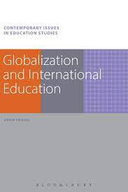

Required Text: Globalization and International Education by Robin Shields. Bloomsbury UK
Supplementary Readings will be assigned each week. Plan on TWO readings each week, approx.



“The life I touch for good or ill will touch another life, and that in turn another until who knows where the trembling stops, or in what far place my touch will be felt” - Frederick Buechner

What’s it all about?

Some of the questions you will grapple with in this course:

- What role does education play in a globalized world? What role might it play?
- What are the social, political, economic and ideological foundations, and global/local processes that shape approaches to International Development and Education policies?
- How are educators in ‘developing’ regions of the world best supported as they work towards positive change?
- How might trust and confidence be built among people working within the contexts of unequal power dynamics, and within historical, cultural and economic inequalities? How does this process intersect with education and educational possibilities?
- How might we expand the power and possibilities of education in diverse regions around the world?

In this course, we examine the role of education as global phenomena. We will explore the effects of globalization on education, and how education itself evolves and changes global spaces. Through analysis and critique, we explore education as a force for change in an inter-dependent, globalized world. We will construct possible education frameworks around building trust, by analyzing socio-cultural issues such as power, voice, silence and discourse.



Course Process, OR, how to approach learning in this course
This process is designed to help you find your own moral-ideological stance relevant to the complex issues you will encounter, and the ability to translate your vision into inclusive and compassionate action.

Our process of learning is based in a critical appreciation of our present, reclaiming, unpacking and uncovering our ‘past’, and using the lessons of theory and practice in the experience of humanity’s struggle for survival and dignity to reconstruct possible futures of justice and equity through education.

Assignments, OR, what needs completing in this course

Weekly Moodle Forum (Posts) 20%
There will be a forum posting required for conceptual and theoretical frames. These forums form a very important platform for the debate, discussion and relevance of the themes and ideas we will encounter through this course. Posts are due each week and adhere to a deadline because they indicate your voice and creative expression, are critical for knowledge co-creation and I our class forum to construct the direction of this course

Reflective Essays (4 short reflective papers) 20%
These essays are self-reflections/ self-evaluations of your learning, growth and sophistication through your engagement with the course process, to highlight your emerging advocacy as a global educator. This course follows a thematic schedule. Reflective essays will be due at the end of each theme so that you can receive generative feedback.

Choose your own global adventure: 10%
Meet with Prof. Mehta to talk about this project which will require your input and will center around your specific interest in some avenue of global education. Together we will craft your own project, your timeline and your chosen medium of expression.

Education as a Global Concern Project 50%
You will be working in groups to research and represent one contemporary global issue related to education in global perspective. As a group, you will also present this issue to the class in a 30-minute presentation as a final project. Groups will be created early in the semester and the presentations will take place in late November/December. Due dates will be posted (end of course)

How to succeed in this course

“When one tugs at a single thing in nature, he finds it attached to the rest of the world”
John Muir

Evaluations/UnGrading

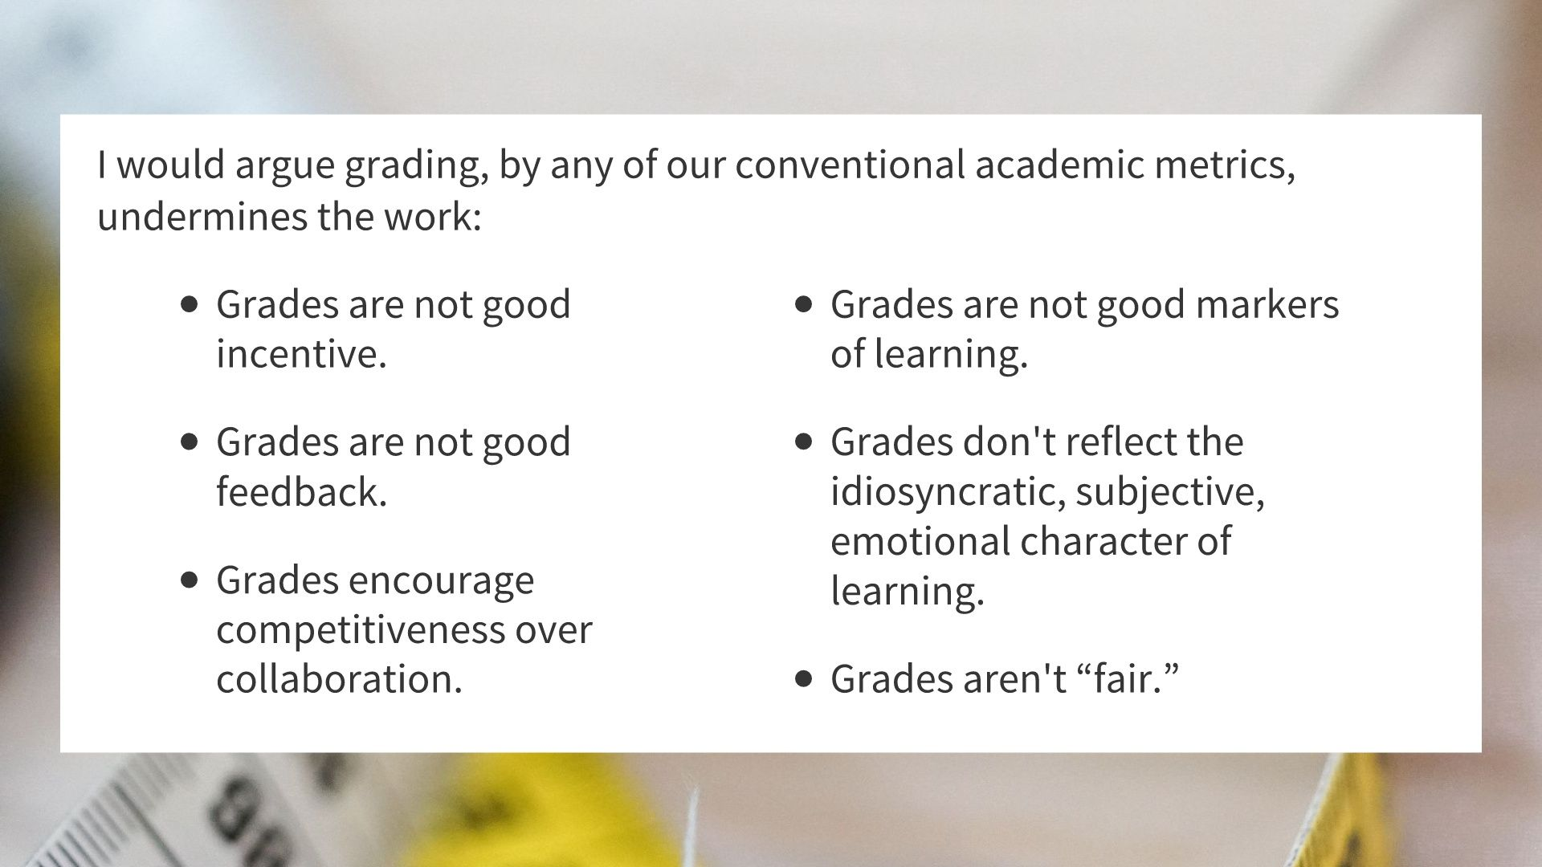

From the work of Jesse Stommel

Let us focus on the learning (not the grading)

I am working towards reducing or eliminating stress from our course. We will engage in an ongoing feedback loop on your work and your growth as an educator of global sophistication, and your increasing understanding of the course material and important points along the semester. The process of assigning a grade will depend on your evaluation of your own work, with input from peers and myself. I do have the responsibility and the final say in what that grade will be, but I am most interested in the rate of your own growth, the engagement you bring, your effort and application, your honesty, academic integrity, and ability to synthesize knowledge creatively. Therefore, I will be evaluating each assignment on these merits as much as on your synthesis and application of course material. I will ask to meet with you at points during the semester, to talk about your ongoing process, your well-being, and your next steps for the course. You have a choice of letter grades or S grades and a clear path of feedback to that end. Even so, I have attached a ‘weightage’ to each assignment or course component to that it gives you a clear sense of the relative importance for each. Grades are not ‘locked’ in for the semester. This builds in time to refine or revisit any of your work.

Evaluation will rest on how much you progress in:
Authenticity, academic integrity: Did you use your own voice, your own expression? Can you draw from your own life, roots, passion, and intersectionality, cultural, whether familial ancestral, academic, experiential?
Knowledge connections and application: How many connections can you make between the various themes of this course? Can you creatively and fully express these relationships?
Effort: Can you go deeper in your analysis? What barriers are you working with?
Respect: Do you respect your own opinions as well as your peers? Can you learn from yourself and from your classmates?
Responsibility: Can you watch and chart for your own growth in understanding, from material, group discussion, personal experience?
Communication and engagement: Have you added to the store of knowledge in this class?

“Classroom practice cannot be disassociated with ideology”
Susan Bloom

Policies, Practice and Protocols
I urge you to stay home if you are not feeling well.
In the event a serious health or family situation come up, please communicate with me; you will find me a friend in need, and an ally, but only inasmuch as I am aware of your circumstances. We must work within a negotiated flexibility, and with accountability, especially since this course includes group work as well as personal development.

I am committed to making this a pleasant and rewarding experience of knowledge building and creative thought-provoking interaction. I am also committed to providing assistance to help you to be successful in this course. Accommodations are available for students with documented disabilities. Contact the Associate Dean of Students at 696-6220 to make an appointment. It is important to meet early in the semester to ensure your accommodations are approved to secure your success this semester

This syllabus contains the course description, course process and components, expected assignments, evaluation strategies with assignment weightage and my general approach to teaching and learning. This course will remain steady in its essentials, but our process may change, readings may be amended and requirements may change depending on how we come together as a group building knowledge as well as trust. To this end, I will be checking in frequently with you to adjust things as needed for you and for our collective learning experience.
- Check Moodle every week for updates
- Read weekly emails
- Be on time as much as possible
- Bring food to class if you like, being respectful of our gathering
- Bring any technology to class that helps you learn, connect, communicate!
- Make a ‘buddy’ in case you need to catch up on a missed class
- We respect all holidays of belief, wellness breaks and stress reduction personal strategies: take them!
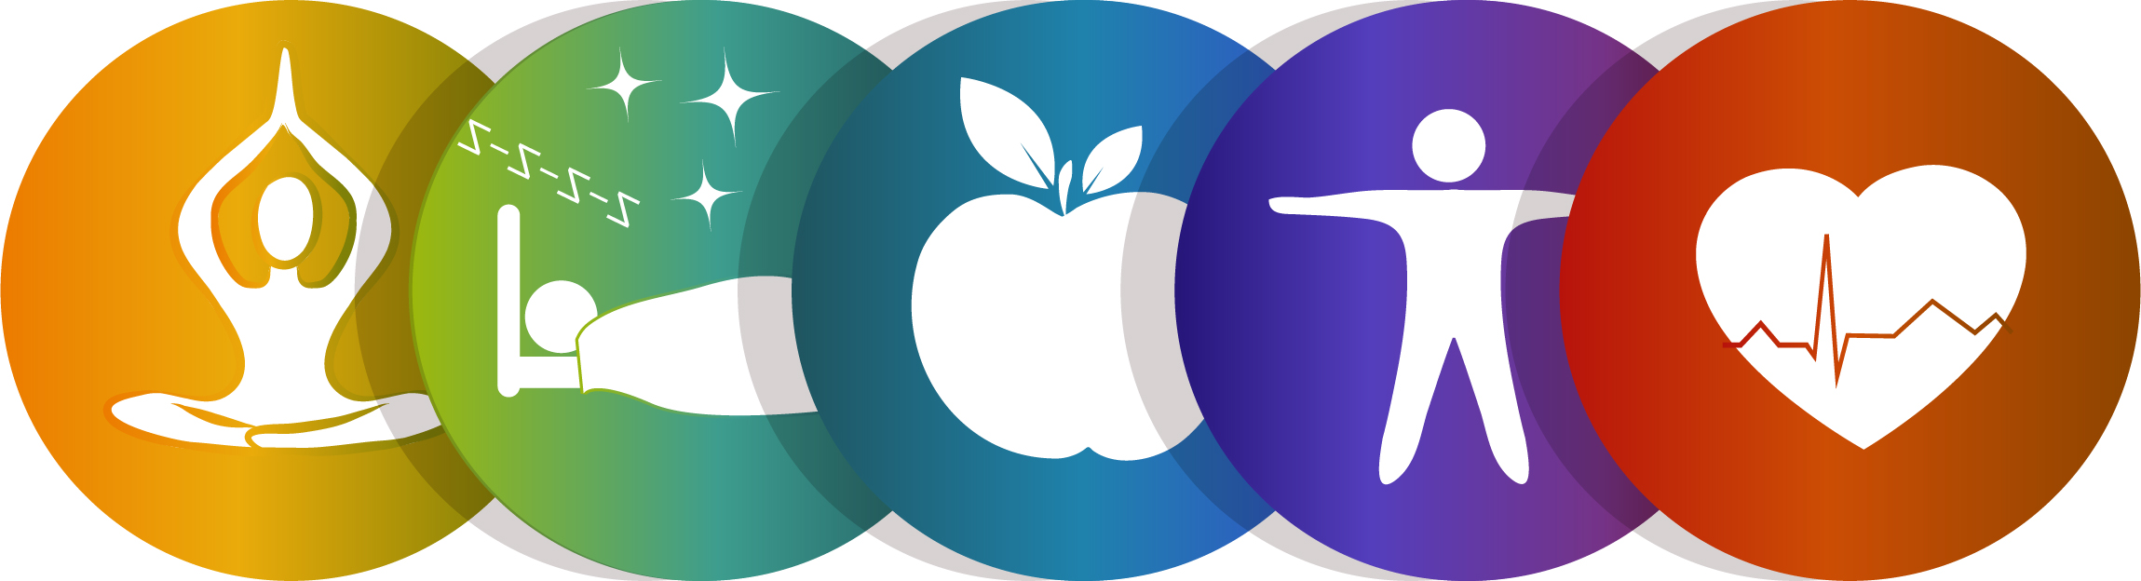

ARTIFICIAL INTELLIGENCE (AI) USE POLICY
Learning to use AI tools is an emerging skill that is available for you to explore. AI can be incredibly generative, and is part of the future of education and as such, and as global educators, it will fall to you to navigate these waters for yourself and your future students.

However, you should be aware of the limits of AI:

- AI is a tool, but one that you need to acknowledge using. Any ideas, language, or code that is produced by AI must be cited, just like any other resource. [sample suggestion: Please include a paragraph at the end of any assignment that uses AI explaining what you used the AI for and what prompts you used to get the results.] Failure to do so is in violation of the academic integrity policy at Macalester College.
- Don’t trust anything AI says. If it gives you a number or fact, assume it is wrong unless you either know the answer or can check in with another source. AI works best for topics you understand.
- If you provide minimum effort prompts, you will get low quality results. You will need to refine your prompts in order to get good outcomes. This will take work.
- Be thoughtful about when this tool is useful. Don’t use it if it isn’t appropriate for the case or circumstance.

If you have any questions about your use of AI tools, please contact me to discuss them. Macalester College policies on plagiarism/cheating continues to apply

The Macalester Library, in association with the AI Literacy Working Group, has assembled an incredibly helpful LibGuide on AI Literacy and Critical Thinking.
https://libguides.macalester.edu/ailiteracy

Suggested/Tentative Course Outline/Topics covered
(Check Moodle for updated)

WEEK 1  Settling in | Sept 5, 7  - Course Overview/Components  - Workshop: Education as a Global Concern; Becoming co-creators of knowledge | Reflection #1
WEEK 2  Understanding Globalization | Sept 12, 14  - Theories, Concepts, Debates  - The Challenges of Globalized Education
WEEK 3  Understanding Globalization and Education | Sept 19, 21  - Class Forum Discussion  - The Knowledge Economy, the Knowledge Society  - Global Theories/Education Effects
WEEK 4  Reading the Globe: Power | Sept 26, 28  - Class Forum Discussion  - Analyzing Power in multi-scalar modalities  - The Power Cube | Reflection #2
WEEK 5  Reading the Globe: Power  WEEK 6  Education and International Development:  Development | Oct 3, 5  - Class Forum Discussion  - Workshop: Education as a Global Concern  Oct 10, 12 IRT (Oct 12, 13)  - Class Forum Discussion
WEEK 7  Education and International Development: | Oct 17, 19  - Education and International Development  - The Critiques of Development
WEEK 8  Education as a Global Concern | Oct 24 (Fall Break 26-29)  - Class Forum Discussion  - Group Work | Reflection #3
WEEK 9  Global Education Policy | Oct 31, NOV 2  - Studies from the field  - Group Work
WEEK 10  FLEXWEEK | Nov 7, 9  - Case Studies  - Group Work
WEEK 11  Education as a Global Concern | Nov 14, 16  - Reimagining Education in an interdependent world  - Group Work
WEEK 12  Global Issues in Ed | Nov 21 (Thanksgiving Break 22-26)  - Group Working Day | Reflection #4
WEEK 13, WEEK 14  Global Issues in Ed. | Nov 28, 30, DEC 5, 7 (LAST CLASS)  - Presentations  - Class Closure

All work is due DEC 15th.

