WEYERHAEUSER BOARDROOM
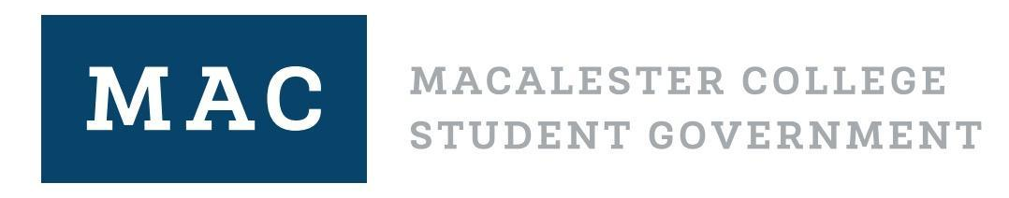
Nov. 2, 2021. 7:00 PM CST

Legislative Body Meeting Agenda

Please sit next to someone you do not know!

Land Acknowledgment (We are on Indigenous land) ~ Mariah, 2 minutes

Settling In ~ 2 minutes

Voting on the Bi-Weekly Newsletter ~ Ayana, 10 minutes

Committee Updates

Chartering Three Organizations ~ Katie, 30 minutes
-PreVet Club
-Writing Club
-Mac Open Mic Club

Reflection on the Sit in ~ Shreya, 15 min
- Hope that we can reflect together and find places to support our community

Break ~ 2 minutes

Unlearning White Supremacy Culture ~ Ayana, 45 minutes

Announcements
What can we do as MCSG members?

What can we do through our committees?

