WEYERHAEUSER BOARDROOM
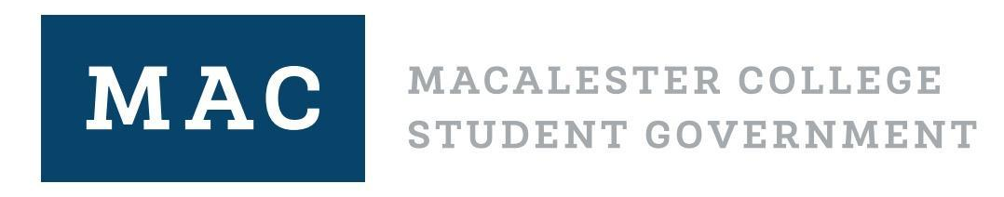
Nov. 16, 2021. 7:00 PM CST

Legislative Body Meeting Agenda

Please sit next to someone you do not know!

Land Acknowledgment (We are on Indigenous land) ~ Mariah, 2 minutes

Settling In ~ 2 minutes

Conversation with President Rivera (7:10) ~ Shreya, 30 minutes

Chartering Three Organizations ~ Katie, 30 minutes

Additional Allocation Requests ~ Rebecca, 10 minutes

Break ~ 2 minutes

Committee Updates

Student Health @ Mac Ad-Hoc ~ Micah, 10 minutes

Unlearning White Supremacy Culture ~ Ayana, 45 minutes

Announcements

