PHILOSOPHY OF MIND
PHIL 362-01 NEUR 362-01
FALL 2012

TR: 9.40 a.m. - 11.10 a.m. Humanities 215

Instructor: Joy Laine Old Main #113 Tel: 696 6353
Office Hours: Mondays 3.00-4.00 p.m. and Thursdays noon-2.00 p.m. or by appt.
E mail: lainej@macalester.edu
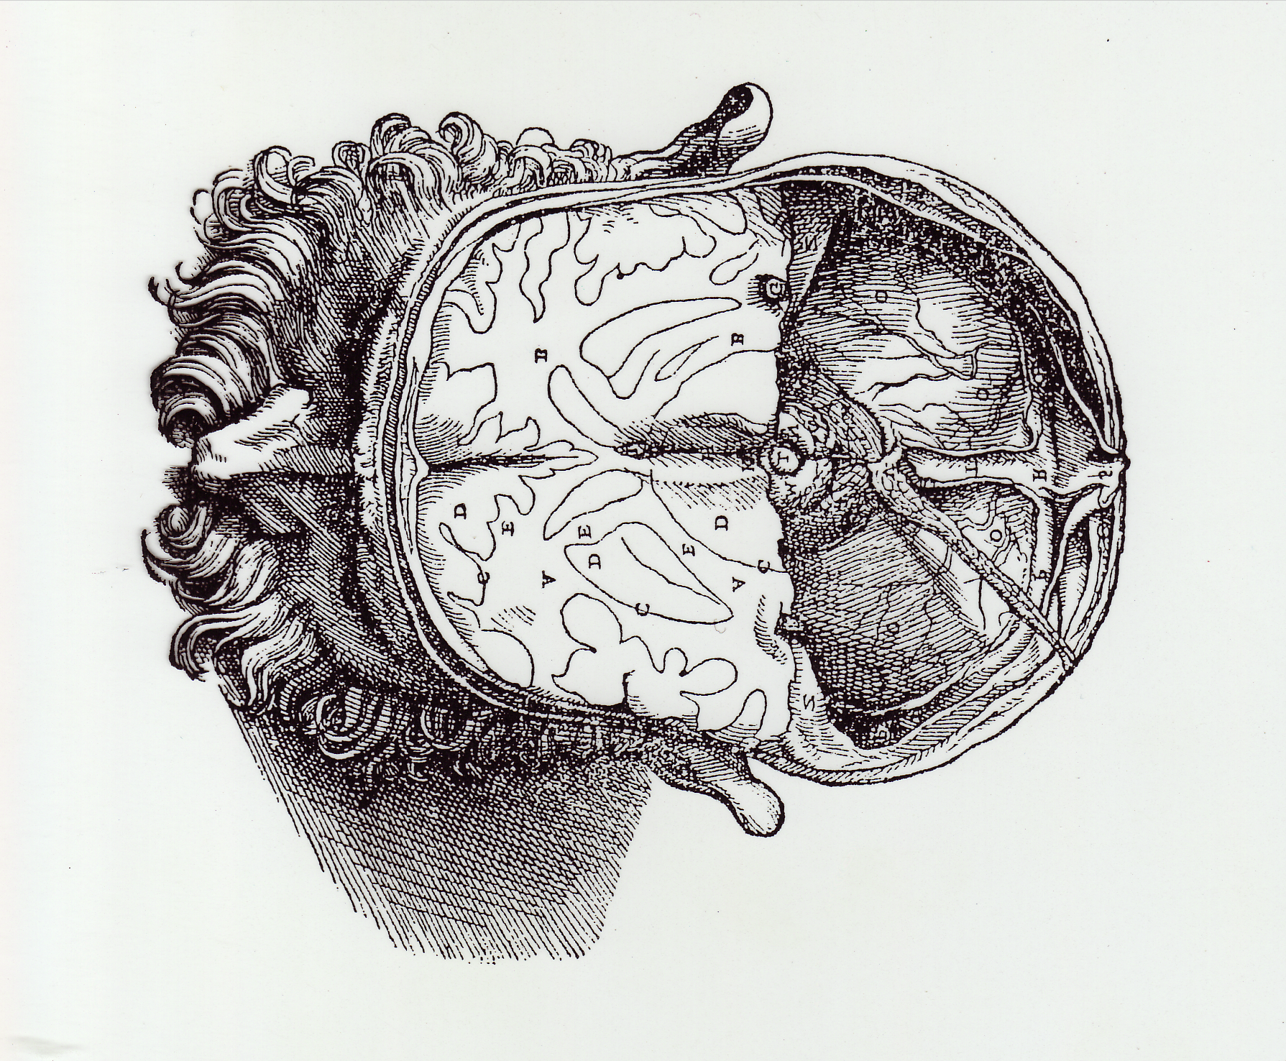

Course Overview

Philosophy of mind has been a central discipline in the tradition of analytical philosophy and proposed solutions to the notorious “mind-body problem” have had implications for all areas of philosophy. Philosophy of mind is also a rapidly changing and hence exciting discipline, influenced by the growing fields of the cognitive and neurosciences. I have chosen the materials for this course with the aim of giving you a good grounding in traditional philosophical studies of the mind but the emphasis will be on twentieth century and contemporary material, much of it being the work of philosophers currently working in the field. Since philosophy of the mind works in concert with the empirical brain sciences, this course also functions as a reflection on what distinctive contributions philosophy (historically a conceptual discipline) can bring to the study of the mind.
Course Description

The course has four main themes.

- THEME ONE: CLASSICAL MODELS OF THE MIND
Although a majority of contemporary philosophers reject the classical mind/body dualism of philosopher Descartes, it is still an influential view insofar as it constitutes the background from which contemporary theorizing has evolved. In order to understand contemporary thinking on the mind, it is therefore necessary to have some grounding in this earlier thinking.

- THEME TWO: CONTEMPORARY MODELS OF THE MIND
Contemporary philosophers of the mind tend to adopt a naturalistic stance, that is, they believe that the mind will be fully comprehensible within the framework of the natural sciences (which places the mind in the material world). The philosophical task, however, has been to find a conceptually coherent way to model the mind within this framework. There may be a general agreement that the mind and its mental states are, in some way, reducible to and explicable within the physical world but, as yet, no consensus on how this should be done. Locating the mind in the natural world is a multi-faceted challenge, spawning such questions as: Do all material states possess consciousness or only some? How do mental states (themselves material states) represent states of affairs in the world? When I inwardly imagine a purple cow, where in the spatio-temporal world do I situate this imagined purple cow? Philosophers have offered a variety of models for situating the mind in the natural world and a large part of this course is devoted to examining the strengths and weaknesses of current competing models of the mind.

- THEME THREE: CONCIOUSNESS AND ITS PLACE IN NATURE
Some contemporary philosophers have felt that naturalistic theories of the mind do not adequately capture our understanding of the nature of consciousness. The “problem of consciousness” has proved to be one of the most intractable problems in philosophy leading contemporary philosopher Chalmers to label consciousness as “the hard problem.” A few contemporary philosophers, most notably Colin McGinn, have suggested that this problem may be beyond the capabilities of the human mind to solve. How one understands consciousness will be closely related to how one models the mind in terms of its relationship to the natural world. Hence themes two and three are closely related.

- THEME FOUR: THE NATURE OF PERSONS
We will focus specifically on two philosophical problems: freedom of the will and personal identity (this is the problem of what makes us the same person from one day to the next, from one year to the next but, more broadly, asks the question of what it is to be a person). We will look at the work of three influential philosophers in the area of personal identity theory: Parfit, Schechtman (a critic of Parfit), and Strawson (a critic of Schechtman).

Course Objectives
This course has three main objectives, one related to knowledge, the other two to developing your individual analytical skills.

- Objective One (Knowledge)
You will learn about the fundamental principles and theories in the philosophy of mind (through a study of the major schools, issues and thinkers). Specifically this can be broken down into the following objectives:

- To give participants a good foundation in classical theories of the mind, focusing on classical mind/body theories and personal identity theory, particularly in the work of Descartes, Locke and Hume.
- To gain an understanding of important schools and issues in contemporary philosophy of mind, focusing on three areas in contemporary theorizing: (1) models of the mind in relation to the physical organism (including a brief study intentionality or how mental states can have content) (2) the problem of consciousness and (3) personal identity theory. (1) entails a familiarity with the various competing mind/brain/body models: to include: logical behaviorism, mind/brain identity theories, functionalism, eliminative naturalism, biological naturalism and cognitive closure. (2) will address problems relating to consciousness and why philosophers argue that there is an explanatory gap when trying to place consciousness within a naturalistic framework. (3) will examine contemporary reductionist and narrative views of the self
- To develop familiarity with some major contemporary philosophers of the mind: to include the Churchlands, Dennett, Flanagan, Jackson, Kim, McGinn, Nagel, Parfit, Schechtman, Searle, Strawson, and Wilkes.

- Objective Two (Skills)
You will learn to analyze and critically evaluate the theories and ideas studied in class (including developing your own questions).

- Objective Three (Skills)
You will work on your ability to express yourself by developing your own oral and writing skills.

These two related skills objectives will be addressed specifically through student papers and active student participation in class sessions (by means of reading guides, class discussion, small group discussion, reading groups, paper presentations at the philosophy café, and formal student led presentations/discussions). See below for more detailed course requirements.

Course Requirements

The course requirements are designed to support the objectives of the course, to ensure individual growth.

- Regular attendance: The first two unexcused absences will result in a deduction of your final grade (A to A- for example). The next two unexcused absences will result in a second further deduction of your final grade (A- to B+ for example). I believe that we all have a responsibility to attend class, not just to ourselves but also to other members of the class. If you start to miss class on a regular basis I will ask to meet with you to remedy the situation.

- Class Participation: The class is an upper level class and, despite the fact that student enrollment can be over 20, we will attempt to maintain a seminar style format for many of the classes. It is essential therefore to come to class having completed the reading on time and ready to discuss the material. There will be a variety of ways in which you can contribute to the intellectual climate of the class. Reading guides will be given out each week and questions posted on the online Moodle page to help you come to class intellectually prepared. We will use a variety of discussion styles to encourage participation for all class participants.

- Group Participation: The class will be organized into reading/discussion groups and these will form the basis for developing class discussion both inside and outside of the classroom. Each group will periodically be given specific but informal tasks to prepare for class discussion. Each group will be asked to prepare in a more formal way one topic to present to the rest of the class (about 40 minutes in length).

- Three written papers as follows:

- One paper on Cartesian dualism and its weaknesses.
- One paper based on the topic of your group presentation.
- One final paper on a relevant topic of your choice. Preliminary drafts of this paper will be peer edited and edited by me. You will present your paper to a small group of peers at the philosophy café at the end of the semester.

Grade Distribution

- Participation and group presentation 20 %
- Paper 1) (c. 2500 words) 20%
- Paper 2) (c. 2500 words) 20%
- Paper 3) (c. 5000 words) 40%
- TOTAL 100%

Texts

Required For Purchase
- David Chalmers, ed. Philosophy of Mind: Classical and Contemporary
Readings
- Marya Schechtman The Constitution of Selves
- Timothy Wilson Strangers To Ourselves
When available, these required texts will also be placed on reserve.

e-Resources
- Bennett and Hacker Philosophical Foundations of Neuroscience (selections)
- Andy Clark “Memento’s Revenge”
- Owen Flanagan The Problem of the Soul (selections)
- Owen Flanagan “Multiple Identity, Character Transformation and
Self”
- David Hume Treatise of Human Nature (selections)
- Frank Jackson “What Mary Didn’t Know”
- Jonah Lehrer Proust was a Neuroscientist Chapter One
- David Lewis “Mad Pain and Martian Pain”
- John Locke Essay Concerning Human Understanding (selections)
- Thomas Nagel “Brain Bisection and the Unity of Consciousness”
- Shaun Nichols “Folk Intuitions and Free Will”
- Galen Strawson “Realistic monism, why physicalism entails
panpsychism”
- Galen Strawson “Against Narrativity”
- Galen Strawson “The Impossibility of Moral Responsibility”
- Kathleen Wilkes “The Importance of Consciousness”
- Kathleen Wilkes “The Relationship Between Commonsense
Psychology and Scientific Psychology”
- Ludwig Wittgenstein Philosophical Investigations [selections]

The following web sites are very helpful:
- http://consc.net/online This site put together by Chalmers gives access to numerous on line papers in the philosophy of mind.
- http://www.earlymoderntexts.com/index.html Jonathon Bennett’s website for early modern texts rendered in contemporary English. Use for the Locke and Hume readings.
- www.bbc.co.uk/radio4/features/in-our-time/archive/ Selected shows posted on moodle.

Texts on Reserve
- Bennett and Hacker Philosophical Foundations of Neuroscience
- Antonio Damasio Descartes Error
- Daniel Dennett Consciousness Explained
- Kathleen Wilkes Real People
- Ludwig Wittgenstein Philosophical Investigations
- Owen Flanagan Consciousness Reconsidered
- Owen Flanagan The Problem of the Soul
- John Searle The Rediscovery of the Mind

Videos/DVD’s to include
- Steven Pinker How The Mind Works [selections]
- PBS video The Human Quest [selections]

Course Outline
This is intended only as a brief outline. It will be supplemented each week with a more detailed reading guide posted on moodle. I like to remain somewhat flexible in response to student interest etc. so you should check the moodle page for up to date reading assignments. The readings given for each date should be completed by the time we meet for class (except for the first class meeting).

WEEK ONE
Thursday September 6
Topic: Introductions and Methodologies
Readings
Bennett and Hacker, Philosophical Foundations of Neuroscience pp. 396-409
(pdf file on moodle)
Lehrer, Proust Was A Neuroscientist Chapter One
(pdf file on moodle)
Listening
In Our Time Archive “Neuroscience in the Twentieth Century”

WEEK TWO
THEME ONE: CLASSICAL MODELS OF THE MIND
Tuesday September 11
Topic: The Cartesian Self
Readings
Descartes, Meditations, II and VI [Chalmers pp. 10-21]
Locke and Hume
[selections from Bennett: online resource]
Listening
In Our Time Archive “Cogito Ergo Sum”
Thursday September 13
Topic: Classical Cartesian Dualism
Readings
Descartes, Passions of the Soul [Chalmers pp. 21-23]
Descartes/Princess Elisabeth Correspondence
[selections from Bennett: online resource]
Listening
In Our Time Archive “The Mind/Body Problem”

WEEK THREE
THEME TWO: CONTEMPORARY MODELS OF THE MIND
Tuesday September 18
Topic: The Unconscious Mind
Readings
Wilson, Strangers To Ourselves Chapters One-Three
Thursday September 20
Topic: Mind as Behavior
Readings
Ryle, "Descartes' Myth" [Chalmers pp. 32-38]
Smullyan, “An Unfortunate Dualist” [Chalmers p. 31]
Wittgenstein, Philosophical Investigations
[selections, see reading guide]
Putnam, "Brains and Behavior" [Chalmers pp. 45-54]

WEEK FOUR
THEME TWO: CONTEMPORARY MODELS OF THE MIND
Tuesday September 25
Topic: Mind As Brain: The Identity Thesis
Readings
Kripke, Naming and Necessity [selections from Chalmers pp. 329-334]
Place, "Is Consciousness a Brain Process?" [Chalmers pp. 60-68]
Smart, "Sensation and Brain Processes" [Chalmers pp. 60-68]
Thursday September 27
Topic: Functionalism
Readings
Armstrong, "A Causal Theory of Mind" [Chalmers pp. 80-87]
Lewis, "Mad Pain and Martian Pain"
[pdf file on moodle]
Kim, "Multiple Realization and the Metaphysics of Reduction"
[Chalmers pp. 135-149]

WEEK FIVE
THEME TWO: CONTEMPORARY MODELS OF THE MIND
Tuesday October 2
Topic: Eliminative Materialism
Readings
Churchland, "Eliminative Materialism and the Propositional Attitudes" [Chalmers pp. 568-580]
Wilkes, "Commonsense and Scientific Psychology" [pdf file on moodle]
Thursday October 4
Topic: Panpsychism
Readings
Chalmers, "The Puzzle of Conscious Experience" [available on http://consc.net/online ]
Strawson, "Realistic monism, why physicalism entails panpsychism" [pdf file on moodle]

WEEK SIX
THEME TWO: CONTEMPORARY MODELS OF THE MIND
Tuesday October 9
Topic: Artificial Minds
Readings
Searle, "Can Computers Think?" [Chalmers pp. 669-675]
Searle, The Rediscovery of the Mind Chapter 9 (pdf file on moodle)
Listening
In Our Time Archive: “Artificial Intelligence I and II”
Thursday October 11
Topic: Extended Minds
Readings
Clark and Chalmers, "The Extended Mind" [Chalmers pp. 643-651]
Clark, "Memento's Revenge" (pdf file on moodle)

WEEK SEVEN
THEME THREE: CONSCIOUSNESS AND ITS PLACE IN NATURE
October 16
Topic: The Nature of Consciousness
Readings
Brentano, "The Distinction between Mental and Physical Phenomena"
Rosenthal, "Explaining Consciousness" [Chalmers pp. 406-417]
October 18
Dennett, “Quining Qualia” [Chalmers, pp. 226-246]
Jackson, "What Mary Didn't Know" [JSTOR and pdf file moodle]
Nagel, "What Is It Like To Be A Bat?" [Chalmers pp. 219-226]
Listening
In Our Time Archive: “Consciousness”

WEEK EIGHT
THEME THREE: CONSCIOUSNESS AND ITS PLACE IN NATURE
October 23
McGinn, "Can We Solve The Mind Body Problem?" [Chalmers pp. 394-405]
Flanagan Consciousness Reconsidered Chapter 6 (pdf file on moodle)
Searle Rediscovery of the Mind Chapters 4 and 5 (extracts: see reading guide)
October 25-28
FALL BREAK

WEEK NINE
THEME THREE: CONSCIOUSNESS AND ITS PLACE IN NATURE
October 30
Topic: Meditation and Neuroscience
Readings
Blackmore, Consciousness
[selections: pdf file on moodle]
Shambala Sun, "Does Meditation Really Work?"
[pdf file on moodle]

THEME FOUR: THE NATURE OF PERSONS
November 1
Topic: Human Agency/Free Will
Readings
Kim, "The Many Problems of Mental Causation" [Chalmers pp. 170-178]
Strawson, "The Impossibility of Moral Responsibility" [JSTOR]
Listening
In Our Time Archive: “Free Will”

WEEK TEN
THEME FOUR: THE NATURE OF PERSONS
November 6
Topic: Experimental Philosophy on Free Will
Readings
Nichols, “Folk Intuitions on Free Will” [pdf file on moodle]
November 8
Topic: Human Agency/Free Will
Readings
Wilson, Strangers To Ourselves Chapters 4-7
WEEK ELEVEN
THEME FOUR: THE NATURE OF PERSONS
November 13
Topic: Personal Identity
Readings
Locke,"Of Identity and Diversity," Chapter 27 from Book Two, Essay Concerning Human Understanding
http://www.earlymoderntexts.com/index.html
November 15
Selfless Persons
Readings
Parfit “Reductionism and Personal Identity”
[Chalmers pp. 655-661]
Hume “Of Personal Identity” Treatise of Human Nature I.IV.6
( http://www.earlymoderntexts.com/index.html )

WEEK TWELVE
THEME FOUR: THE NATURE PERSONS
November 20
Topic: Multiple Selves
Readings
Flanagnan, "Multiple Personality..." [pdf file on moodle]
Nagel, "Brain Bisection and the Unity of Consciousness" [pdf file on moodle]
November 22
THANKSGIVING BREAK

WEEK THIRTEEN
THEME FOUR: THE NATURE OF PERSONS
November 27
Topic: Critique of Classical P.I. Theories
Readings
Schechtman, The Constitution of Selves Part One
November 29
Topic: Narrative Persons
Readings
Dennett "Why Everyone Is A Novelist"
Schechtman The Constitution of Selves Part II

WEEK FOURTEEN
THEME; THE NATURE OF PERSONS
December 4
Topic: Against Narrativity
Readings
Strawson, "Against Narrativity"
Wilson, Strangers To Ourselves Chapters 8-10
December 6
Paper Discussions
Course Evaluations
Conclusion

WEEK FIFTEEN
December 11
PHILOSOPHY CAFÉ
(Long paper presentations)
CLASSES END

