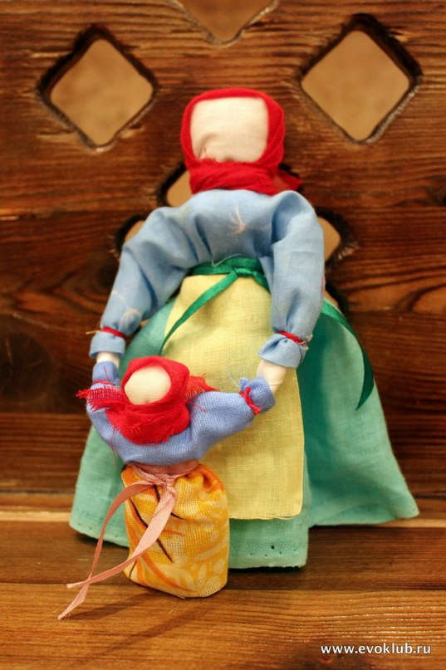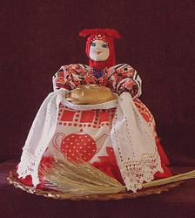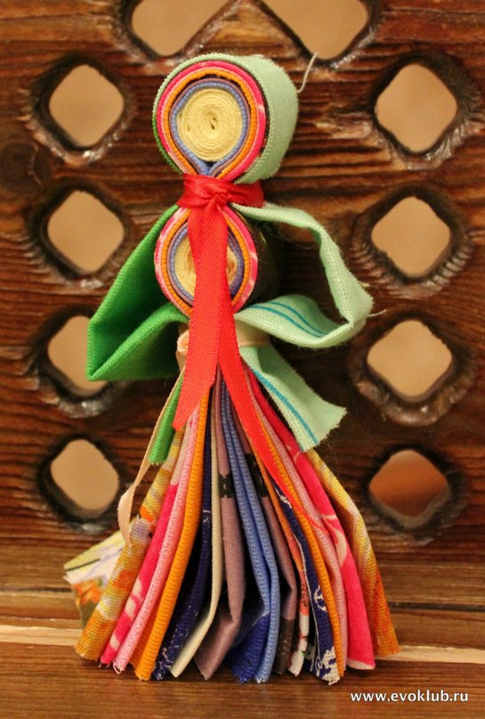

***P.S. Delicious Russian cakes provided***

**Friday, October, 18**

**Russian House, 5 pm**

**Learn how to make Russian traditonal lucky charm dolls («берегиня», «травяница»)!**

**Русские куклы! Russian Dolls Workshop!**