DISABILITY SERVICES
We strive to create a welcoming environment to ensure all students have equal access to academic and co-curricular activities.

RE-ORIENTATING AND RE-VISIONING
A FLEXIBLE ENVIRONMENT FOR ALL
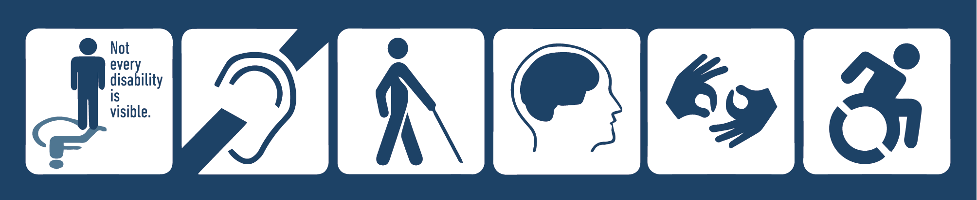

WHO ARE WE?
Our staff provides accommodations and support for students with disabilities such as learning, psychiatric, physical, or sensory disabilities. We offer additional services and opportunities including mentoring, assistive technology, academic skills training, and educational programming.

WHERE ARE WE?
VIRTUAL FRONT DOOR
Monday–Friday 8:30 a.m.–4:30 p.m.
visits by appointment
Monday–Friday 11 a.m.–1 p.m.
drop-in visits

PHYSICAL FRONT DOOR
Monday–Friday 11 a.m.–1 p.m.
Kagin Commons, First Floor, Room 125

CONNECT WITH US:
Website: macalester.edu/disabilityservices Facebook: MacalesterDS
Email: disabilityservices@macalester.edu Instagram: disabilityservices_macalester
Phone: +1 651-696-6974

HOW DISABILITY SERVICES IS ADVOCATING FOR EQUAL ACCESS:
- ACCOMMODATIONS
We provide reasonable accommodations for courses, programs and co-curricular activities in an individualized, confidential process. Access is part of any part of college experience from courses, to residential living to eating at Café Mac to studying abroad.
- UNIVERSAL DESIGN FOR LEARNING (UDL)
We’ve assembled a working group of staff, faculty, and students who promote the goal of flexibility into the educational context to reduce barriers to learning and engagement in all parts of campus life.

HOW DISABILITY SERVICES IS CONNECTING STUDENTS:
- DISABILITY SERVICES MENTOR PROGRAM
Seven upper class mentors are paired with incoming students (your participation is voluntary!) to help with integration into college life at Mac, connection to resources, and assisting in developing the skills necessary for your success.
- BI-WEEKLY VIRTUAL GATHER EVENTS
Provide an opportunity for larger brainstorming and connection with other students with disabilities. Identity collectives and student groups like: Voices on Mental Health, the Macalester Autism Collective and the ADHD group provide more intimate support if that’s your preference.

HOW DISABILITY SERVICES IS INVOLVING AND INCLUDING STUDENTS:
- RADICAL MacACCESS
Our annual event, which invites our community to engage in programming that supports disability identity and is run by and for our students. Student voice is important in inclusion, diversity and equity that is essential to Macalester’s mission.
- COOPERATIVE PROGRAMMING
Disability services collaborates with campus partners and our larger community to develop current events programming and speakers. Students are an essential part of developing and implementing programming and we need and welcome your input!

HOW DISABILITY SERVICES IS EDUCATING OUR COMMUNITY:
- CREATING ACCESS TOGETHER
A variety of virtual trainings and information for faculty, staff and students such as: ways to learn remotely. This includes a frequently updated list of resources specifically for students with disabilities in connection with our campus Virtual Community and Wellness initiative.
- takeCOVER!
Face coverings are an essential part of our community health agreement to each other, and required in the State of MN. Think a mask may not work due to a health condition? Let us help you explore options!

