Weyerhaeuser Boardroom
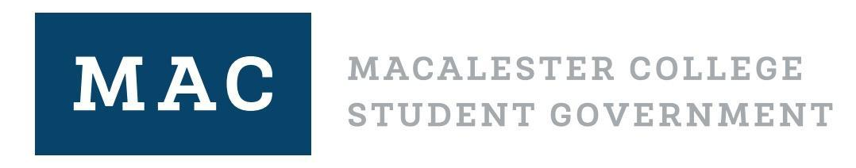
Sept. 21, 2021. 7:00 PM CST

Legislative Body Meeting Agenda

Please sit next to someone you do not know!

Land Acknowledgment (We are on Indigenous land) ~ Jordanella, 2 minutes

Introductions/settling~ 5 minutes

Financial Barriers Working Group ~ Shreya, Brian Lindeman, Angi Falks, Josh Groven, 45 minutes
- Overall goal for FBWG
- Discuss the textbook program
- Proposal Website

Retreat ~ Shreya, 5 minutes

Break ~ 5 minutes

Additional Allocation ~ Rebecca, 15min
Climbing club
  - FAC recommendation: approve $3,330.90
  - Yes: 13
  - No: 0
  - Abstain: 2
- Mac First Aid
  - FAC recommendation: approve $988
  - Yes: 18
  - Opposed: 0
  - Abstain: 0
- Outing Club
  - FAC Recommendation: approve $1850
  - In favor: 18
  - Opposed: 0
  - Abstain: 0

Election Code ~ Shreya, 3 minutes
- Not enough time tonight, so please read and submit comments.
- This is edited every year by EPC for the 3rd LB meeting of the semester
- The edits will not affect the current election

Election Procedures Commission: Violation ~ Shreya, 10 minutes
- Disqualify Daryll Seneque from election
- In favor: 14
- Opposed: 0
- Abstain: 3

LB agenda items ~ Shreya, 30 minutes
- Trigger warning: we will be discussing transphobia and homophobia on campus.
- For those affected, resources are below:
  - Title IX Bias and Response page
  - Title IX Report
  - Hamre Health and Wellness
  - Center for Religious and Spiritual Life
- Create an ad-hoc community to address discrimination and bias on campus
  - In favor: 17
  - Opposed: 1
  - Abstain: 0

Break ~ 2 minutes

Community Chest Request ~ Jordanella, 10 minutes

UWC Day/International Day of Peace
- SSRC recommendation: approve $500
  - In favor: 17
  - Opposed: 0
  - Abstain: 0

Event for Latinx Heritage Month:
- SSRC recommendation: approve $1000
  - In favor:
  - Opposed:
  - Abstain:

Election Update ~ Shreya, 2 minutes

Open Floor

Announcements

