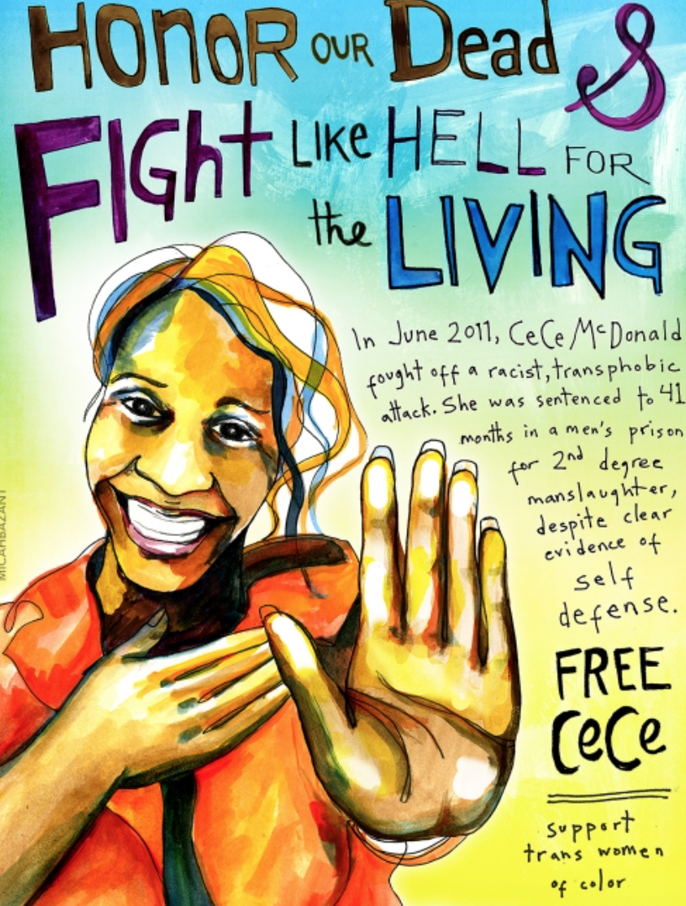

WGSS 100-01: Intro to LGBTQ Studies
Queering Pandemics, Queering Uprisings
Prof. Myrl Beam
Fall 2020 Module 1
Course Syllabus

Course Description
This course introduces key debates and issues in queer theory and LGTBQ Studies through a close examination of the uprisings following the police murders of Mr. George Floyd, Tony McDade, Breonna Taylor, and Elijah McClain, all in the context of the ongoing COVID-19 crisis. We will think about the relationship between anti-Blackness, sexuality, gender embodiment, and policing, as well as the differential distribution of health and exposure to risk. We will focus on the way these interact in the Twin Cities, and also think about the ways that uprisings like Stonewall and the Compton’s Cafeteria Riot and pandemics like HIV/AIDS offer lessons to help us think through the present moment. Throughout the course, we will think about queerness as an analytic rather than a specific identity or sexual practice – in other words, we will think about the production of racialized norms around gender and sexuality, how those norms are policed, and the role of the state, and of capitalism, in producing what Michael Warner has called “a whole field of normalization,” the analysis of which lives at the heart of queer theory. In taking up these queer analytics students will develop your own queer questions, reading practices, theoretical resources, activist communities, and knowledge formations. We will pay particular attention to how scholars theorize power and imagine possibilities for social transformation. Sophomore or junior standing or permission of instructor; one introductory WGSS core or course-listed recommended. Please discuss with me, if you do not meet these criteria.

Learning Objectives
- Critically engage with key concepts and frameworks in LGBT Studies, including the social construction and policing of normativities around racialized gender and sexuality in order to place our contemporary reality of the triple pandemic - the disproportionate impact of illness, economic inequality, and police violence on communities of color - in historical and social context.
- Synthesize key frameworks in LGBTQ Studies to analyze the operations of power at work in producing and maintaining those inequalities.
- Apply theoretical arguments from LGBTQ Studies to contemporary issues, producing original argumentation and analysis.

Required Texts
All required course content, including readings and films, will be available online, via our Moodle site.

Course Structure
This is a fully remote course, meaning we will never have any required in-person meetings. We may, public health and weather conditions permitting, have optional outdoor, socially distant, masked walking office hours - I will send an update about this following the quiet period.

The basic structure of our weeks will be as follows:

We will meet together for synchronous all-class sessions via Zoom on Mondays and Fridays.

Mondays we will discuss the key theme and framework of the week.

Tuesday, Wednesday, and Thursday you will have two days of asynchronous work and one small group meeting. The class will be split into thirds, and each small group will have a 45 minute meeting with me each week during class time, on Tuesday (group 1), Wednesday (group 2), or Thursday (group 3). On these three days you will be working on your team reading and annotation assignment and/or prepping if it is your week to lead class on Friday (we will rotate groups, each group leading class on Friday twice).

Friday’s all-class synchronous zoom session is all about making connections. Connections between each other and connections between the ideas in our readings and the context we are all living in - uprisings for racial justice, economic inequality, and a global pandemic.

Schedule

Week 1 - Sept 2-4
Asking Queer Questions
Date | Mode | In Class | Due
Wed, Sept 2 | All Class Zoom | Introduce Class  Discuss “What if We Radically Re-Examined the School Year” and “Characteristics of White Supremacy Culture”  Assign Team Reading and Social Annotation Small Groups
Thurs, Sept 3 | All Class Zoom | Troubleshoot Perusall  Introduce Team Reading and Annotation Assignment | Annotated Syllabus  Annotated “We Aren’t Here to Learn What We Already Know”
Friday, Sept 4 | All Class Zoom | Queer Approaches to the Present | Reading: Somerville, Siobhan, “Queer” In Keywords for American Cultural Studies

Week 2: Sept 8-11
Using Queer Studies to Think About Not-(Necessarily)-Gay Things
Date | Mode | In-Class | Due
Mon, Sept 7 | No Class | No Class | Nothing
Tues, Sept 8 | All Class Zoom | Introducing the “Subjectless Critique” | Munoz, Halberstam, Eng, “What’s Queer about Queer Studies Now?”
Wed, Sept 9 | Small Group 1 |  | Annotate Gayle Rubin, “Thinking Sex”
Thurs, Sept 10 | Small Groups 2 and 3 |  | Annotate Gayle Rubin, “Thinking Sex”
Friday, Sept 11 | All Class Zoom | Group 1 Facilitates | Rod Ferguson, One Dimensional Queer, Introduction

Week 3: Sept 14-18
Co-construction of Race, Queerness, and Gender Non-Conformity
Date | Mode | In-Class | Due
Mon, Sept 14 | All Class Zoom | The Social Construction of Race, Queerness, and Gender | Siobhan Somerville, Queering the Color Line, Introduction and Chapter One
Tues, Sept 15 | Group 1 |  | Cohen, Cathy. “Punks, Bulldaggers, and Welfare Queens: The Radical Potential of Queer Politics?”
Wed, Sept 16 | Group 2 |  | Cohen, Cathy. “Punks, Bulldaggers, and Welfare Queens: The Radical Potential of Queer Politics?”
Thurs, Sept 17 | Group 3 |  | Cohen, Cathy. “Punks, Bulldaggers, and Welfare Queens: The Radical Potential of Queer Politics?”
Fri, Sept 18 | All Class Zoom | Group 2 Facilitates | Rod Ferguson, One Dimensional Queer, Chapter One

Week 4: Sept 21-25
Race, queerness, and the construction of illness/pathogen/risk
Date | Mode | In-Class | Due
Mon, Sept 21 | All Class Zoom | The Social Construction of Risk and the Differential Distribution of Death | Nayan Shah, “Perversity, Contamination, and the Dangers of Queer Domesticity”
Tues, Sept 22 | Group 1 |  | AIDS and the Distribution of Crisis, Preface and Introduction
Wed, Sept 23 | Group 2 |  | AIDS and the Distribution of Crisis, Preface and Introduction
Thurs, Sept 24 | Group 3 |  | AIDS and the Distribution of Crisis, Preface and Introduction
Fri, Sept 25 | All Class Zoom | Group 3 Facilitates | Dispatches from AIDS and the Distribution of Crisis

Week 5: Sept 28-October 2
Sexuality/Gender Transgression as an Object of State Knowledge and Control
Date | Mode | In-Class | Due
Mon, Sept 28 | All Class Zoom | Producing Racialized Sexuality and Genders | Eithne Luibhéid, Entry Denied: Controlling Sexuality at the Border Introduction
Tues, Sept 29 | Group 1 |  | Claire Sears, Arresting Dress, Introduction
Wed, Sept 30 | Group 2 |  | Claire Sears, Arresting Dress, Introduction
Thurs, Oct 1 | Group 3 |  | Claire Sears, Arresting Dress, Introduction
Fri, Oct 2 | All Class Zoom | Group 1 Facilitates | Karma Chavez, “ACT UP, Haitian Migrants, and Alternative Memories of HIV/ AIDS”

Week 6: Oct 5-9
The policing and control of racialized sexual and gender non-normativity
Date | Mode | In-Class | Due
Mon, Oct 5 | All Class Zoom |  | Regina Kunzel, “Lessons In Being Gay”
Tues, Oct 6 | Group 1 |  | Rod Ferguson, One Dimensional Queer, Chapter Four
Wed, Oct 7 | Group 2 |  | Rod Ferguson, One Dimensional Queer, Chapter Four
Thurs, Oct 8 | Group 3 |  | Rod Ferguson, One Dimensional Queer, Chapter Four
Fri, Oct 9 | All Class Zoom | Group 2 Facilitates | Mogul, Whitlock, Ritchie, Queer (In)Justice, Introduction

Week 7: Oct 12-16
Uprisings for Queerer Futures
Date | Mode | In-Class | Due
Mon, Oct 12 | All Class Zoom | Uprisings, Abolition, and the Context for the Now | Kwame Holmes, “Beyond the Flames: Queering the History of the 1968 DC Riots”
Tues, Oct 13 | Group 1 |  | Spade, Lee, Bassachis, “Building an Abolitionist Queer and Trans Movement With Everything We’ve Got”
Wed, Oct 14 | Group 2 |  | Spade, Lee, Bassachis, “Building an Abolitionist Queer and Trans Movement With Everything We’ve Got”
Thurs, Oct 15 | Group 3 |  | Spade, Lee, Bassachis, “Building an Abolitionist Queer and Trans Movement With Everything We’ve Got”
Fri, Oct 16 | All Class Zoom | Group 3 Facilitates | See Moodle Resource List

Week 8: Oct 19-20
Final Presentations
Date | Mode | In-Class | Due
Mon, Oct 19 | All Class Zoom | Final Presentations | No Readings  DUE: Final Project
Tues, Oct 20 | All Class Zoom | Final Presentations | No Readings

Assignments:

Team Reading and Annotation (25%)
Each week you will work with your small group to read and annotate an assigned reading as a team, with each group member taking on a different role, which you will rotate each week. We will use the social annotation platform Perusall, which allows you to comment on, annotate, highlight, and respond to your group members annotations.

Leading Class (25%)
Twice in the Module your team reading and annotation small group will lead class on Friday, facilitating the class in making connections between the readings that you worked on in your small group and our contemporary context. Using news and current event items that have been posted on our class Padlet, the small group will draw connections between the theme of the week and the contemporary context. The small group will facilitate discussion via synchronous zoom class, using breakout rooms, slide decks, jamboards, video clips, or other platforms and methods of facilitation. (Each class facilitation is worth 12.5% of your grade)

Final Project (25%)
Over the second half of the module you will develop a substantive final project, either individually, in pairs or small groups (no more than four). This assignment asks you to use a theoretical approach that we’ve discussed in class to EITHER a) analyze one aspect of the “triple pandemic” or b) imagine a queer/feminist activist response. A proposal will be due at the midpoint in the module. Detailed assignment information will be handed out in class.

Attendance/Participation, or “Showing Up” (25%)
This class will be an adventure in new ways of communicating and learning for all of us, and it will take high levels of active, enthusiastic participation from all of us - and your consistent presence and engagement is key! Given the pandemic context of our class, my approach to attendance will be more flexible than usual, but my expectation around communication will be higher than usual. Please stay in communication and connection with me if you need to miss class, and let’s work together to figure out how you can stay connected. I’ve structured this class according to principles of universal design, with both synchronous and asynchronous elements, in the hopes that it will accommodate not just a diversity of learning styles, but also a diversity of life circumstances. Again, though, the key to making it work for all of us is communication.

This Module more than ever, the success of our course relies on students to be thoughtful and active contributors to class, both when we are all together on Zoom, as well as in your small groups, and via our asynchronous Padlet, which lets us share connections between the course material and the world around us. So, beyond simply (virtually) raising your hand, there are six interrelated qualities I especially look for in student participation. Together, they constitute what I call “Showing Up” (with thanks to my colleague Dr. Cáel Keegan for the idea):

Investment—Demonstrating that you value the course, your classmates, and me. Also: demonstrating that you’re willing to struggle with concepts when they’re difficult!
Preparation—Being ready to talk, think, and be in community with people different from you.
Openness—Showing us what you care about. This includes sharing viewpoints respectfully with your peers and me—not just when you disagree, but also when you admire others’ contributions. It also includes being candid about what you don’t know. One of the questions that impresses me most is: “I don’t get it. Can you explain that again?” This shows me that you’re paying attention, you’re invested, and you care about learning more than retaining an image of being an infallible, woke genius (see also “risk-taking” and “questions”).
Risk-taking—Willingness to try and fail in order to expand your skills and thinking. In the words of Dr. Kyla Wazana Tompkins: “we aren’t here to learn what we already know.” Intellectual and political growth occur by encountering ideas we aren’t already familiar with. Dealing with new ideas and issues means that we will—indeed, should—mess up sometimes.
Questions – Ask them promiscuously! And ask them of your peers—not just me. You do not need to have invaluable, unique insights to raise your hand – you only need to want to know more about something. I regard question-asking as one of the most valuable kinds of participation: it demonstrates your investment and curiosity; moreover, you almost always do a service to your peers (and me) by asking questions. We will all usually benefit both from the question itself and from the answer(s) it generates.
Integrity—Honesty, generosity, and respect in your behavior and work.

So beyond physically attending, “showing up” means being present, being real, and contributing sincerely to the class community. It’s showing that you value other students by offering your thoughts/feelings and responding respectfully to theirs. It’s risking disagreement while still practicing empathy. And it means recognizing that you are a resource to everyone else in the room.

One concrete way you can “show up” is by participating in our class Padlet, by posting links to news articles, videos, tweets, facebook posts, or anything that strikes you as being connected to the themes we are discussing in class. The more we post here the more help we to the group who is presenting on Friday each week, as well as giving each of you a headstart on your final project, helping to make connections between the course readings and current events.

Grading

Team Reading and Annotations 25%
Class Facilitation (12.5% x 2) 25%
Final Project 30%
Participation 20%

Accessibility
I am deeply committed to making my classroom accessible to all students. We all enter the classroom with different abilities, needs, and capacities. Please come talk to me if you are having trouble accessing any aspects of the course. If you are a student with learning differences or access needs, please meet with me as soon as possible to discuss the arrangements that need to be made to make this course work for you. Students with long or short term disabilities should schedule an appointment by emailing disabilityservices@macalester.edu, or calling the Disability Services Office, 651-696-6874.

Late Policy
The key to this course is connection and communication. If life circumstances are making it difficult for you to keep up with readings and assignments, please contact me so we can figure out how to make things work for you. That said, because much of this particular class is done in small groups, please also communicate with your group members, and be cognizant of the distribution of labor within your group.

Course Content - Much of this class will involve reading and talking about oppression, including forms of interpersonal and institutional violence. Specifically, we will spend quite a lot of the semester talking about policing, police violence, illness, state abandonment, and death and dying. Accordingly, course content may at times be personal, charged, uncomfortable, or demanding in unexpected ways. Due to the course foci and to the variability of individual triggers, generally, I do not independently issue trigger warnings. I treat trigger warnings like other access considerations: if you anticipate that your ability to participate in class may be compromised in any way, please speak with me to discuss appropriate accommodations—this can include developing specific parameters for trigger warnings as needed, which I am happy to do.

Recording Class Content
In order to accommodate students who will not be able to attend synchronous class meetings during this module, I plan to record our synchronous class sessions in a manner consistent with Macalester’s classroom recording policy. I will share these recordings in a password-protected (and not public) place. If you download any class recordings, you must store them in a password-protected file or on a password-protected site. Please note that the recording policy clearly states that you may not share, replicate, or publish any class recording, in whole or in part, or use any of the recordings for any purpose besides knowing what happened during the class period, without my written approval. If I use any recorded content from any of our classes for purposes beyond our class, I will – in accordance with the policy – obtain your written permission to do so.
Health and Wellbeing
Here at Macalester, you are encouraged to make your well-being a priority throughout this semester and your career here. Investing time into taking care of yourself will help you engage more fully in your academic experience. Remember that beyond being a student, you are a human being carrying your own experiences, thoughts, emotions, and identities with you. It is important to acknowledge any stressors you may be facing, which can be mental, emotional, physical, financial, etc., and how they can have an academic impact. I encourage you to remember that you have a body with needs. In the classroom, eat when you are hungry, drink water, use the restroom, and step out if you are upset and need a break. Please do what is necessary so long as it does not impede your or others’ ability to be mentally and emotionally present in the course. Outside of the classroom, sleep, moving your body, and connecting with others can be strategies to help you be resilient at Macalester. If you are having difficulties maintaining your well-being, please don’t hesitate to contact me and/or find support from other resources listed below.

Support for Mental Health
*In cases of life-threatening emergency, call 911.*

On-Campus Resources
Laurie Hamre Center for Health & Wellness
Leonard Center Room 53, 651-696-6275 (call to make an appointment). Follow macalesterhwc on Instagram. www.macalester.edu/healthandwellness/
- Medical Services
  - There is no charge for an office visit to see a provider for most appointments
  - Medical providers can talk to you about your mental health.
- Counseling Services
  - Health & Wellness counselors provide short-term counseling to students.
  - Drop-in counseling sessions are available each day; first-come, first-served basis.
  - Counseling staff offers multiple groups each semester. Check Hamre Center website for more information on specific groups being offered.
  - 24 Hour Urgent Phone Counseling – PRESS 2
    - To speak to a mental health counselor at any time, call 651-696-6275, then press “2” to be connected to ProtoCall, a free phone counseling service that Macalester provides for students, available 24/7.
- Self-Care Resources
  - Health Promotion
    - Provides a variety of resources and events, including free movement classes, tea, sleep masks, earplugs, and sexual health resources. Visit the HWC website, visit the Wellness Lounge in Leonard Center room 55 (across from Studio 2) for resources.
  - PAWS @ Mac (therapy dog program)
    - To learn more about when and where to find the therapy dogs, email paws@macalester.edu, or follow pawsatmac on Instagram or Facebook.

Resident Advisor (RA) and Resident Hall Director (RHD)
- Both RAs and RHDs can serve as a first point of contact and are able to connect you to resources during mental health crises.

Other Support Offices
- Center for Religious and Spiritual Life, (651-696-6298), Weyerhaeuser Chapel
- Office of Student Affairs (651-696-6220), Weyerhaeuser 119

Urgent and Off-Campus Resources
(www.macalester.edu/healthandwellness/afterhours)
Macalester Security
- Call 651-696-6555 in the case of any emergency to reach Macalester Security. They will connect you with other campus response personnel.
- On Friday and Saturday nights (9 pm – 2 am), student EMTs are on call, and will respond to health-related emergencies when Security is called

Press 2 – Phone Mental Health Counseling (see description above)
651-696-6275, menu option 2

Crisis Text Line
- Minnesota’s suicide prevention and mental health crisis texting services are available 24 hours a day, seven days a week. Text MN to 741741 to be connected to Crisis Text Line.

Transgender Suicide Hotline
- 877-565-8860

Urgent Care for Adult Mental Health
402 University Ave E.
St. Paul, MN 55130
651-266-7900 (24/7 phone support; walk-ins M-F 8am - 5:30pm)

Regions Hospital (Emergency Room)
640 Jackson St
St. Paul, MN 55101
651-254-3456

Transportation
If you have an urgent health need and do not have transportation to get to a clinic or hospital, Hamre Center staff, Residential Life staff, and other campus response individuals can arrange for a ride share (Uber) to and from the clinic/hospital. There is no charge for the ride.

